PREFACE

This report is a compilation of documents by the 2019 Applied Computing Project Group under the heading of LTC-TMS Project version 2.1 dealing with the information gathering, planning, development, implementation and management aspects of the project.

The LTC-TMS project has undergone many iterations since version 1.0, when it was initially started as a Task Management System by Kutztown University. This project is in fact a collaboration between Ming Chuan University and Kutztown University, with the new focus on Long Term Care facilities being added in version 1.1 when the project was handed over to the first Ming Chuan University development group to continue work on the project. The project was then handed over to a new development group at Kutztown University for version 2.0, before finally being handed over to Ming Chuan Univerisity’s Applied Computing group of 2019 for continued development as version 2.1 which this document shall discuss.

The intent of this report is to inform the reader about the various stages of development this project has undergone in version 2.1 and it has been a challenge to translate the realities of the level of planning, preparation and hard work that goes into a project of this sort in to mere pages and text. Certainly, when the group first started the preparation stage of the project, there was no clear idea what it would entail, therefore it is hoped that the reader finds these documents to be useful and informative on the processes behind such projects, whether the readers intend to undertake one of their own or not.

TABLE OF CONTENTS

**1 INTRODUCTION** **1**

**2 SYSTEM REQUIREMENTS SPECIFICATION** **3**

**1.0 INTRODUCTION** **4**

1.1 Purpose of Document 4

1.2 High-Level Product Overview 5

1.3 Acronyms & Extrapolations 6

**2.0 PROJECT CONSIDERATIONS** **8**

2.1 Identified Costs 8

2.2 Possible Tools 9

2.3 Open Issues and Questions 10

2.4 Long-Term Plans for Future Releases and Features 11

**3.0 PROJECT SCOPE** **12**

3.1 Feature Outline 12

3.1.1Application Component 12

3.1.2 Browser Component 13

3.1.3 Hardware Component 14

3.2 User Profile 15

3.2.1 Application Component 15

3.2.2 Browser Component 16

3.3 User Interface Map 17

3.3.1 Application Component 17

3.3.2 Browser Component 18

3.4 System Architecture Diagram 19

**4.0 FUNCTIONAL REQUIREMENTS** **20**

4.1 Table of Functions 21

4.1.1 Application Component 21

4.1.2 Browser Component 32

4.1.3 Hardware Component 56

4.2 Database Requirements 60

4.2.1 Application Component 60

4.2.2 Browser Component 60

4.2.3 Hardware Component 61

**5.0 NON-FUNCTIONAL REQUIREMENTS** **62**

5.1 Application Component 62

5.2 Browser Component 64

5.3 Hardware Component 66

**6.0 USE CASE DIAGRAM** **67**

6.1 Application Component 67

6.2 Browser Component 68

**7.0 USE CASE DESCRIPTIONS** **70**

7.1 Application Component 70

7.2 Browser Component 72

**8.0 CONFIGURATION MANAGEMENT** **74**

8.1 Installation 74

8.1.1 Installing Git - Installing on Linux 74

8.1.2 Installing on macOS 75

8.1.3 Installing on Windows 76

8.2 First-Time Git Setup 77

8.3 Best Practices with Git 79

**3 SYSTEM DEVELOPMENT DOCUMENT** **81**

**1.0 INTRODUCTION** **82**

**2.0 SYSTEM PLANNING** **83**

2.1 System Capabilities 83

2.1.1 General 83

2.1.2 Application Component 83

2.1.3 Browser Component 84

2.1.4 Hardware Component 84

2.1.5 System Benefit 84

2.2 Context Diagram 85

2.2.1 Browser Component 85

2.2.2 Application Component 86

2.3 Risk and Feasibility 87

2.3.1 Organizational and Cultural Risks and Feasibility 87

2.3.2 Technological Risks and Feasibility 90

2.3.3 Resource Risks and Feasibility 92

2.3.4 Schedule Risks and Feasibility 94

2.4 Work Breakdown Structure 95

2.5 Gantt Chart 96

2.6 System Planning Conclusion 97

**3.0 SYSTEM ANALYSIS** **98**

3.1 Requirement Investigation 98

3.1.1 Stakeholders 98

3.1.2 Hardware 100

3.2 Use Cases 101

3.2.1 Use Case Diagram 101

3.2.2 Brief Use Cases Description 104

3.2.3 Activity Diagrams 107

3.2.4 System Sequence Diagram 114

3.2.5 State Machine Diagram 117

3.3 System Analysis Conclusion 120

**4.0 SYSTEM DESIGN** **121**

4.1 Network Design Diagram 121

4.1.1 Browser Component 121

4.1.2 Application Component 122

4.2 Device Design Diagram 123

**4 SYSTEM IMPLEMENTATION DOCUMENT** **125**

**1.0 VISITING A LONG-TERM CARE CENTER** **126**

1.1 Photos of Long Term Care Center 127

1.2 System Users 129

1.2.1 User Categories 129

**2.0 PROJECT FOCUS** **130**

**3.0 HARDWARE TEAM** **131**

3.1 Introduction 132

3.1.1 Hardware Diagram 132

3.2 How it works 132

3.2.1 Tools and Requirements 134

3.2.2 Explanation of Hardware 136

3.2.3 Mu: Python IDE 140

3.3 Planned Changes 142

3.3.1 Improved Monitoring Capability 142

3.3.2 Improved scalability 143

3.3 Backend Code 144

3.4 Industry Conventions 159

3.4.1 Current Marketability 160

3.4.2 Improved Scalability 162

3.5 Limitation of hardware and solutions 164

3.5.1 Raspberry pi 164

3.5.2 BBC:Micro:bit 165

**4.0 BROWSER TEAM** **165**

4.1 Tools and Software 168

4.2 Users, Focus, and Goals 169

4.3 Users Interface Map 170

4.3.1 Director/CNO User Interface Map 170

4.3.2 IT Admin User Interface Map 171

4.4 Browser Functions 172

4.4.1 About Us page 172

4.4.2 E-portfolio sort and search bar 174

4.4.3 Status Record 178

4.4.4 Help and Support 182

4.4.5 User Information 186

4.5 UI Change 189

4.6 Problem and Difficulty 194

4.7 Future Changes 196

4.7.1 Calendar 196

4.8 Industry Standards and Best Practices(Browser) 198

4.8.1 Account Options 198

4.8.2 Search and Sort Bar 200

**5.0 APPLICATION TEAM** **203**

5.1 Tools and Requirements 204

5.2 Users, Focus and Goals 205

5.3 User Interface Maps 206

5.4 APP FUNCTIONS 208

5.4.1 Login Page 208

5.4.2 Home Page 209

5.4.3 CNA - Patient Records 212

5.4.4 CNA - Daily Status Add 214

5.4.5 CNA - Vital Status Add 218

5.4.6 Family - Patient Record 220

5.4.7 Daily Status Read 222

5.4.8 Library 223

5.4.9 Centre Info 226

5.4.10 Submit Feedback 228

5.4.11 Call Centre 229

5.4.12 Portfolio 229

5.4.13 Logout Page 232

5.5 Industry Standards and Best Practices(App) 234

5.5.1 Clearer Page Layout 235

5.5.2 Visual Element Design 236

5.5.3 Shallow interface map 238

5.6 Limitation of Application and Solutions 240

**6.0 QA TEAM** **240**

6.1 Quality Management Report 242

6.2 System Quality Summary 243

6.3 Quality Manager’s Reflection 245

**7.0 DATABASE TEAM** **246**

**5 APPENDIX** **247**

**1.0 WORKING HOURS** **249**

1.1 Table of Work Hours 249

1.2 Meeting Minutes 250

**2.0 QA Testing** **285**

2.1 INTRODUCTION 285

2.1.1 Purpose 285

2.1.2 Test Approach 285

2.1.3 Testing and Product Delivery Dates 285

2.1.4 Explanatory Material: Acronyms & References Table 286

**3.0 TEST CONFIGURATIONS** **287**

**4.0 TEST CASES** **288**

4.1 Browser 288

4.1.1 General Testing 288

4.1.2 Director Specific Testing 293

4.1.3 CNO Specific Testing 305

4.2 APP 316

4.2.1 General Testing 317

**5.0 New Changes Testing** **329**

5.1 APP 329

5.2 Browser 342

5.2.1 Director Specific Testing 342

5.2.2 CNO Specific Testing 348

5.3 Hardware Testing 354

**6.0 SOFTWARE DEFECT STATES AND SEVERITY** **356**

**7.0 TESTING RESPONSIBILITIES** **360**

**8.0 TEST ENTRANCE CRITERIA** **360**

8.1 Acceptance Testing Criteria 360

**9.0 FINAL TESTING SCHEDULE** **361**

**10.0 RISKS AND CONTINGENCIES** **362**

**6 REFERENCES** **362**

LIST OF FIGURES

**1 INTRODUCTION** **1**

**2 SYSTEM REQUIREMENTS SPECIFICATION** **3**

Figure 2.3.1:User-Interface Map of LTC-TMS(Application component) 17

Figure 2.3.2: User-Interface Map of LTC-TMS(Browser version) 18

Figure 2.3.3: System architecture of LTC-TMS 19

Figure 2.6.1: Use case diagram(Application Component) 67

Figure 2.6.2: Use case diagram(Browser component) 68

Figure 2.8.1: Git macOS Installer 75

Figure 2.8.2: Showing the project’s GitHub Repository 78

**3 SYSTEM DEVELOPMENT DOCUMENT** **81**

Figure 3.2.1: Browser_Context Diagram 85

Figure 3.2.2: App_Context Diagram 86

Figure 3.2.3: Work Breakdown Structure 95

Figure 3.2.4: Gantt Chart 96

Figure 3.3.1: Stakeholders 99

Figure 3.3.2: Browser Component use case diagram 101

Figure 3.3.3: Application Component use case diagram 103

Figure 3.3.4: Browser-Activity Diagram _Edit Schedule 107

Figure 3.3.5: Browser-Activity Diagram _Edit Memo 108

Figure 3.3.6: APP-Activity Diagram _View Task Instruction 109

Figure 3.3.7: APP-Activity Diagram _View Status Record 110

Figure 3.3.8: APP-Activity Diagram _Summit Feedback 111

Figure 3.3.9: APP-Activity Diagram _Check Daily Status 112

Figure 3.3.10: System Sequence Diagram_Browser Component 114

Figure 3.3.11: System Sequence Diagram_App Version 115

Figure 3.3.12: System Sequence Diagram_Hardware 116

Figure 3.3.13: State machine diagram_protfolio 117

Figure 3.3.14: State machine diagram_memo 118

Figure 3.3.15: State machine diagram_memo 119

Figure 3.4.1: Network Design diagram_browser 121

Figure 3.4.2: Network Design diagram_browser 122

Figure 3.4.3: Data flow of hardware component in v2.0 123

Figure 3.4.4: Planned data flow of hardware component in v2.1 124

**4 SYSTEM IMPLEMENTATION DOCUMENT** **124**

Figure 4.1.1: Announcement board in a real Long-Term Care Center 127

Figure 4.1.2: Environment of the Long-Term Care Center 127

Figure 4.1.3: Group photos with the staff 127

Figure 4.1.4: Examples of various tasks performed at the LTC 128

**3.0 HARDWARE TEAM** **130**

Figure 4.3.1 System Diagram showing the Hardware component outlined with an Orange box 132

Figure 4.3.2 Hardware Data Flow Diagram 133

Figure 4.3.3 Hardware Data Flow Diagram 134

Figure 4.3.4 Hardware Data Flow-wearable part 136

Figure 4.3.5: Section of code for fall and step detection 137

Figure 4.3.6: Section of code for Button press functionality 137

Figure 4.3.7: Diagram of Hardware Data Flow (Base station) 138

Figure 4.3.8: Section of Master BBC Micro:bit code 139

Figure 4.3.9 data monitor and GUI 140

Figure 4.3.10: sending format from raspberry to DB 141

Figure 4.3.11 data monitor and GUI 141

Figure 4.3.12: Hardware dataflow after moving pulse sensor to wearable unit 142

Figure 4.3.13: Connection diagram showing base-station supporting one-to-one connections with wearable 143

Figure 4.3.14: Connection diagram showing base-station supporting one-to-many connections with wearables 144

Figure 4.3.15: Picture of our backend server unit 145

Figure 4.3.16: Column chart from reports pdf generated from test data values showing daily average heart rate 147

Figure 4.3.17: Column chart from reports pdf generated from test data values showing daily average step count 148

Figure 4.3.18: Line graph from reports pdf generated from test data values showing daily average Systolic and Diastolic blood pressure 149

Figure 4.3.19: Line graph from reports pdf generated from test data values showing resident’s daily average body temperature 150

Figure 4.3.20: section of table in reports pdf generated from test data values showing daily average values (icon is test image) 151

Figure 4.3.21: Interior image of backend server 152

Figure 4.3.22: Window capture of i-nex showing SSD model number and firmware version of SSD installed in backend server unit 153

Figure 4.3.23: Window capture of i-nex showing Operating system currently installed on backend server unit 154

Figure 4.3.24: Window capture of i-nex showing CPU model of the backend server 155

Figure 4.3.25: Code showing some dependencies required for reports.py to run 156

Figure 4.3.26: Code segment showing config section of reports.py 157

Figure 4.3.27: Code segment showing prior Kutztown University URL for storing reports 158

Figure 4.3.28: Images of Mi Band 4 and FitBit Inspire HR 160

Figure 4.3.29: Line Graph of estimated cost for deploying hardware at increasing scale, in groups of 4. (Costs calculated in NTD) 162

**4.0 BROWSER TEAM** **165**

Figure 4.4.1: Tools and Software of the browser team 168

Figure 4.4.2: Director/ CNO User Interface Map 170

Figure 4.4.3: IT Admin User Interface Diagram 171

Figure 4.4.4: blank space of the About Us page in version 2.0 172

Figure 4.4.5: changes to the About Us page as seen in version 2.1 172

Figure 4.4.6: Section of code for the About Us Page 173

Figure 4.4.7: E-portfolio page from version 2.0 showing the extended search options 174

Figure 4.4.8: Screen capture showing the change in the filter bar’s position on the E-portfolio page 174

Figure 4.4.9: Section of code for the E-Portfolio Page 176

Figure 4.4.10: Section of code for the E-Portfolio Page 176

Figure 4.4.11: Section of code for the E-Portfolio Page 177

Figure 4.4.12: Status Record page template from version 2.0 178

Figure 4.4.13: working Status Record page which can search resident records 178

Figure 4.4.14: Section of code for the Status Record Page 180

Figure 4.4.15: Section of code for the Status Record Page 181

Figure 4.4.16: Help and Support page from version 2.0 182

Figure 4.4.17: Help and Support page in version 2.1 which can now receive feedback from the application 182

Figure 4.4.18: Section of code for the Help and Support page 184

Figure 4.4.19: Section of code for the Help and Support Page 185

Figure 4.4.20: User Information bar from version 2.0 186

Figure 4.4.21: User Information is combined with language options in version 2.1 186

Figure 4.4.22: Section of code for the User Information Page 188

Figure 4.4.23: Magnified image of the same section 188

Figure 4.4.24: Section of code for the User Information Page 189

Figure 4.4.25: Magnified image of the same section 189

Figure 4.4.26: log in page from version 2.0 190

Figure 4.4.27: image showing the colour changes Chinese login page in version 2.1 190

Figure 4.4.28: Section of code for the UI Changes 192

Figure 4.4.29: Section of code for the UI Changes 192

Figure 4.4.30: Section of code for the UI Changes 193

Figure 4.4.31: Section of code for the UI Changes 193

Figure 4.4.32: Screenshot of the database 194

Figure 4.4.33: Announcements 196

Figure 4.4.34: Calendar 196

Figure 4.4.35 : Example of design philosophies present in the LTC-TMS v2.1 web portal compared side by side with the Google logout button 198

Figure 4.4.36 : comparison of search bars from the LTC-TMS v2.1web portal and Youtube’s search page 200

**5.0 APPLICATION TEAM** **201**

Figure 4.5.1: Application Tools 204

Figure 4.5.2 :CNA User Interface Map 206

Figure 4.5.3:Family User Interface Map 207

Figure 4.5.4 : Comparison of old and new Login Page 208

Figure 4.5.5: Section of code for the Login Page 209

Figure 4.5.6 : Image showing changes to the Announcements page 210

Figure 4.5.7: Section of code for the Home Page 211

Figure 4.5.8: Another section of code for the Home Page 211

Figure 4.5.9 : Image showing changes made to the CNA’s patient records page 212

Figure 4.5.10: Section of code for the CNA’s Patient Records Page 213

Figure 4.5.11 : Image showing changes made to the CNA’s Daily Status Add page 214

Figure 4.5.12: Section of code for the CNA’s Daily Status Add 215

Figure 4.5.13 : Image showing changes made to the Vital Status Add Page 218

Figure 4.5.14: Section of code for the CNA’s Vital Status ADD 219

Figure 4.5.15 : Image showing changes made to the Patient Record page 220

Figure 4.5.16: Section of code for Family patient record 221

Figure 4.5.17 :Image showing changes made to the Daily Status Read page 222

Figure 4.5.18: Section of code for Family read daily status 223

Figure 4.5.19 :Image showing changes to the new Task Library 224

Figure 4.5.20: Section of code for Task Library 225

Figure 4.5.21 : Image showing difference between old and new Center Info page 226

Figure 4.5.22: Section of code for the Centre Info page 227

Figure 4.5.23 : the Submit Feedback Page as it appears in version 2.1 228

Figure 4.5.24 : Image showing LTC phone number loaded into the mobile dialing area 229

Figure 4.5.25 : Image showing difference between old and new Portfolio page 230

Figure 4.5.26: Section of code for the Portfolio page 231

Figure 4.5.27: Another section of code for the Portfolio page 231

Figure 4.5.28 : the Log Out page as it currently appears in version 2.1 232

Figure 4.5.29: Section of code for the logout button 233

Figure 4.5.30: Example of spacing used in popular public transport app “BusTracker Taiwan” and LTC-TMS v2.1 mobile application component 235

Figure 4.5.31: Examples of improved visual element designs in the LTC-TMS v2.1 mobile application component 236

Figure 4.5.32: Example of “page” button layout from Facebook App and LTC-TMS v2.1 mobile application component 238

**6.0 QA TEAM** **240**

Figure 4.6.1 Bar Chart of Testing Results 244

**7.0 DATABASE TEAM** **245**

Figure 4.7.1: Screenshot of database 247

**5 APPENDIX** **247**

Figure 5.6.1 Image showing severity index parameters 357

Figure 5.6.2 Image showing app severity index 357

Figure 5.6.3 Image showing second app severity index 358

Figure 5.6.4 Image showing browser severity index 359

Figure 5.6.5 Image showing hardware severity index 359

**6 REFERENCES** **362**

LIST OF TABLES

**1 INTRODUCTION** **1**

**2 SYSTEM REQUIREMENTS SPECIFICATION** **3**

Table 2.1.1: Acronyms and definitions 6

Table 2.2.1: Hardware purchase list 8

Table 2.4.1: The Old Table of Family Mobile Functional Requirements 21

Table 2.4.2: The Old Table of CNA Mobile Functional Requirements 23

Table 2.4.3: The New Table of Family Mobile Functional Requirements 26

Table 2.4.4: The New table of CNA Mobile Functional Requirements 28

Table 2.4.5: Table of old Functional Requirements 32

Table 2.4.6: Table of new or modified Functional Requirements 50

Table 2.4.7: Table of old Functional Requirements 56

Table 2.4.8: Table of New or Modified Functional Requirements 58

Table 2.4.9: Functional Requirements 60

Table 2.4.10: Functional Requirements(BW) 60

Table 2.4.11: Functional Requirements(HW) 61

Table 2.5.1: Non-functional Requirements 62

Table 2.5.2: Non-functional Requirements 64

Table 2.5.3: Non-functional Requirements 66

Table 2.7.1: Fully Developed Use Case Description for View Task Instruction(APP) 70

Table 2.7.2: Fully Developed Use Case Description for View Task Instruction(BW) 72

**3 SYSTEM DEVELOPMENT DOCUMENT** **81**

Table 3.3.1: Brief Use Case Description of LTC-TMS 104

Table 3.3.2: Brief Use Case Description of LTC-TMS 105

**4 SYSTEM IMPLEMENTATION DOCUMENT** **125**

Table 4.3.1: Table of estimated costs for deploying 1:1 vs 1:4 model (in NTD) 163

Table 4.5.1: the content of daily status add 203

Table 4.6.1. QA Team Members 242

Table 4.6.2 System Total Test Results 243

**5 APPENDIX** **248**

Table 5.1.1: Total working hours 249

Table 5.2.1 Acronyms frequently used 286

Table 5.3.1 Showing QA team test configurations 287

Table 5.9.1 Showing Test Schedule for the QA Team 361

Table 5.10.1 Showing Risks and Contingencies 362

**6 REFERENCES** **363**

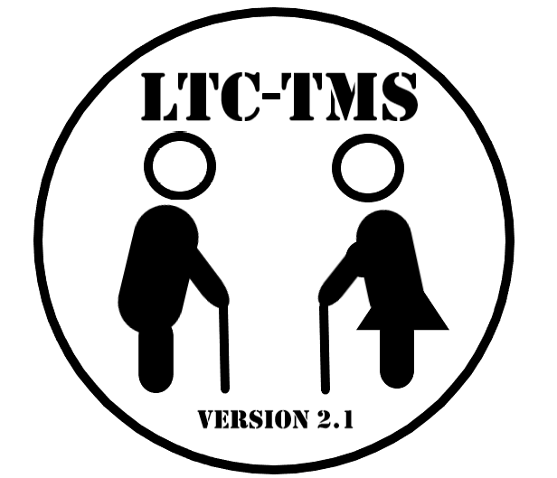

## 

## 

# 1 INTRODUCTION

### Project Name

Long-Term Care Center Task Management 2.1

### Project Goal

The goal of the LTC-TMS project is to digitize the LTC staff’s work by increasing resident monitoring efficiency, implementing efficient hierarchical communication, and increasing work productivity for Long Term Care Centres. This is achieved by integrating three subsystems, namely APP, Browser, and Hardware, that work together seamlessly.

### Acknowledgement

2019 Applied Computing Project Group would like to thank Professor Michael Yu-Ching Lin for the supervision of the project, and Anita Liu, the secretary of Applied Computing Program, for the administrative support.

Special thanks are given to Kutztown University, the collaborative partner of the project, and to Guang En Private Elderly Care Centre, where information regarding LTC centres’ activities and operational processes is gathered and obtained.



## 

## 

# 2 SYSTEM REQUIREMENTS SPECIFICATION

## 1.0 INTRODUCTION

### 1.1 Purpose of Document

This document is the Software Requirements Specification for the Long-Term Care Task Management System. The purpose of this document is to list all project considerations, define the project scope, list all functional and nonfunctional requirements, and create use case diagrams with proper descriptions. The project considerations section identifies all potential expenses, problems, ongoing questions, and tools. The project scope section lists all functions that the Long-Term Care Task Management System must provide.

The section also lists the different roles and actions that each user may take. The System Architecture Diagram section is a visual representation of the flow of information inside the Long-Term Care Task Management System from a hardware perspective. Sections four and five lists all of the functional and nonfunctional requirements. Existing functional requirements are given a category, requirement ID, description, and priority level. New functional requirements, as well as changes to existing requirements, are given a new requirements ID or corresponding ID respectively. Nonfunctional requirements are given a purpose and a metric used to quantify each requirement. Section six and seven detail the use cases of the system.

### 1.2 High-Level Product Overview

The Long-Term Care Task Management System is a product that will provide a convenient data logging, tracking and patient monitoring system for healthcare facilities to document and manage their patients, facility, and staff. The system will provide applications that are available through a web browser and smartphones.

These applications allow staff to document patient information as well as manage their work schedule and store notes relevant to their many tasks on a daily basis. The system provides a hierarchical management interface which allows a Supervisor to delegate and oversee tasks that are given to the Chief Nursing Officer or Certified Nursing Assistant. The Chief Nursing Officer may also oversee and delegate tasks for the Certified Nursing Assistant. The system will gather patient metrics such as heart rate through a wearable device as well as track conditions such as air quality through static hardware located in each patient's room. A database will store all of the information related to the Long-Term Care Task Management System.

### 1.3 Acronyms & Extrapolations

Listed below in Table 2.1.1 are all of the acronyms used in the Software Requirements Specification. All acronyms and definitions may be used interchangeably throughout the document.

###### Table 2.1.1: Acronyms and definitions

|  |  |
| --- | --- |
| Acronym | Definition |
| KU | Kutztown University of Pennsylvania |
| MCU | Ming Chuan University |
| SRS | Software Requirements Specification |
| ID | Identifier |
| IT | Information Technology |
| AI | Artificial Intelligence |
| LTC-TMS | Long-Term Care Task Management System |
| CNO | Chief Nursing Officer |
| CNA | Certified Nursing Assistant |
| App | Application |
| HIPPA | Health Insurance Portability and Accountability Act |
| FR | Functional Requirement |
| DB | Database |
| HW | Hardware |
| PM | Project Management |
| SPP | Software Project Plan |
| PDF | Portable Document Format |
| AN | Indicates new Application requirements (ID number) |
| AM | Indicates change in Application requirement (ID number) |
| BN | Indicates new Browser requirement (ID number) |
| BM | Indicates change in Browser requirement (ID number) |
| HN | Indicates new Hardware requirement (ID number) |
| HM | Indicates change in Hardware requirement (ID number) |

## 2.0 PROJECT CONSIDERATIONS

Section 2.0 outlines information regarding the project in terms of costs, tools, concerns, future development and adherence to industry standards.

### 2.1 Identified Costs

Costs are being structured to only have the needed products and future progress will be with this guideline in mind. As of this moment, Firebase has been selected as the database/host. Hardware will be the largest expense based on acquiring the micro:bit and Raspberry Pi units with all the needed accessories such as a grove shield and other sensors. Table 2.2.1 below shows the demand buying list of the project.

###### Table 2.2.1: Hardware purchase list

|  |  |  |  |  |  |  |
| --- | --- | --- | --- | --- | --- | --- |
| SPRING SEMESTER BUYING LIST | | | | | | |
| ITEM | | PRICE | DESCRIPTION | | | Total |
| Raspberry Pi 3 B+ | | $1890 | 1. Raspberry PI 3 B+  2. 專用六片組合外殼+散熱風扇  3. 32G記憶卡  4. 專用散熱片 | | | $1890 |
| Micro bit | | $450 | 單片Micro bit | | | $1800 |

## 

### 2.2 Possible Tools

Tools will be clearly stated, whether in terms of Firebase (Real-Time Database) modifications or hardware structure. Firebase Cloud services will be used for the duration of the project. Communication/file sharing tools used are Google-based services such as google hangouts/drive. For overall group communication, Line is used. Lucidchart was used for the creation of all diagrams in this document. GitHub will be used for storing all code and will be shared for the entire class.

##### Hardware Requirements

The following is a list of all the possible tools needed for the project.

* Raspberry Pi 3 B+ and power cord
* iUniker Dual Fan Cooling System Module with Heat sink
* slave Micro: bit
* master Micro: bit
* Heart Rate Sensor
* Adafruit ADS1015
* seven Breadboard Jumper cables
* USB A-Male to micro B cable
* HDMI cable
* 16 GB SD card
* Grove GPS sensor
* Temperature sensor
* Air quality sensor

##### Coding Tools:

* JavaScript
* python
* makecode editor

### 2.3 Open Issues and Questions

Open concerns that will continue throughout the duration of the project are in terms of scalability and the structure of data processing. How much storage in Firebase will be required to store patient data? How frequently can the database be updated and how long will client information be held in the database? What limits are set on the internal users as to what they can and can't access? Will those restrictions be the same for the external users as well? Will the MCU development group be able to duplicate the computing environment of the KU development group? Will the MCU development group be able to maintain and improve the LTC-TMS system handed over by the KU development group?

Another important issue is the availability of the proper technological infrastructure at LTC facilities. Do they already possess the adequate hardware and networking facilities needed to implement this new system? How many routers or access points would be necessary to have a stable internet connection? Also, the group needs to consider the fact that if multiple PCs are to connect via ethernet cables and switches there might need to be some running of wires or light construction done in or around the building. These are things the group should keep in mind if the team are to successfully implement the new system.

Furthermore, there are concerns about data loss and data security. How will security in the current version be implemented? How might future versions improve security? Will user data be safe? To what extent is hashing and encryption used throughout? Could future versions implement local buffer servers to store and distribute data locally in case of network failure? These are some of the concerns that the development team should ethically consider very seriously as should future development groups, however, existing time and budget constraints are always a force for compromise on the issue. Setting an ideal compromise that ensures sufficient security while allowing the system to be feasible with the resources will be a difficult issue.

### 2.4 Long-Term Plans for Future Releases and Features

The project is to have an incremental improvement over the previous version 2.0 and provide the necessary functionality to support an iterative evolution. The following steps are implemented:

* Close to real-time data logging and patient monitoring on browser and application client via data from Hardware units.
* Improve cost scaling allowing more Wearable (Microbit Units) to connect and communicate with one Base Station (Raspberry Pi and Master Microbit unit)
* Improvement of Usability across the whole system
* Implement improved user account access
* Creating a document of possible future features and improvements.

## 

## 3.0 PROJECT SCOPE

The LTC-TMS is aimed to reduce the paperwork of the facilities staff by digitizing the data with increased retrieval efficiency, effective hierarchical communication, and work productivity. It also provides a user friendly interface for checking the patients’ information quickly and conveniently.

### 3.1 Feature Outline

#### 3.1.1Application Component

##### CNA’s Perspective:

The CNA receives information from CNO/ Director, and views or modifies the information by utilizing the following services:

* View task instruction
* View CNA portfolio
* View announcement
* View opening time
* Create/View daily status
* Create/View AI status
* Create/View vital status
* View working schedule

##### Family Perspective:

A Family member receives information from a CNO/ Director, and can view it by utilizing the following services:

* View task instruction
* View patient portfolio
* View announcement
* View opening time
* View daily status
* View AI status
* View vital status

#### 3.1.2 Browser Component

##### Director and CNO’s Perspective:

The Director and CNO of the Long Term Care Center must able to create and assign tasks to the CNAs and the patients. The following is a list of all the services that the Director and CNO will need:

* Create a task
* Edit a task
* Delete a task
* Assign a task to a CNA
* Assign a task to patient
* Input center schedule
* Edit center schedule
* Delete center schedule
* Create announcement
* Edit announcement
* Delete announcement
* View the status record of a patient
* View a report of a patient
* View the task list
* View e-portfolio of CNA and patients
* Give feedback to staff and family

##### IT Admin’s Perspective:

The IT Admin mostly deals with the system and account management. The IT admin has to be able to:

* Create a director or CNO account
* Delete user account
* Modify user account
* Give feedback to users

#### 3.1.3 Hardware Component

##### Wearable Perspective:

The CNA will attach the wearable Micro:bit to the Patient. The micro:bit wearable will support the following:

* heart rate sensor
* fall sensor
* Distress/calling button (Micro:bit)
* communicate data/state to the base station (Raspberry Pi)

##### Base Station Perspective:

The Raspberry Pi with attached Master Microbit unit will serve as the Hardware base station for the hardware system. The base station will also serve a number of functions such as:

* Temperature sensor
* air quality sensor
* Live data monitoring from wearable unit’s sensors
* Audio/Visual patient monitoring capabilities via installed camera and microphone

### 3.2 User Profile

#### 3.2.1 Application Component

The LTC-TMS Application component is intended for two main categories of users, Family and CNA. Both users generally have similar functions as far as the APP is concerned. The Family account, however, can be more convenient for checking patients’ status. The CNA account can be more efficient for checking information on their work.

##### Family:

Are able to view the patient’s status, patient’s portfolio, task instruction, and check up announcements and scheduled events. They can also click the setting button to switch between two languages (Chinese and English). Also, the task instruction page can be utilized if they are not really familiar with some of the LTC centre’s procedures. They can view these processes step by step. However, other than logging in and feedback purposes, family members cannot input or modify data via the application component.

##### CNA:

Are able to view their own portfolio, task instructions, and check up on announcements and scheduled events. They can also switch languages in the settings page and view the task instructions. In addition, they can view their working hours and working schedule. Therefore, CNAs should be able to fully understand how to use mobile devices and perform facility operations.

#### 3.2.2 Browser Component

The LTC-TMS browser component is intended for the Director and CNO. The Director and CNO will focus more on facility administration. Both the Director and CNO will have similar functions regarding the use of the LTC-TMS web portal. However, the CNO is given the most access privileges considering their uses on a daily basis. The Director will act in place of the CNO to perform most of the functions only if the CNO is not available. Also, the major difference between the Director and CNO is that the Director is given the authority to create and edit information in user accounts, while the CNO is only given the authority to view existing accounts.

##### Director:

Will mainly be able to create and edit portfolios. The Director will input all the personal information for both Staff and patients separately according to the designed format. Moreover, a Director is allowed to create and edit announcements and task instructions. In addition, they are also allowed to assign task instructions to others. The Director will only input information when the need arises. Thus, the Director is given the highest authority in the LTC-TMS. However, the Director is limited to his/her personal account. The Director is not allowed to access the CNO’s account.

##### CNO:

The CNO is not able to create or edit any accounts. The CNO is only given the authority to view accounts. The CNO will be able to create and edit announcements and task instructions. In addition, the CNO will be able to assign task instructions as well. Moreover, CNOs are not allowed to access the Director’s account.

### 3.3 User Interface Map

#### 3.3.1 Application Component

Careful planning in User Interface design is used to make the application as simple, quick, and painless to use by the intended users. To design a high-quality app, user interface maps are used to illustrate the workflow of the typical user interaction. The map will provide a bird's eye view of the entire set of paths and reveals the separation of functions between various pages and buttons. It gives the developer an overview of what pages should be linked together and which functions should appear to the end user before any changes are made to the UI design.

Figure 2.3.1 is a user interface map that is useful to understand what pages users must go through to access certain functions. It is vital to improving the quality of user experience, ensuring quick and easy access to important functions on all pages.

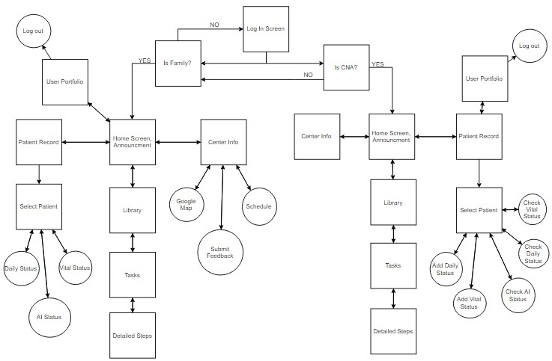

###### Figure 2.3.1:User-Interface Map of LTC-TMS(Application component)

#### 3.3.2 Browser Component

The following Figure 2.3.2 displays the user interface map of the LTC-TMS web portal. The box describes the main function design in each web-page while the arrows illustrate the menu paths throughout the application. Basically in this diagram, it shows the interconnection between different pages in the browser application.

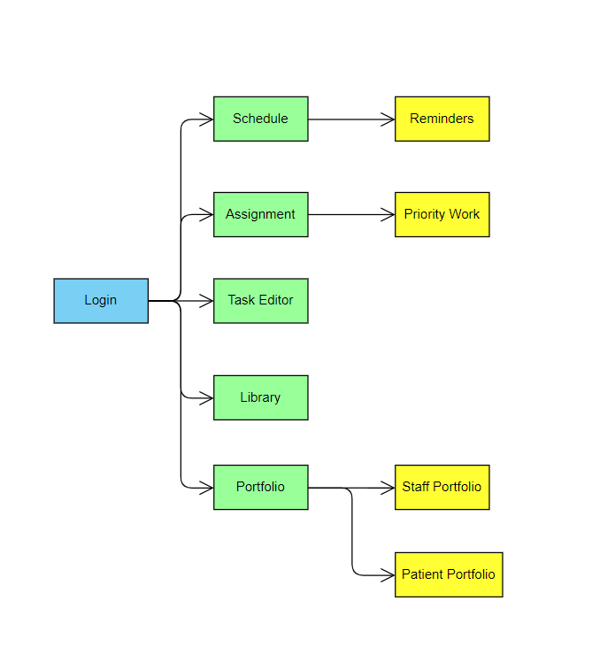

###### Figure 2.3.2: User-Interface Map of LTC-TMS(Browser version)

### 3.4 System Architecture Diagram

Figure 2.3.3 shows the communication between the various components and the database.

The application on both Android and iOS mobile devices connect to the cloud based Database. The arrows in the diagram indicate that the application both sends and receives data from the database. The Browser component, the web portal, also sends and receives data from the database. The hardware component has an arrow that only points in one direction as the data flow in one way only. The hardware component uploads data but does not require any input from the database to carry out its functions.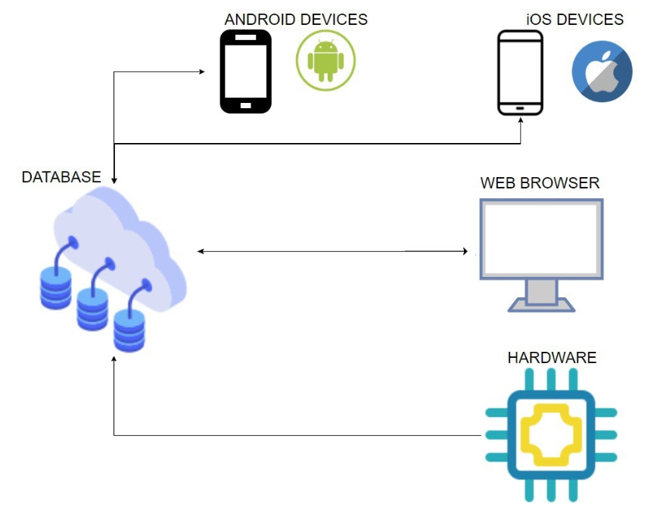

###### Figure 2.3.3: System architecture of LTC-TMS

## 4.0 FUNCTIONAL REQUIREMENTS

Tables 2.4.1(family mobile), Table 2.4.2(CNA mobile), Table 2.4.3 (database/hardware), and Table 2.4.4 (browser) are the current functional requirements for the LTC-TMS project. Each table is organized into a category that represents a larger scope than one individual requirement, “Requirement ID” or “REQ ID” is an identification number assigned to each requirement. The “Requirement Description” column is a listing of the requirements themselves, with the “Explanation” being how the teams intend to facilitate the requirement. The priority number given to each requirement indicates the necessity for it to be in the project, with 1 being a base requirement, 2 as something that would be very beneficial to have in the application, and 3 as a requirement that would be nice to have, but not a necessity.

### 4.1 Table of Functions

#### 4.1.1 Application Component

Table 2.4.1 shows the functional requirements for the mobile version of LTC-TMS 2.0 with a family member as the intended user. Table 2.4.2 lists the functional requirements for the mobile version of LTC-TMS with CNA as the intended user.

###### Table 2.4.1: The Old Table of Family Mobile Functional Requirements

|  |  |  |  |  |
| --- | --- | --- | --- | --- |
| Category | REQ  ID | Requirement Description | Explanation | Priority |
| User Login | 1 | Family member must be able to login to the system. | Family will be provided with default login info which can be changed to enable secure login. | 1 |
| Tasks Instruction Viewing | 2 | Family members must be able to select the instruction type. | All task instructions are created from the browser page and this enables Family to select the instruction type. | 1 |
| 3 | Family member must be able to view the page of tasks instruction list. | System will list task instructions on the page. | 1 |
| 4 | Family member must be able to view task instructions. | Task instructions will be shown. | 1 |
| Daily Status Record Viewing | 5 | Family member must be able to view Daily Status Record page | Daily status record will be shown. | 1 |
| 6 | Family member must be able to access a Status Record page by date. | In the page, users need to select a date in order to let the app to show the status record data for the selected date. | 1 |
| 7 | Family member must be able to view status record with a selected date. | After selecting a date, the status record data will be shown to family. | 1 |
| Announcement Board Viewing | 8 | Family member must be able to view the announcement board. | App will retrieve announcement board information from the LTC-TMS database, that is generated in the browser version. | 1 |
| Portfolio Viewing | 9 | Family member must be able to view portfolio page. | App will display portfolio information. | 1 |
| Feedback Sending | 10 | Family members must be able to submit feedback. | Family is able to submit feedback to the database which is also forwarded to CNO/Director. | 1 |
| 11 | Family member ID must be captured along with the feedback sent back. | Each feedback is entitled to a user, for CNO/Director to locate and reply to the user. | 1 |
| Voice Output | 12 | Family member is able to listen to the information when they click on the sound icon as voice. | Family are able to listen to a voice version of the information when click on the sound icon. | 2 |
| Voice Input | 13 | Family member is able to input information using their voice. | Family are able to speak into the device to input data in fields when tapping the microphone icon. | 1 |

###### Table 2.4.2: The Old Table of CNA Mobile Functional Requirements

|  |  |  |  |  |
| --- | --- | --- | --- | --- |
| Category | REQ  ID | Requirement | Description | Priority |
| User Login | 14 | A CNA must be able to login to the system. | CNA will be provided with default login info which can be changed to enable secure login. | 1 |
| Tasks Instruction Viewing | 15 | A CNA must be able to select the instruction type. | All task instructions are created from the browser page and this enables a CNA to select the instruction type. | 1 |
| 16 | A CNA must be able to view the page of tasks instruction list. | System will list tasks on the page. | 1 |
| 17 | A CNA must be able to view task instructions. | Task instructions will be listed for selected task. | 1 |
| Daily Status Record Viewing | 18 | A CNA must be able to view Daily Status Record page | Daily status information will be shown. | 1 |
| 19 | A CNA must be able to access a Status Record page by date. | In the page, users need to select a date in order to let the app to show the status record data for the selected date. | 1 |
| 20 | A CNA must be able to view status record with a selected date. | After selecting a date, the status record data will be shown to family. | 1 |
| Announcement Board Viewing | 21 | A CNA must be able to enter home page and view the announcement board. | Announcement board will be displayed. | 1 |
| Portfolio Viewing | 22 | A CNA must be able to enter and view portfolio page. | Portfolio page will be displayed. | 1 |
| Center Schedule Viewing | 23 | A CNA must be able to view all the center schedules for the month. | Home page will show a sample table that include events for 5 days (past 2 days/today/next 2 days) | 1 |
| 24 | A CNA must be able to view all the center schedules for the month. | If a CNA clicks on the Center schedule on the home page, the app opens the calendar for the current month. Users can switch to different months for the center schedule. | 1 |
| Working Schedule Viewing | 25 | A CNA must be able to view working schedule for the month. | CNA can select the work schedule in menu page, which opens the working schedule page. The CNA is able to switch months and view data. | 1 |
| Working hour data Viewing | 26 | A CNA must be able to view the number of hours they work for the month. | CNA can select work schedule in menu page, the app will direct to working hour page, and also allow CNA to switch months and view data. | 1 |
| Feedback Sending | 27 | A CNA must be able to send feedback. | CNA is able to submit the feedback which is forwarded to the CNO/Director. | 1 |
| 28 | A CNA’s ID must be captured along with the feedback sent back. | Each feedback is entitled to a user, for CNO/Director to locate and reply to the user. | 1 |
| Voice Output | 29 | A CNA is able to listen to the information when they click on the sound icon as voice. | CNA is able to listen to a voice version of the information when click on the sound icon. | 2 |
| Voice Input | 30 | A CNA is able to input information using their voice. | CNA are able to speak into the device to input data in fields when tapping the microphone icon. | 1 |
| Patient from a room selection | 31 | A CNA must be able to select a patient from the room. | When the CNA initiate the tablet version, he/she needs to select a patient from a room in order to update the selected patient’s status. | 1 |
| Daily Status Updating | 32 | A CNA must be able to input data. | The CNA needs to be able to fill in data to the fields, and select appropriate checkboxes provided on the tablet version. | 1 |
| 33 | A CNA must be able to identify themselves before submitting the data to the database. | Each batch of data submitted is identified with the CNA in charge. | 1 |
| 34 | A CNA must be able to receive the confirmation of the data entered. | Before the data is stored, the CNA receives a pop-up dialog box to ensure the accuracy of the data. | 1 |
| Vital Status Updating | 35 | A CNA must be able to update vital status. | The CNA needs to be able to fill in data to the fields provided on the tablet version. | 1 |
| 36 | A CNA must be able to identify themselves before submitting the data to the database. | Each batch of data submitted to the database is identified with the CNA in charge. | 1 |
| 37 | A CNA must be able to receive the confirmation of the data entered. | Before the data is, the CNA receives a pop-up dialog box to ensure the accuracy of the data. | 1 |
| AI Status Viewing | 38 | A CNA is able to view the patient’s automated recorded status. | There are sensors placed in the center as well as on the patient’s wearables, the CNA are able to view the collected data of the patient which is organized and displayed on the tablet version. | 1 |
| Voice Input | 39 | A CNA is able to input information using their voice. | A CNA is able to speak into the device to input data in fields when tapping the microphone icon. | 1 |

###### Table 2.4.3: The New Table of Family Mobile Functional Requirements

|  |  |  |  |  |
| --- | --- | --- | --- | --- |
| Category | REQ  ID | Requirement Description | Explanation | Priority |
| User Login  (iOS & Android) | AM-1 | The family is able to login to the system by google account. | Family can link their account with a google account (use firebase to recognize the account) so that CNA can choose default login or google login. | 1 |
| Tasks Instruction Viewing | AM-2 | The family member must be able to select the instruction type. | All task instructions are created from the browser page and this enables Family to select the instruction type. | 1 |
| AM-3 | The family member must be able to view the page of tasks instruction list. | The system will list task instructions on the page. | 1 |
| AM-4 | The family member must be able to view task instructions. | Task instructions will be shown. | 1 |
| Daily Status Record Viewing | AM-5 | The family member must be able to view the Daily Status Record page | The daily status record will be shown. | 1 |
| AM-6 | The family member must be able to access a Status Record page by date. | In the page, users need to select a date in order to let the app to show the status record data for the selected date. | 1 |
| AM-7 | The family member must be able to view status record with a selected date. | After selecting a date, the status record data will be shown to the family. | 1 |
| Announcement Board Viewing | AM-8 | The family member must be able to view the announcement board. | The app will retrieve announcement board information from the LTC-TMS database, that is generated in the browser version. | 1 |
| Portfolio Viewing | AM-9 | The family member must be able to view the portfolio page. | The app will display portfolio information. | 1 |

###### Table 2.4.4: The New table of CNA Mobile Functional Requirements

|  |  |  |  |  |
| --- | --- | --- | --- | --- |
| Category | REQ  ID | Requirement | Description | Priority |
| User Login  (iOS & Android) | AN-40 | A CNA is able to login to the system by google account. | CNA can link their account with a google account (use firebase to recognize the account) so that CNA can choose default login or google login. | 2 |
| Tasks Library Instruction Viewing | AM-11 | A CNA must be able to view the page of tasks instruction list and the detailed step of task instruction. | The system will list tasks on the page. Detailed step of task instructions will be in the drop-down menu for the selected task. | 1 |
| AM-12 | A CNA must be able to view the completed time of each task. | Each task with the completion time are created from the browser page and it is displayed to the right of the task name. | 1 |
| Patient Record Viewing | AM-13 | A CNA must be able to view all of his/her own patients. | All patients in a room will be listed. CNA can see the photo and ID of each patient in the room. | 1 |
| AM-14 | A CNA must be able to select a patient from the room. | When the CNA initiate the system, he/she needs to select a patient from a room in order to update the selected patient’s status. | 1 |
| AM-15 | A CNA must be able to view the options of daily status record. | After CNA selected the patient, there is a drop-down menu that will have all the options in the daily status record  (include add daily status, check daily status, Check AI status, Check Vital status and add vital status). | 1 |
| Add Daily Status Viewing | AN-41 | A CNA must be able to access daily status add page by date. | In the page, CNA needs to select a date in order to let the app to know which day it is recording. | 1 |
|  | AN-42 | A CNA must be able to select what data they want to record. | In the page, the system has the selected button in each of showered/Ate/Brush teeth/poop/urinate options.  User can choose what data they want to record by clicking the button on. | 1 |
|  | AN-43 | A CNA must be able to enter the time in the selected options. | After CNA selected the data options, there is a drop-down menu to enter the accurate happen time. | 1 |
| Check Daily status Viewing | AN-44 | A CNA must be able to access daily status read page by date. | In the page, CNA needs to select a date in order to let the app to show the daily status record data for the selected date. | 1 |
|  | AN-45 | A CNA must be able to view daily status record with a selected date. | After selecting a date, the showered/Ate/Brush teeth/poop/urinate data will be shown to the CNA. | 1 |
| AI status read Viewing | AN-46 | A CNA must be able to access AI status read page by date. | In the page, CNA needs to select a date in order to let the app to show the AI status record data for the selected date. | 1 |
| AN-47 | A CNA is able to view the patient’s automated recorded status with a selected date. | After selecting a date, there are sensors placed in the center as well as on the patient’s wearables, the CNA is able to view the collected data of the patient which is organized and displayed on the mobile and tablet version. | 1 |
| Add Vital Status Viewing | AN-48 | A CNA must be able to access daily status add page by date. | In the page, users need to select a date in order to let the app to know which day it is recording. | 1 |
| Check vital status Viewing | AN-49 | A CNA must be able to update vital status. | CNA needs to be able to fill in data to the fields provided on the tablet version. | 1 |
| AN-50 | A CNA must be able to access check vital status page by date. | In the page, CNA needs to select a date in order to let the app to show the Vital status record data for the selected date. | 1 |
| AN-51 | A CNA must be able to view vital status record with a selected date. | After selecting a date, the vital status data will be shown to the CNA. | 1 |
| Home Viewing | AN-52 | A CNA must be able to view the announcement board. | Announcement board will be displayed. All announcements will have an assigned title, date and details. | 1 |
| Portfolio Viewing | AN-53 | A CNA must be able to enter and view the portfolio page. | The user’s portfolio page will be displayed. | 1 |
|  | AM-54 | A CNA must be able to log out of the system. | The user can log out the system by clicking on the top right button on the page. |  |
| Center Info Viewing | AN-55 | A CNA must be able to view all the center schedules for the month. | The center info page will show a calendar for the current month and automatically updating the schedule from the database. Users can switch to different months for the center schedule. | 1 |
| AN-56 | A CNA must be able to view long term care center location. | CNA can see where is the long term care center in google map. | 1 |
|  | AN-57 | A CNA can call the center. | CNA can make a one-click call to the center in a crisis situation. | 1 |

#### 4.1.2 Browser Component

Table 2.4.5 provides each of the functional requirements of the LTC-TMS system in the area of browser functionalities. The functional requirements will each have a category name, requirement ID (unique), requirement (name), description, and priority (1-3).

###### Table 2.4.5: Table of old Functional Requirements

|  |  |  |  |  |
| --- | --- | --- | --- | --- |
| Category | REQ  ID | Requirement | Description | Priority |
| Create and Edit Portfolio | 1 | IT Admin must be able to create a portfolio. | When a new staff member/patient joins the Facility, IT Admin should be able to create a Portfolio for them. | 1 |
| 2 | Director must be able to create a portfolio. | When a new staff member/patient joins the Facility, the Director should be able to create a Portfolio for them. | 1 |
| 3 | IT Admin must be able to edit existing portfolio. | When a patient/staff changes their personal information, IT Admin should be able to edit the Portfolio. | 1 |
| 4 | Director must be able to edit existing portfolio. | When a patient/staff changes their personal information, Director should be able to edit the Portfolio. | 1 |
| 5 | IT Admin must be able to view an existing portfolio. | IT Admin should be able to review a staff member's/patient's Portfolio. | 1 |
| 6 | Director must be able to view an existing portfolio. | Director should be able to review a staff member's/patient's Portfolio. | 1 |
| 7 | IT Admin must be able to embed picture(s) into the portfolio. | IT Admin must be able to upload a staff member's/patient's picture as needed. | 1 |
| 8 | Director must be able to embed picture(s) into the portfolio. | Director must be able to upload a staff member's/patient's picture as needed. | 1 |
| 9 | CNO must be able to view an existing portfolio. | CNO should be able to review existing staff/patient Portfolio. | 1 |
| 10 | IT Admin must be able to remove an existing portfolio. | When a staff/patient quits the facility, IT Admin should be able to remove an existing portfolio. | 1 |
| 11 | Director must be able to remove an existing portfolio. | When a staff/patient quits the facility, Director should be able to remove an existing portfolio. | 1 |
| Create and Edit Announcement | 12 | Director must be able to create an Announcement. | When Director wants to deliver news, they must be able to create a new Announcement | 1 |
| 13 | CNO must be able to create an Announcement. | When CNO wants to deliver news, they must be able to create a new Announcement | 1 |
| 14 | Director must be able to edit existing Announcement. | Given there is an error in the published announcement, Director must be able to edit an announcement. | 1 |
| 15 | CNO must be able to edit existing Announcement. | Given there is an error in the published announcement, CNO must be able to edit an announcement. | 1 |
| 16 | Director must be able to delete existing Announcement. | Given there is an unwanted announcement, Director must be able to delete the announcement. | 1 |
| 17 | CNO must be able to delete existing Announcement. | Given there is an unwanted announcement, CNO must be able to delete the announcement. | 1 |
| Create and Edit Memo | 18 | Director must be able to create a Memo | If Director needs a personal reminder, they must be able to create a memo. | 1 |
| 19 | CNO must be able to create a Memo | If CNO needs a personal reminder, they must be able to create a memo. | 1 |
| 20 | Director must be able to edit a Memo. | Given that a memo must be changed, Director must be able to edit memos. | 1 |
| 21 | CNO must be able to edit a Memo. | Given that a memo must be changed, CNO must be able to edit memos. | 1 |
| 22 | Director must be able to delete a Memo. | Deleting Memo allows Director to delete unwanted Memo. | 1 |
| 23 | CNO must be able to delete a Memo. | Deleting Memo allows CNO to delete unwanted Memo. | 1 |
| View Status Record | 24 | Director must be able to view the daily status record. | After CNA submitted a patient’s daily status record of the day, Director must be able to view it. | 1 |
| 25 | CNO must be able to view the daily status record. | After CNA submitted a patient’s daily status record of the day, CNO must be able to view it. | 1 |
| 26 | Director must be able to view vital status record. | After CNA submitted a patient’s vital status record of the day, Director must be able to view it. | 1 |
| 27 | CNO must be able to view vital status record. | After CNA submitted a patient’s vital status record of the day, CNO must be able to view it. | 1 |
| 28 | Director must be able to view AI status record. | After CNA submitted a patient's AI status record of the day, Director must be able to view it. | 1 |
| 29 | CNO must be able to view AI status record. | After CNA submitted patient's AI status record of the day, CNO must be able to view it. | 1 |
| 30 | Director must be able to select a group of patients filtered by room numbers | When Director has to input status records, Director must be able to find all patients' names listed according to the room number. | 2 |
| 31 | CNO must be able to select a group of patients filtered by room numbers | When CNO must input status records, CNO must be able to find every patient's name listed according to the room number. | 2 |
| Create and Edit Event | 32 | Director must be able to create an event. | When there is a new event for the facility, Director must be able to create a new event. | 1 |
| 33 | CNO must be able to create an event. | When there is a new event for the facility, CNO must be able to create a new event. | 1 |
| 34 | Director must be able to edit an event. | When an event is inaccurate, Director must be able to edit an event | 1 |
| 35 | CNO must be able to edit an event. | When an event is inaccurate, CNO must be able to edit an event | 1 |
| 36 | Director must be able to key in event's date | After an event is created, Director must be able to set event's date | 1 |
| 37 | CNO must be able to key in event’s date | After an event is created, CNO must be able to set event's date | 1 |
| 38 | Director must be able to edit an event's date | When there is an error in the date of an event, Director must be able to edit the event's date. | 1 |
| 39 | CNO must be able to edit an event’s date. | When there is an error in the date of an event, CNO must be able to edit the event's date. | 1 |
| 40 | Director must be able to delete event. | When an event is expired or invalid, Director must be able to delete an existing event. | 2 |
| 41 | CNO must be able to delete event. | When an event is expired or invalid, CNO must be able to delete an existing event. | 3 |
| Upload Work Schedule and Working Hour | 42 | Director must be able to upload schedule file(s). | Given that a work schedule file is to be submitted Director must be able to upload the file. | 1 |
| 43 | CNO must be able to upload schedule file(s). | Given that a work schedule file is to be submitted CNO must be able to upload the file. | 1 |
| 44 | Director must be able to delete uploaded schedule file(s). | After file expired/out of date, Directors are allowed to remove the file from the website. | 2 |
| 45 | CNO must be able to delete uploaded schedule file(s). | After file expired/out of date, CNO are allowed to remove the file from the website. | 2 |
| Create and Edit Task | 46 | Director must be able to create a new task. | When a lesson or command needed to be delivered, Director must be able to create new task instruction. | 1 |
| 47 | CNO must be able to create a new task. | When a lesson or command needed to be delivered, CNO must be able to create new task instruction. | 1 |
| 48 | Director must be able to add main steps to a task. | After a task has been created, Director must be able to add main steps to a certain task when needed. | 1 |
| 49 | CNO must be able to add main steps to a task. | After a task has been created, CNO must be able to add main steps to a certain task when needed. | 1 |
| 50 | Director must be able to add detail steps to a task. | After the main step has been created, Director must be able to add detail steps to each main step correspondingly. | 1 |
| 51 | CNO must be able to add detail steps to a task. | After the main step has been created, CNO must be able to add detail steps to each main step correspondingly. | 1 |
| 52 | Director must be able to remove task. | Given that a task is no longer needed, Directors should be able to remove a specific task. | 2 |
| 53 | CNO must be able to remove task. | Given that a task is no longer needed, CNO should be able to remove a specific task. | 2 |
| 54 | Director must be able to remove the main steps from a task. | When a main step is not needed, Director should be able to delete that main step. | 1 |
| 55 | CNO must be able to remove the main steps from a task. | When a main step is not needed, CNO should be able to delete that main step. | 1 |
| 56 | Director must be able to remove detailed steps from a task. | When a detailed step should be removed, Director must be able to delete a detail step. | 1 |
| 57 | CNO must be able to remove detailed steps from a task. | When a detailed step should be removed, CNO must be able to delete a detail step. | 1 |
| 58 | Director must be able to embed image(s) into a task. | If an image can help explain a step, Director must be able to upload an image. | 1 |
| 59 | CNO must be able to embed image(s) into a task. | If an image can help explain a step, CNO must be able to upload an image. | 1 |
| 60 | Director must be able to embed video(s) into a task. | Given that the steps for a given task require a demonstration, Director should be able to upload a video. | 1 |
| 61 | CNO must be able to embed video(s) into a task. | Given that the steps for a given task require a demonstration, CNO should be able to upload a video. | 1 |
| 62 | Director must be able to access a task from the database. | When Director wishes to edit a task, Director must be able to retrieve the task from the database. | 1 |
| 63 | CNO must be able to access task from the database. | When CNO wishes to edit a task, CNO must be able to retrieve the task from the database. | 1 |
| 64 | Director must be able to edit a task. | When a task’s information needs to be changed, Director should be able to change task information. | 1 |
| 65 | CNO must be able to edit a task. | When a task’s information needs to be changed, CNO should be able to change task information. | 1 |
| 66 | Director must be able to save unfinished tasks as draft. | Saving tasks before completion would give flexibility to Director to work on a task at different times | 2 |
| 67 | CNO must be able to save unfinished tasks as draft. | Saving tasks before completion would give flexibility to CNO to work on a task at different times | 2 |
| 68 | Director must be able to save completed tasks to the Task Library | Once a task is completed, it must be saved to the Task Library. | 1 |
| 69 | CNO must be able to save completed tasks to the Task Library. | Once a task is completed, it must be saved to the Task Library. | 1 |
| 70 | Director must be able to create a new keyword for a task. | Keywords allow tasks to be found without knowing their full name | 2 |
| 71 | CNO must be able to create a new keyword for a task. | Keywords allow tasks to be found without knowing their full name | 2 |
| 72 | Director must be able to choose an existing keyword for a task. | Preset keywords allow tasks to be found without knowing their full name using common keywords. | 2 |
| 73 | CNO must be able to choose an existing keyword for a task. | Preset keywords allow tasks to be found without knowing their full name using common keywords. | 2 |
| 74 | Director must be able to edit the main steps of a task. | Given that the main steps of a task needs to be changed, Director must be able to modify the main steps. | 1 |
| 75 | CNO must be able to edit the main steps of a task. | Given that the main steps of a task needs to be changed, CNO must be able to modify the main steps. | 1 |
| 76 | Director should be able to reorder the main steps when creating a task. | The Director can switch step positions instead of deleting and rewriting the step. | 2 |
| 77 | CNO should be able to reorder the main steps when creating a task. | CNO can switch step positions instead of deleting and rewriting the step. | 2 |
| 78 | Director should be able to reorder the main steps when editing a task. | The Director can switch step positions instead of deleting and rewriting the step. | 2 |
| 79 | CNO should be able to reorder the main steps when editing a task. | CNO can switch step positions instead of deleting and rewriting the step. | 2 |
| 80 | Director must be able to edit detailed steps. | When the detailed steps must be changed, Director must be able to edit the detailed step. | 1 |
| 81 | CNO must be able to edit detailed steps. | When the detailed steps must be changed, CNO must be able to edit the detailed step. | 1 |
| 82 | Director should be able to reorder detailed steps when creating a task. | The Director can switch step positions instead of deleting and rewriting the step. | 2 |
| 83 | CNO should be able to reorder detailed steps when creating a task. | The CNO can switch step positions instead of deleting and rewriting the step. | 2 |
| 84 | Director should be able to reorder detailed steps when editing a task. | The Director can switch step positions instead of deleting and rewriting the step. | 2 |
| 85 | CNO should be able to reorder detailed steps when editing a task. | The CNO can switch step positions instead of deleting and rewriting the step. | 2 |
| 86 | Director must be able to set a task's status to visible. | The Director can set a task to visible so it can be assigned to patients. | 1 |
| 87 | CNO must be able to set a task's status to visible. | The CNO can set a task to visible so it can be assigned to patients. | 1 |
| 88 | Director must be able to set a task's status to invisible | The Director can set a task to invisible so it cannot be assigned to patients. | 1 |
| 89 | CNO must be able to set a task's status to invisible | The CNO can set a task to invisible so it cannot be assigned to patients. | 1 |
| Assign Tasks | 90 | Director must be able to distribute a task an individual patient. | Director wishes to assign a task to an individual patient. | 1 |
| 91 | CNO must be able to distribute a task to an individual patient. | CNO wishes to assign a task to an individual patient. | 1 |
| 92 | Director must be able to distribute a task to specific groups of patients. | Director wishes to assign a task to a specific group of patients. | 1 |
| 93 | CNO must be able to distribute a task to specific groups of patients. | CNO wishes to send a task to a specific group of patients. | 1 |
| 94 | Director must be able to cancel assigned task(s). | In the event a task is no longer applicable to its assignee(s), the Director should be able to un-assign the task. | 2 |
| 95 | CNO must be able to cancel assigned tasks | In the event a task is no longer applicable to its assignee(s), the CNO should be able to un-assign the task. | 2 |
| View Task Library | 96 | Director must be able to view Task Library. | After a task is created, Director should be able to view it in the task library. | 1 |
| 97 | CNO must be able to view Task Library. | After a task is created, CNO should be able to view it in the task library. | 1 |
| Login | 98 | IT Admin must be able to log in with the provided account. | IT Admin with an account must be able to login to the browser version of LTC-TMS. | 1 |
| 99 | Director must be able to log in with the provided account. | Director with an account must be able to login to the browser version of LTC-TMS. | 1 |
| 100 | CNO must be able to log in with the provided account. | CNO with an account must be able to login to the browser version of LTC-TMS. | 1 |
| Logout | 101 | IT Admin must be able to logout of their session. | IT Admin must be able to logout from the browser version of LTC-TMS. | 1 |
| 102 | Director must be able to logout of their session. | Director must be able to logout from the browser version of LTC-TMS. | 1 |
| 103 | CNO must be able to logout of their session. | CNO must be able to logout from the browser version of LTC-TMS. | 1 |
| Query Function | 104 | Director is able to search for tasks from task library. | Director is able to search for a task in the task library. | 3 |
| 105 | CNO is able to search for tasks from task library. | CNO is able to search for a task in the task library. | 3 |
| 106 | IT Admin is able to search for patients from patient user list | IT Admin is able to search for a patient in the patient user list. | 3 |
| 107 | Director is able to search for patients from patient user list | Director is able to search for a patient in the patient user list. | 3 |
| 108 | CNO is able to search for patients from patient user list | CNO is able to search for a patient in the patient user list. | 3 |
| 109 | IT Admin is able to search for staff members from staff member user list | IT Admin is able to search for a staff member in the staff member user list. | 3 |
| 110 | Director is able to search for staff members from staff member user list | Director is able to search for a staff member in the staff member user list. | 3 |
| 111 | CNO is able to search for staff members from staff member user list | CNO is able to search for a staff member in the staff member user list. | 3 |
| Voice Input | 112 | Director is able to dictate information to be translated to text while creating tasks. | Director’s speech will be translated to text while creating tasks. | 1 |
| 113 | CNO is able to dictate information to be translated to text while creating tasks. | CNO’s speech will be translated to text while creating tasks. | 1 |
| 114 | Director is able to dictate information to be translated to text while editing tasks. | Director’s speech will be translated to text while editing tasks. | 1 |
| 115 | CNO is able to dictate information to be translated to text while editing tasks. | CNO’s speech will be translated to text while editing tasks. | 1 |
| Voice Output | 116 | Director is able to listen to the information when the sound icon is clicked. | Director is able to listen to a voice version of the information the sound icon is clicked while viewing tasks. | 2 |
| 117 | CNO is able to listen to the information when the sound icon is clicked. | CNO is able to listen to a voice version of the information the sound icon is clicked while viewing tasks. | 2 |
| Show QR Code | 118 | User is able to view QR code from the home page. | User is able to view QR code from the home page. | 2 |
| View Help and Support | 119 | Director is able to view feedback on the facility. | Director is able to view comments and suggestions from users about the long-term care facility. | 2 |
| 120 | CNO is able to view feedback on the facility. | CNO is able to view comments and suggestions from users about the long-term care facility. | 2 |
| 121 | Director is able to submit feedback on LTC-TMS. | Director is able to add comments and suggestions for LTC-TMS | 3 |
| 122 | CNO is able to submit feedback on LTC-TMS. | CNO is able to add comments and suggestions for LTC-TMS | 3 |
| 123 | IT Admin is able to view feedback on LTC-TMS | IT Admin is able to view comments and suggestions from users about LTC-TMS |  |
| Language | 124 | IT Admin should be able to choose the language in which they want to view the system. | IT Admin would be able to select the language they prefer which would increase usability | 3 |
| 125 | Director should be able to choose the language in which they want to view the system. | Director would be able to select the language they prefer which would increase usability | 3 |
| 126 | CNO should be able to choose the language in which they want to view the system. | CNO would be able to select the language they prefer which would increase usability | 3 |
| Browser Support | 127 | IT Admin must be able to use the system on Chrome browser. | IT Admin should be able to use Chrome when using the system | 1 |
| 128 | Director must be able to use the system on Chrome browser. | Director should be able to use Chrome when using the system | 1 |
| 129 | CNO must be able to use the system on Chrome browser. | CNO should be able to use Chrome when using the system | 1 |
| 130 | IT Admin must be able to use the system on Firefox browser. | IT Admin should be able to use Firefox when using the system | 1 |
| 131 | Director must be able to use the system on Firefox browser. | Director should be able to use Firefox when using the system | 1 |
| 132 | CNO must be able to use the system on Firefox browser. | CNO should be able to use Firefox when using the system | 1 |
| 133 | IT Admin must be able to use the system on Safari browser | IT Admin should be able to use Safari when using the system | 1 |
| 134 | Director must be able to use the system on Safari browser | Director should be able to use Safari when using the system | 1 |
| 135 | CNO must be able to use the system on Safari browser | CNO should be able to use Safari when using the system | 1 |
| 136 | IT Admin must be able to use the system on Internet Explorer browser | IT Admin should be able to use Internet Explorer when using the system | 1 |
| 137 | Director must be able to use the system on Internet Explorer browser | Director should be able to use Internet Explorer when using the system | 1 |
| 138 | CNO must be able to use the system on Internet Explorer browser | CNO should be able to use Internet Explorer when using the system | 1 |
| 139 | IT Admin must be able to use the system on Edge browser | IT Admin should be able to use Edge when using the system | 1 |
| 140 | Director must be able to use the system on Edge browser | Director should be able to use Edge when using the system | 1 |
| 141 | CNO must be able to use the system on Edge browser | CNO should be able to use Edge when using the system | 1 |

###### Table 2.4.6: Table of new or modified Functional Requirements

|  |  |  |  |  |
| --- | --- | --- | --- | --- |
| Category | REQ ID | Requirement | Description | Priority |
| Edit and View About Us | BM-1 | Director must be able to edit the Introduction | When Director wants to change the introduction, they must be able to edit the introduction. | 1 |
| BM-2 | Director must be able to view the Introduction | After Director change the introduction, they must be able to view the introduction. | 1 |
| BM-3 | CNO must be able to edit the Introduction | When CNO wants to change the introduction, they must be able to edit the introduction. | 1 |
| BM-4 | CNO must be able to view the Introduction | After CNO change the introduction, they must be able to view the introduction. | 1 |
| BM-5 | Director must be able to edit the Center Info | When Director wants to change the Center Info, they must be able to edit the Center Info. | 1 |
| BM-6 | Director must be able to view the Center Info | After Director change the Center Info, they must be able to view the Center Info. | 1 |
| BM-7 | CNO must be able to edit the Center Info | When CNO wants to change the Center Info, they must be able to edit the Center Info. | 1 |
| BM-8 | CNO must be able to view the Center Info | After CNO change the Center Info, they must be able to view the Center Info. | 1 |
| BM-9 | Director must be able to add the Sponsored | When Director wants to plus the sponsored, they must be able to add the sponsored. | 2 |
| BM-10 | Director must be able to remove the Sponsored | When Director wants to delete the sponsored, they must be able to remove the sponsored. | 2 |
| BM-11 | Director must be able to view the Sponsored | After Director change the sponsored, they must be able to view the sponsored.. | 1 |
| BM-12 | CNO must be able to add the Sponsored | When CNO wants to plus the sponsored, they must be able to add the sponsored. | 2 |
| BM-13 | CNO must be able to remove the Sponsored | When CNO wants to delete the sponsored, they must be able to remove the sponsored. | 2 |
| BM-14 | CNO must be able to view the Sponsored | After CNO change the sponsored, they must be able to view the sponsored.. | 1 |
| Create and Edit Schedule and Memo | BM-15 | Director must be able to view the Center schedule in calendar view | Director must be able to view the center schedule in calendar after if there is a schedule | 1 |
| BM-16 | Director must be able to input the center schedule into the calendar | Director able to put the center open and close time into the calendar | 1 |
| BM-17 | Director must be able to edit the center schedule | Director able to edit existing center schedule in the calendar | 1 |
| BM-18 | Director must be able to view the memo in a specific date in a calendar | Director able to see existing memo in the calendar | 1 |
| BM-19 | Director must be able to input a memo into a specific date in a calendar | Director able to create a memo and put it into specific date | 1 |
| BM-20 | Director must be able to edit a memo in the calendar | Director able to edit an existing memo | 1 |
| BM-21 | Director must be able to zoom in to the calendar and view the memo by hourly | Director able to view the details of the memo by showing the time of the memo | 1 |
| BM-22 | Director must be able to view the schedule difference in color depending on the center schedule | Center open will have green in color. Center closed will have red in color. Irregular time will be yellow in color | 1 |
| View Status Record and Report | BN-142 | Director is able to read the record from hardware. | Implement the status record feature, and make sure the feature is able to connect to hardware. | 1 |
| BN-143 | Director is able to read the status record and generate a report at the same time. | Change the reports page and combine it with status record by listing all available records | 2 |
| BN-147 | Director is able to generate a report after reading the record | Create a button below the status recorded, and Director is able to generate a report. | 2 |
| BN-148 | Director is able to read previous status record from database. | Setting the environment for database, and make sure connects to the status record. | 1 |
| BN-149 | CNO must be able to view the status record | After CNA submitted a patient’s status record of the day, CNO must be able to view it. | 1 |
| View and Edit Help and Support | BM-23 | Director is able to view the message on the facility. | Make sure this function is able to implement on browser. | 1 |
| BM-24 | CNO is able to view the message on the facility. | Make sure this function is able to implement on browser. | 1 |
| BM-25 | Director is able to reply to the message to other users on the facility. | Director is able to reply to the feedback of the staff and other users. | 1 |
| BM-26 | CNO is able to reply the message to other users on the facility. | CNO is able to reply to the feedback of the staff and other users. | 1 |
| BM-27 | Director is able to read about us feature in view and edit help and support function. | About us function is not necessary to divide into independent function. | 2 |
| View and Edit Profile | BM-28 | Director don’t need to read the account each webpage all the time. | The account profile is not necessary to display all the time. | 1 |
| BM-29 | Director is able to read the account profile which combines with setting function. | Put the profile into the drop down list together with setting function in which includes language option and logout. | 1 |
| Contact Us-IT admin | BM-30 | It Admin is able to edit the information about the facility. | It Admin is able to edit the information about the facility. | 1 |
| Feedback - IT Admin | BM-31 | It Admin is able to view feedback on LTC-TMS. | It Admin is able to view comments and suggestions from users about LTC-TMS. | 2 |
| BM-32 | It Admin is able to edit feedback on LTC-TMS. | It Admin is able to edit comments and suggestions about LTC-TMS. | 2 |
| User Management - IT admin | BM-33 | It Admin must be able to create an account. | When a new staff member/patient joins the facility, It Admin should be able to create an account for them. | 1 |
| BM-34 | It Admin must be able to edit existing account. | When a patient/staff change their personal information, It Admin should be able to edit the account. | 1 |
| BM-35 | It Admin must be able to remove an existing account. | When a staff/patient quits the facility, It Admin should be able to remove an existing account. | 1 |
| BM-36 | It Admin is able to search for patient from patient list. | It Admin is able to search for patient from patient list. | 3 |
| BM-37 | It Admin is able to monitor the user activity(login - logout). | It Admin is able to check the login and logout time of accounts. | 3 |

#### 4.1.3 Hardware Component

Table 2.4.7 provides each of the functional requirements of the LTC-TMS system in terms of the hardware component. The functional requirements will each have a category name, requirement ID (unique), requirement (name), description, and priority (1-3).

###### Table 2.4.7: Table of old Functional Requirements

|  |  |  |  |  |
| --- | --- | --- | --- | --- |
| Category | REQ  ID | Requirement | Description | Priority |
| Hardware | 001 | Build the wearable device for patient to record their vitals. | Constructing the wearable technology for the patient will be fulfilled using the hardware components purchased. | 1 |
| Hardware | 002 | Assemble the raspberry pi with a case for each room. | Each room will have a raspberry pi that will receive the data from the wearable device the patient has and send it to the database. | 1 |
| Hardware | 003 | Maintain the hardware. | This will involve ensuring the battery is charged and wearable is functioning for the CNA to use with the patient. | 1 |
| Hardware | 004 | Log data from the sensors. | When sensors are being used, the DB/HW team will be responsible for ensuring the proper data is being captured (e.g. heart rate sensor recording heart rate, not another vital). | 1 |
| Hardware | 005 | Send data to the DB over Radio. | The hardware device will be capable of sending patient vitals (data) over Wi-Fi connection to the database. | 1 |
| Hardware | 006 | Sensor will send data to micro:bit via radio frequency. | Patient vital data will be sent over radio frequency from the sensors to the micro:bit | 1 |
| Hardware | 007 | Ensure that micro:bit and sensor use the same radio frequency. | Each sensor will be channeled to the same radio frequency as the micro:bit. | 1 |
| Hardware | 008 | Ensure the patient does not inadvertently break the device. | The wearable sensors will be worn in a location that would not be in the way of the patient’s day to day life. | 3 |
| Hardware | 009 | Ensure the security of the hardware device. | The CNA and CNO will monitor the device throughout the day, ensuring it does not leave the room. | 2 |
| Hardware | 010 | The speaker must trigger a sound to alarm the CNA on duty. | The speaker will sound when the patient’s heart rate is below or above a normal rate. | 1 |

Table 2.4.8 below shows the modification and changes for the hardware component.

###### Table 2.4.8: Table of New or Modified Functional Requirements

|  |  |  |  |  |
| --- | --- | --- | --- | --- |
| Category | REQ  ID | Requirement | Description | Priority |
| Hardware | HM-002 | Maintain the hardware. | Designing and implementing new battery holder for smaller coin cell type batteries for use on the wearable units, to reduce size. | 1 |
| Hardware | HM-003 | Log data from the sensors. | Data will now be sent from the wearable unit more frequently to ensure as close to real-time monitoring possible | 1 |
| Hardware | HM-005 | Sensor wearables data to base station via radio frequency. | Wearables to base station connections will be implemented as “many to one” to reduce the cost of installation and improve system scalability. | 2 |
| Hardware | HM-006 | Ensure that data collisions do not occur when multiple wearables are assigned to the same base station. | Each wearable must either have it’s own radio channel or designated transmission time. | 2 |
| Hardware | HN-011 | Live, visual patient monitoring to check the patient's condition | Each raspberry pi will have a camera installed so an APP user can visually check patient’s condition status in real-time. | 3 |
| Hardware | HN-012 | Live monitoring of air quality condition in patient area. | Install an air quality sensor on Base station units to monitor the quality of air. | 2 |
| Hardware | HN-013 | Base Station status display. | An LCD screen on the raspberry pi will show the data of its sensors. | 1 |

### 4.2 Database Requirements

The tables below show the functional requirements of the system components in connecting with firebase.

#### 4.2.1 Application Component

###### Table 2.4.9: Functional Requirements

|  |  |  |
| --- | --- | --- |
| ​V/X | Requirement | Description |
|  | Retrieve Data | The system will retrieve data depending on account type. |
|  | Verified ID | Make sure CNA/Family input the right ID, that is, they are able to login if input ID is correct. |
|  | Send Data | CNA is able to send patient record data to the database. |

#### 4.2.2 Browser Component

###### Table 2.4.10: Functional Requirements(BW)

|  |  |  |
| --- | --- | --- |
| ​V/X | Requirement | Description |
|  | Retrieve Data | The system will retrieve data depending on account type. |
|  | Verified ID | Make sure CNO/Director input the right ID, that is, they are able to login if input ID is correct. |
|  | Send Data | CNO is able to send patient record data to the database. |

#### 4.2.3 Hardware Component

###### Table 2.4.11: Functional Requirements(HW)

|  |  |  |
| --- | --- | --- |
| V/X | Requirement | Description |
|  | Send Data | Send the data from the sensor. Allow APP and Browser to get reliable data from the database. |
|  | Record Temperature | Send the data from Raspberry Pi to the database |
|  | Measure Heartbeat | Send the data from BBC Micro:bit slave unit through radio to master unit BBC Micro:bit |
|  | Fall Down Detector | Detect if the patient falls down, then sends a signal to the database. |

## 

## 5.0 NON-FUNCTIONAL REQUIREMENTS

### 5.1 Application Component

Table 2.5.1: The five non-functional requirements that the APP Team used for LTC-TMS are performance, security, compatibility, privacy, and memory. These non-functional requirements make the application work more efficiently and conveniently. In addition, the LTC-TMS application component must be able to handle new and different versions of iOS and Android.

###### Table 2.5.1: Non-functional Requirements

|  |  |  |
| --- | --- | --- |
| Requirement | Purpose | How The Requirement Will Be Measured |
| Performance | The App Version is designed for CNA to enter patients’ daily health record. Performance is necessary to save time. | The performance will be measured from millisecond to second to complete a specific task. |
| Security | The App Version is designed for CNA to enter patients’ daily health record. CNA must sign in with their ID and password. Lockouts after 5 repeated failed attempts. Tablets can only be used inside care center premises. | The employee who lockouts after 5 repeated failed attempts. The application will send a message to the administration. The employee needs to contact the administration to use the ID card or other things that can show their identity. |
| Compatibility | LTC-TMS app version will meet the expectations for the end users by creating the application so that it is compatible with different operating systems. | LTC-TMS app version will be developed with software testing to ensure compatibility of the system/application/website built with various other objects such as other web browsers, hardware platforms. |
| Privacy | LTC-TMS app version is designed for Family/CNA to view data in order to get important information about a patient or the Long-term Care Center.  The data is submitted by CNO or Director from LTC-TMS browser version. | To view all the information which are provided by LTC-TMS app version, users must log in with their own ID. The content which is displayed differs from user to user. |
| Memory | LTC-TMS app version will be able to remember the user id and password after user login and unless the user clicks the logout function the app will keep in logged on. | Users can open their app without seeing the login page. |

### 

### 5.2 Browser Component

Table 2.5.2: The non-functional requirements will describe how the system works. These are criteria that are used to judge the operation of a system, rather than specific behaviors. The browser team will focus on the system’s non-functional requirements in the areas of performance, reliability, usability, and security aspects.

###### Table 2.5.2: Non-functional Requirements

|  |  |  |
| --- | --- | --- |
| Requirement | Changes in Focus | Metric to Measure Requirement |
| Performance | The group believes the performance achieved by the KU development group is good enough and the focus is now on improving other aspects of the system. Therefore the group just wants to maintain the current performance metric. | Average response time, the amount of time it takes the system to respond to a request sent by one user or multiple requests from many users at the same time, will be monitored. Performance will be considered satisfactory if average response time is 3 seconds or less. |
| Reliability | A reliable system should perform its basic functionality consistently and without failure. Reliability is crucial since the system will be used to keep track of staff, patient, and facility information in a fast-paced health care setting. | Performance will be used to measure reliability. Consistent performance of 3 seconds or less contributes to classifying the system as reliable. Additionally, testing the availability of the server at different times of the day will be completed. To do this, testers will attempt to access the system once every hour for 24 hours during a test. The server must be accessible at least 90% of the time with performance speeds of 3 seconds or less to be considered satisfactorily reliable. |
| Usability | The new focus for the usability is to make the system to have a better user friendliness which the team will improve the User Experience and the User Interface of the website. The group wants the website to appear better and improve design flow. | The team wants to make sure the User to focus on the important information on each page therefore unnecessary UI elements have been modified. The team want to reduce the number of clicks required to perform on the page. The system also will appear |
| Security | Security is one of the important  factor of a website. The security of the account will be enhanced so that it will not be prone to attack from third party. The data that is sent and retrieved from the database will be securely protected. The team also will protect the private data and information by creating a secure security protocol to protect the information. | A third party cannot get access to the account and cannot get access to all the data for the account such as account name and password. The data in the database is not open and cannot be breached. |

### 5.3 Hardware Component

###### Table 2.5.3: Non-functional Requirements

|  |  |  |
| --- | --- | --- |
| Requirement | Changes in Focus | Metric to Measure Requirement |
| Performance | The group intends to make the data logging from the wearables and base stations more frequent. | Average amount of time between data updates from the Hardware units. Target cycle time is 1 second between updates. |
| Reliability | Hardware units must be reliable and produce accurate, reliable and consistent results so that false readings regarding patient health and status are not generated. | Testing of wearables will be required, and their output values must be compared against each other to make sure each sensor and wearable unit is detecting and reporting its data accurately and consistently. Fall sensor and alarms will also need to be carefully calibrated to prevent false alarms.  To accomplish this, all test results must fall within 5% of the control value. |

## 6.0 USE CASE DIAGRAM

### 6.1 Application Component

Figure 2.6.1 shows a complete use case diagram for the LTC-TMS APP version. Readers should be able to understand more of the system functions through the use case diagram and get a clearer picture of the system. CNA and Family users can all access the application.

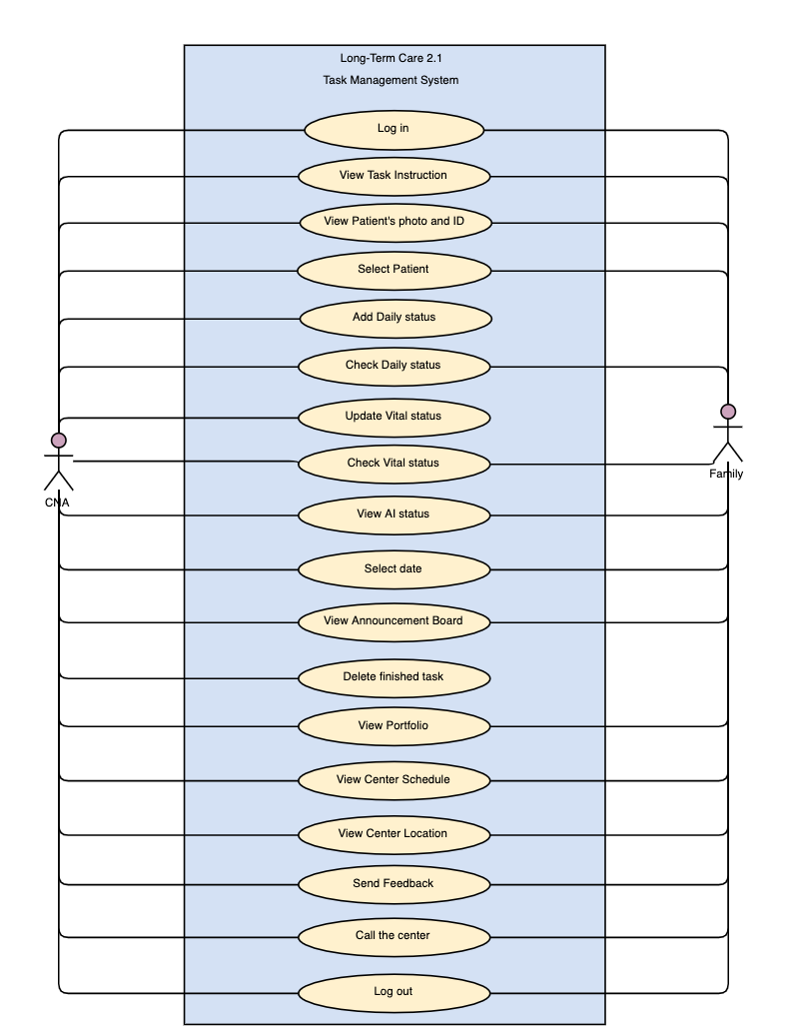

###### Figure 2.6.1: Use case diagram(Application Component)

### 6.2 Browser Component

Figure 2.6.2 shows a complete use case diagram for the LTC-TMS web portal. Use cases describe activities that users of the web portal can perform which is illustrated by the interactions between actor(s) and the system.

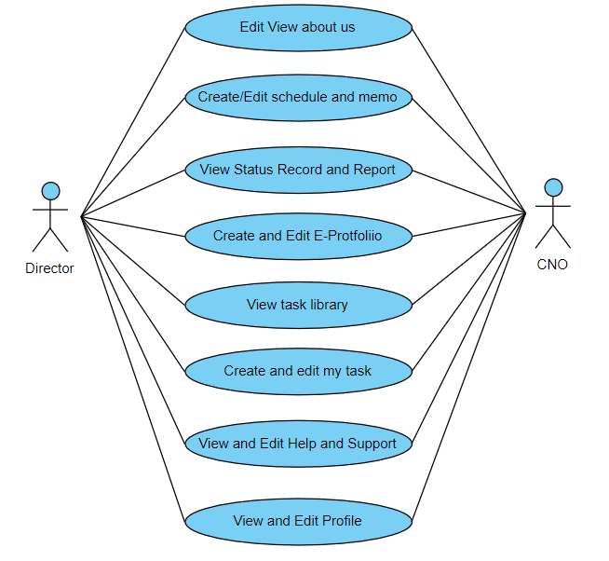

###### Figure 2.6.2: Use case diagram(Browser component)

## 7.0 USE CASE DESCRIPTIONS

### 7.1 Application Component

##### Fully Developed Use Case Description: View Task Instruction

Table 2.7.1 shows the fully developed use case description for the view task instruction use case. The scenario for this use case assumes that users will enter the hamburger menu page and click on the task instruction page. Users can view the task instruction step by step. In this use case, the preconditions show that existing objects must already exist before the use case can be viewed. The postcondition describes the state of the system at the end of the use case.

###### Table 2.7.1: Fully Developed Use Case Description for View Task Instruction(APP)

|  |  |
| --- | --- |
| Use Case Name | View Task Instruction |
| Scenario | Let users view the task instruction. |
| Triggering event | Users log in and view the given task instruction. |
| Brief Description | The system provides tasks to be viewed on the task instruction page. Within the task there are main steps and detail steps displayed, when CNA or Family click on the main step then the system might return a video demo page, next, when CNA or Family click on detail step the system might return a photo demo page. |
| Actors | CNA and Family. |
| Stakeholders | CNA and Family. |
| Pre-Conditions | 1. User_ID must exist to enable login.  2. Users must log in. |
| Post-Conditions | 1. The System has to output task instruction.  2. Staff received notification due to the creation of task instruction.  3. System stored the task instruction into the library. |
| Flow of Activities | |  |  | | --- | --- | | Actor | System | | 1. Users click the Library button. | 1.1 System direct to the Your Assigned Tasks page.  1.1 System list tasks. | | 2. Users select a specific task. | 2.1 System will show steps of that specific task with a brief explanation. | | 3. Users select the step in task instruction. | 3.1 System will show a detailed explanation of that step.  3.2 System shows the video which is attached to the main step. | |
|
| Exception Conditions | 1. If the type-in ID is wrong, the user will not be able to login LTC-TMS.  2. If there is no internet connection, the user can’t log in. |

### 7.2 Browser Component

Table 2.7.2 shows the fully developed use case description for the create new portfolio case. The scenario for this use case assumes that a new staff/patient has entered the facility and needs a new portfolio.

###### Table 2.7.2: Fully Developed Use Case Description for View Task Instruction(BW)

|  |  |
| --- | --- |
| Use Case Name | Create an E-portfolio |
| Scenario | There is a new portfolio are going to be creative. |
| Triggering Event | New staff/patient comes to the facility and need a new portfolio. |
| Brief Description | CNO/Director create, edit or edit a new portfolio in to the system and store the information in the database. |
| Actors | CNO, Director |
| Related Use Cases | Create and Edit E-Portfolio |
| Stakeholders | CNO, Director |
| Pre-Conditions | 1. Must be logged-in. |
| Post-Conditions | 1. New portfolio is stored in the database. |
| Use Case Name | Create a Task instruction |
| Flow of Activities | |  |  | | --- | --- | | Actor | System | | 1. CNO/ Director have to select and click the Create Portfolio button. | 1.1 System retrieve Web page from the database.  1.2 System display Web page for the actor to view. | | 2. Insert the information of staff/patient and click on the create button. | 2.1 Insert the information of portfolio in the database. | |
| Exception Condition | 1.Data loss during transportation during poor connectivity  2. Webpage format failure. |

## 8.0 CONFIGURATION MANAGEMENT

### 8.1 Installation

#### 8.1.1 Installing Git - Installing on Linux

Users can install the basic Git tools on Linux via a binary installer. This is generally done so through the package management tool that comes with the Linux distribution. On Fedora (or any closely-related RPM-based distribution, such as RHEL or CentOS), user can use dnf:

$ sudo dnf install git-all

If on a Debian-based distribution, such as Ubuntu, use apt:

$ sudo apt install git-all

#### 8.1.2 Installing on macOS

The easiest way to install Git on a Mac is to install the Xcode Command Line Tools. On Mavericks (10.9) or above, this can be done simply by trying to run git from the Terminal the very first time.

$ git --version

If Git is not already installed, it will prompt for installation.

For a more up to date version, Git can also be installed via a binary installer. A macOS Git installer is maintained and available for download at the Git website, at https://git-scm.com/download/mac.

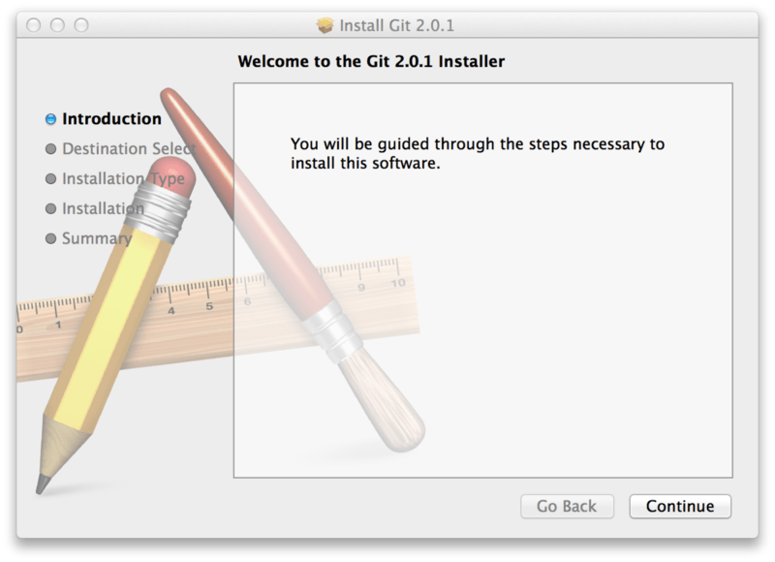

###### Figure 2.8.1: Git macOS Installer

Git can also be installed as part of the GitHub for macOS install. The GUI Git tool has an option to install command line tools as well. These can download the tool from the GitHub for macOS website, at <https://desktop.github.com>.

#### 8.1.3 Installing on Windows

There are also a few ways to install Git on Windows. The most official build is available for download on the Git website at <https://git-scm.com/download/win>. The download will start automatically. Note that this is a project called Git for Windows, which is separate from Git itself; more information on this is available at <https://gitforwindows.org>. To get an automated installation, users must select the Git Chocolatey package. Note that the Chocolatey package is community maintained.

Another easy way to get Git installed is by installing GitHub Desktop. The installer includes a command line version of Git as well as the GUI. It also works well with PowerShell, and sets up solid credential caching and sane CRLF settings. This can be downloaded from the GitHub Desktop website.

### 8.2 First-Time Git Setup

Once Git is installed on the system,it is recommended for the user to customize their Git environment. Most of these are requirements that need to be done only once on any given computer; the settings are persistent between upgrades. They can also be changed at any time by running through the commands again. Git comes with a tool called git config that allows user to get and set configuration variables that control all aspects of how Git looks and operates.

The first requirement after installing Git is to set the user name and email address for logging into GitHub repositories. This is important because every Git commit uses this information, and is immutably baked into the commits generated:

$ git config --global user.name "John Doe"

$ git config --global user.email johndoe@example.com

Once the user account is set up, the user must configure the default text editor that will be used when typing a message in Git. If not configured, Git will use the current Operating System’s default editor.

To select a different text editor, such as Emacs, users can do the following:

$ git config --global core.editor emacs

On a Windows system, to use a different text editor, the full path to the executable file must be specified. This can be different depending on how the chosen editor is packaged.

In the case of Notepad++, a popular programming editor, users are likely to want to use the 32-bit version, since at the time of writing the 64-bit version does not support all plug-ins. If on a 32-bit Windows system, or selecting a 64-bit editor on a 64-bit system, the commands will look something like this:

$ git config --global core.editor "'C:/Program Files/Notepad++/notepad++.exe' -multiInst -nosession"

For a 32-bit editor on a 64-bit system, the program will be installed in C:\Program Files (x86):

$ git config --global core.editor "'C:/Program Files (x86)/Notepad++/notepad++.exe' -multiInst -nosession"

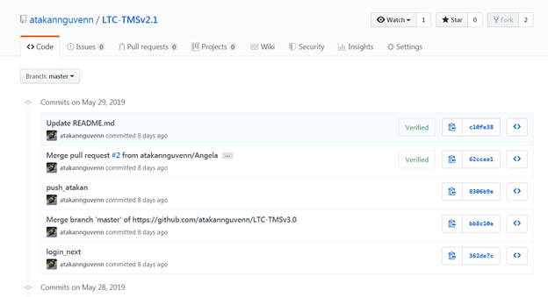

###### Figure 2.8.2: Showing the project’s GitHub Repository

### 8.3 Best Practices with Git

##### Cloning from Master Repo and Updating Your Fork

Users should be sure of which git repo will update when using commands like git push or git commit -m. The following will show users what repo they are connected to.

git remote -v

After verifying the repo currently connected to is correct, users can change to another own repo with the following command:

git remote set-url origin <your GitHub repo URL.git>

It is recommended to run the following again to verify that git is connected to the correct repo.

git remote -v



## 

# 3 SYSTEM DEVELOPMENT DOCUMENT

## 1.0 INTRODUCTION

This document is the System Development Document for the Long-Term Care Task Management System. The purpose of this document is to outline the general structure of the system and list the planning and considerations that went into the development of the system. The various considerations for this system include target users, improvements and feasibility assessments.

The LTC-TMS is consists of 3 components. The browser component is intended for the Director and CNO(Chief Nursing Officer). It focuses on the input of data and facility administration. The application component is intended for the CNA(Certified Nursing Assistant) and patients’ family members. It focuses mostly on displaying data and allowing the CNA to add patients’ data to the database. The hardware component is intended for data collection and increased ease of monitoring the facility residents’ daily physical status. The team focuses on physical resource management, managing connections and data flow in this project. After collecting data from the resident such as help requests, pulse record, and ambient temperature, the data will be packaged as a message and sent to firebase to be categorised and analysed by users of the other components.

This is a necessary project to undertake because it helps both nurses and caregivers as well as family members to have a better understanding of the health of their loved ones in the case of family members and LTC residents in the case of the administration personnel. Taiwan has an aging population and taking care of the elderly is very important to their culture and society.

## 2.0 SYSTEM PLANNING

System planning is done to layout the roadmap of features and interface changes to be made to the system, and allows all team members to understand their roles, goals and intentions of the changes.

### 2.1 System Capabilities

The following lists what planned capabilities and features will be present in LTC-TMS version 2.1. The system capability list is separated by General, Browser component, App component, and Hardware component categories.

#### 2.1.1 General

* Provide a two language interface: English and Chinese
* Support storing of digital information
* Retrieve information from the database
* Support video and photo in the task instruction pages
* Provide filter functions for specific pages

#### 2.1.2 Application Component

* Provide dual-language support (Chinese version not yet supported)
* View Tasks and task details
* View Announcements
* Add Daily Status
* Add AI Status
* Send Feedback
* Check Daily Status
* Check Vital Status
* Call Center
* View Schedule
* Find Location

#### 2.1.3 Browser Component

* Provide multi-language support (English and Chinese)
* Add tasks and task detail
* Add Announcements
* Add Schedule
* Add memo
* Check status record
* Check patient’s record
* View Tasks and task detail
* View patient’s and CNA e-portfolio
* Reply to feedback

#### 2.1.4 Hardware Component

* Close to real-time data logging and monitoring.
* One to many connections between Base Station to wearable units.
* Health status record.
* Patient call CNA button.

#### 2.1.5 System Benefit

The features of the LTC-TMS are intended to benefit users and clients of the system. Benefits of this system are as follows:

* Decrease the complexity of viewing assigned tasks
* Increase trust and communications between family and center
* Increase visibility regarding the operational processes of the LTC
* Increase convenience of information viewing
* Streamline information retrieval
* Improve task assignment/monitoring efficiency
* Raises the competitiveness of the LTC
* Reduce paperwork dependency
* Prevent duplication of effort due to task management system
* Provide greater value to customer

### 2.2 Context Diagram

A context diagram is a high-level diagram which shows relationships that the system has with other external entities.

#### 2.2.1 Browser Component

Figure 3.2.1 showcases a context diagram for the web portal of the LTC-TMS. The purpose of the context diagram is to illustrate how each type of end user interacts with the applications and database.

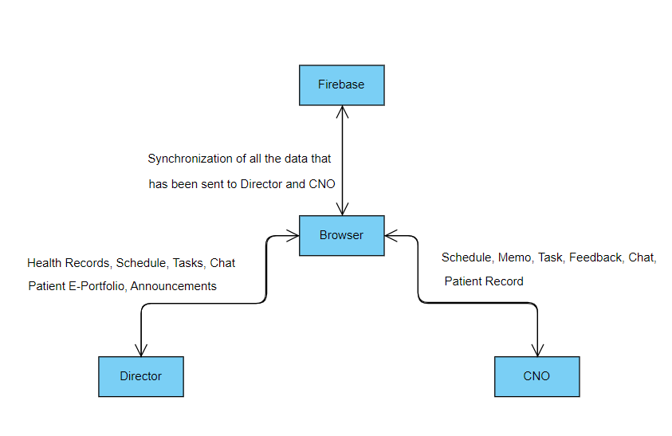

###### Figure 3.2.1: Browser_Context Diagram

#### 2.2.2 Application Component

Figure 3.2.2 showcases a context diagram for the mobile application. The purpose of the context diagram is to illustrate how each type of end user interacts with the applications and database.

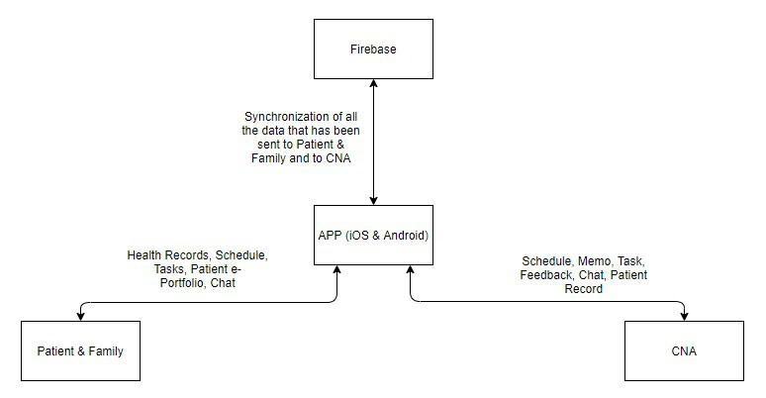

###### Figure 3.2.2: App_Context Diagram

### 2.3 Risk and Feasibility

This section examines various types of feasibility and how they could impact the project. The following section includes organizational and cultural feasibility, technological feasibility, resource feasibility, and schedule feasibility.

#### 2.3.1 Organizational and Cultural Risks and Feasibility

Due to the different aspects of the LTC centre such as staff, manager, hierarchy, and culture, the system might encounter several risks which are listed below.

* LTC staff are comfortable with existing, traditional operating procedures of the LTC center. There will be problems convincing them to switch over to the LTC-TMS. Also, the staff might have a low level of computer competency which will result in difficulties in using the system.

Solution: Providing training and long term technical support to the LTC center will help alleviate any worries and problems, while customising the design of the system to match the organisations needs and operating practices as much as possible will make the transition simpler.

* Employee morale might be affected by the new system. The implementation of the system might make employees think that they will soon be replaced by technology and take a negative view towards the system.

Solution: Communicating with the employees that the new system is only there to assist them in their daily activities and ensuring that jobs are enhanced, not reduced.

* The director and CNO of the LTC center might assign the job and task to CNA to patient digitally. The director and CNO will therefore rarely meet with the patients and CNAs. This can lead to lack of physical contact and face to face meetings and lead to miscommunication because there are things that cannot be handled remotely.

Solution: Reminding the director and CNO that the Task Management System is no replacement for physical meetings will be important..

* The current hardware device is still quite bulky. The patients might be unwilling to wear the device, especially for long periods of time.

Solution: Minimise volume and mass of the wearable units. Assert the uses and benefits the live monitoring provided will have towards the patient’s family and visitors.

* Cost relating to hardware will make clients unreceptive to the system.

Solution: Reduce per unit cost, increase supported number of connections to base station unit to improve scalability and focus clients on potential cost savings on traditional paperwork, efficiency improvements over non-integrated monitoring systems and increased visibility into operational processes.

#### 2.3.2 Technological Risks and Feasibility

The LTC-TMS might require more technical tools to develop the system. It is important for the development group to list out all the possible technological risks and feasibility for problems that might be encountered. The developers are expected to think and come up with solutions for each feasibility.

* Lack of coding experience in developers working on the system.

Solution: Developers should focus on program design carefully before thinking about code implementation. Tutorials on coding can be learnt on the job, design cannot. Therefore, developers should examine problems carefully, and make sure they can design reliable solutions first before moving on to code.

* Insufficient equipment or software tools to establish the system.

Solution: Ensure sufficient hardware and software technology resources by purchasing or renting the tools.

* The LCT center database contains too many patients and too many user logs, exceeding database load.

Solution: Regular updates and maintenance to the system database to accommodate the patients, and delete user logs will be required in the long term.

* Poorly designed system components or unreliable performance may lead to a system crash, causing delays and loss of productivity for clients.

Solution: The developer must test and integrate their code carefully to ensure the system will function consistently and reliably. Bugs and errors found during operation will have to be fixed quickly in long term maintenance.

* Difficulty of determining technical feasibility for certain hardware changes due to granular nature of hardware parts and implementations.

Solution: Extensive research to determine possible feasibility. Determine risk and resource requirements are sufficiently low before proceeding to actual parts acquisition and testing.

#### 2.3.3 Resource Risks and Feasibility

There are many types of resources needed to be considered in system risk and feasibility. Insufficient resources might cause delays and problems which lead to project failure. The resource risks and feasibility is listed as below:

* Developers do not have enough time to finish the assignments on time.

Solution: More communication with all the project members to manage time as best as possible depending on everyone's availability.

* The system might not be reliable or effective for the employees using it, the family members and also patients.

Solution: Developers should pay attention to resources such as skilled personnel, physical facilities, relevant hardware components, and software to ensure a reliable system.

* The hardware has the possibility of being broken or becoming non-functional due to the present design requiring many complicated wire connections and separate parts.

Solution: Devices need to be checked weekly to make sure all devices are working properly. Furthermore, durability should be improved and tested thoroughly in development. Wire connections should be secured and protected from daily use.

* Developers do not have the knowledge of the operations in the LTC-center.

Solution: Development group will conduct research on various LTC and medical facilities in different areas to ensure the system is designed to be flexible and adaptable to differing LTC requirements in different circumstances.

* High cost of hardware parts and development.

Solution: Development and planning must proceed as carefully as possible. Choices in hardware are difficult to undo especially due to the differences in hardware platforms, and the behaviours of different variants of the same sensors. Careful decision making is vital to prevent unnecessary waste of resources. Also the group should find a way to simulate additional wearable units to test base station scalability without needing to produce additional wearables.

#### 2.3.4 Schedule Risks and Feasibility

This project commenced on the 22nd of February and is expected to be fully completed by December 24th. The schedule should be well defined yet flexible enough to finish the application by considering the training, development, testing, unexpected delays, etc.

* The LTC-TMS development is not proceeding according to schedule.

Solution: All the developers must communicate effectively to adhere to strict deadlines. Failing to do so, the group must re-evaluate the delayed tasks, determine scope feasibility and restructure the development schedule.

* Developers do not have the skills necessary to apply the technology. The learning of new technologies necessary to complete the project will take time.

Solution: Determine whether deadlines are mandatory or desirable and try to learn only what is needed to complete important tasks first.

* Developers do not assign the work well and have different opinions in the work tasks.

Solution:It necessary to plan ahead together and all the members in a team must have a clear division of labor.

* Developers do not allocate time well and requiring periods of completing too much work in a short time.

Solution: It is necessary to set up a well defined project schedule such that all members of the group have adequate time to finish their work. Of course, no plan survives contact with reality, therefore constant monitoring and re-evaluation on priorities and remaining time will be necessary as well.

### 2.4 Work Breakdown Structure

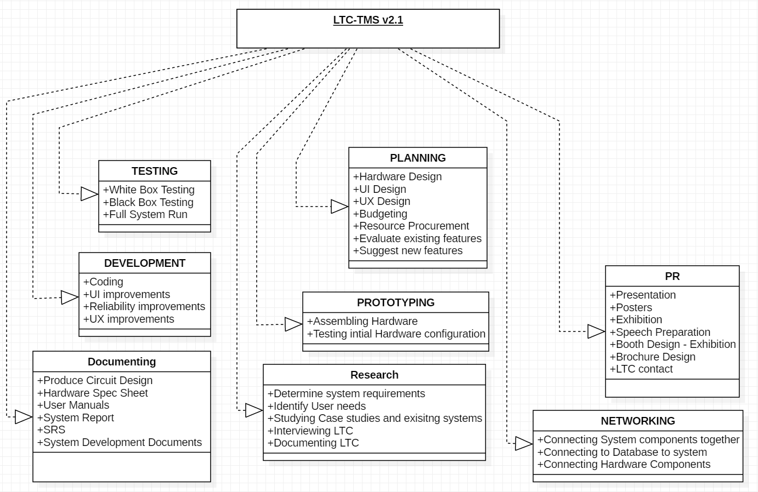

###### Figure 3.2.3: Work Breakdown Structure

### 2.5 Gantt Chart

A Gantt chart is a type of bar chart that illustrates a project schedule. Figure 3.2.4 shows the remaining time of each task of LTC-TMS.

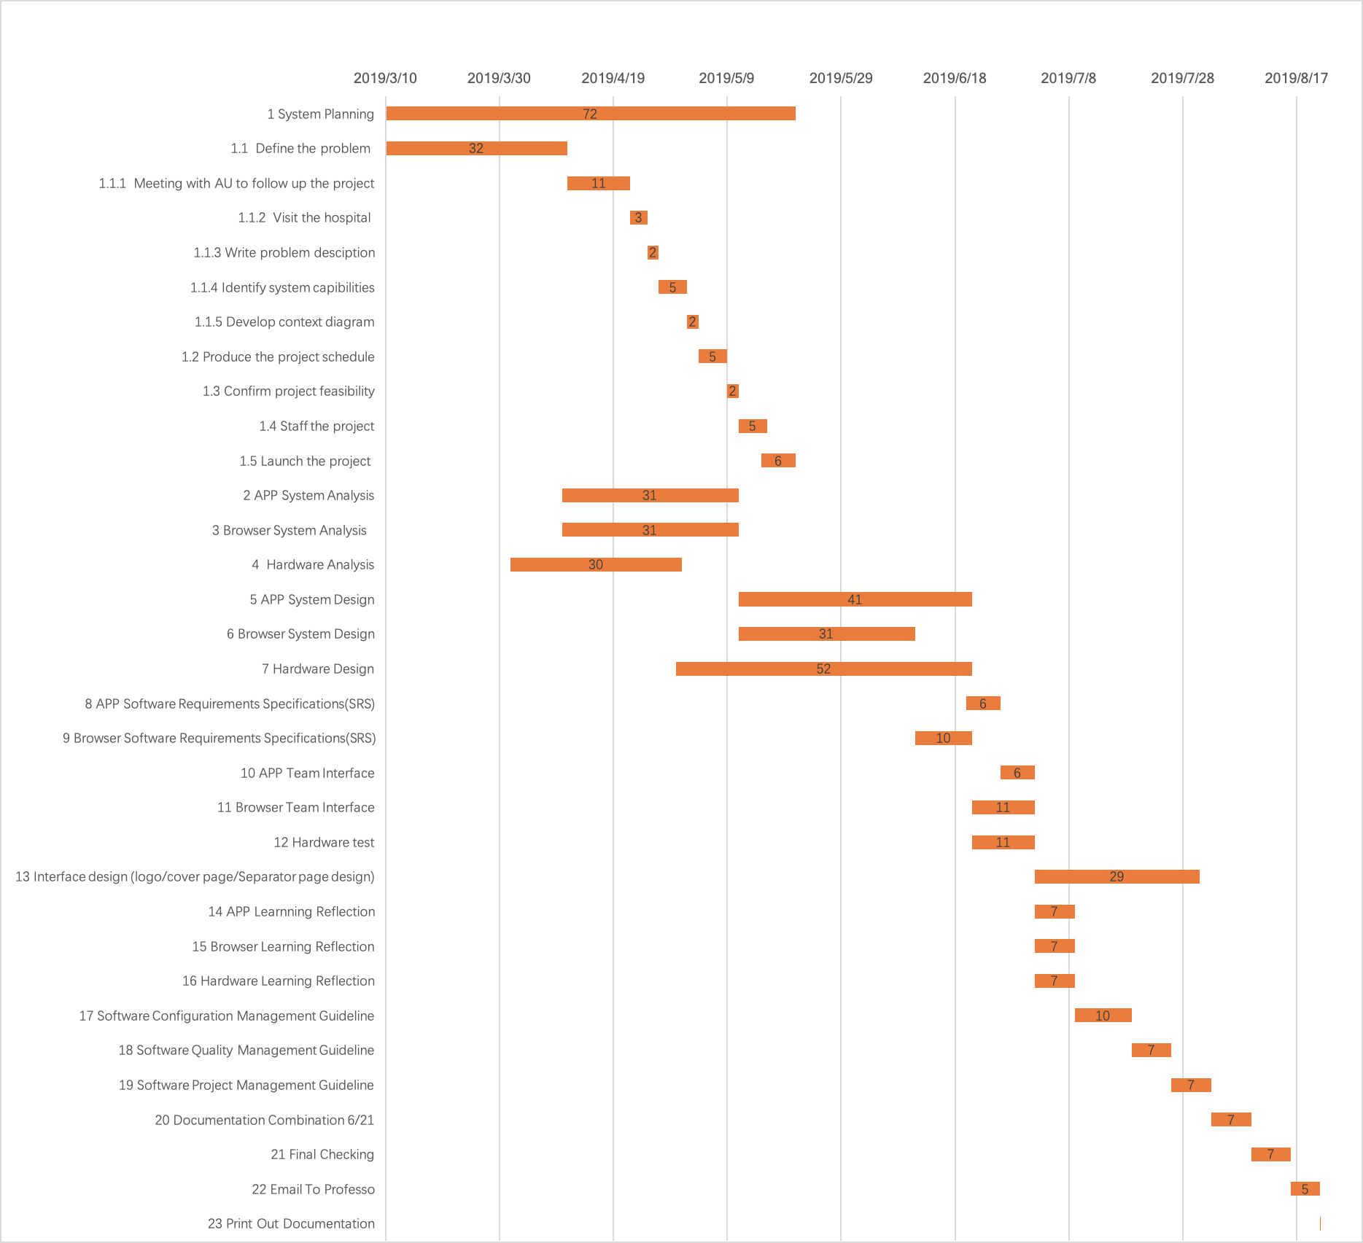

###### Figure 3.2.4: Gantt Chart

### 

### 2.6 System Planning Conclusion

The goal of this LTC-TMS v2.1 project is to finish all the old and the new planned implementations successfully to make this project more effective and simpler to use for all the users when it is compared to v2.0. Due to the coding language change in v2.0, the project suffered some setbacks but the team is planning to reimplement all prior functionality as well as add new ones so as to increase work productivity and efficiency. Overall, the shift in focus to improve Usability, reliability and scalability will make the system more attractive to potential clients and their user base.

Furthermore, it is unclear whether this project will ever reasonably satisfy a real LTC. Traditional ways of doing things are not easily changed and LTC facilities have become very set in their ways. However, it is hoped that his project can serve as a successful proof of concept, and that such systems will be accepted by Taiwanese society that is very technology and “instant” driven as it will improve the transparency and trust of LTCs with family members.

## 3.0 SYSTEM ANALYSIS

A system analysis is the process of studying a procedure or business in order to identify its goals and purposes and create systems and procedures that will achieve them in an efficient way.

### 3.1 Requirement Investigation

The purpose of requirement investigation is to specify the system requirements by identifying “what” the system can do for the stakeholders. Before identifying the requirements, an investigation of processes is required by the development team. The development team needs to understand what the system does and what minimum requirements are to improve existing processes.

#### 3.1.1 Stakeholders

There are four kinds of characteristics of stakeholders. Internal Stakeholders are those within the LTC center who interact with LTC-TMS. External Stakeholders are those outside the LTC center’s control and influence who also interact with LTC-TMS or have a significant interest in its operation and functions. Operational stakeholders are people who regularly interact with the LTC-TMS. Executive stakeholders are persons who do not interact with the LTC-TMS directly or on a daily basis but who either use information produced by the system or have a significant financial or other interest in its operation and success. A list of stakeholders is given below.

##### Internal-Operational Stakeholders:

* CNA

##### External-Operational Stakeholders:

* Family

##### Internal-Executive Stakeholders:

* IT admin
* CNO
* Director

##### External-Executive Stakeholders:

* Customer Service Representative
* Investors

Figure 3.3.1 is an investigation of stakeholders for the application component of the LTC-TMS. All stakeholders are identified. Internal Stakeholders are the CNA. External Stakeholders are the Family. For Operational stakeholders, they are the CNA and the Family, who directly interact with the system. Executive stakeholders are CNO, Director, and the IT admin. Although CNO, IT admin and Director do not interact directly with the app version of LTC-TMS, the content in the system is mostly retrieved from the database in which the data is input from CNO,IT admin and Director.

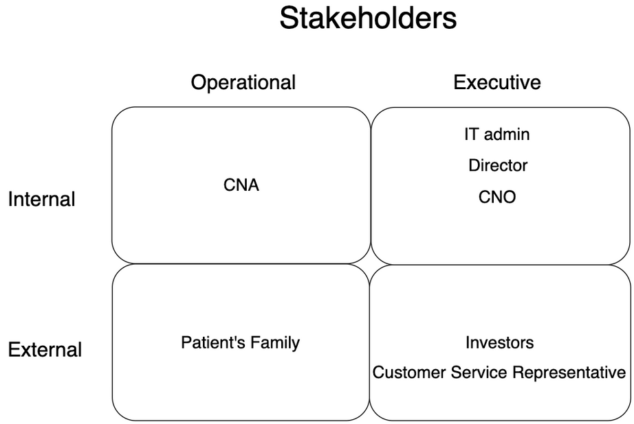

###### Figure 3.3.1: Stakeholders

#### 3.1.2 Hardware

The following is the analysis of stakeholders of the hardware phase. All stakeholders are defined. Internal Stakeholders are the CNA, and CNO to handle the data logs from the hardware devices. Operational Stakeholders are patients and CNA who directly work with the hardware devices. Executive stakeholders are the director which will monitor reports generated from the data provided by the hardware.

##### Internal Stakeholders:

* CNA
* CNO

##### Operational Stakeholders:

* Patients
* CNA

##### Executive Stakeholders:

* Director

### 3.2 Use Cases

A use case diagrams lists all of the primary actions or event steps typically defining the interactions between a role and a system to achieve a goal.

#### 3.2.1 Use Case Diagram

##### Browser Component

Figure 3.3.2 shows a primary use case diagram for the LTC-TMS Browser component.



###### Figure 3.3.2: Browser Component use case diagram

##### Application Component

Figure 3.3.3 shows a complete use case diagram for the LTC-TMS APP version. Readers are able to understand more of the system functions through the use case diagram and get a clear picture of the system. CNA and Family can all access this system. Both can view task instruction, notification, schedule, announcement, and portfolio but only CNA can create, edit or modify certain parts of the system.



###### Figure 3.3.3: Application Component use case diagram

#### 3.2.2 Brief Use Cases Description

The following tables are to show the brief description of the use cases.

##### Browser Component

###### Table 3.3.1: Brief Use Case Description of LTC-TMS

|  |  |
| --- | --- |
| Use Case | Brief use case description |
| Edit/View About Us | Users can view the information about the facility. If their account has permission, it can edit the information. |
| Create/Edit Schedule and Memo | The account which has permission can create and edit schedules and memos in the system that are stored in the database. |
| View Status Record and Report | The account which has permission can view status records and reports of the patient. |
| Create and Edit E-Portfolio | The account which has permission can create an E-portfolio for the new staff/patient and edit the E-portfolio in the database if the staff/patient changes their personal information. |
| View Task Library | The account which has permission can view and modify the tasks in the library page. |
| Create and Edit My Task | The account which has permission can create and edit “my task”. |
| View and Edit Help and Support | Users can give feedback to the facility and view the support in the Help and Support webpage. |
| View and Edit Profile | The account user can edit their own user account profile. |

##### 

##### Application Component

###### Table 3.3.2: Brief Use Case Description of LTC-TMS

|  |  |
| --- | --- |
| Use Case | Brief use case description |
| Log in | After logging into the system, there is a page for Family members to view the updates about their patient, and this is kept up to date by the centre. |
| View Task Instruction | The system provides tasks to be viewed on the task instruction page. Within the task, there are main steps and detailed steps displayed. When a CNA and Family user clicks on the main step, the system will return a video demo page. When the CNA or Family user clicks on detailed step the system might return a photo demo page. |
| View Patients photo & ID | The system will provide the CNA with all the patients’ Photo next to their ID. Meanwhile, family members can only see their family members. |
| Select Patient | For family members, the Patient record page will list all of the family members for the user to check their current status. Meanwhile, CNAs will be able to access all of the patient's portfolio from the same page. |
| Add Daily Status | CNAs will be able to record the daily status of the selected patient on the Patient Record page. |
| Check Daily Status | CNAs and the family members will both be able to check the patient’s daily status. So family members can get updated reports without needing to call the center. |
| Update Vital Status | CNAs will be able to Add Vital Status reports on the Patient Record page. |
| Check Vital Status | CNA and family members can check the patient’s blood pressure and ambient temperature. |
| View AI Status | CNA and family members can check the patient’s latest heart rate, the number of steps walked and even how many times the patient has fallen. |
| Select Date | When a CNA wants to enter data for the patient in the Daily Status add, they will be able to change the date to add the data to another day. |
| View Announcement board | As long as the CNA and Family login into the system, they can view the LTC-TMS center announcement board on the home page. This enables each user to view recent announcements with notifications of the latest news but cannot modify them. |
| Delete Finished Task | When the CNA has done their task, they will have the option to remove that task until it reappears again. Doing that will not remove the task for all the CNAs but it will only remove it from the current CNA’s list of pending tasks. |
| View portfolio | The system provides a portfolio on the page. Regardless of whether it is a CNA or family member, they can only view their own information is this page. |
| View Center schedule | The CNA and Family once logged in to the system can view the LTC center schedule on the Center Information page but cannot modify it. |
| Send Feedback | Family members will be able to send feedback to the LTC centre. |
| Call the Center | Family members will be able to call the center from a convenient button in Center Info page. |
| Log Out | CNA and family members will both be able to log out from the Portfolio page. |

#### 3.2.3 Activity Diagrams

An activity diagram is basically a flowchart to represent the flow from one activity to another activity.

##### Browser Component

Activity Diagram - Add/Edit/Delete Schedule

First the CNO/Director clicks on a schedule. There are three options that are available in a schedule table. Users can select Add New Schedule, Edit Existing Schedule or Delete A Schedule. Deleting a schedule require a confirmation.

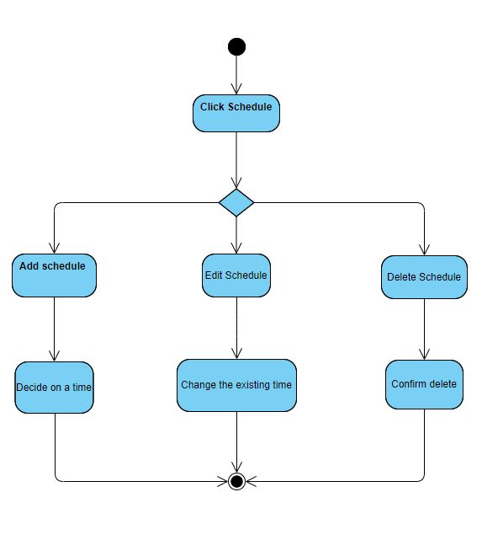

###### Figure 3.3.4: Browser-Activity Diagram _Edit Schedule

Activity Diagram - Add/Edit/Delete Memo

There are 3 activities options available in the memo section. Users can select Add A New Memo, Edit An Existing Memo, and Delete Memo. For Add Memo, the user is asked to fill a specific date for the memo. Deleting a memo requires a confirmation from the user.

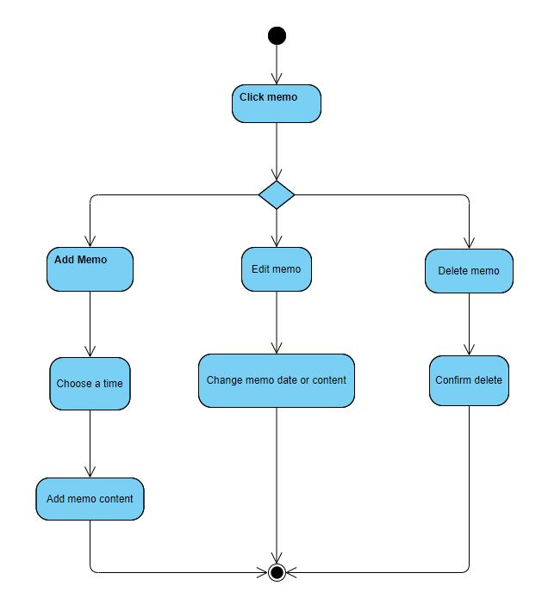

###### Figure 3.3.5: Browser-Activity Diagram _Edit Memo

##### Application Component

Activity Diagram - View Task Instruction

First, a CNA or Family user clicks on Task library. It will then display all the tasks instruction in it. CNA and Family are allowed to select any one of them. After choosing one, the user can choose to look at the main steps or detailed steps. For the main steps the system might return a video demo page. When CNA and Family click on detailed steps the system might return a photo demo page.

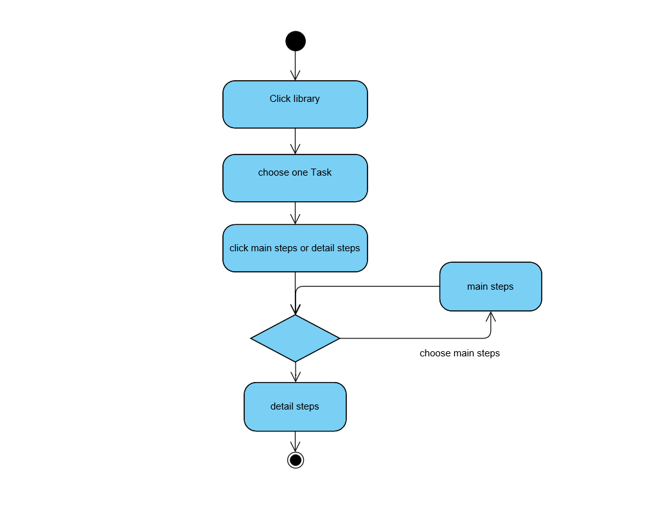

###### Figure 3.3.6: APP-Activity Diagram _View Task Instruction

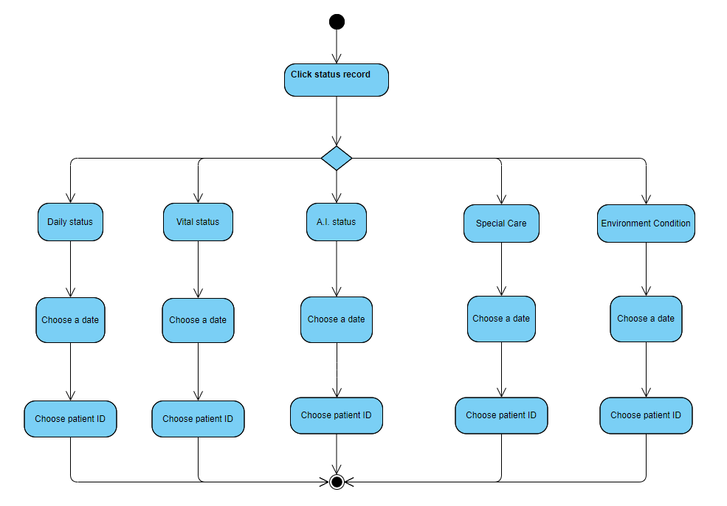

###### Figure 3.3.7: APP-Activity Diagram _View Status Record

Activity Diagram - Submit Feedback

First, at the centre of the info button page clicking on Submit Feedback, the application will jump to another page for feedback entry. In this page, the user can choose two feedback types: Center and System. After done typing, the user must click submit to send the feedback.

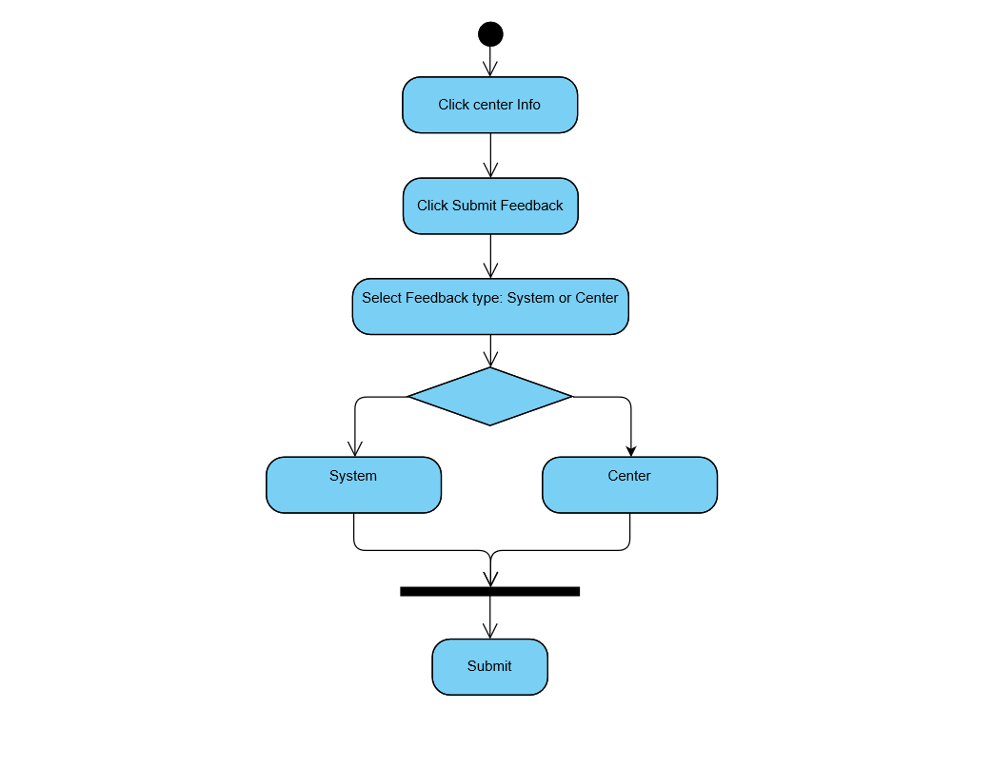

###### Figure 3.3.8: APP-Activity Diagram _Summit Feedback

Activity Diagram - Check Daily Status

On the portfolio page, when a user clicks the Check Daily Status button, the application will jump to another page displaying the requested status update. The CNA user can scroll to select which patient to check. After selecting the patient ID and date, clicking the submit button will show that patient’s daily status for the time and date entered.

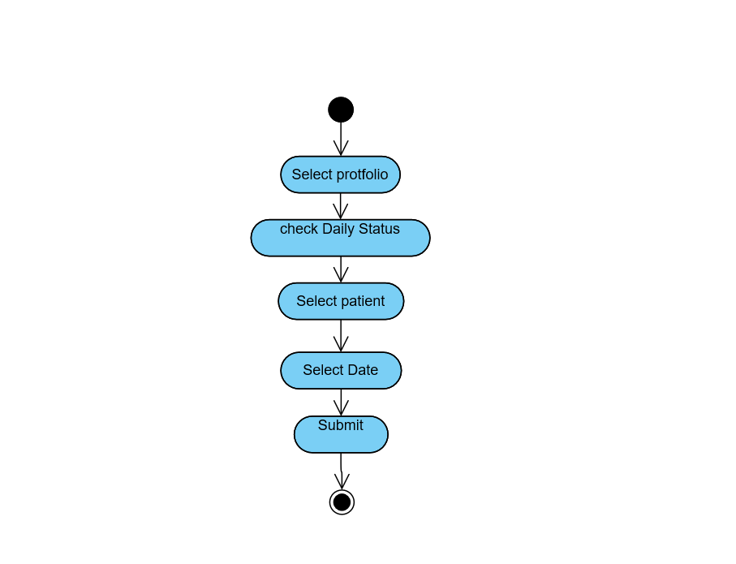

###### Figure 3.3.9: APP-Activity Diagram _Check Daily Status

#### 

#### 3.2.4 System Sequence Diagram

A sequence diagram shows object interactions arranged in a time sequence. It depicts the objects and classes involved in the scenario and the sequence of messages exchanged between the objects needed to carry out the functionality of the scenario.

##### Browser Component

In Figure 3.3.10, a System Sequence Diagram, the Director/CNO have entered logged into the system. Once logged in, the Director/CNO will select the name of the patient. The Director/CNO is then able to enter the status record of the patient and confirm the status is correct, and generate reports. After confirmation, the data is written to the Firebase database. The Director/CNO will then be returned to the previous data for review.

###### Figure 3.3.10: System Sequence Diagram_Browser Component

##### Application Component

In Figure 3.3.11, the sequence diagram below, the CNA has entered the patient’s room and has logged into the system. Once logged in, the CNA will select the name of the patient. The CNA is then able to enter the vital status of the patient and confirm the status is correct. After confirmation, the data is written to the Firebase database. The CNA will then be returned to the previous screen where they are able to continue their work.

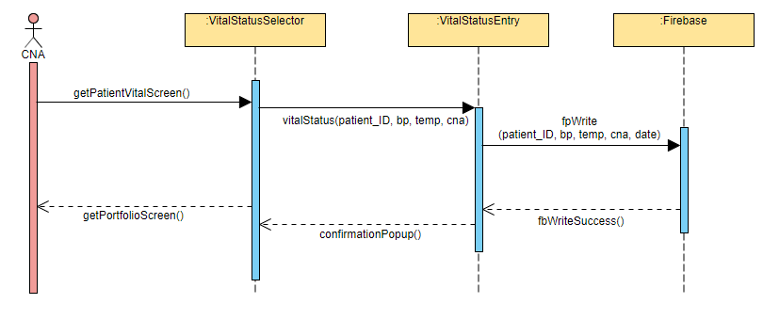

###### Figure 3.3.11: System Sequence Diagram_App Version

##### Hardware Component

The Figure 3.3.12 below outlines the sequence of regular communications for the HW base station.

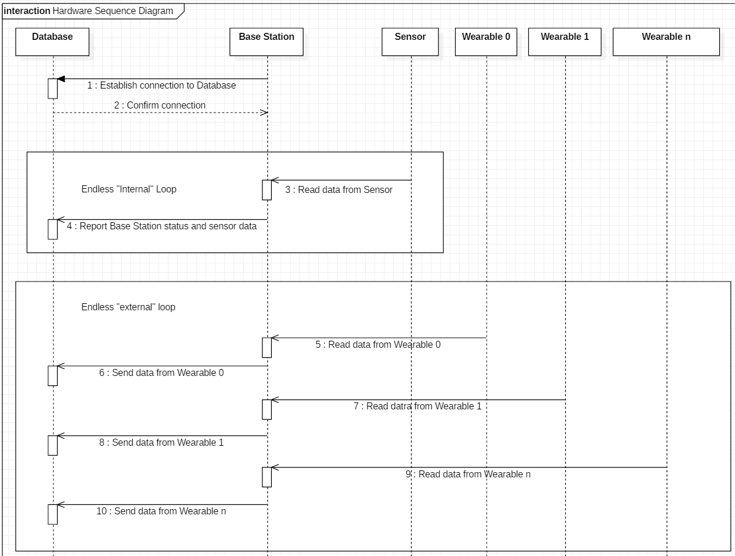

###### Figure 3.3.12: System Sequence Diagram_Hardware

#### 3.2.5 State Machine Diagram

A state machine diagram is a behavior diagram which shows discrete behavior of a part of designed system through finite state transitions.

##### Browser Component

**State Machine Diagram - Portfolio**

Figure 3.3.13 is a state machine diagram for the class of portfolio. There are three states for portfolio, which are creating, displaying and editing states. First of all, when the user requests to create a new portfolio, the portfolio will move to the creating state. Then after the user finishes with the input and uploads the portfolio, the portfolio will move into the displaying state. In the case that the user need to edit the information in the portfolio, the portfolio will move into the editing state. After the user is finished with editing, the portfolio will move back to the displaying state. Lastly, when the user decides to delete the portfolio, the portfolio lifeline is terminated.

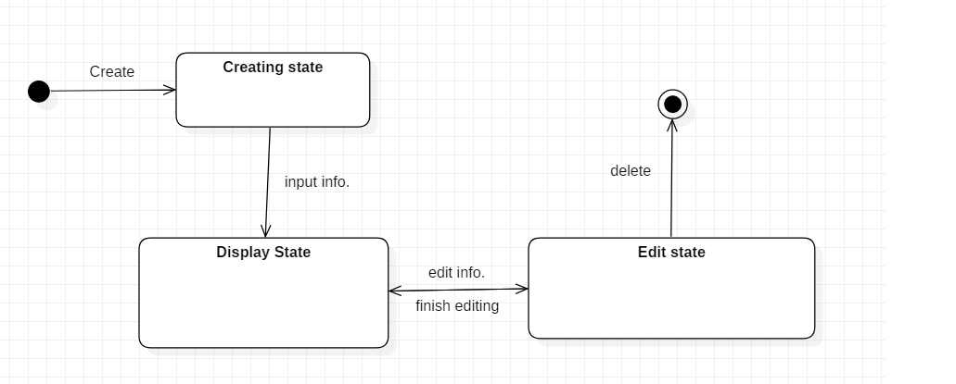

###### Figure 3.3.13: State machine diagram_protfolio

**State Machine Diagram - Memo**

Figure 3.3.14 is a state machine diagram for the class of memo. There are three states for portfolio, which are creating, displaying and editing states. First of all, when the user requests to create a new memo, the portfolio will move to the creating state. Then after the user finishes with the input and upload of the memo, the portfolio will move into the displaying state. In the case that the user need to edit the information in the memo, the memo will move into the editing state. After the user completes their edits, the memo will move back to the displaying state. Lastly, when the user decides to delete the portfolio, the portfolio lifeline is terminated.

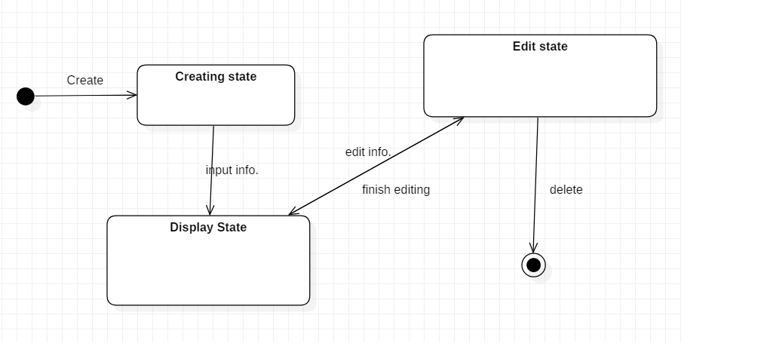

###### Figure 3.3.14: State machine diagram_memo

**State Machine Diagram - My Task**

Figure 3.3.15 is a state machine diagram for the class of task. There are four states for task instruction: creating, storing, displaying and editing. To start with, when the user requests to create a task, the task instruction will move to creating state. After the user finished with the input and upload, the task instruction will move into the storing state. After the storing state is done processing, the system will add the task to the library and will move to displaying state. In the occasion that the user wishes to edit any of the tasks, the task page will move into the editing state. After modifying the information, the task instruction page will move into the storing state and displaying state accordingly. Finally, when the user decides to delete the task, then the lifeline of the task instruction is aborted.

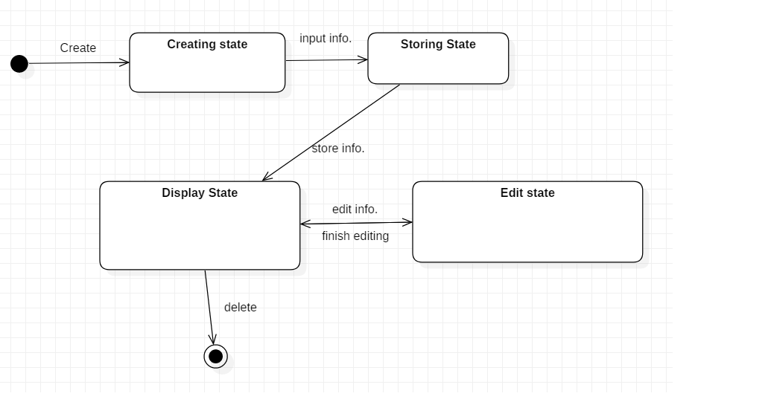

###### Figure 3.3.15: State machine diagram_memo

### 

### 3.3 System Analysis Conclusion

In this system analysis document, the development team has made and drawn use case diagrams, written brief descriptions of each use case, drawn activity diagrams, system sequence diagrams, domain class diagram and state machine diagrams for LTC-TMS v2.1. The development team has provided these diagrams to illustrate and communicate the ideas for the new system that is going to be built.

Furthermore, readers should note that the Director, CNO, and CNA are able to interact with most of the functions of the system. The target for creating this system is to digitize data in the Long-term care center to prepare for the coming aging future population. Since the number of elderly in the population is increasing, there might be a lot of elderly people that will be entering the LTC center. In order for the Director, CNA, CNO and other staff to work conveniently and effectively, this information system should help them to manage the task, profiles, records, and data.

## 

## 4.0 SYSTEM DESIGN

Systems design is the process of defining the architecture, modules, interfaces, and data for a system to satisfy specified requirements.

### 4.1 Network Design Diagram

A network diagram is a visual representation of a computer or telecommunications network. It shows the components that make up a network and how they interact, including routers, devices, hubs, firewalls, etc.

#### 4.1.1 Browser Component

The browser team hosts the website from the Firebase server and also sets up the database on Firebase. The PC or laptop is connected to the internet via the router and loads the website on the browser.

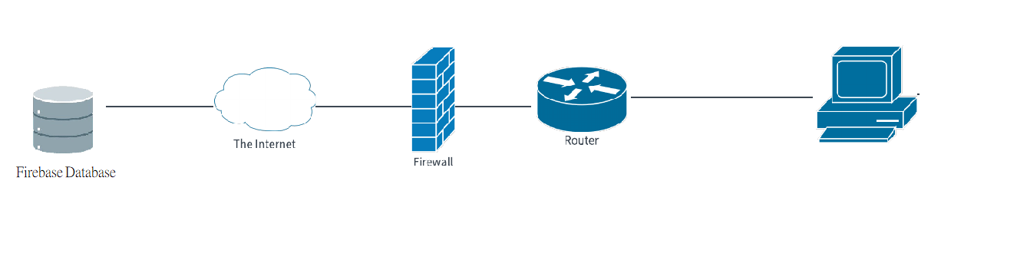

###### Figure 3.4.1: Network Design diagram_browser

#### 4.1.2 Application Component

The mobile application loads all of its’ data from Firebase, therefore internet connectivity is a must to ensure the application is working properly and the most up to date information is downloaded. Figure 3.4.2 shows how the application on mobile devices can connect to the internet using wifi connectivity in the absence of cellular network data services. 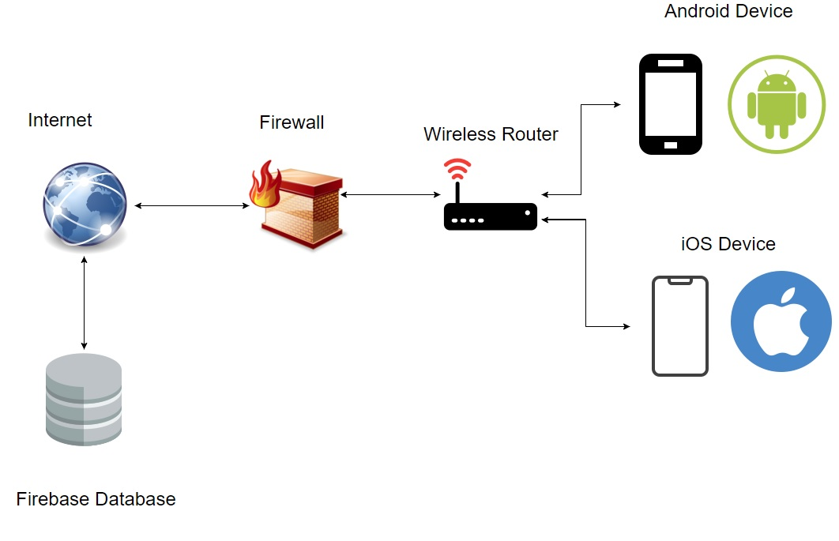

###### Figure 3.4.2: Network Design diagram_browser

### 4.2 Device Design Diagram

This section discusses the changes planned for the hardware component in this development cycle.

The following diagram shows the data flow for the hardware component as it exists in version 2.0

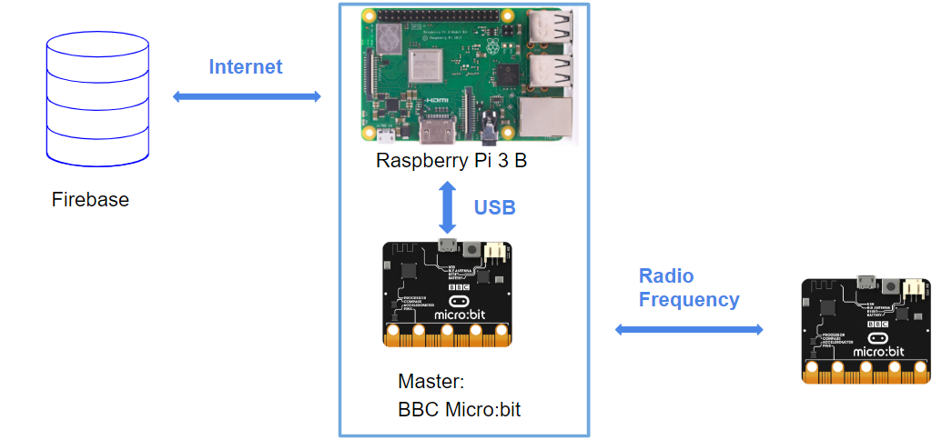

###### Figure 3.4.3: Data flow of hardware component in v2.0

The Hardware team plans to modify the hardware component’s current communication relationships as it exists in version 2.0. In the prior versions, hardware communicated on a one to one basis from base station to wearable. The team intends to modify this into a one to many relationship, from one base station to multiple wearables, as shown in Figure 3.4.4. This is intended to improve system scalability and decrease installation costs. The Raspberry Pi 3 B+ will communicate with the database through a Wi-Fi or Ethernet connection and uses a USB port to connect to the Master BBC Micro:bit. The Master Unit will be responsible for connecting with the wearable units via Radio.

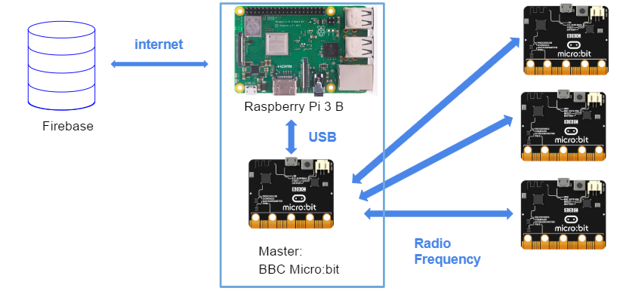

###### Figure 3.4.4: Planned data flow of hardware component in v2.1



## 

# 4 SYSTEM IMPLEMENTATION DOCUMENT

## 1.0 VISITING A LONG-TERM CARE CENTER

##### Name of the Long-Term Care Center

財團法人私立廣恩老人養護中心

GuanNenn Nursing Home Foundation

##### Date and Time of visit

2019/07/18 14:00-16:00

##### Group Members visiting

Angela, Eva, Andre, Kevin, Francois

##### Goal

1. Gather information about LTC centre processes.
2. List the centre’s hardware devices.
3. Learn how the centre records the daily status record of the residents.
4. Learn how the centre manages information and announcements.
5. Learn how the centre communicates with and contacts the family members.
6. Receive some feedback from the centre staff on how to improve and develop the system.

### 1.1 Photos of Long Term Care Center

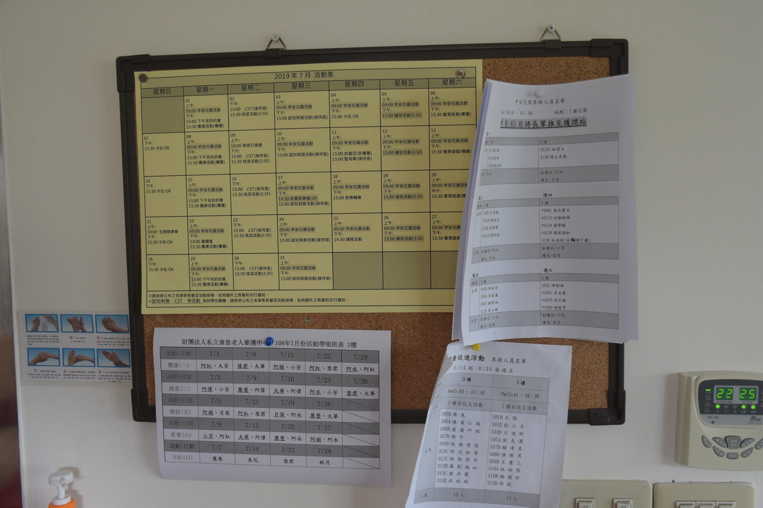

###### Figure 4.1.1: Announcement board in a real Long-Term Care Center

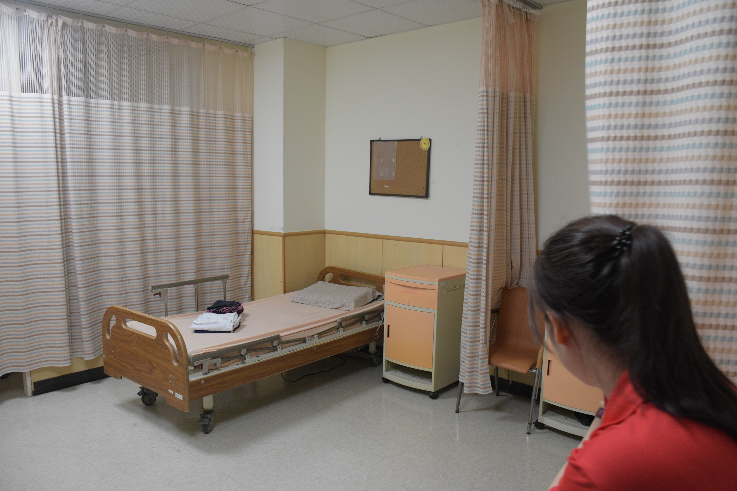

###### Figure 4.1.2: Environment of the Long-Term Care Center

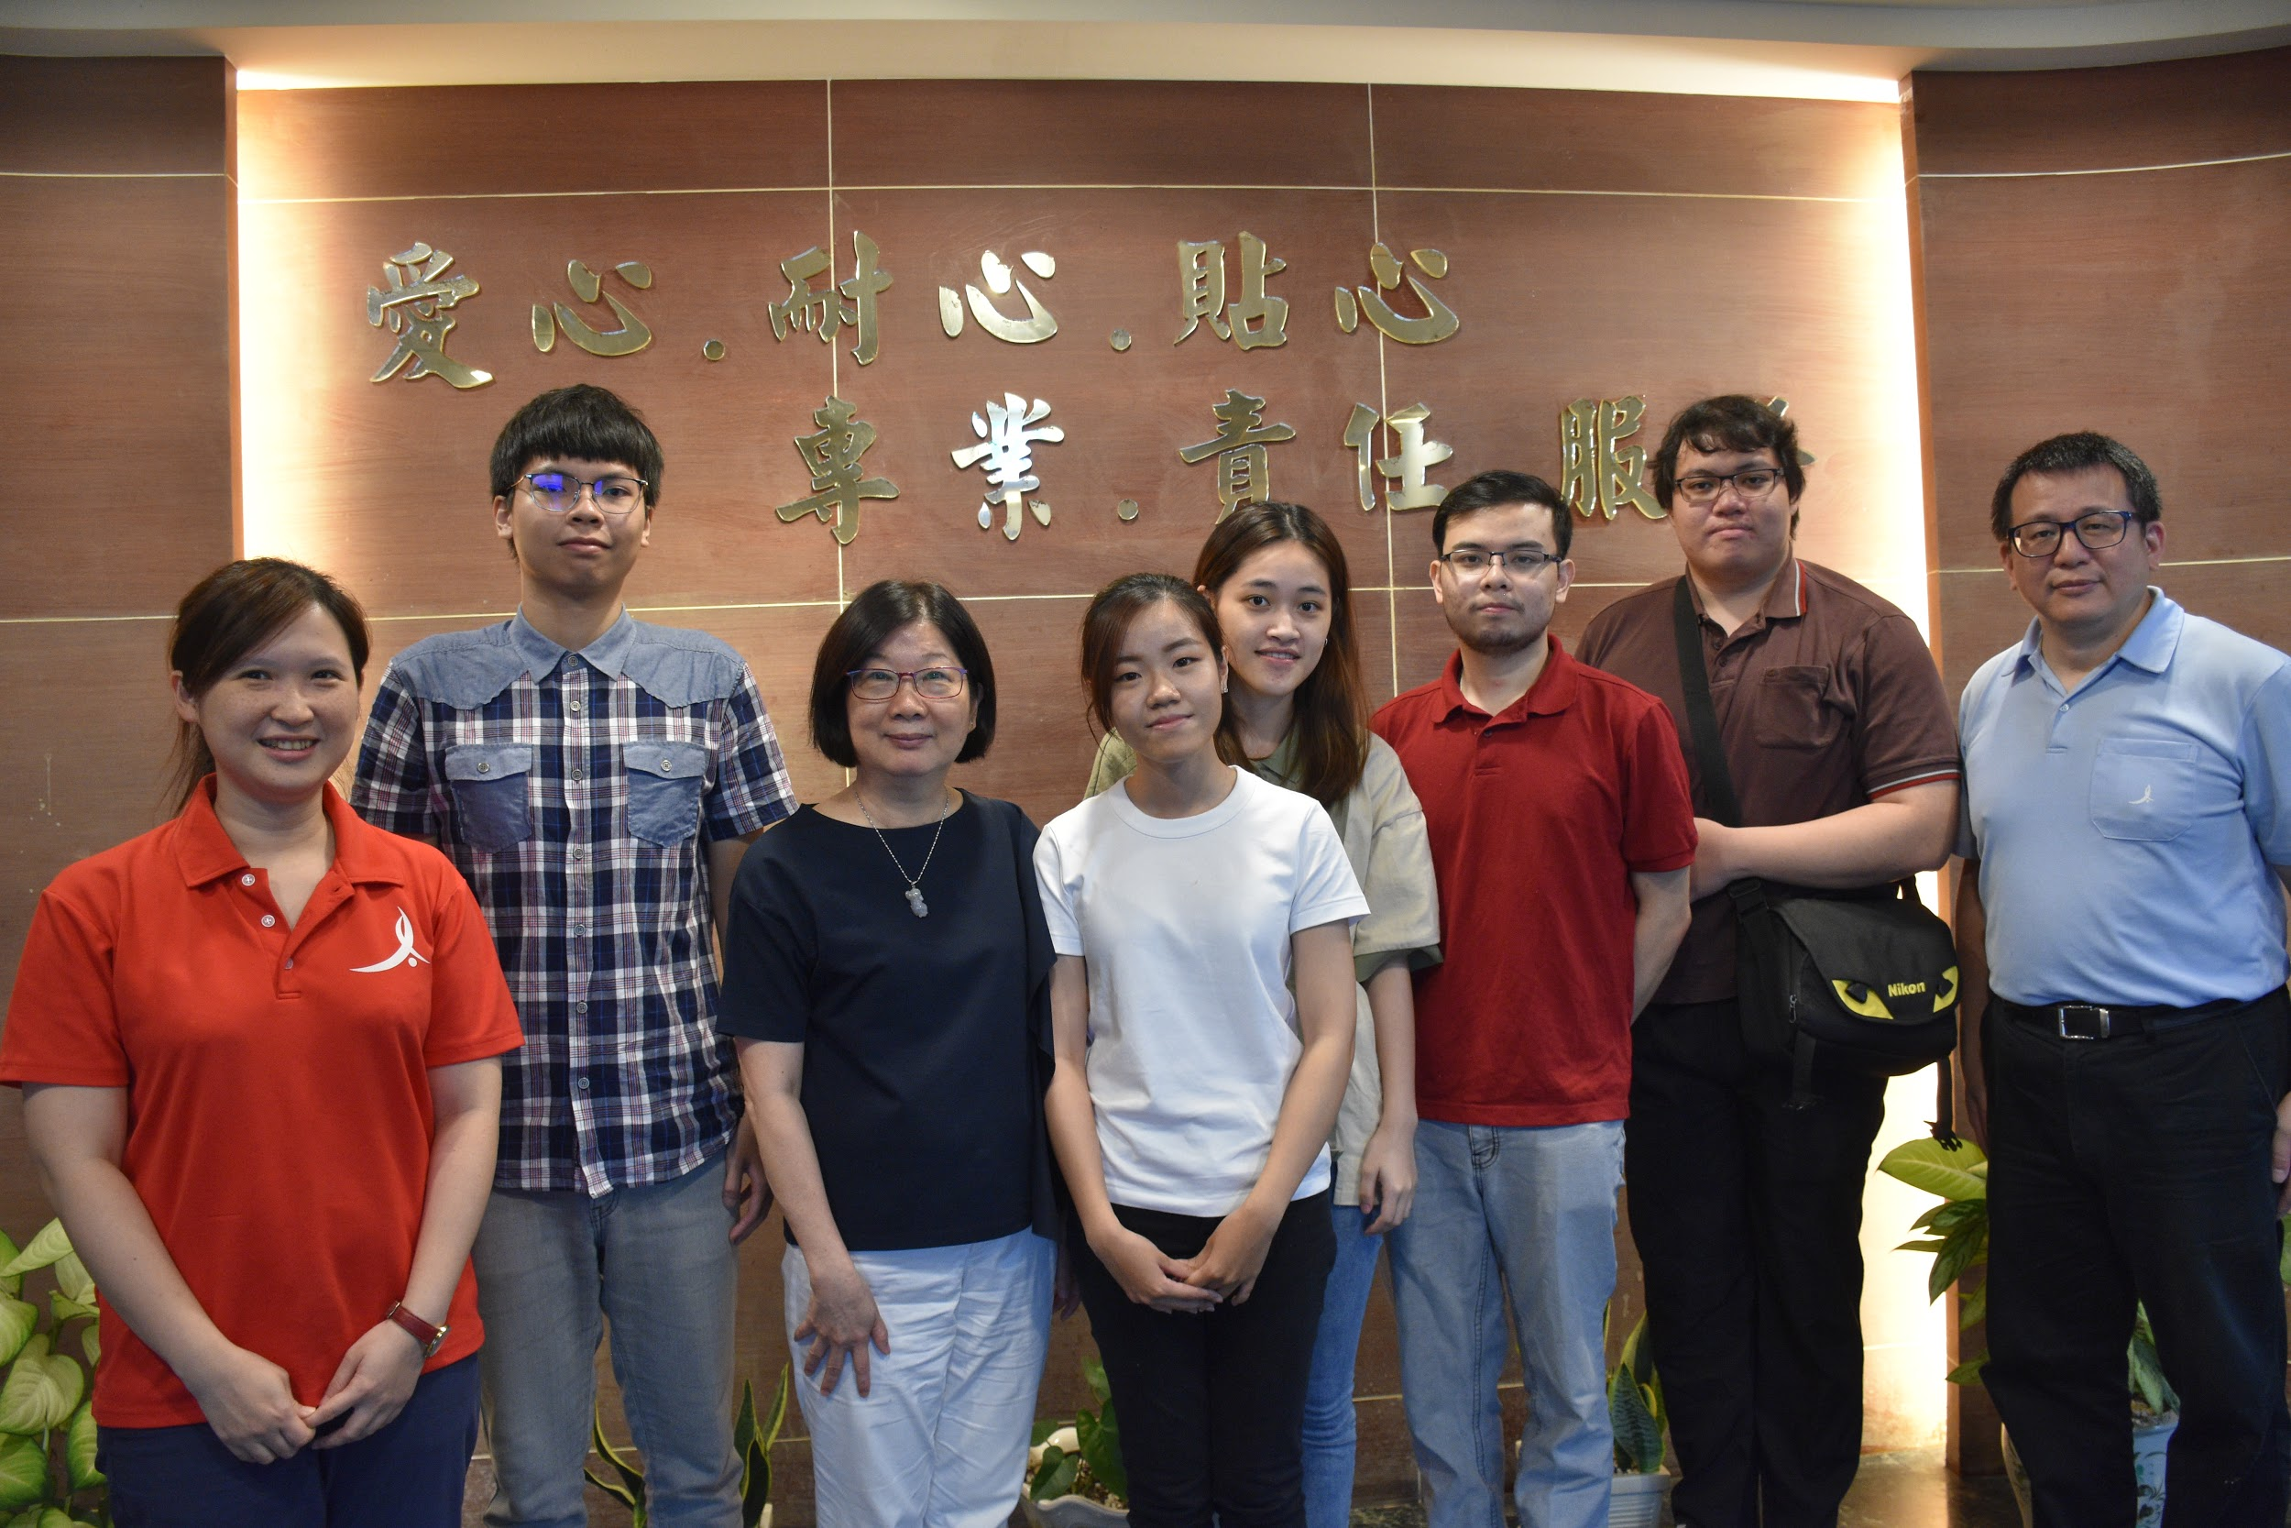

###### Figure 4.1.3: Group photos with the staff

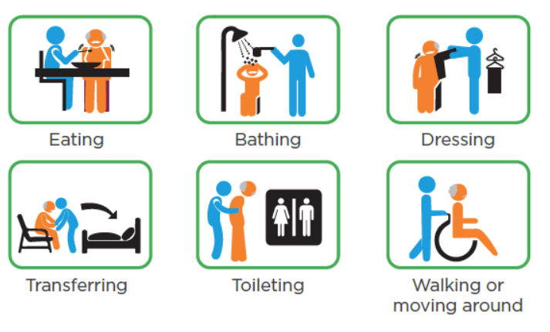

###### Figure 4.1.4: Examples of various tasks performed at the LTC

###### 

### 

### 1.2 System Users

1. Director of Nursing(Director)
2. Patient
3. Chief Nursing Officer(CNO)
4. Certified Nursing Assistant(CNA)
5. Family

#### 1.2.1 User Categories

##### Browser Component:

Director of Nursing(Director)

Chief Nursing Officer(CNO)

IT Admin

##### Hardware Component:

Resident

Certified Nursing Assistant(CNA)

##### Mobile Application Component:

Family and Friends of Resident

Certified Nursing Assistant(CNA)

## 2.0 PROJECT FOCUS

Main goal: Improving system usability through better system functionality and better interface design

The primary focus of this iteration of the project was improving the UI and UX design of the System. Overall, by the end of the project, the system should be easier to use and implement by end-users and administrators.

To accomplish this, the group studied common design patterns found in popular applications and websites in use today as well as common industry best practices for certain processes and procedures and then determining where such aspects could be feasibly applied to the project, given what the group already knew about the needs and operations of a functioning Long Term Care Facility.

## 3.0 HARDWARE TEAM



### 3.1 Introduction

The Hardware component consists of two devices. One is the base station and the other is the wearable unit. The base station is primarily used to connect to and collect data from the wearable devices. The wearable device is intended to be worn on the LTC resident’s wrist.

#### 3.1.1 Hardware Diagram

###### Figure 4.3.1 System Diagram showing the Hardware component outlined with an Orange box

As shown in this system diagram, the hardware component of this project consists of a wearable unit and a base station unit which sends the data directly to the cloud database, Firebase. The data collected by the hardware will then be accessible in the Web Portal and the Mobile Application via Firebase.

### 3.2 How it works

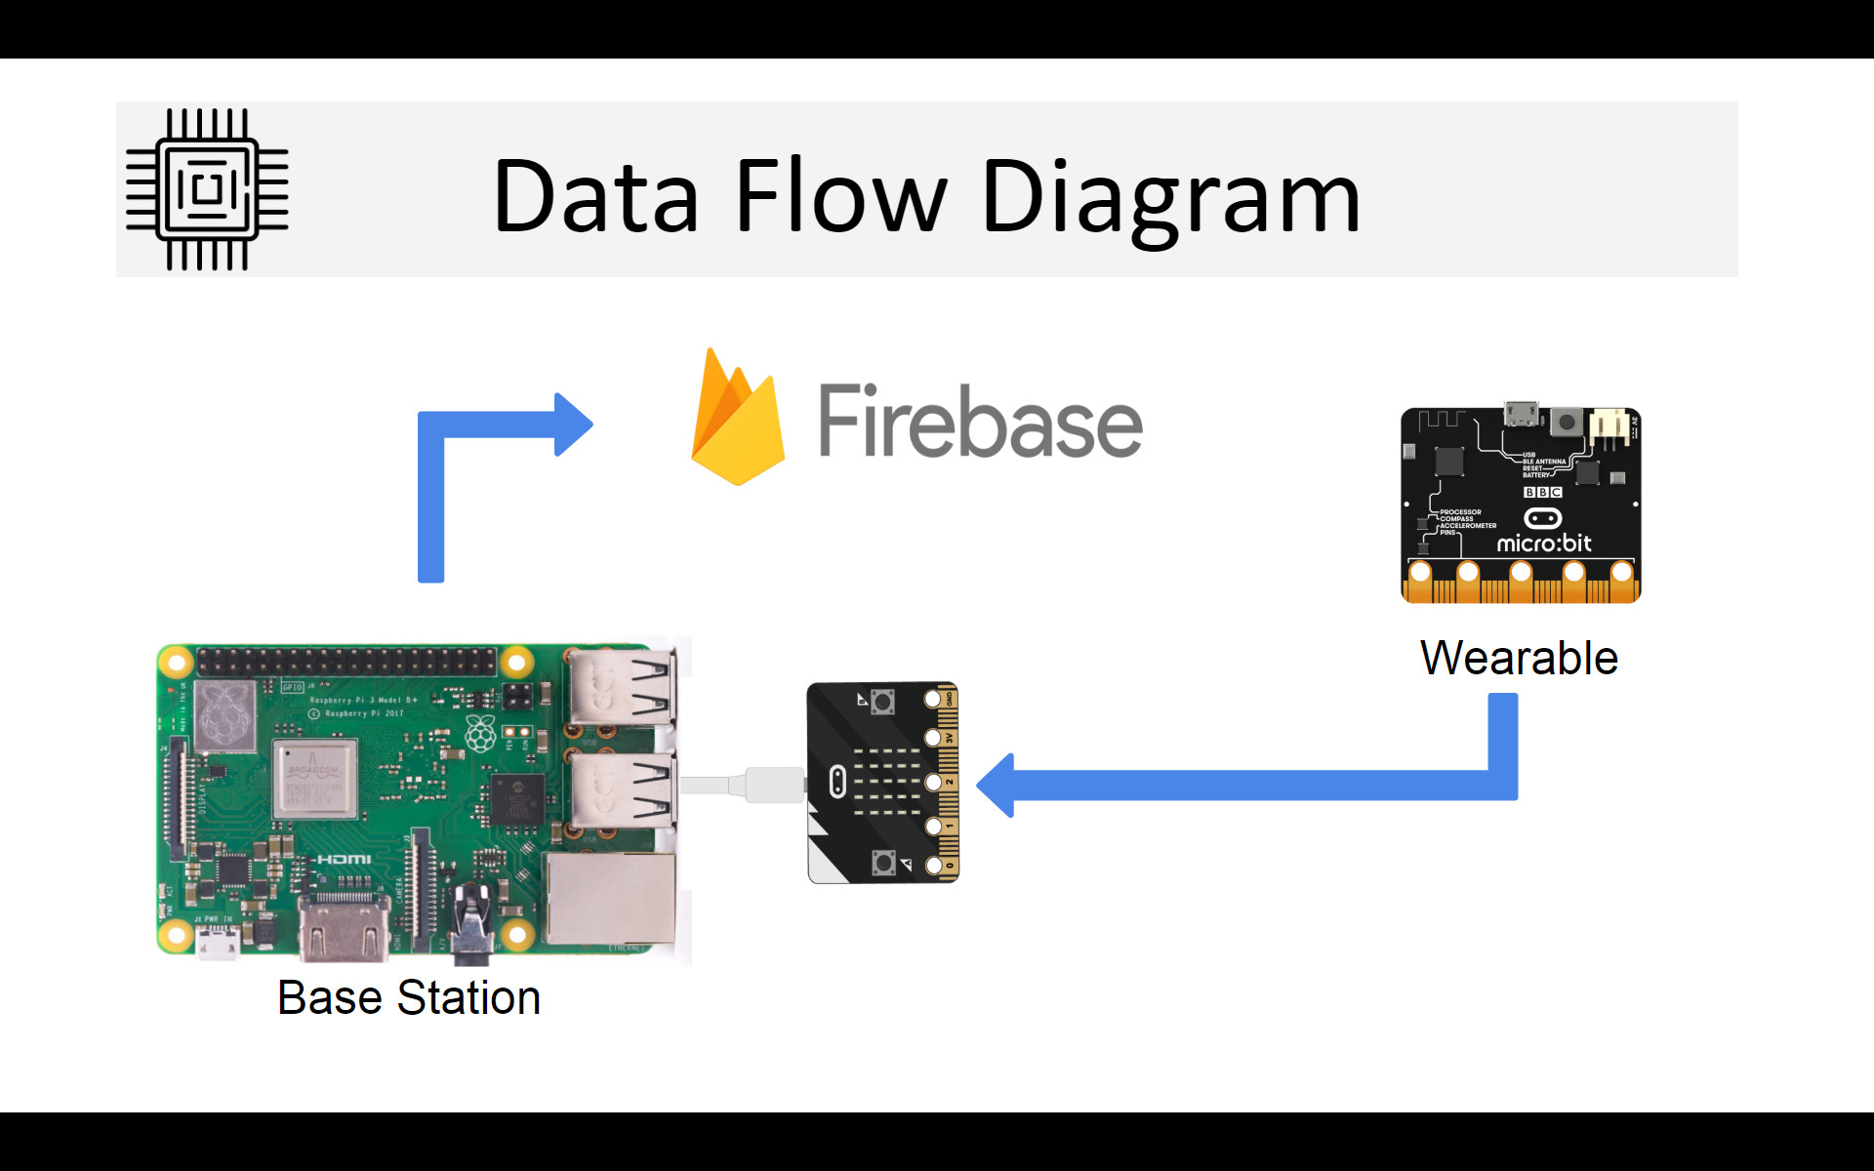

###### Figure 4.3.2 Hardware Data Flow Diagram

The data-flow diagram in Figure 4.3.2 shows how is the data in the hardware component is sent and received between the devices. The wearable unit consists of a micro:bit and pulse sensor which is used to detect the wearer’s heartbeat. The wearable unit collects the wearer’s heartbeat, step count, fall status, and ambient temperature. The data is then sent to the base station by radio using the micro:bit’s antenna. The Base station consists of a Raspberry pi 3 B+ and USB attached micro:bit. The purpose of the master unit is to receive the data from the wearable and send it to the cloud database over the internet.

#### 3.2.1 Tools and Requirements

###### 

###### Figure 4.3.3 Hardware Data Flow Diagram

For coding, the team made the decision to switch platforms from Makecode online to an offline Micro:bit python editor. In version 2.0, the KU development group had been using the MakeCode platform to code the BBC Micro:bit, but the online block-based editor was too limited and slow.[1] There were multiple library and functionality errors and editing large code files could lead to significant slow downs or lead to the editor becoming entirely unresponsive. The selection of functions available in the online editor’s “blocks” was also insufficient for the new changes being made in this iteration. Library functions for the micro:bit written in python code were far more extensive and editing in python code gave the team far more control than MakeCode Online.[2]

Secondly, Mu-Editor allowed team members to monitor data inputs directly in the IDE. Furthermore, debugging on the MakeCode platform meant having to download the generated hex file, importing it into the wearable micro:bit via USB connection and running it.[3] Members of the team would then need to keep watch on the LED matrix display of the unit for it to return an erroneous line of code and the error type. This was often slow and time consuming, so when the Mu-Editor IDE was able to immediately point out problems in the code file during editing, it saved many hours without having to import and run the code on the micro:bit.

Changing the platform not only made coding much easier, but also decreased the required testing time, allowing team members to focus on actual problem solving.

#### 

#### 3.2.2 Explanation of Hardware

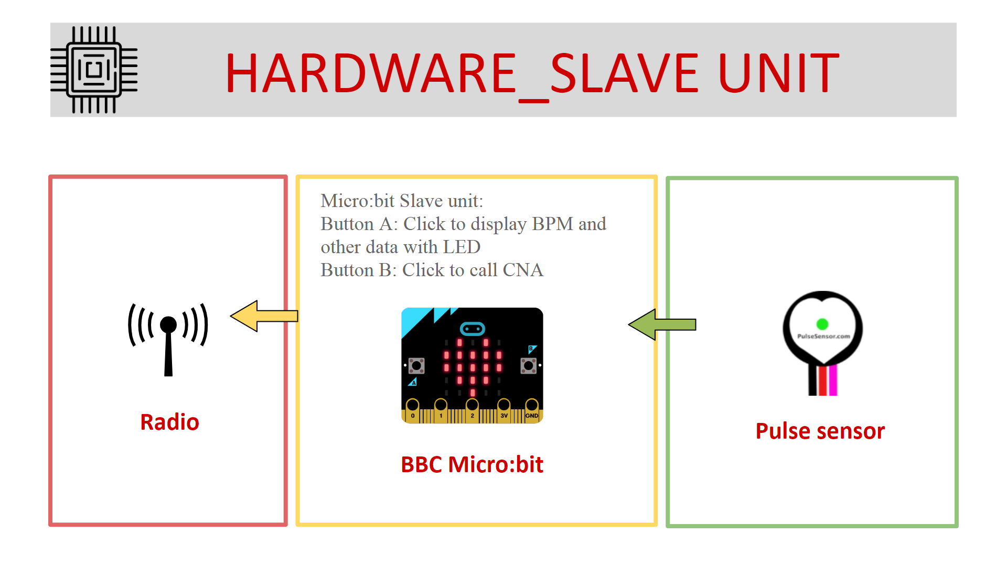

###### Figure 4.3.4 Hardware Data Flow-wearable part

To connect the pulse sensor, the team connected the pulse sensor’s signal line to port 2 of the wearable BBC Micro:bit, the + line to the 3 volt supply, and the - line to the GND port.[4]

The wearable unit does require some time to start taking accurate pulse sensor readings, and some more time after that to start sending them to the base station. Overall, this process may take up to 3 minutes after the wearable unit’s activation.

The hardware team also added a new “Call CNA” function which allows the wearer to press one of the top side buttons on the Micro:bit unit to call for help.

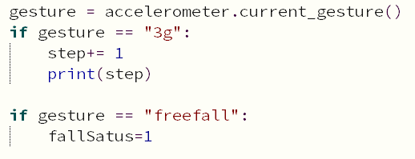

###### Figure 4.3.5: Section of code for fall and step detection

The wearable is constantly checking for patterns of acceleration which indicate specific gestures. Here, when it detects the gesture “3g”, it increments the step counter. When the wearable detects it is in freefall, it changes the fall status to 1.[4]

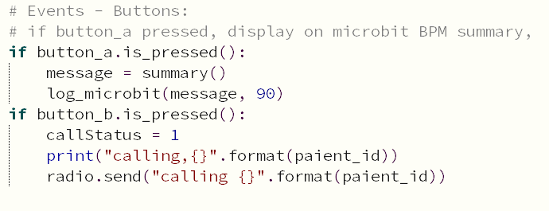

###### Figure 4.3.6: Section of code for Button press functionality

When button A is pressed, any recorded data will be shown on the Micro:bit unit’s LED Matrix display. Pressing button B will cause the wearable unit to sends a signal to the Base Station to call the CNA.

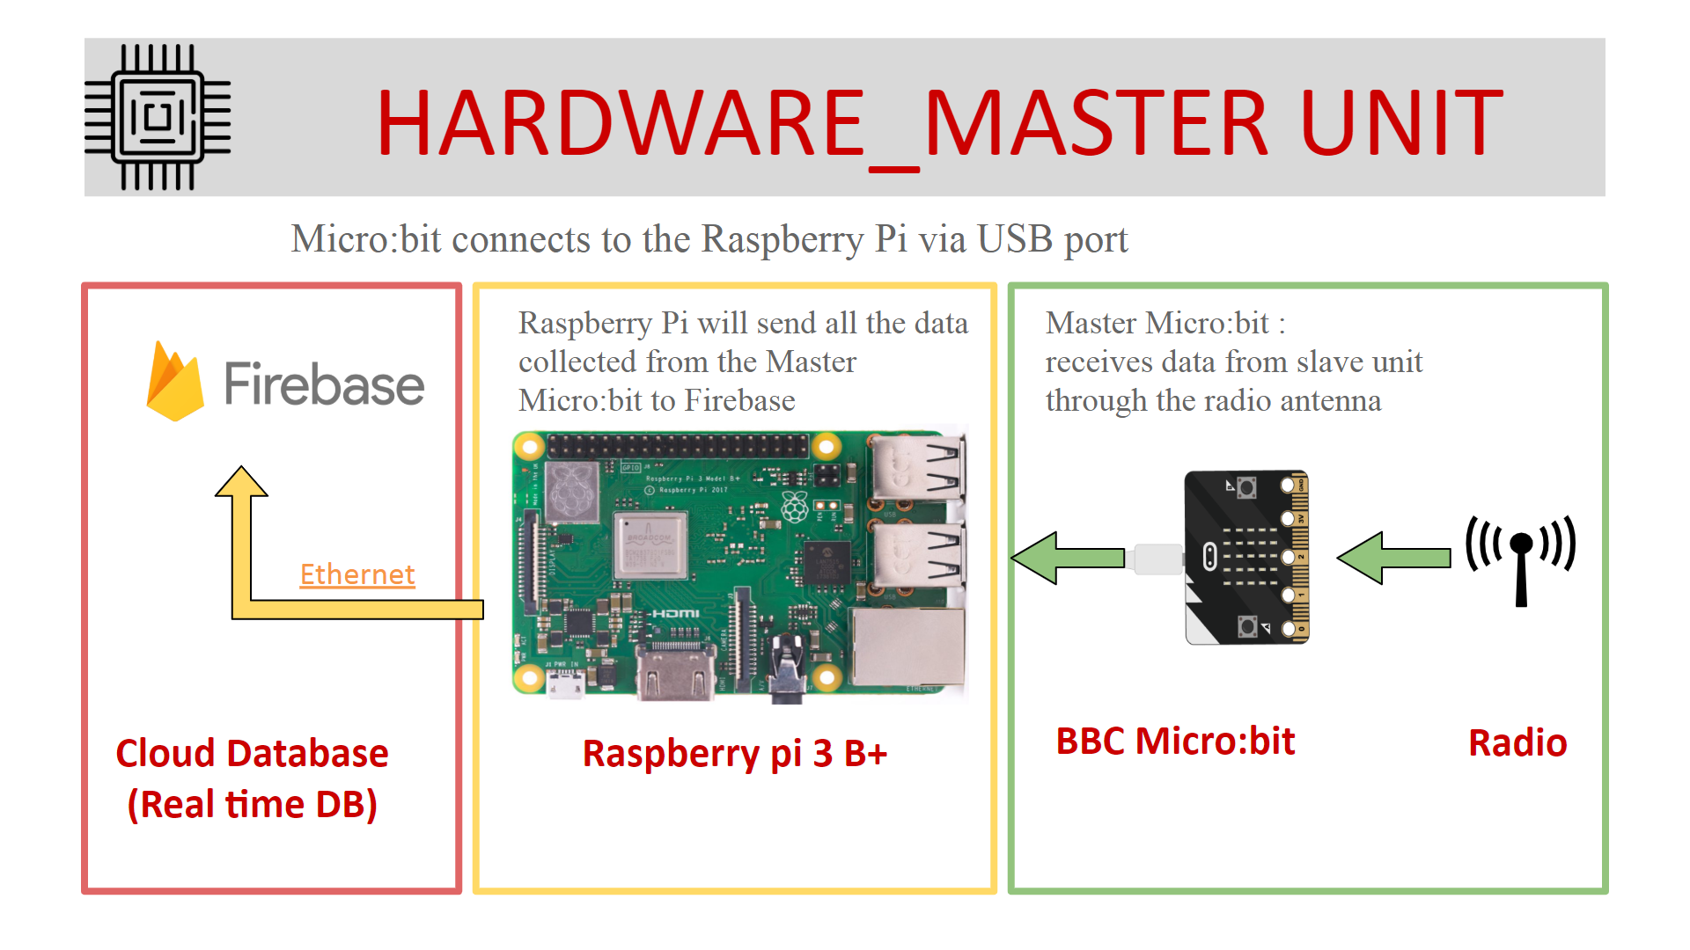

###### Figure 4.3.7: Diagram of Hardware Data Flow (Base station)

After the base station Micro:bit receives the data via radio, it is then sent through the USB cable to the Raspberry pi. The Raspberry pi will then send it to be stored in the real time database, Firebase over the internet. For this iteration, testing and implementation was done using the Raspberry Pi’s EE602.3 ethernet although it’s Wi-Fi connection is also usable.

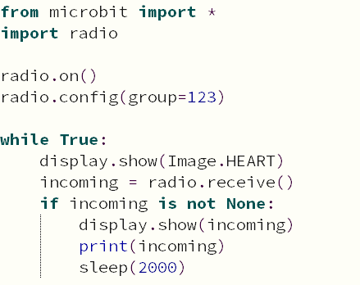

###### Figure 4.3.8: Section of Master BBC Micro:bit code[5]

The radio group of wearable units and the base station were set up to be the same channel to allow the wearable units to transmit to the base station. If the master unit receives data from the radio, data != null, which will then allow the base station Micro:bit to display any received input data on its’ LED Matrix. The data is also sent over to the Raspberry Pi and the variable Set round_trip is set to 2000ms(2sec). The Raspberry Pi will then send the data to the online database.

#### 3.2.3 Mu: Python IDE

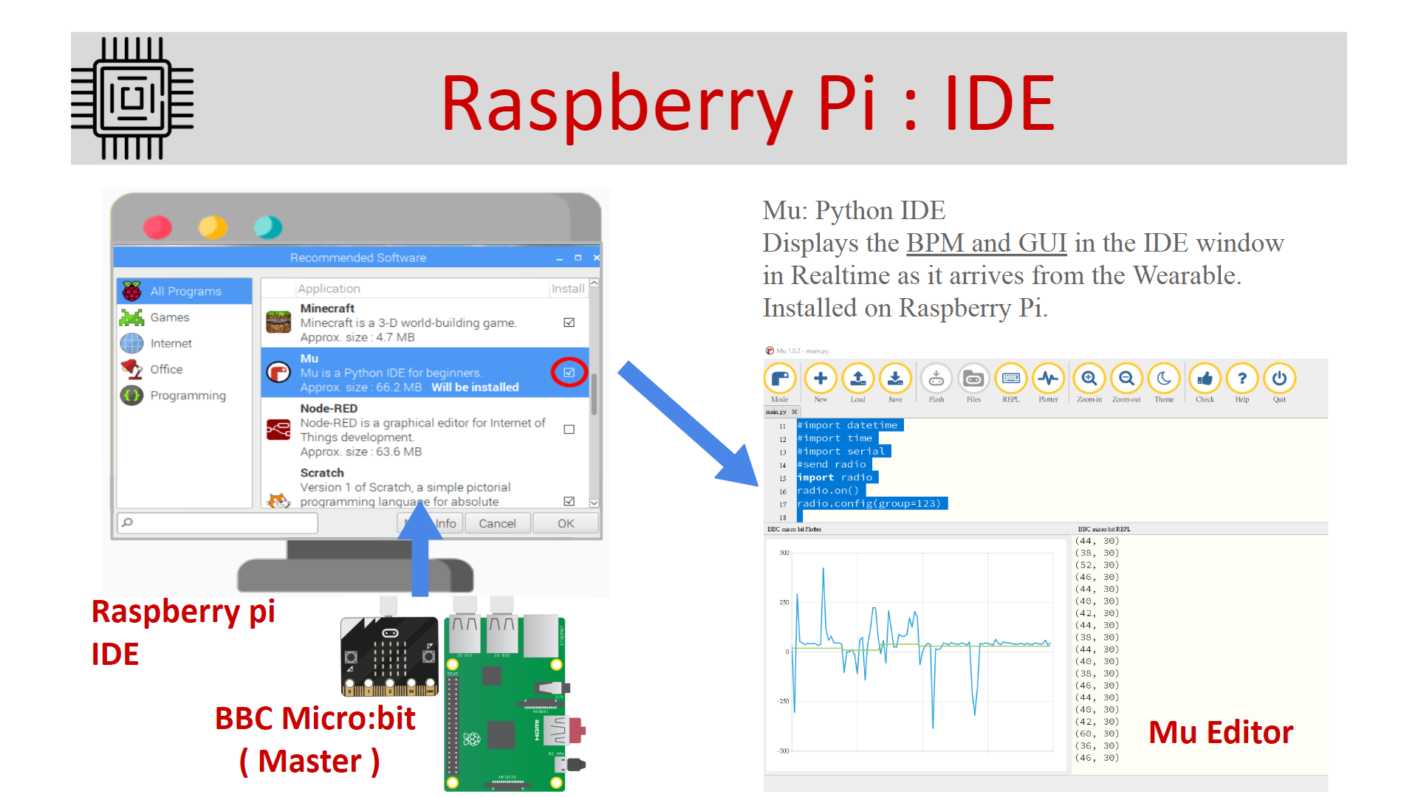

###### Figure 4.3.9 data monitor and GUI

For this iteration of the project, the Hardware team made the decision to use Mu-Editor IDE for their python coding. The main reason behind the change in coding platform is the flexibility and greater control over the hardware granted by coding in Python compared to the limited and restricted blocks of MakeCode Online. Another benefit of this is the editor’s functionality of displaying incoming data flow in real time as graphs or terminal outputs, allowing team members to check dataflow to the base station without having to wait for it to arrive on Firebase.

The IDE displays the BPM as a plotted Graph in the IDE window in real time as it arrives from the Wearable unit. The platform also comes as a preinstalled programming tool on the Raspbian OS used on the Raspberry Pi, easily allowing team members to view arriving data from the base station Micro:bit. However, learning to navigate the Debian based OS proved a challenge in itself, as was installing the additional prerequisites.[6]

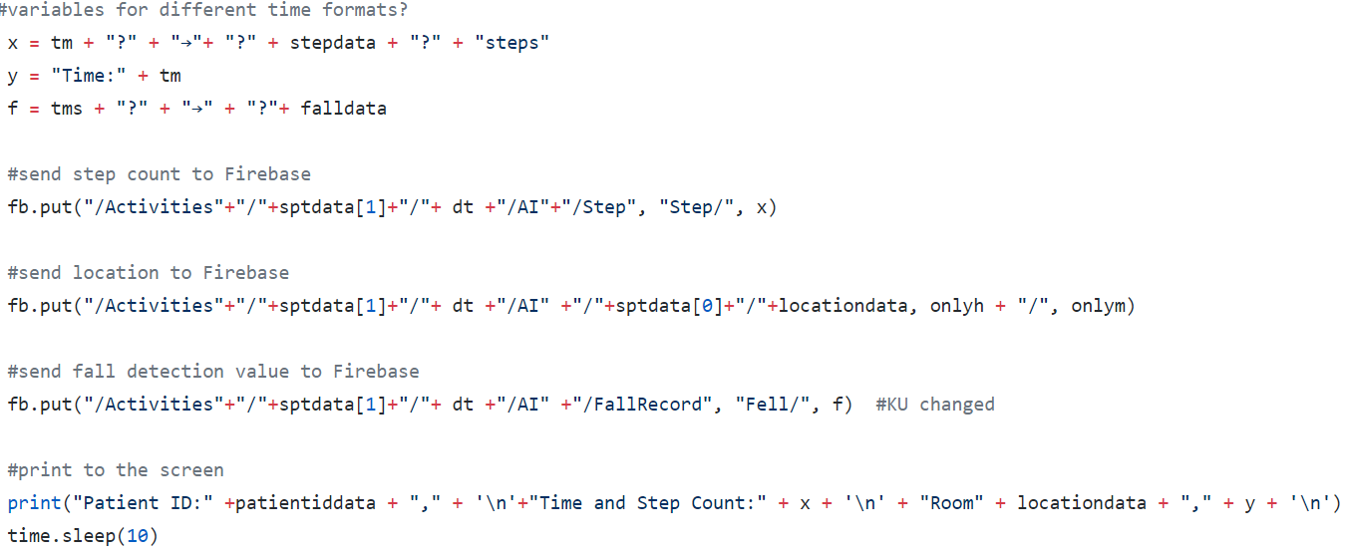

###### Figure 4.3.10: sending format from raspberry to DB

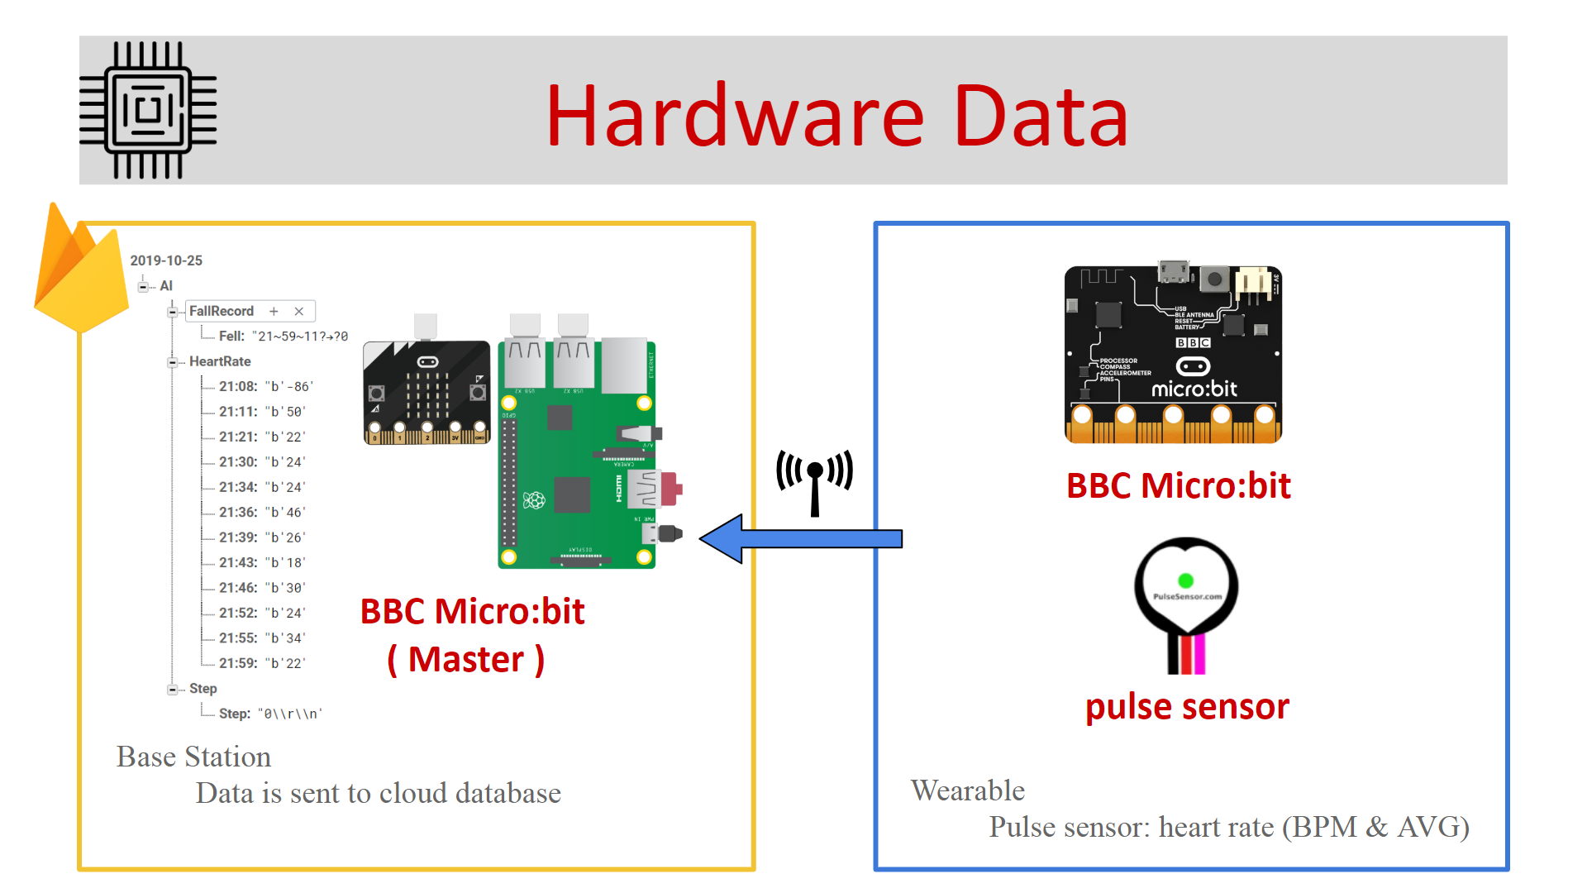

###### Figure 4.3.11 data monitor and GUI

After Firebase receives the data, it stores it into various folders under specific format in the database. This can be seen in Figure 4.3.11, on the left side of the picture. Here, the data for heart rate is stored under the category of “HeartRate” with time of measurement taken as well. The data updates from the base station on average every five to ten minutes.

### 3.3 Planned Changes

#### 3.3.1 Improved Monitoring Capability

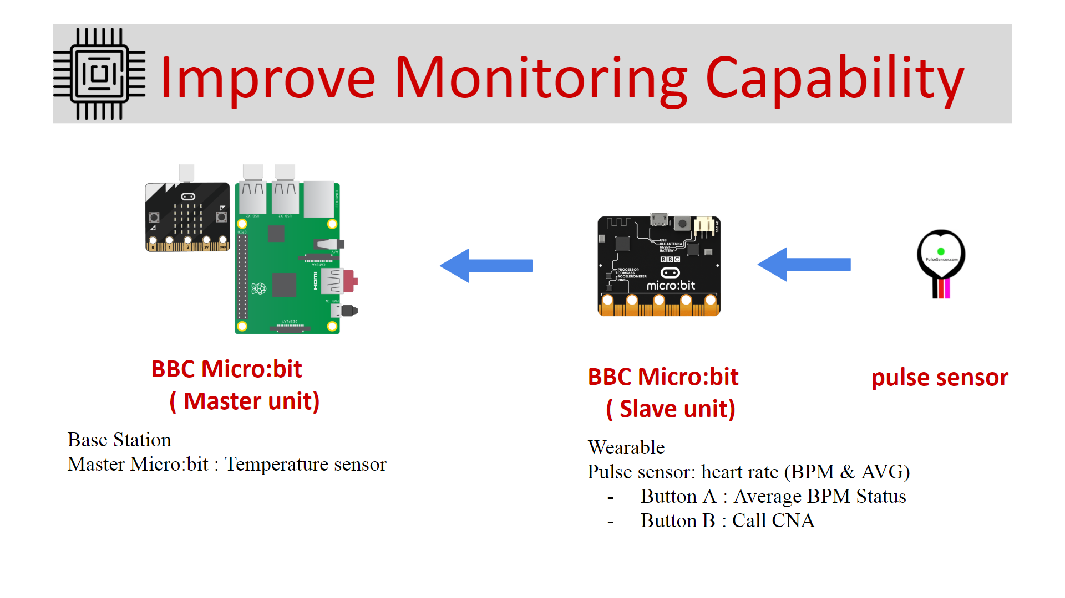

###### Figure 4.3.12: Hardware dataflow after moving pulse sensor to wearable unit

Again, in keeping with the understanding of industry standards and market conventions, the group made it a priority to move the pulse sensor to the wearable unit, bringing it closer in line with established industry products like certain fitness tracking watches like the fitbit models that come equipped with heart rate sensors.

The thinking was to improve the practicality of the wearable (slave) unit beyond a simple step counter and fall detect device. Leaving the pulse sensor on the Base Station (master unit) would have made the it superfluous as LTC residents would not be able to use it while away from their bedside. Furthermore, the LTC facilities commonly already have a dedicated machine to measure blood pressure that also registers heart rate. Therefore it was felt that the pulse sensor would need to be moved onto the wearable unit for it to be useful, by providing up to the minute monitoring of residents to the system.

#### 3.3.2 Improved scalability

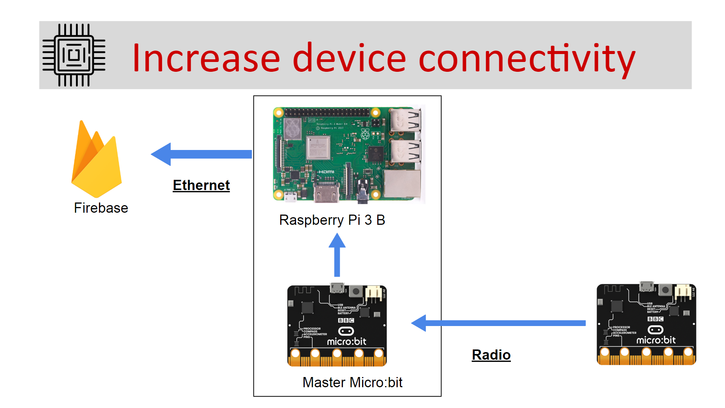

###### Figure 4.3.13: Connection diagram showing base-station supporting one-to-one connections with wearable

The decision to move the pulse sensor to the wearable unit also nicely falls in line with plans to improve scalability.

In version 2.0 and prior, the hardware components worked together on a one to one basis. That is to say, one Base Station was designed to communicate reliably with only one wearable unit.

It was decided that this was unacceptable from a product perspective. The cost of purchasing one raspberry pi and two microbit units per resident monitored in the LTC would have been prohibitively expensive. No realistic industry product would ever be designed and sold in this manner.

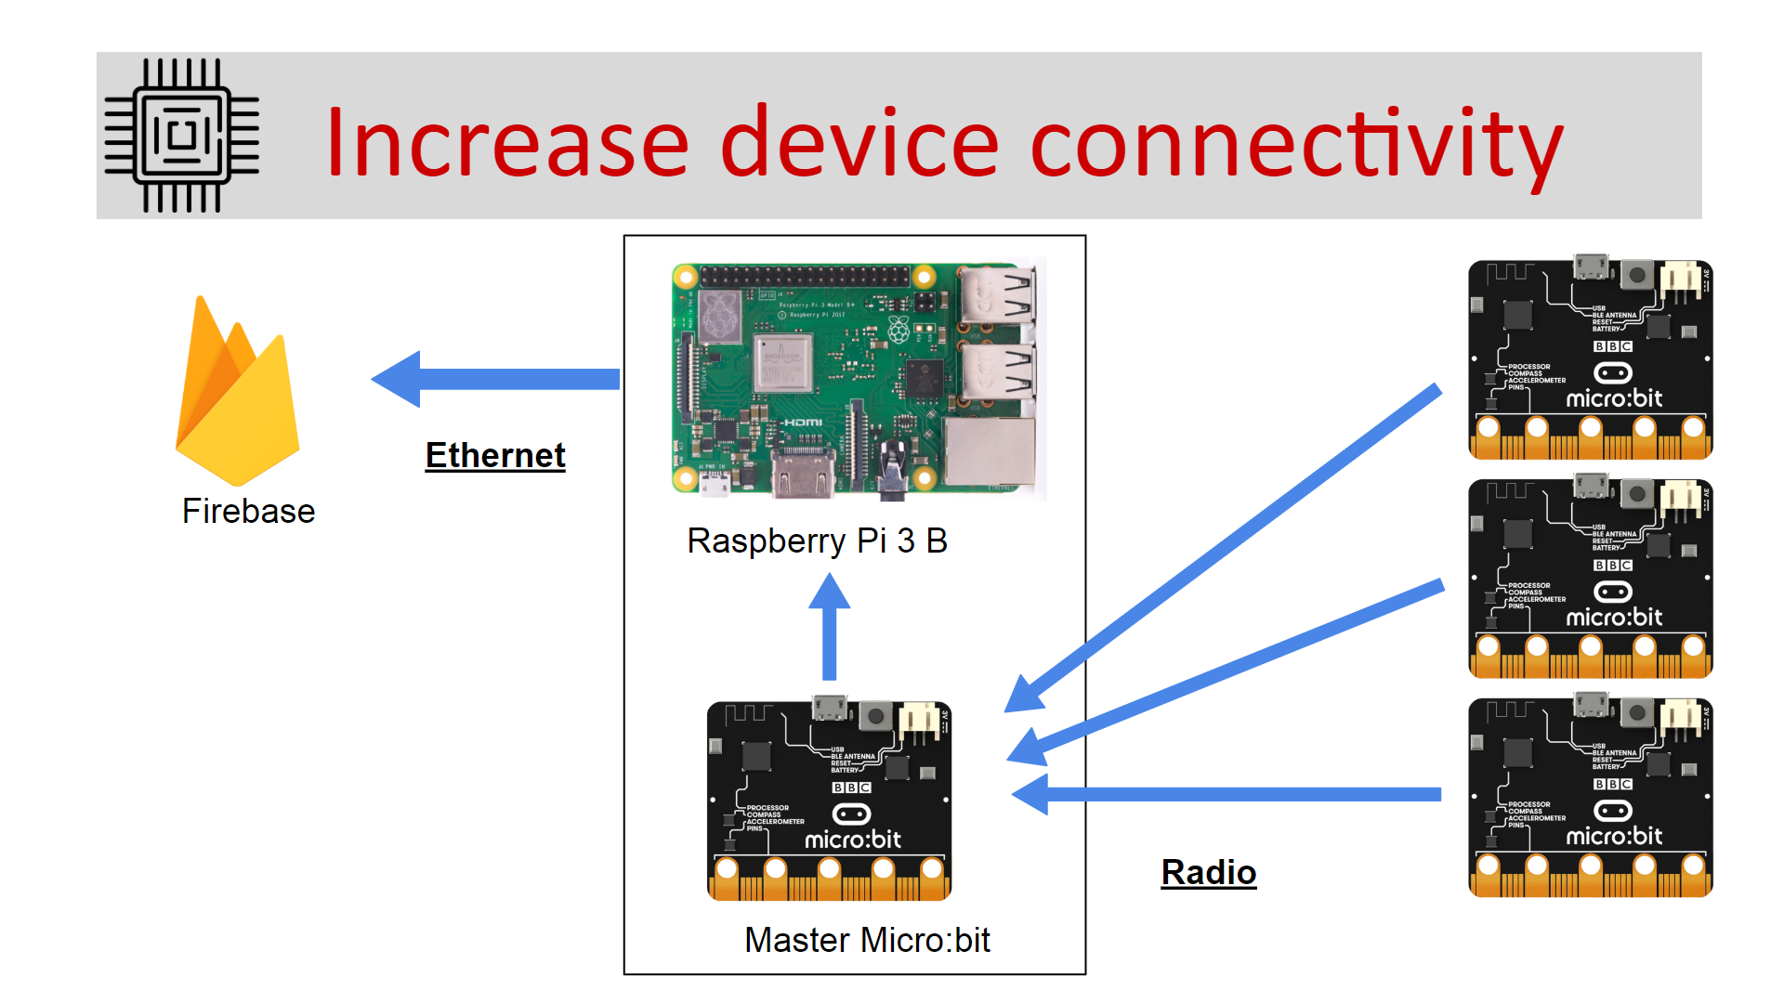

###### Figure 4.3.14: Connection diagram showing base-station supporting one-to-many connections with wearables

The plan was therefore to allow the base station to scale up connectivity as needed.

By allowing multiple wearables to connect to one single Base Station, the team introduce economies of scale. An LTC should be able to setup a single Base Station in a moderately sized room, which would then be able to communicate with and support multiple wearable units.  
 Considering that a single Base Station consists of a Microbit unit and Raspberry pi together, there would be considerable cost savings for implementing this project on a larger scale.

To implement this feature change, the team studied the concept of three-way handshakes often used in TCP/IP connections and planned a simplified version of it for the project.

In this, a wearable unit would broadcast its’ registered ID number to a Base Station. If the Base Station is ready to receive the data, it will reply with an OK to the wearable to send its’ data. Upon receiving the OK, the wearable will transmit its data, and upon completion, transmit a message to the base station to “close the session”, that is to say, stop listening for data under that ID number. However, time and personnel constraints would eventually require the team to drop this idea, resulting in connectivity issues in the one to many model.

### 3.3 Backend Code

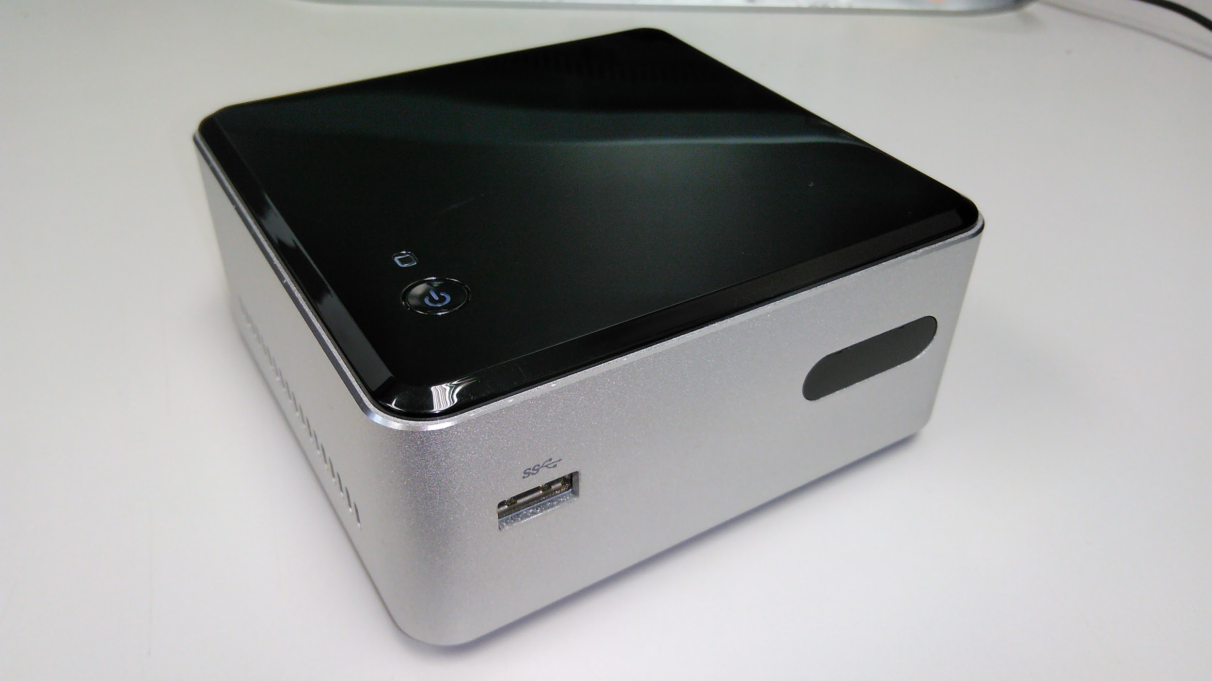

###### Figure 4.3.15: Picture of our backend server unit

One of the features in the Web portal (Browser Component), is reports generation. What this feature is, is essentially to allow the user to enter a LTC resident’s ID number along with a range of dates, a start date and an end date, into the reports generation page of the web portal, in order to get a PDF containing tables, charts and graphs of the resident’s data which can be downloaded and printed for easy viewing and record keeping.

In order to accommodate this feature, a server or device must be set up to run backend code that generates the graphs and tables. This device would have to be set up in a way that it can receive requests from the web portal that is hosted on Google Firebase, access the necessary data from the cloud database, and then generate a pdf report.

This feature was first introduced by the Kutztown University development group in version 2.0.[7] For this feature, the backend code ran on a linux virtual machine on one of their universities servers. The pdf would then be generated and stored temporarily on the virtual machine, and was accessible by going through their university’s academic web portal for download.

This feature is dependent on python code to run. In fact, several python dependencies must be installed in order for the code to run successfully, primary among them being matplotlib which is responsible for graph and chart generation. Further complicating things, matplotlib requires certain older versions of dependencies to run properly, so careful checking of installations is required.

For iteration 2.1, the team decided to make this feature less dependent on university infrastructure. Thankfully, the only alterations the team needed to make to the code was in the URLs and configuration sections.

For future implementations, the team believes that transitioning the backend code to Google’s Firebase backend hosting would be optimal in keeping much of the project consistently in the cloud, which would also improve ease of implementation for small scale facilities by negating complicated hardware setups and requirements. However, at this time, Firebase backend hosting only supports running of Java code so a change over to the cloud based backend would require porting all existing python code over to Java.

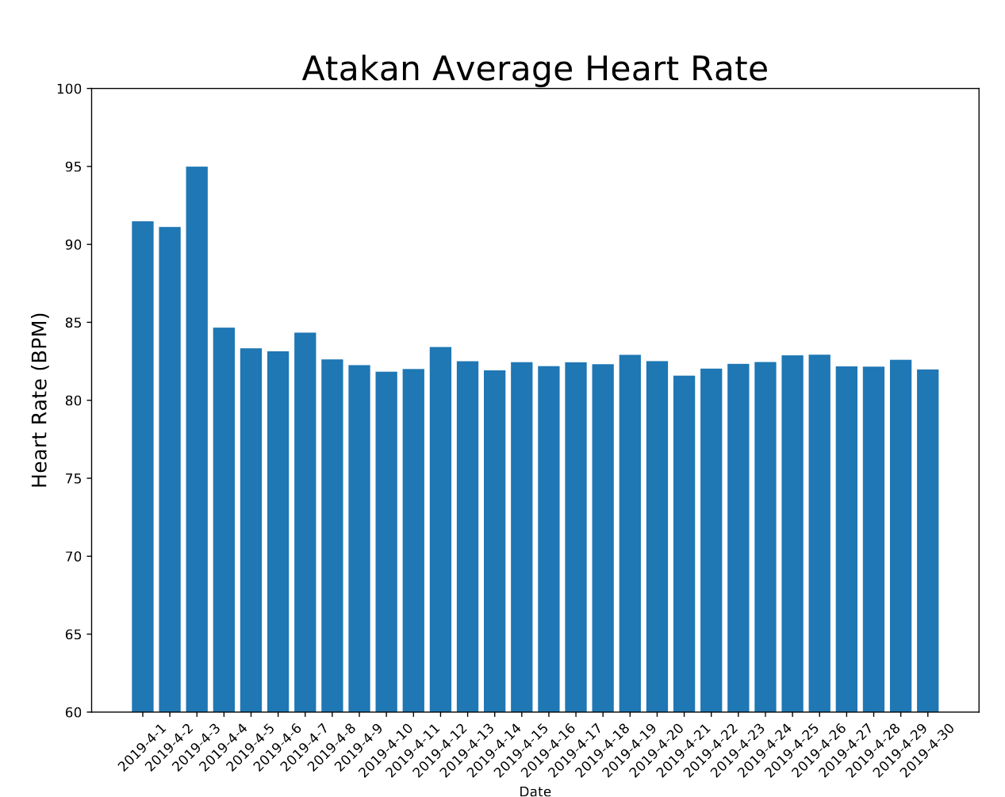

###### Figure 4.3.16: Column chart from reports pdf generated from test data values showing daily average heart rate

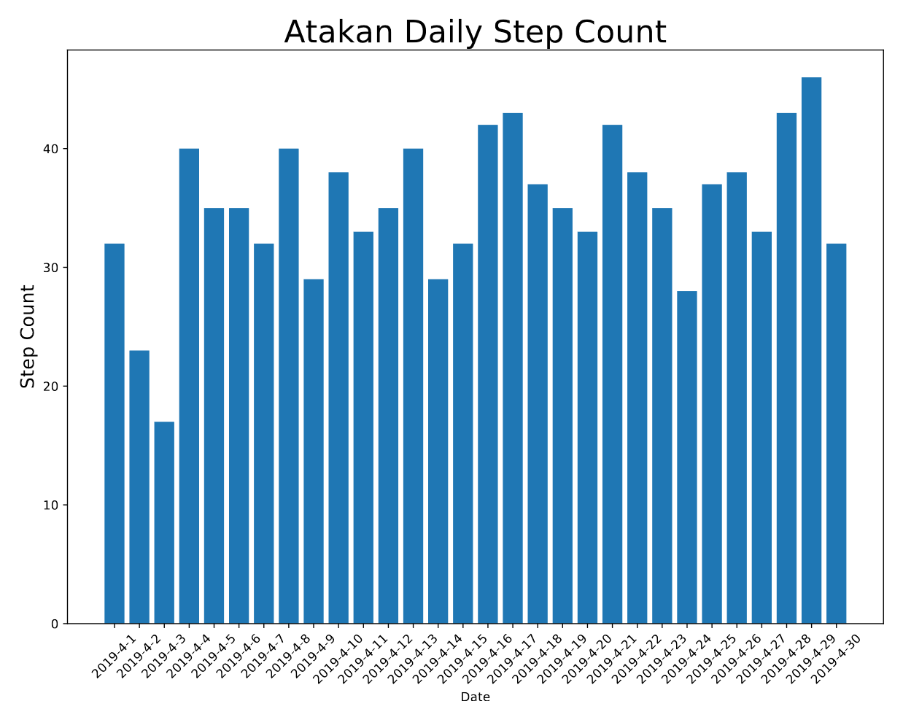

###### Figure 4.3.17: Column chart from reports pdf generated from test data values showing daily average step count

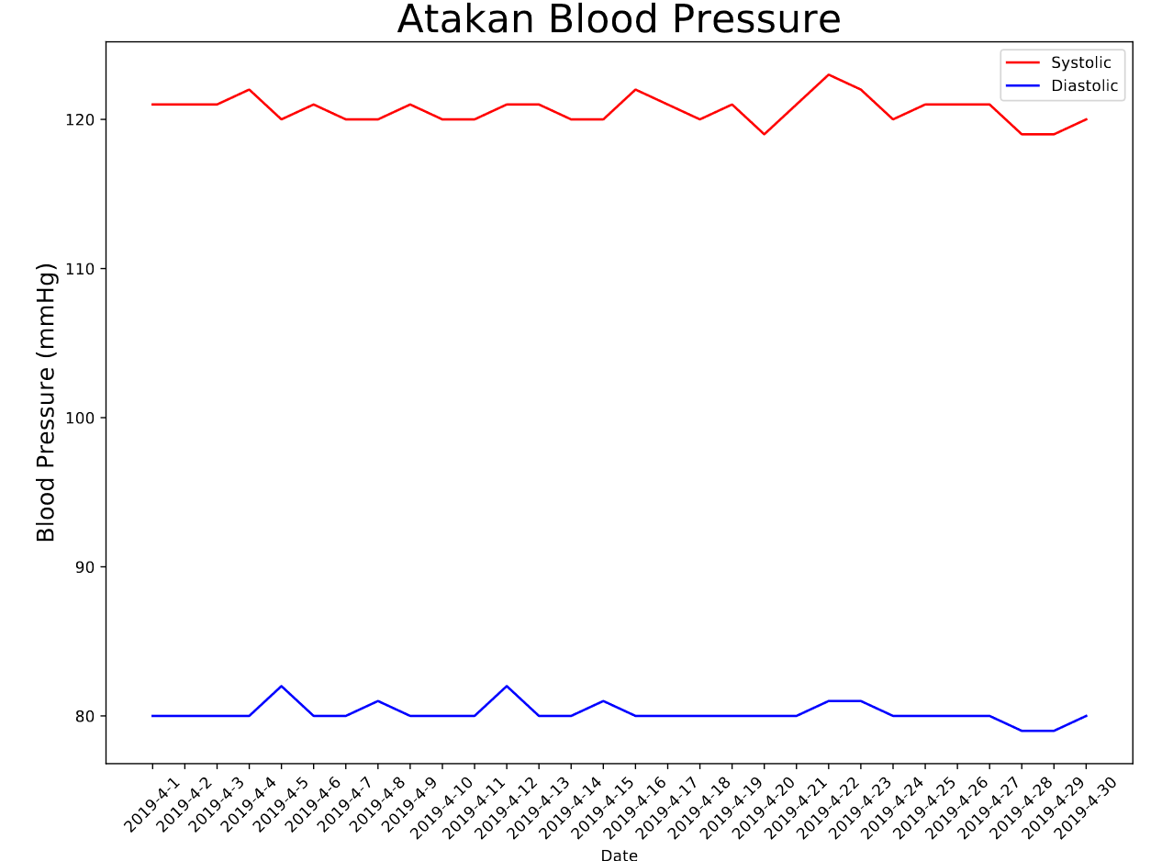

###### Figure 4.3.18: Line graph from reports pdf generated from test data values showing daily average Systolic and Diastolic blood pressure

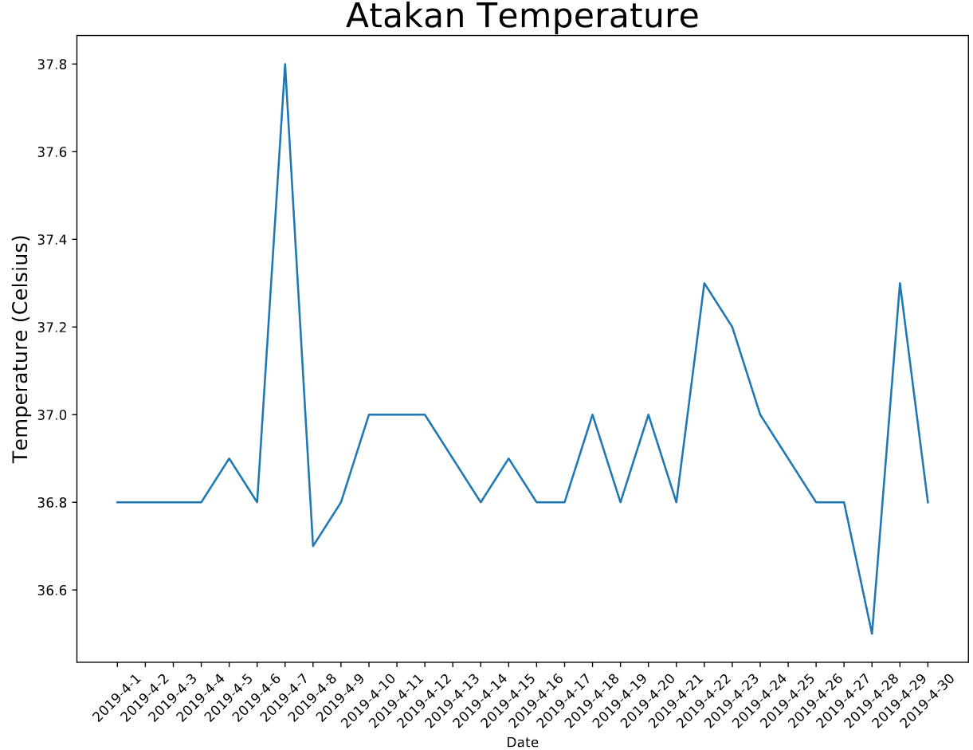

###### Figure 4.3.19: Line graph from reports pdf generated from test data values showing resident’s daily average body temperature

###### Figure 4.3.20: section of table in reports pdf generated from test data values showing daily average values (icon is test image)

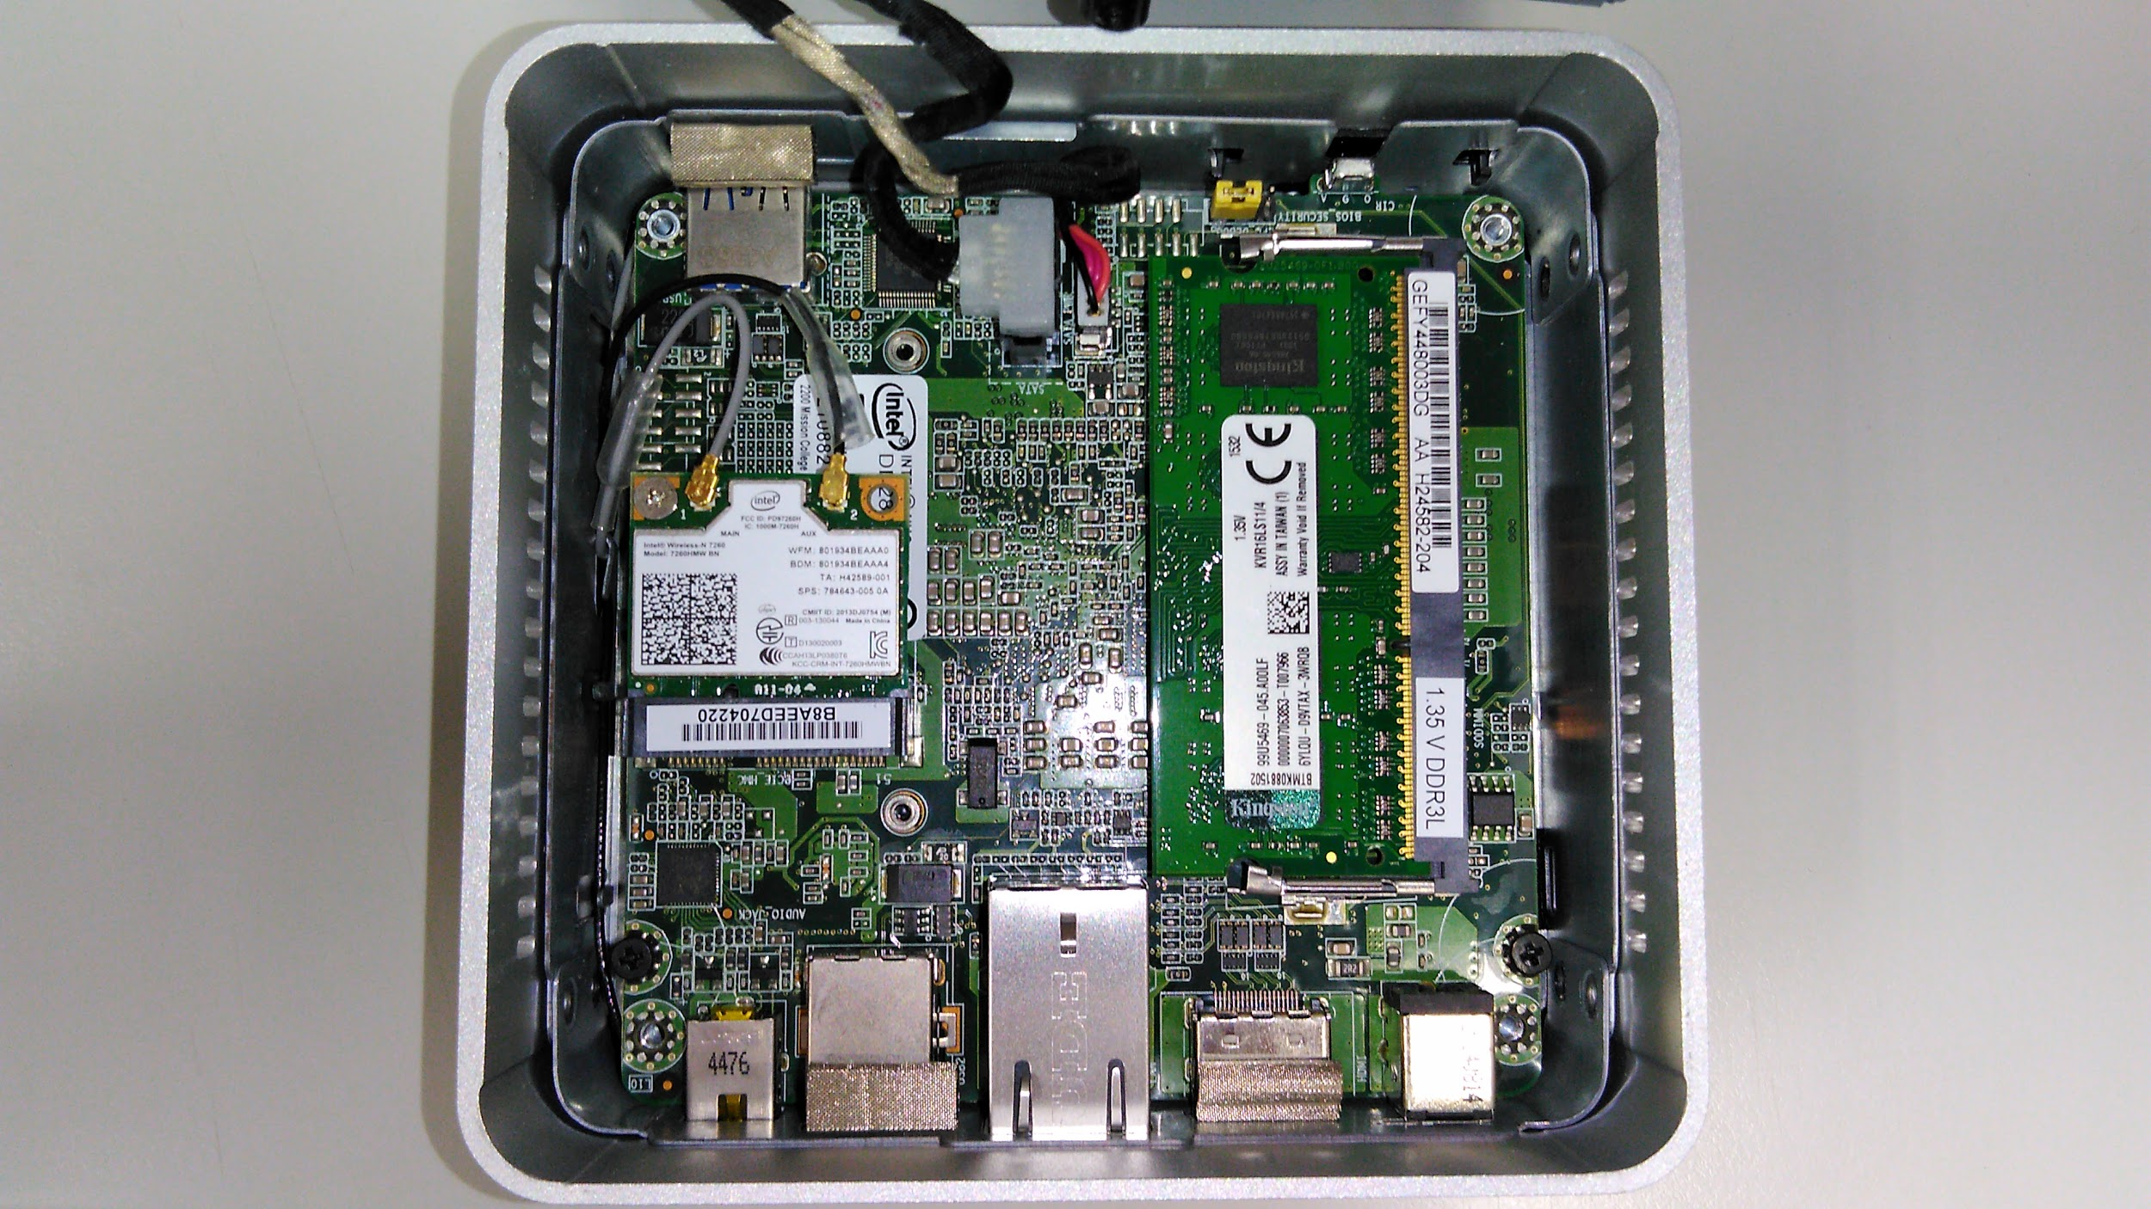

###### Figure 4.3.21: Interior image of backend server

For the backend server, an intel NUC kit model DN2820FYKH was used. This model comes with a Ball Grid Array mounted intel Celeron N2830. For storage and memory 4GB of DDR3L RAM, and a 240GB SanDisk Extreme ii Solid State Drive.

Despite its’ age and coming as a second hand unit, the PC is still able to perform very well for the purposes of this project.

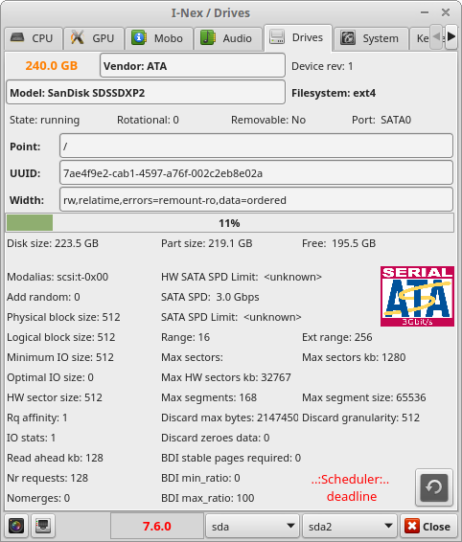

###### Figure 4.3.22: Window capture of i-nex showing SSD model number and firmware version of SSD installed in backend server unit

This particular configuration was chosen due to its smallest form factor and energy consumption among the second hand devices available to the team at the time. The Solid State Drive was an important choice among the parts due largely due to the longer boot and loading times of a more conventional Hard Disk Drive.

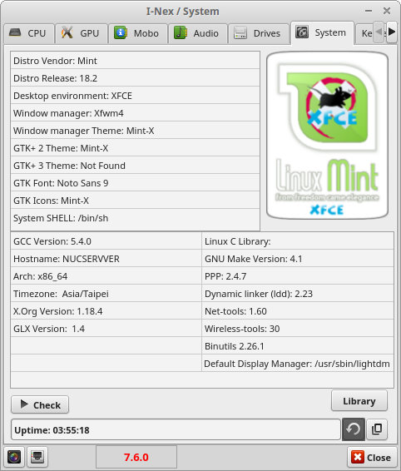

###### Figure 4.3.23: Window capture of i-nex showing Operating system currently installed on backend server unit

The Operating System chosen for this device was Linux Mint version 18.2 for several reasons. Primarily, this device had been used in a prior, unrelated project, and a hardware team member was already rather familiar with this Linux “distro”. Secondly, using a Linux Mint distro would allow the team to circumvent the need to pay for an Operating System license. Lastly, using a Linux Operating System would give the server more operational stability considering that in the team’s experience, Linux devices can work for weeks without rebooting, while non-Server Windows Operating Systems typically encounter some problems after 3 days. The desktop environment is XFCE as the least demanding of the available options.

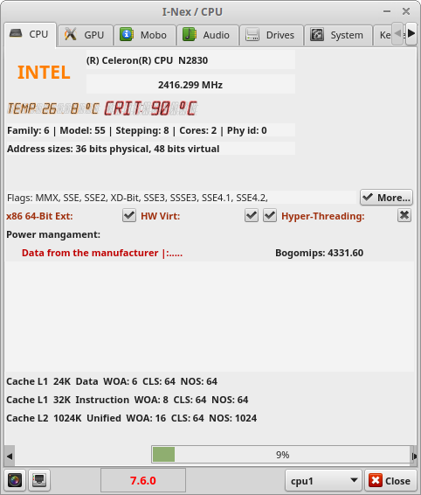

###### Figure 4.3.24: Window capture of i-nex showing CPU model of the backend server

During the past project and in the current one, it was found that for small scale testing and implementation, the hardware of the server was not a limiting factor. In fact, RAM usage and network activity was far from its limits due to low level traffic and usage, and as such, it is recommended for any future plans to implement this iteration of the project on a small scale to use the appropriate hardware for their goals.

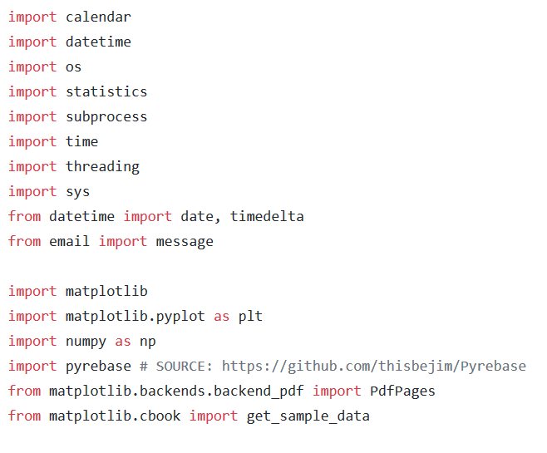

###### Figure 4.3.25: Code showing some dependencies required for reports.py to run[8]

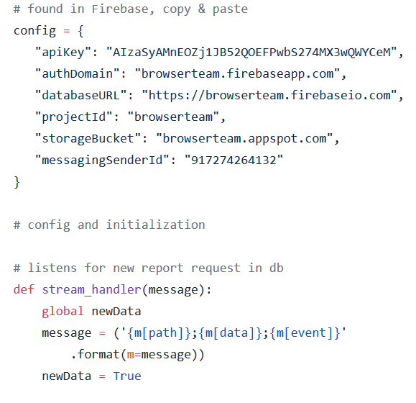

###### Figure 4.3.26: Code segment showing config section of reports.py[8]

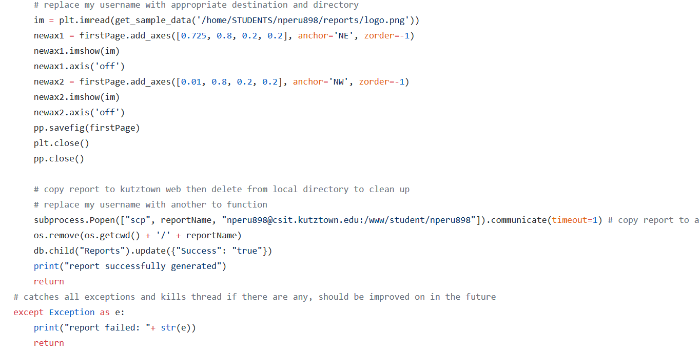

###### Figure 4.3.27: Code segment showing prior Kutztown University URL for storing reports[8]

### 3.4 Industry Conventions

When planning the changes for this project, one of the major areas of concern was how to bring this project closer towards becoming a real marketable product.

Firstly, the major focus in this iteration for the Web Portal and Mobile Application were the User Interface and User Experience, which heavily rely on established industry conventions, standards and best practices.

In contrast, considering that the available hardware is relatively simple, there were not many possible changes to the User Interface that were possible or even feasible. Therefore, the Hardware Team turned to consider improving the hardware components in the area of User Experience by bringing the project closer to a realistic market product.

To this end, there were two major points of consideration. Current Marketability of the project, and its scalability.

#### 3.4.1 Current Marketability

When deciding upon the changes upon the changes and how to prioritise them, the Hardware Team first studied existing market products such as the Mi Band 4 and the FitBit Inspire HR.

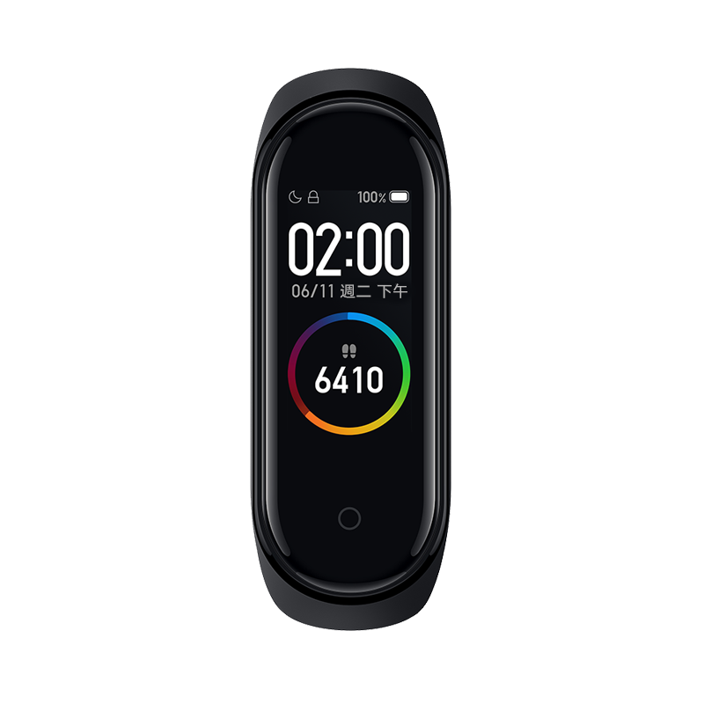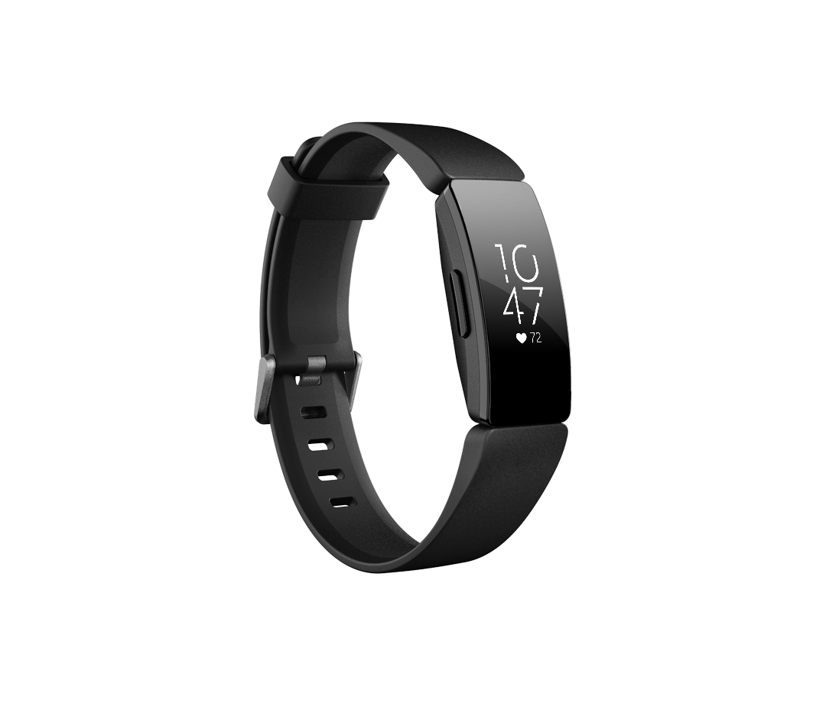

###### Figure 4.3.28: Images of Mi Band 4 and FitBit Inspire HR[9][10]

Similar to the Project’s vision of having a wearable hardware unit, both of these market products are wearable devices which connect to a smartphone for greater functionality. Both devices also have screen displays, and heart rate sensors. The Mi Band 4 also has a gyroscope and accelerometer.

When the Project was first handed over to this development group, as iteration 2.0, the Microbit wearable unit did not have a heart rate sensor as it did in version 1.1, although fall detection was added as a feature in version 2.0

The Hardware team found 2 major factors important to the design and functionality of the 2 products. Mobility, and providing sufficient functionality. Both market devices, the Mi Band 4 and FitBit Inspire HR are very light and convenient devices. In contrast, the design of the Microbit wearable in version 1.1 was large, relatively heavy, fragile and too cumbersome to easily put on a wrist. Mobility and durability are also important considering the intended end users are the LTC residents, which are not likely to tolerate a large cumbersome device on their wrists.

The decision was therefore made not to reuse the Grove Shield extension card from from version 1.1 to keep the Microbit wearable small, light and easy to wear. This did bring the problem however, of having to find new ways to connect the sensors to the device which took considerable time and resources in the implementation stage.

Another key point in many consumer market devices, is that they provide sufficient functionality to have a sufficiently high enough perceived level of value to the customer. To that end, functionality of products were designed with the user’s needs in mind to reduce redundancy and provide maximum value to the customer.

Utilizing the knowledge from the information gathering trip to Guang En LTC centre, the Heart Rate sensor that was moved to the Raspberry Pi Base Station in version 2.0, was moved back to the wearable Micro Bit for version 2.1 to avoid superfluity as the LTC already has a non mobile medical device for measuring the blood pressure and heart rates of LTC residents. Leaving the heart rate sensor on the Base Station would have made it superfluous, however, by moving the heart rate sensor back to the wearable unit, it would now serve a useful niche function by providing constant and mobile monitoring of LTC residents. Of note is that the heart rate sensor used by the Kutztown University development group in version 2.0 and now in 2.1, are significantly smaller and easier to use than the sensor used in version 1.1.

#### 3.4.2 Improved Scalability

In all projects and product solutions there is always the question of scale and cost effectiveness. How well does the solution scale? Is it still effective at larger scales?

In considering these questions, the hardware team examined the connection model of the hardware component, which at the time of version 2.0, worked on a one to one basis between the base station and the wearable unit. It was decided that this type of configuration did not scale well, hence the decision to change the model from one to one, to a one to four basis. The number four in particular comes from the information gathering trip where it was found that most rooms in the LTC generally did not house more than 4 residents, with many rooms only housing 2 to 3 residents.

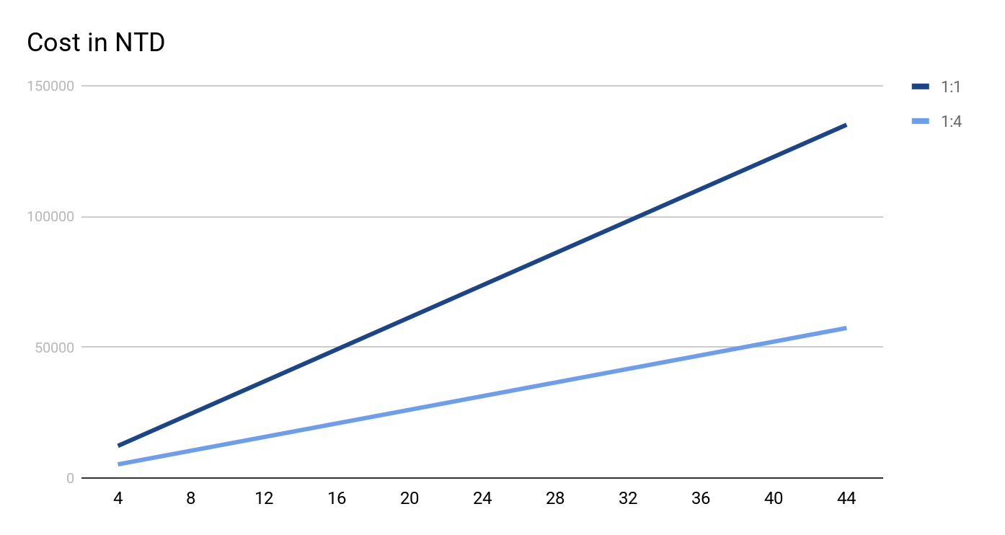

###### Figure 4.3.29: Line Graph of estimated cost for deploying hardware at increasing scale, in groups of 4. (Costs calculated in NTD)

As shown in Figure 4.3.29, the cost of purchasing the necessary hardware alone increases linearly.

Table 4.3.1 helps put the graph in clearer perspective.

|  |  |  |  |  |
| --- | --- | --- | --- | --- |
| Residents | 1:1 | 1:4 | Difference | Factor |
| 4 | 12280 | 5215 | 7065 | 0.4246742671 |
| 8 | 24560 | 10430 | 14130 | 0.4246742671 |
| 12 | 36840 | 15645 | 21195 | 0.4246742671 |
| 16 | 49120 | 20860 | 28260 | 0.4246742671 |
| 20 | 61400 | 26075 | 35325 | 0.4246742671 |
| 24 | 73680 | 31290 | 42390 | 0.4246742671 |
| 28 | 85960 | 36505 | 49455 | 0.4246742671 |
| 32 | 98240 | 41720 | 56520 | 0.4246742671 |
| 36 | 110520 | 46935 | 63585 | 0.4246742671 |
| 40 | 122800 | 52150 | 70650 | 0.4246742671 |
| 44 | 135080 | 57365 | 77715 | 0.4246742671 |

###### Table 4.3.1: Table of estimated costs for deploying 1:1 vs 1:4 model (in NTD)

Considering the one to one model requires one base station per wearable, monitoring four residents would require purchasing 4 Raspberry Pi’s costing NTD1890 each, 8 MicroBit units costing NTD 465 each, and 4 heart rate sensors costing NTD 250 each. The total cost of this for four residents would come up to NTD 12280.

The one to four model however, requiring only one Base Station to service four wearables would only require the purchase of one raspberry pi, 5 MicroBit units, and 4 heart rate sensors, totalling in NTD 5215.

Therefore, in considering just the cost of purchasing the hardware alone, the one to four model offered significant cost savings over the one to one model, by more than half. The one to four model is actually only 0.425 times the cost of the one to one model in hardware cost alone. Furthermore, that number does not even account for the time required to set up each base station’s Raspberry Pi unit, and maintenance over time, which means real world savings could be even greater.

### 3.5 Limitation of hardware and solutions

From the beginning of this project, it was clear to the Hardware team that every part of the hardware component would be a new challenge for each member of the hardware team.

The team had to make use of many tutorial websites to begin learning the basics, but sought out some experienced advice from not only online forums but also students in other university departments when it came to a difficult problem or uncertainty of feasibility.

A major issue regarding tutorials is that there are so many solutions and sometimes contradictory advice to the problem, so much time was spent trying to separate correct and useful information from masses of text.

#### 3.5.1 Raspberry pi

When it comes to the Raspberry Pi, each member in the team spent much time in trying to understand not only the code that was passed to the development group from the Kutztown University group that worked on version 2.0, but the basic fundamentals of working with the hardware itself. Not only was there a need to understand what the Raspberry Pi 3B+ was capable in terms of specifications, but also its pin configuration, Input and Output specifications, and some basic soldering. The Operating System of the Raspberry Pi, Raspbian, required team members to read up on kernel functions as well as familiarising themselves with a Debian-based OS.

Some problems also surround the practical implementation of the Raspberry Pi. The initial setup and installation of prerequisites took a minimum of 6 hours, and can sometimes get stuck, so occasional supervision in between stages is required. Worse still, is that on one occasion, an entire Raspberry Pi unit simply refused to work any further, required a costly replacement that took 10 days to arrive. The fact of having to deal with its many wires was also a point of contention for team members, as using a breadboard to easily and clearly layout the wires and connections of the Pi unit’s I/O pins for easy connection was seen as making it too bulky and complicated by some other members. Remembering the polarity of voltage terminals, and not to touch signal terminals to voltage sources was also a point of constant anxiety.

With the focus in this iteration by the team to improve usability and functionality of the Hardware, features such as an external case design, an air quality sensor or an e-ink display, which was an idea that was somewhat discussed earlier in the planning stages, have been left for future development groups to work on.

#### 3.5.2 BBC:Micro:bit

In comparison with the Raspberry Pi, the MicroBit Units were much easier to work with for the Hardware Team. The only few problems encountered were the difficult and slow process of debugging the component considering its limited display and that the code needs to run on the actual hardware itself, and the change over of the coding platform to an offline IDE. The reason for this change is that, despite the ease of coding in MakerCode, the prior used Browser based online coding platform being similar to Scratch and its’ block-based visual programming language, the platform itself was very slow, and too limited for the project purpose. The decision was then made by members of the Hardware Team, to rewrite the code in Python for use with Mu-Editor. Mu-Editor was also available on the Raspbian OS which allowed for access to the same features when it came to testing code on the Base Station. This rewrite of the existing code to another language gave an increase in flexibility and eased the debugging process as errors would show up in the IDE first without having to load and run the code on actual hardware.

Unfortunately, despite confirming that the Base Station and Wearable unit are able to communicate on a one to four basis, the nature of the communications being on the same channel results in collisions and data loss when more than one Wearable Unit is transmitting at the same time.

Finally, due to major delays from rewriting the code and the multiple issues from the Raspberry Pi unit, coupled with a lack of resources in terms of personnel and funding, the Hardware Team was unable to focus beyond the current changes made. Case design, strap design, and choice of mobile battery will have to be passed on to the next development group to work on.

## 4.0 BROWSER TEAM

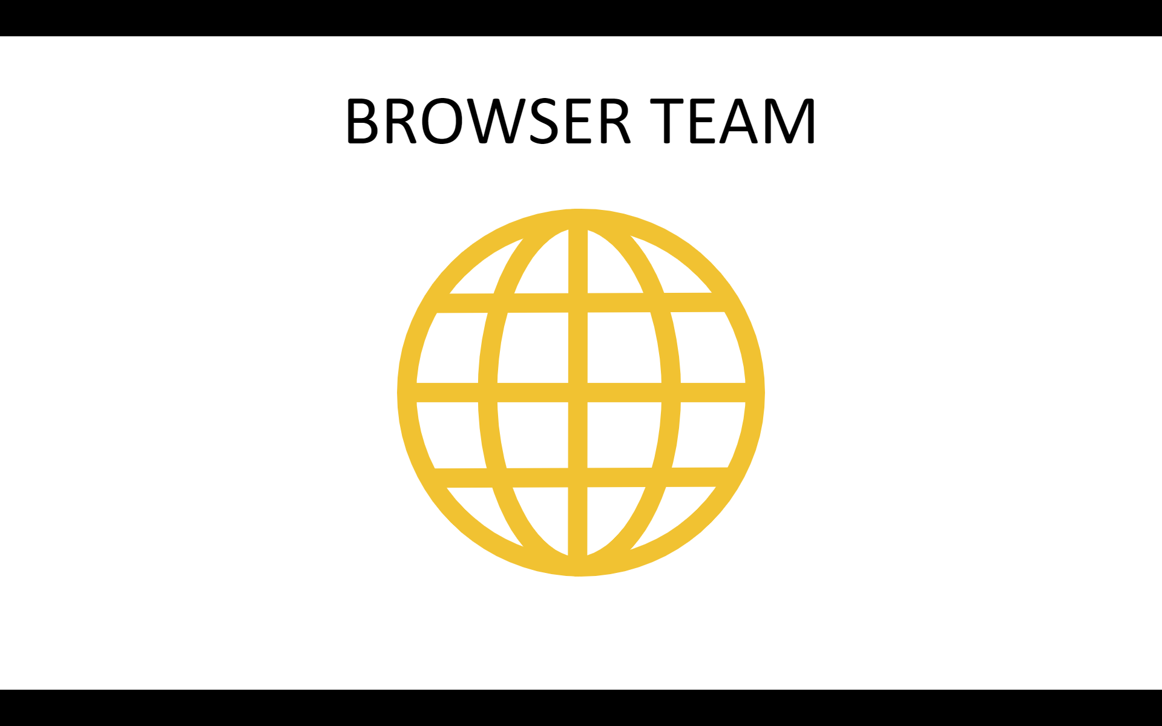

###### 

### 4.1 Tools and Software

   

  

###### Figure 4.4.1: Tools and Software of the browser team

In the browser team all the coding is done in the Windows OS environment. For the code editor Visual Studio code is used to edit the code because its’ functionality and extensions make the coding work much easier. Node.js[11] is used for deploying[12] the code to the hosting database. The database and its’ hosting is all stored and handled by Firebase[13].

For the frontend of the website the coding is done in HTML and CSS, while the backend code is mainly done using Javascript[14]. JQuery[15] supports and eases the coding process of Javascript. JQuery is a JavaScript library designed to simplify HTML DOM tree traversal and manipulation, as well as event handling, CSS animation, and Ajax.

### 4.2 Users, Focus, and Goals

##### Users

Director and CNO, IT admin

##### Focus

Data viewing, Data Record, Quality Control of the LTC, Technical control of the system

##### Goals

View center status, and manage center task and activity

In the browser component of the LTC Task Management System, the main intended users are director and CNO, and IT admin. The director and CNO have the same type of account which mostly handle:

* Data viewing: View the data of the LTC through the system
* Data recording: Record and modify data in the system
* Quality control of the LTC

The director and CNO able to access all the crucial data of the LTC remotely and are even able to build and assign tasks to the app component of the LTC TMS. The activity of managing of the Long Term Care Centre can be done easily with the help of the system. By using the database, operations will depend less on paperwork and everything will be handled digitally.

### 4.3 Users Interface Map

The User Interface Map consists of two components Director/CNO account and IT admin account.

#### 4.3.1 Director/CNO User Interface Map

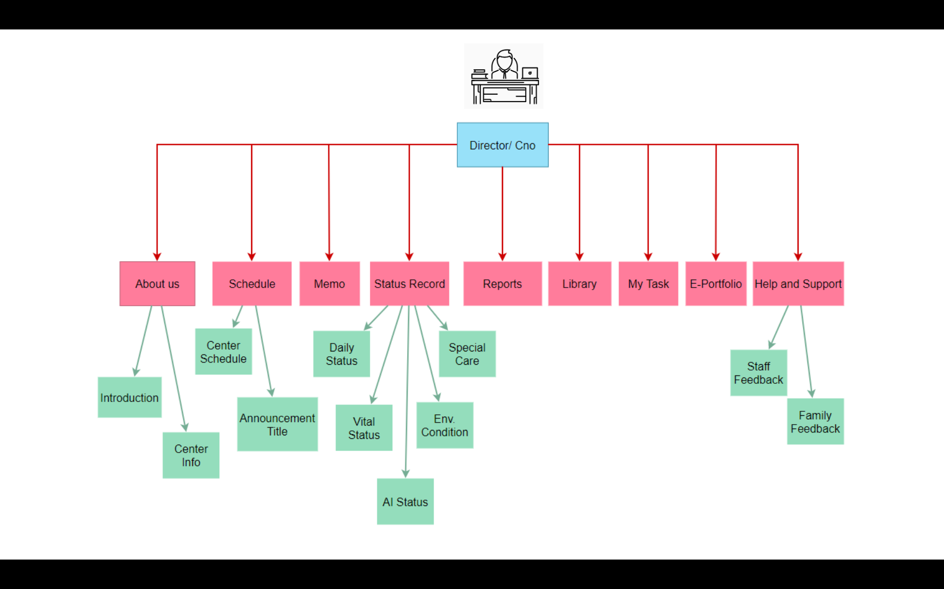

###### Figure 4.4.2: Director/ CNO User Interface Map

In the Director/CNO user interface there are 9 functions in the system that the user can access: About us, Schedule, Memo, Status Record,Reports, Library, My Task, E-portfolio, and Help and Support. The status of the resident is recorded by the hardware and app component. There are 5 sub-components in the status record: Daily Status, Vital Status, AI Status, Environment Condition, and Special Care.

#### 4.3.2 IT Admin User Interface Map

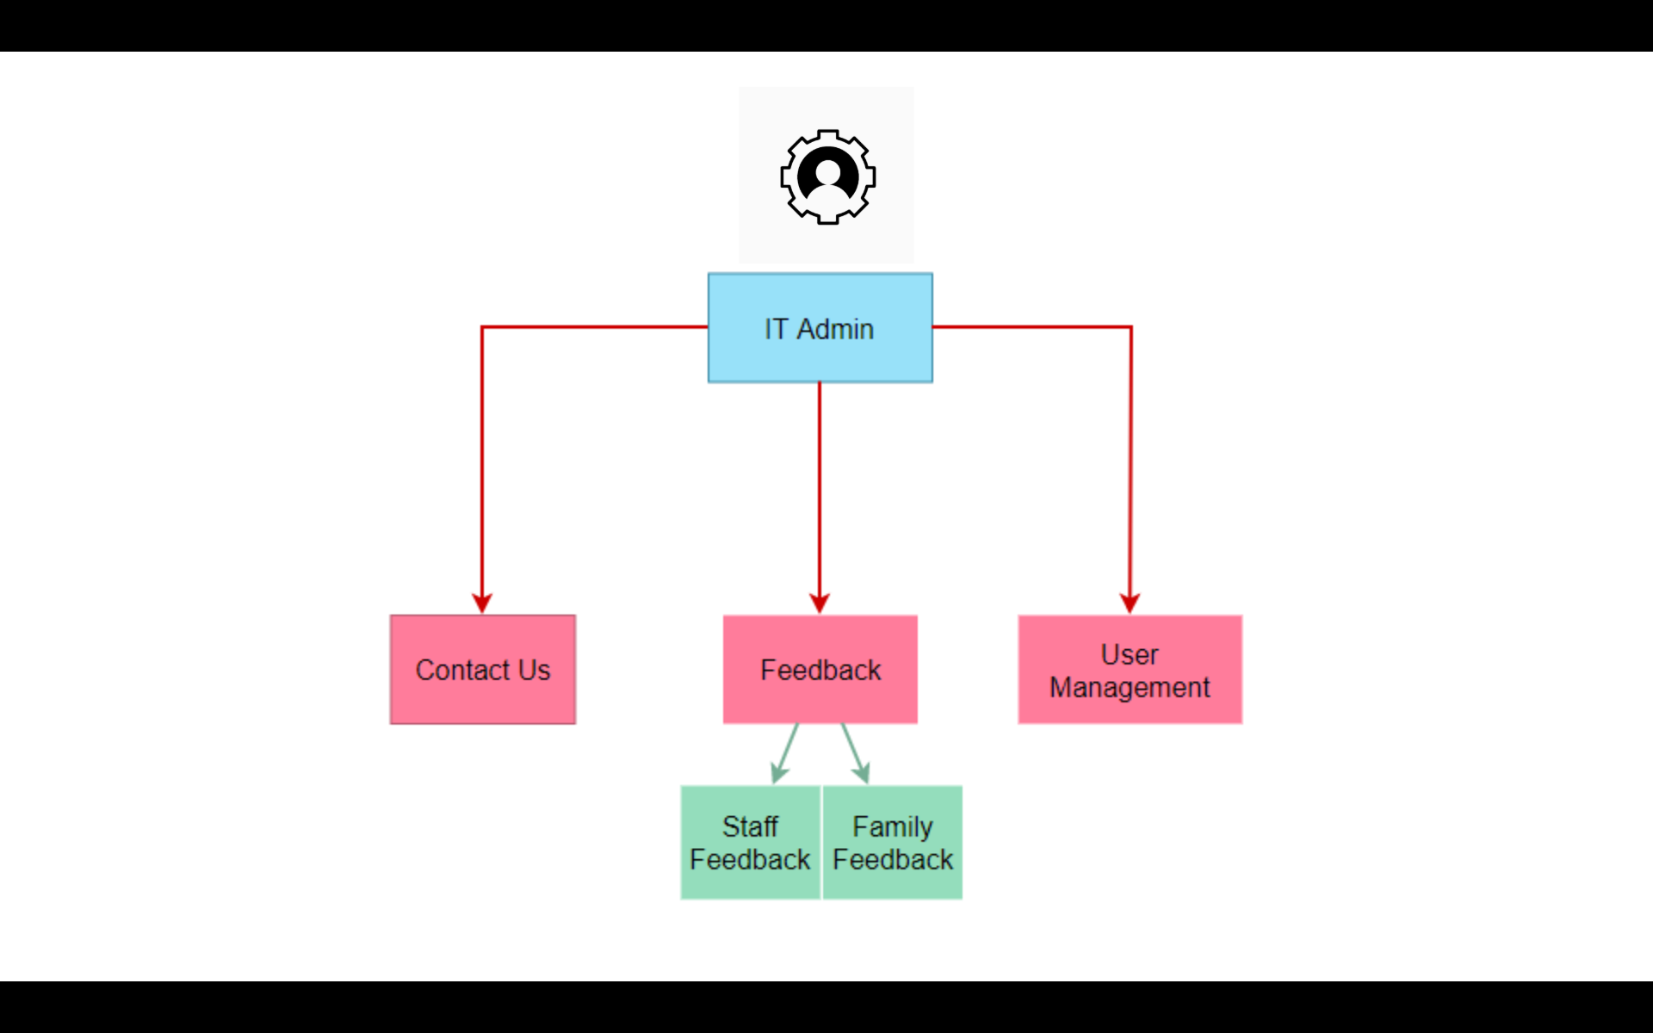

###### Figure 4.4.3: IT Admin User Interface Diagram

The main function for the IT admin account is account management. The IT admin can create, edit, and delete the account of the users of the system.

There are 3 functions in the IT admin User Interface: Contact us is the information of the IT admin, Feedback is the feedback of the system (the interface is still a template in the current version), User Management is the interface where IT admin can manage the users of the system.

### 4.4 Browser Functions

#### 4.4.1 About Us page

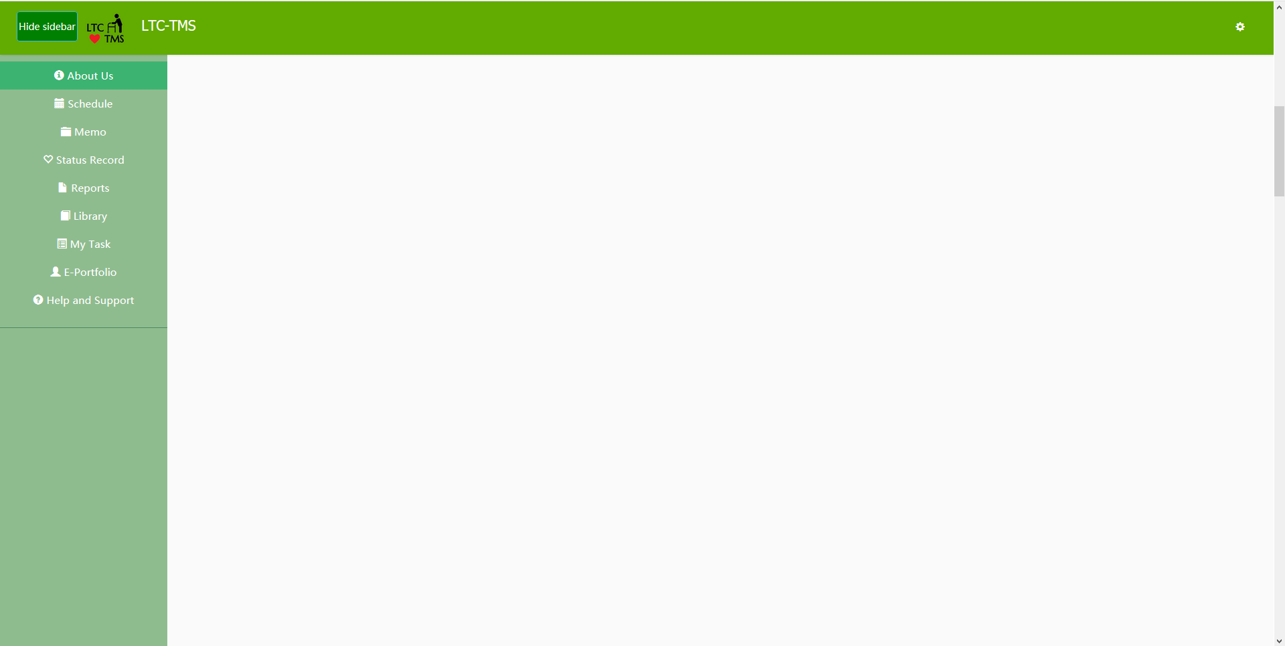

###### Figure 4.4.4: blank space of the About Us page in version 2.0

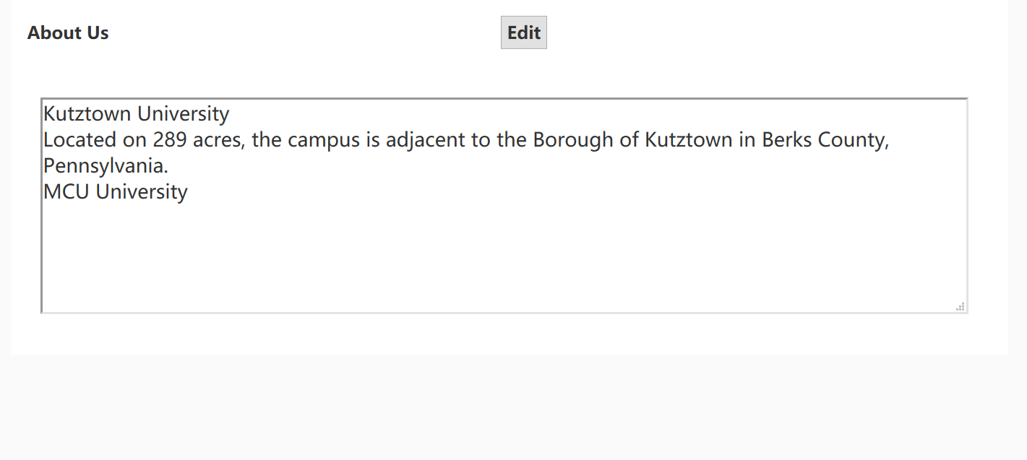

###### Figure 4.4.5: changes to the About Us page as seen in version 2.1

##### Aims

To make the website more efficient and effective in terms of space and to develop the information displayed.

##### Features

In the past iteration, the page was blank and therefore was a wasted page. Now the blank space has been removed and the unused area has a functioning display of information with easy editing built in.

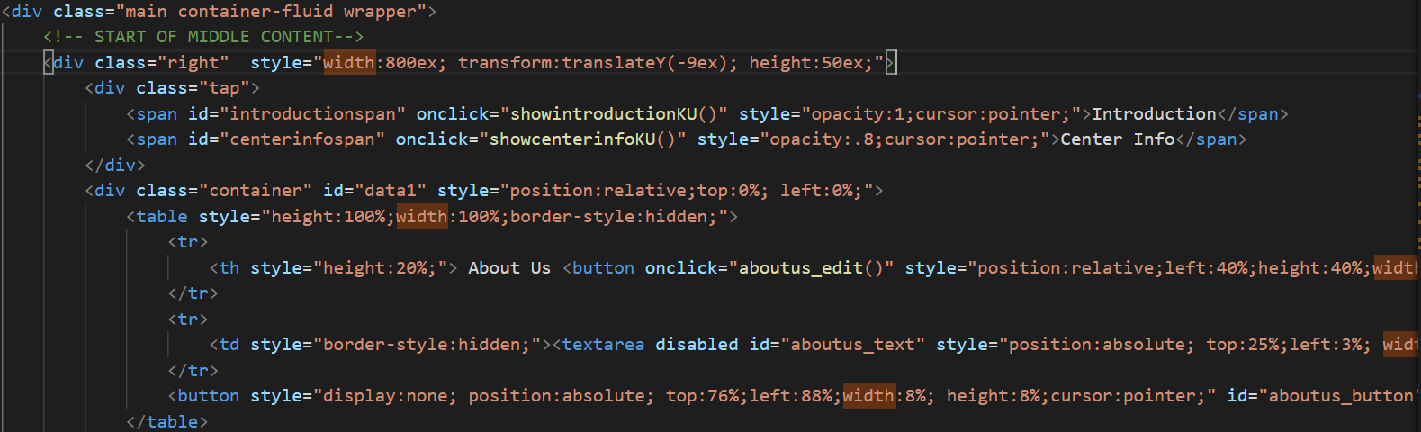

###### Figure 4.4.6: Section of code for the About Us Page

#### 4.4.2 E-portfolio sort and search bar

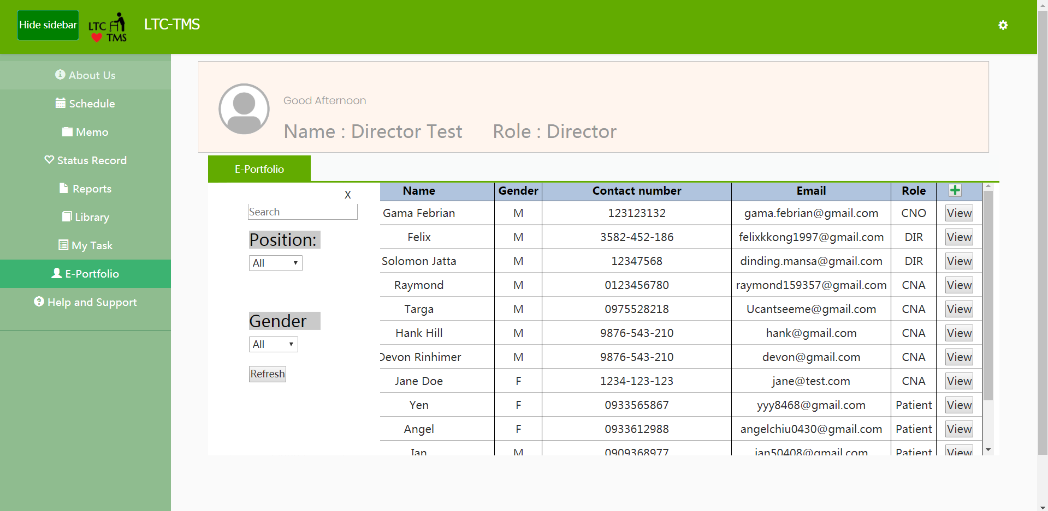

###### Figure 4.4.7: E-portfolio page from version 2.0 showing the extended search options

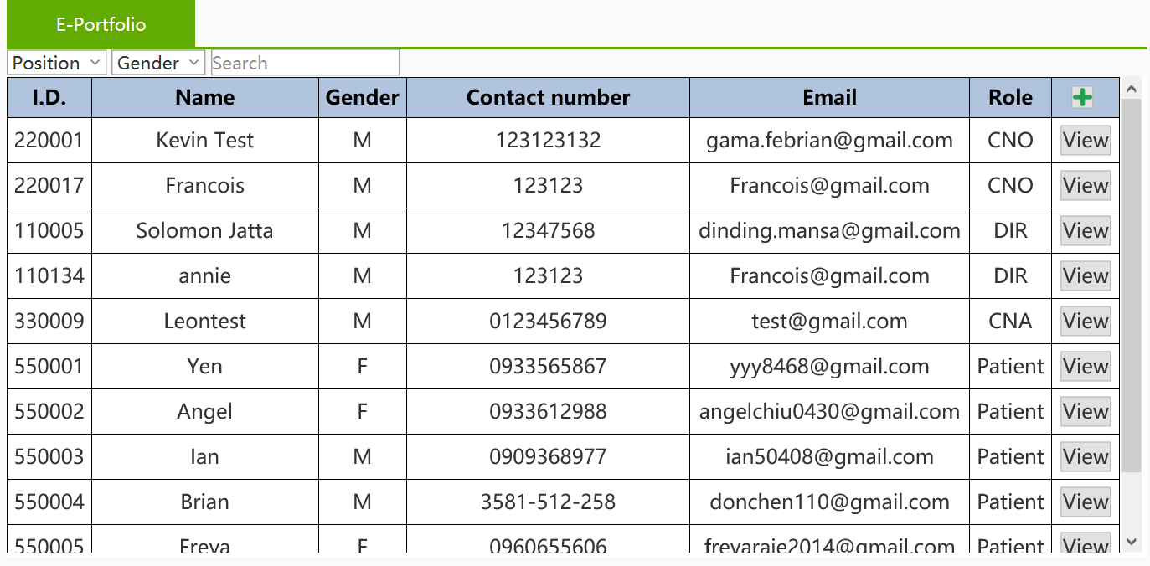

###### Figure 4.4.8: Screen capture showing the change in the filter bar’s position on the E-portfolio page

##### Aims

Prevent the search bar from obstructing the table and removing the animation from the search bar to speed up searching.

##### Features

The sort and search bar in version 2.0 was not very efficient because when used, it covers part of the table, requiring the user to dismiss it to view the returned data. Furthermore, the user had to wait through the search bar’s animation which resulted in further delay, hence the decision to remove the animation and to make the search bar permanently visible at the top of the table instead.

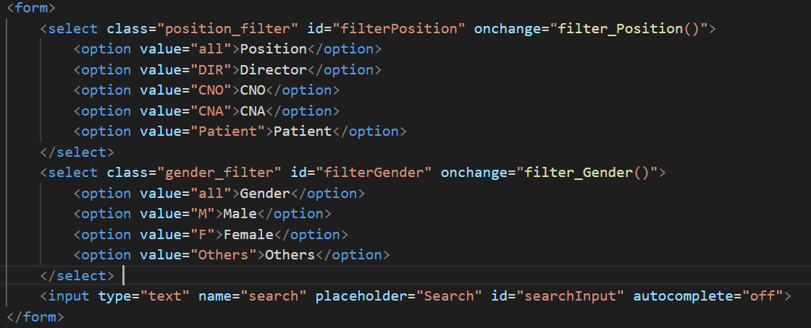

###### Figure 4.4.9: Section of code for the E-Portfolio Page

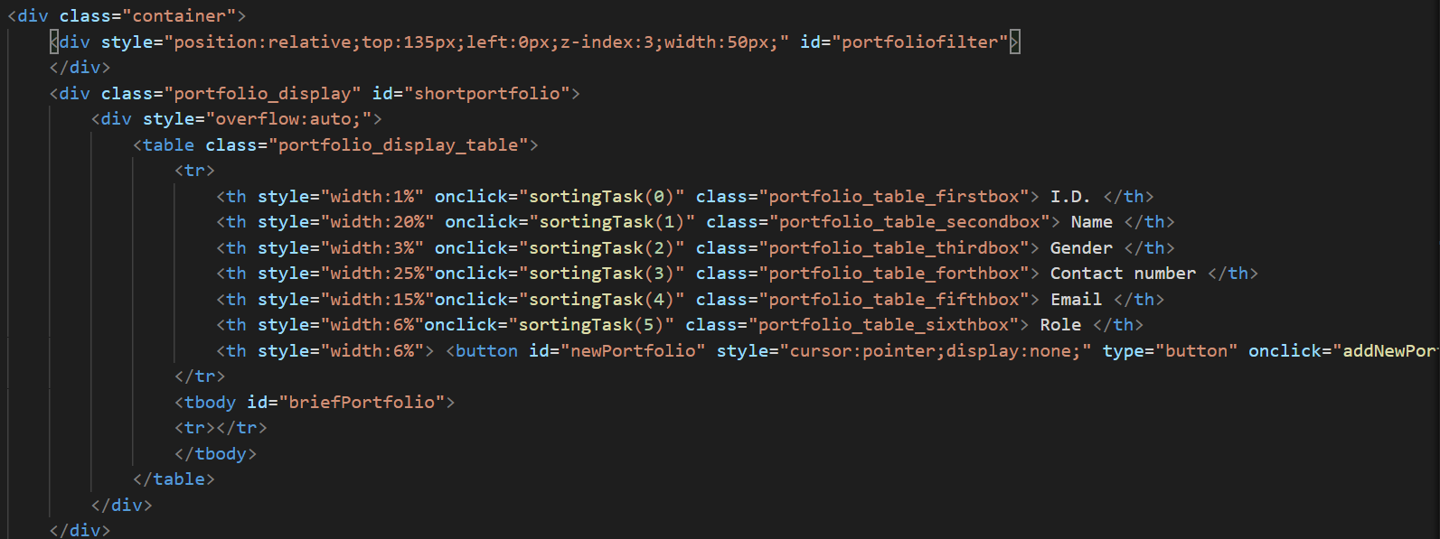

###### Figure 4.4.10: Section of code for the E-Portfolio Page

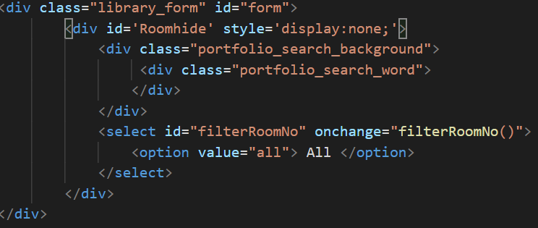

###### Figure 4.4.11: Section of code for the E-Portfolio Page

#### 4.4.3 Status Record

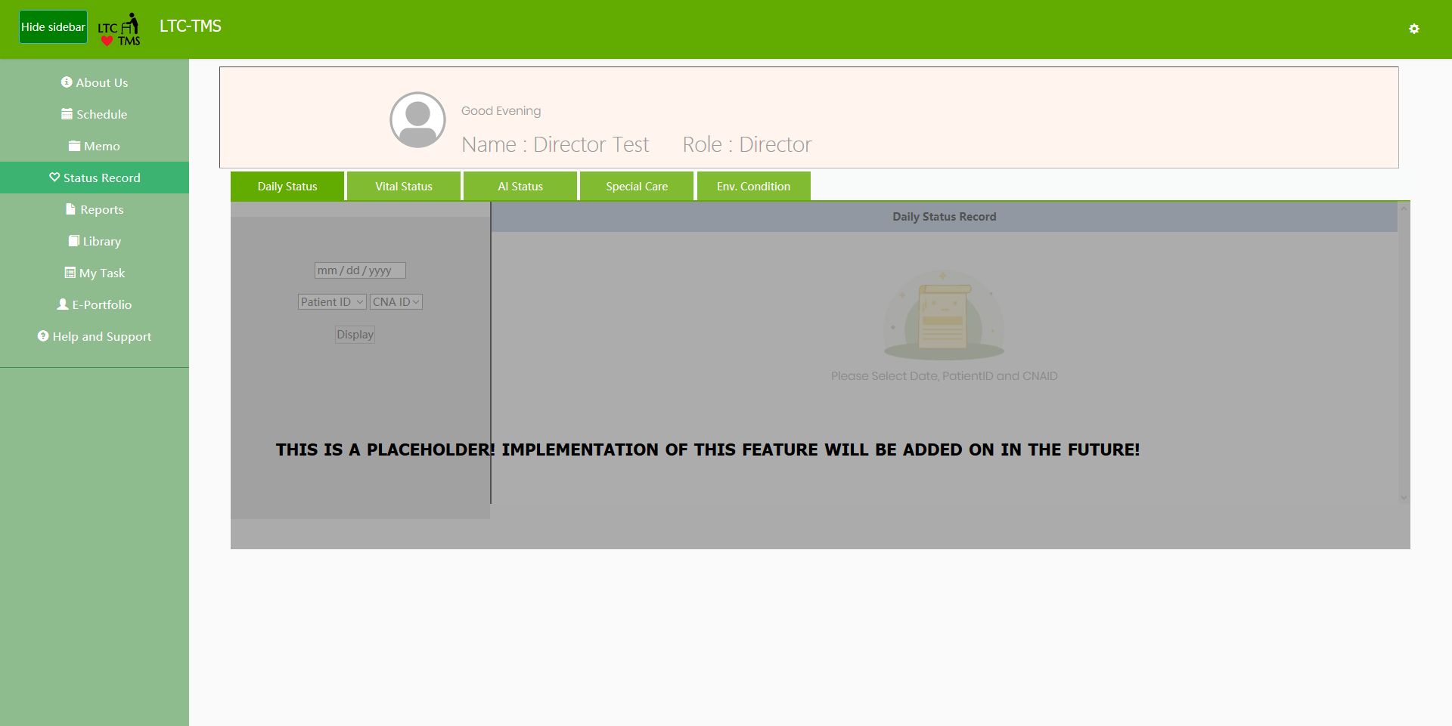

###### Figure 4.4.12: Status Record page template from version 2.0

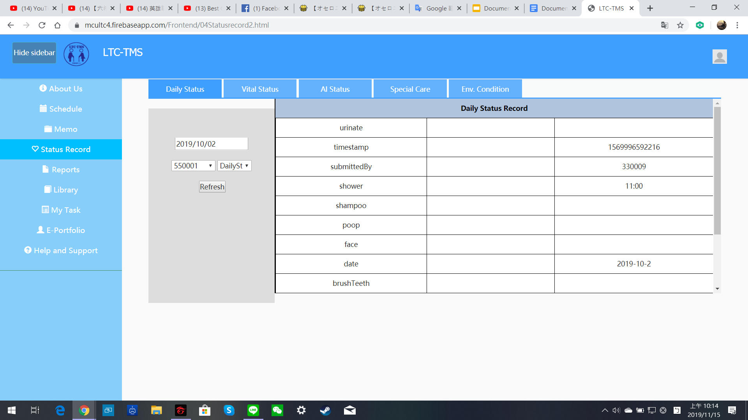

###### Figure 4.4.13: working Status Record page which can search resident records

##### Aims

Display the status record of the resident using data retrieved from the Application and Hardware.

##### Features

The CNO and Director will be able to easily view the status records of the resident as soon as the data from the application and hardware are uploaded to the database. This function has been completed and is based on the template that KU provided in version 2.0.

The page will retrieve the status record of the patient from the Database. Staff can upload the status record via the application while the hardware component provides up to the minute updates on the resident’s status to the Database.

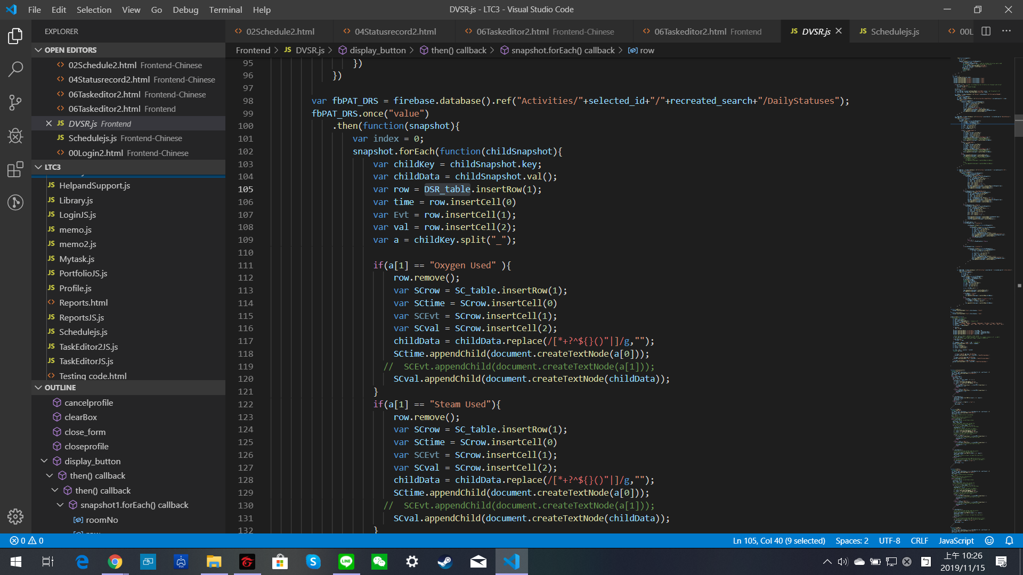

###### Figure 4.4.14: Section of code for the Status Record Page

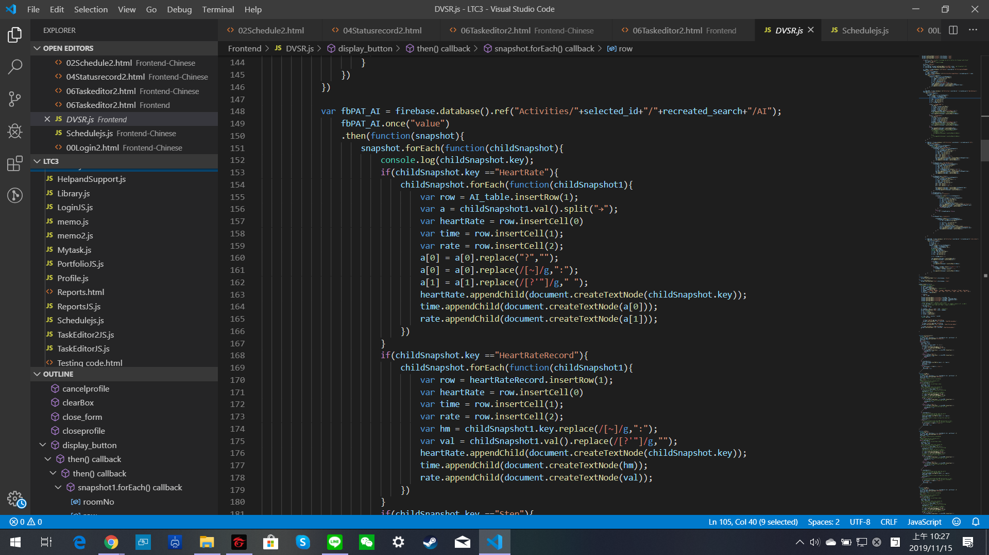

###### Figure 4.4.15: Section of code for the Status Record Page

#### 4.4.4 Help and Support

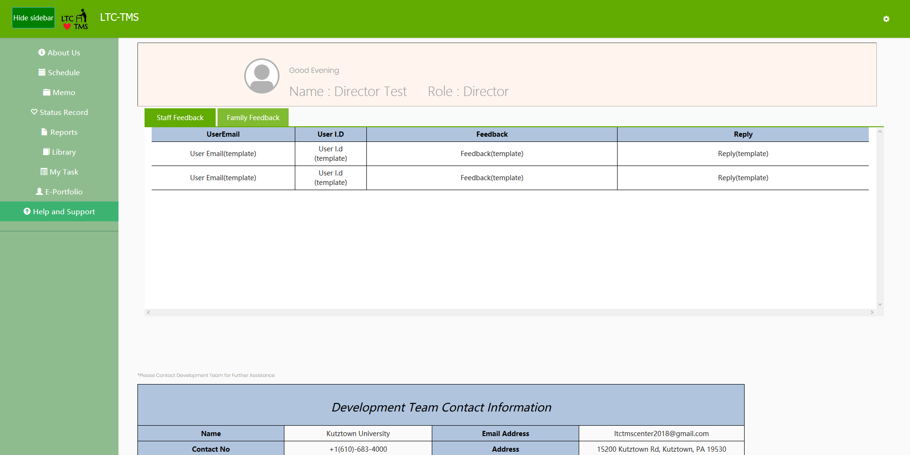

###### Figure 4.4.16: Help and Support page from version 2.0

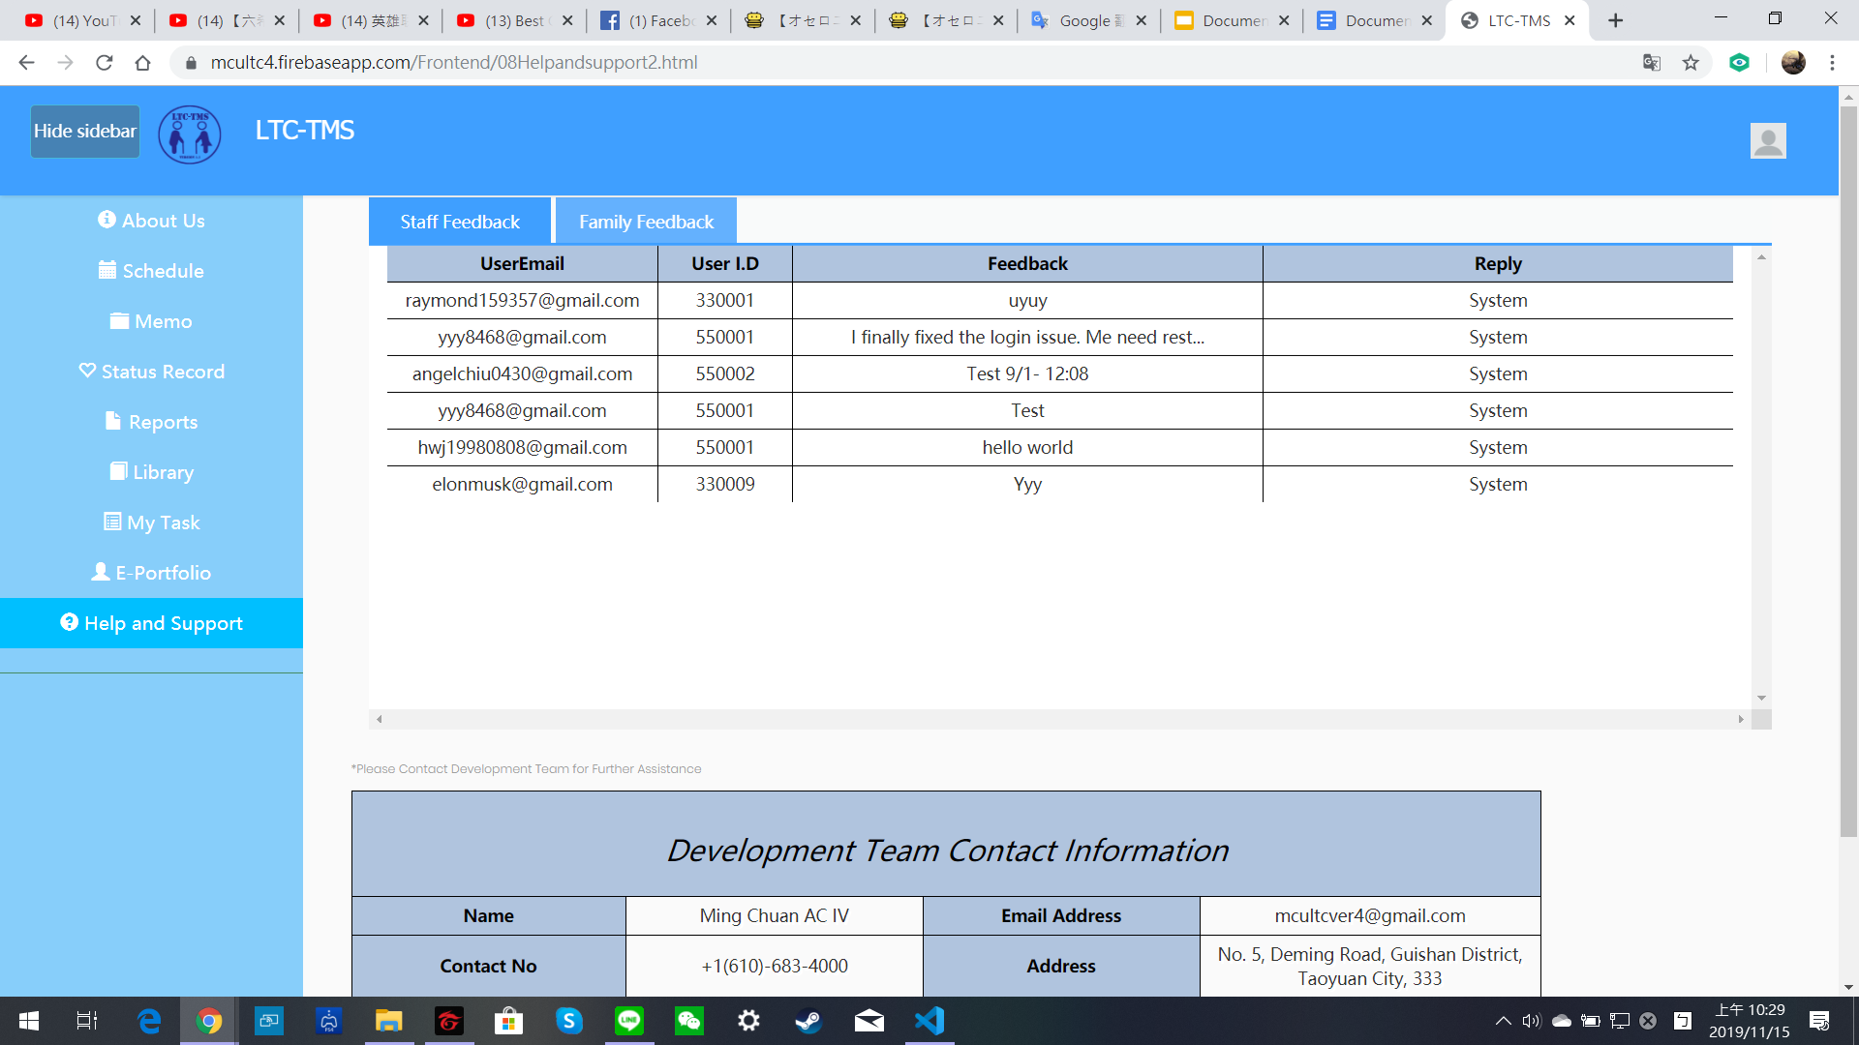

###### Figure 4.4.17: Help and Support page in version 2.1 which can now receive feedback from the application

##### Aims

Receive feedback for the LTC from the family and staff.

##### Features

The template that was left from the previous iteration is now a completed function. This function is based on the template that KU provided from version 2.0. Users, family and staff, can now write feedback through the application component and send it to the database. The feedback will be displayed on the webpage as shown in Figure 4.4.17.

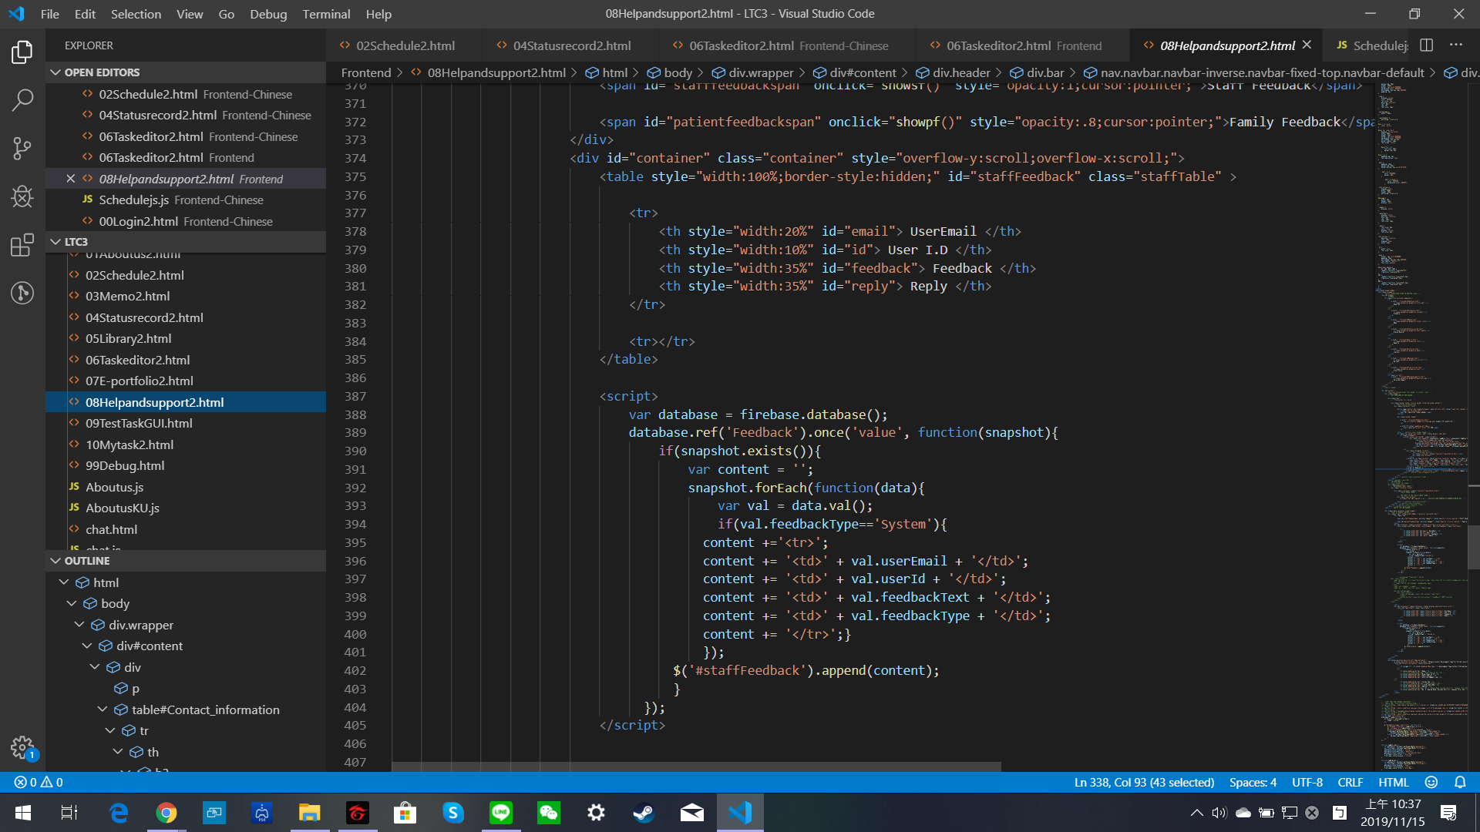

###### Figure 4.4.18: Section of code for the Help and Support page

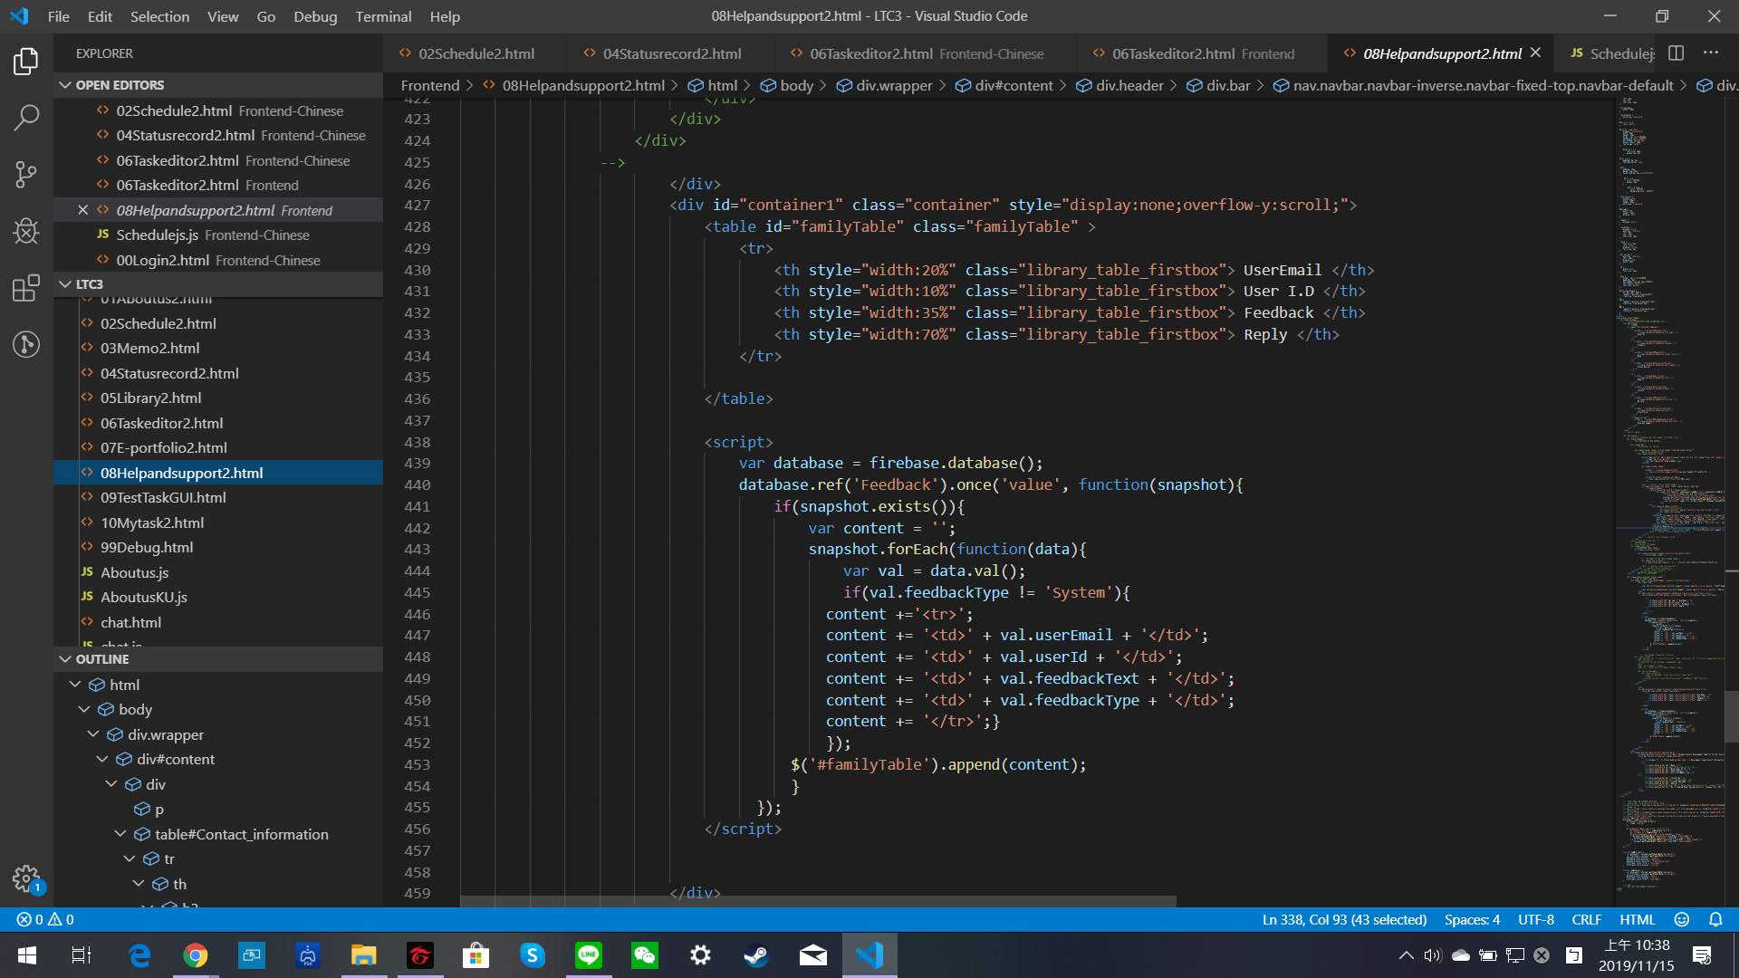

###### Figure 4.4.19: Section of code for the Help and Support Page

#### 4.4.5 User Information

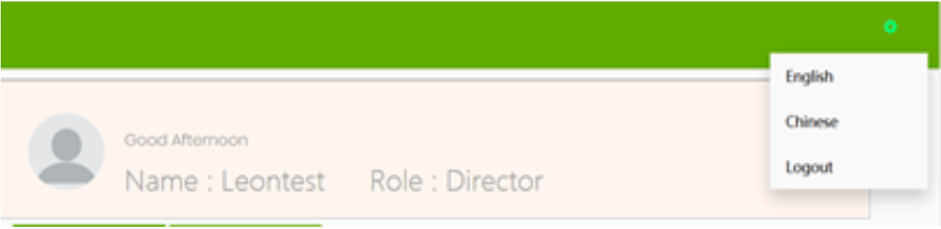

###### Figure 4.4.20: User Information bar from version 2.0

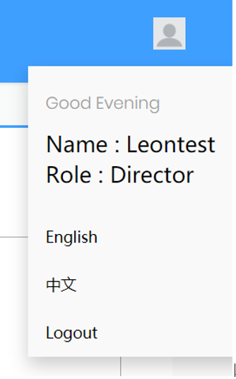

###### Figure 4.4.21: User Information is combined with language options in version 2.1

##### 

##### Aims

The aim is to reduce page clutter on the webpage, and move the user information into a drop down list together with language settings

##### Features

Figure 4.4.20 is a screenshot of the page as it appeared in version 2.0 from the KU group, and the account profile displays in each webpage as a permanent bar. The profile is not needed to be displayed all the time and it takes up quite a lot of screen space. In version 2.1,language setting uses a drop down list. The account profile is moved in together with the language setting function which includes the logout button. This significantly reduces page clutter as the drop down box only appears when the user icon is clicked on.

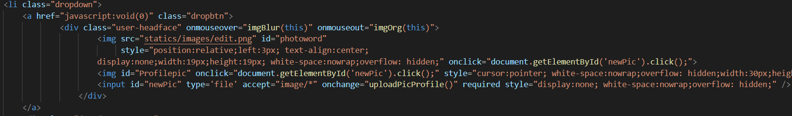

###### Figure 4.4.22: Section of code for the User Information Page

###### Figure 4.4.23: Magnified image of the same section

###### Figure 4.4.24: Section of code for the User Information Page

###### Figure 4.4.25: Magnified image of the same section

### 4.5 UI Change

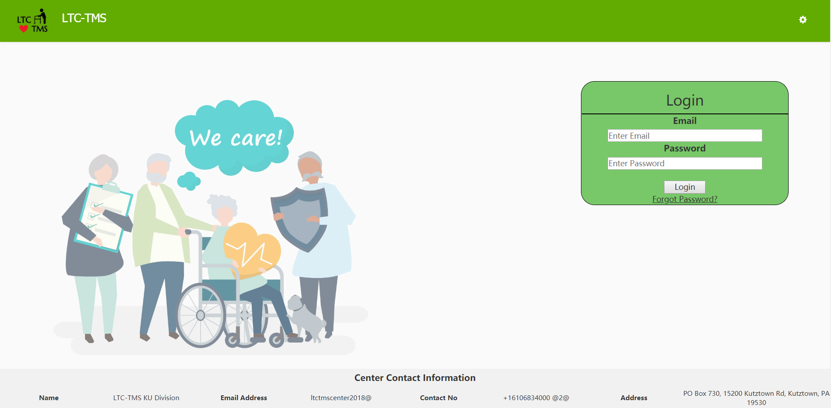

###### Figure 4.4.26: log in page from version 2.0

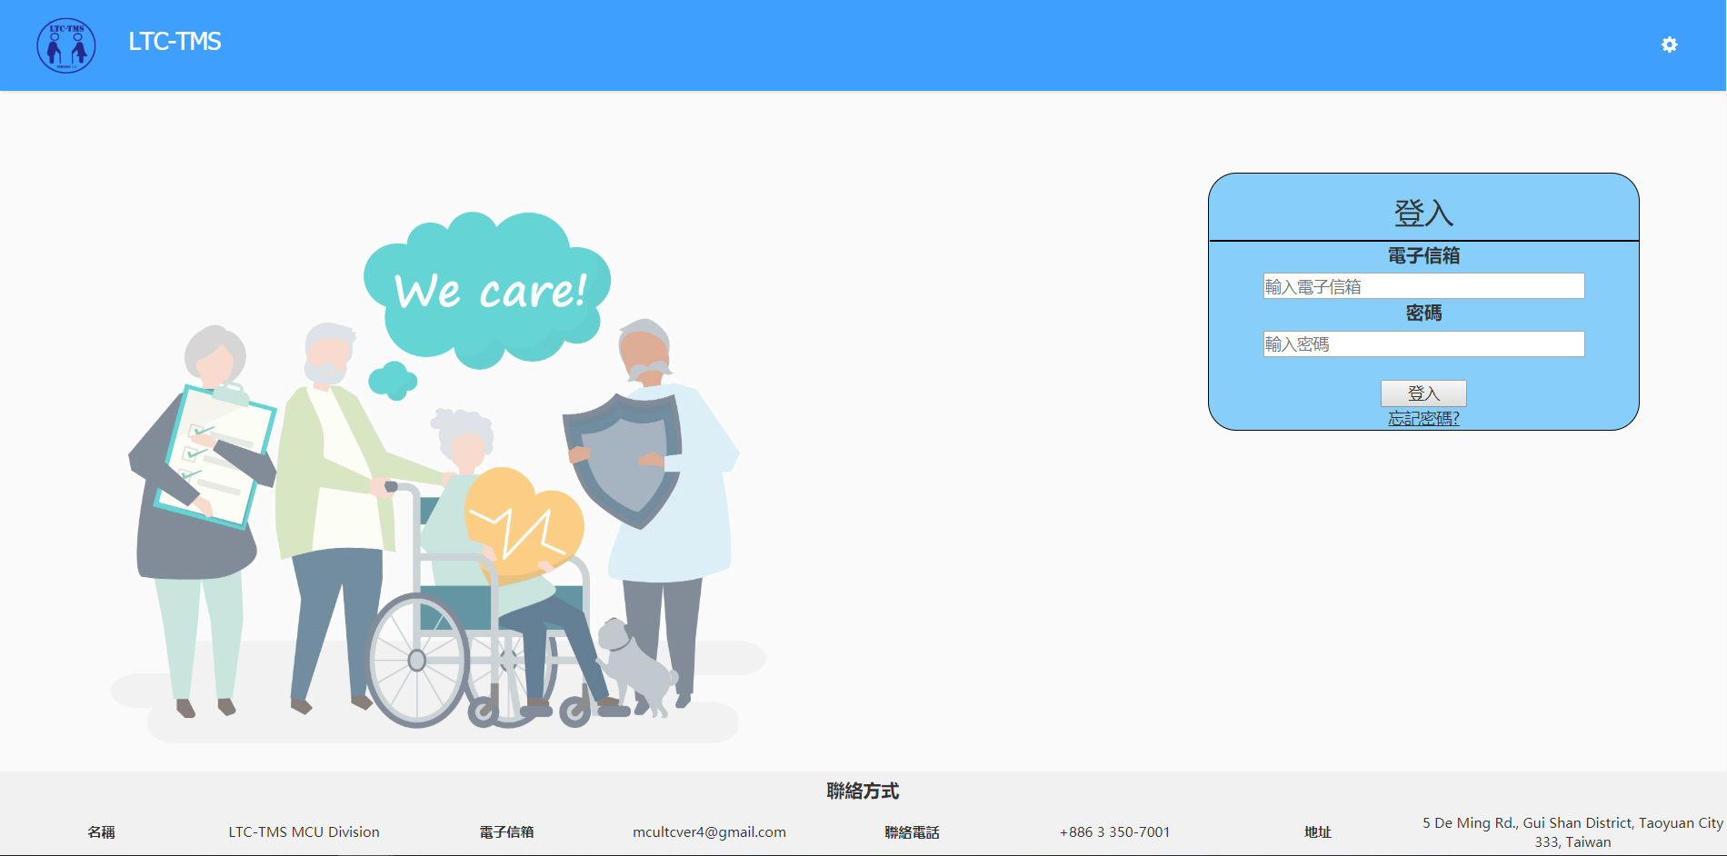

###### Figure 4.4.27: image showing the colour changes Chinese login page in version 2.1

##### Aims

The aim is to increase readability and use a more user friendly color for the web page in keeping with the colour theme of the mobile application component and provide a Chinese version of the web portal.

##### Features

The browser team changed the green colour theme into a blue colour theme to make the web page consistent with the colour theme used in the mobile application. Version 2.0 also did not feature a Chinese translation of the web portal due to technical issues. This has been rectified, and version 2.1 now has a fully functional chinese version of the web portal. Users can click the user profile icon in the upper right corner to access language settings in the drop down menu.

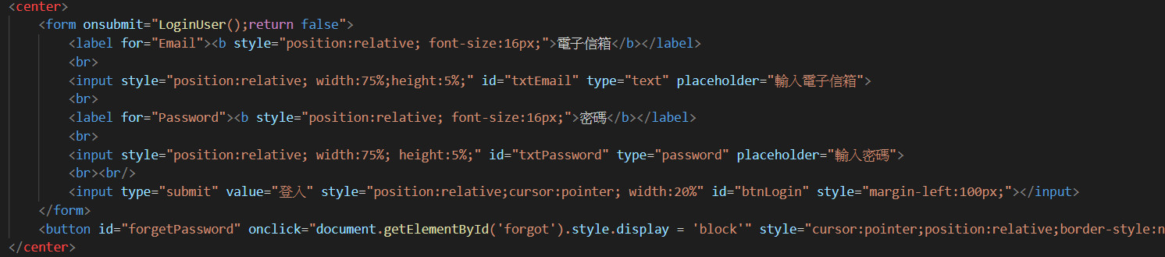

###### Figure 4.4.28: Section of code for the UI Changes

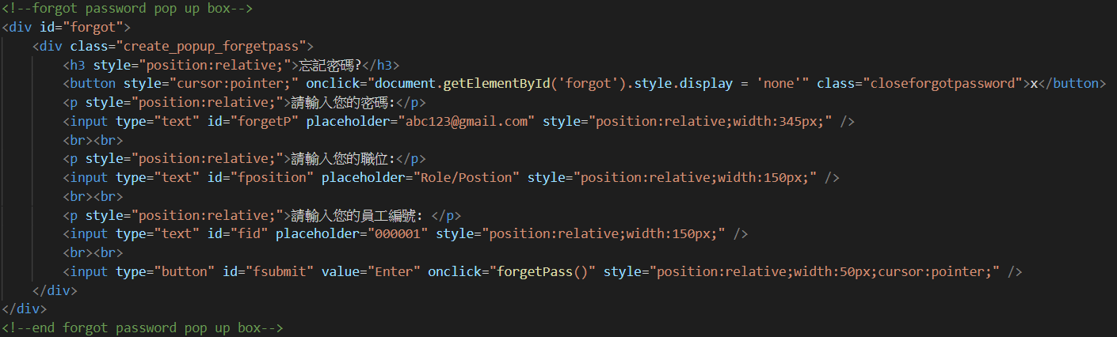

###### Figure 4.4.29: Section of code for the UI Changes

###### 

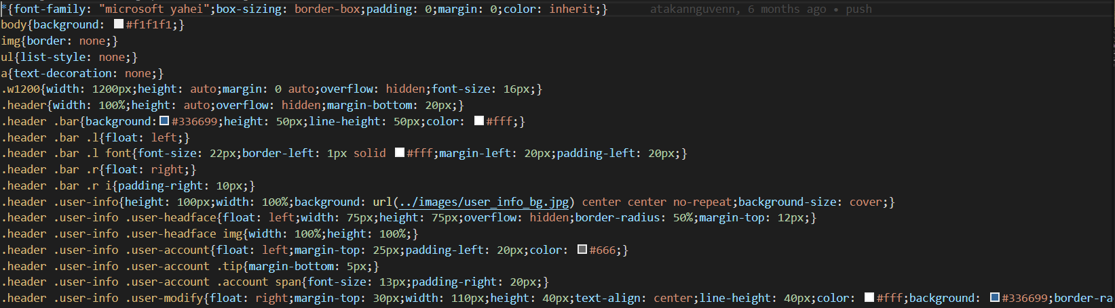

###### Figure 4.4.30: Section of code for the UI Changes

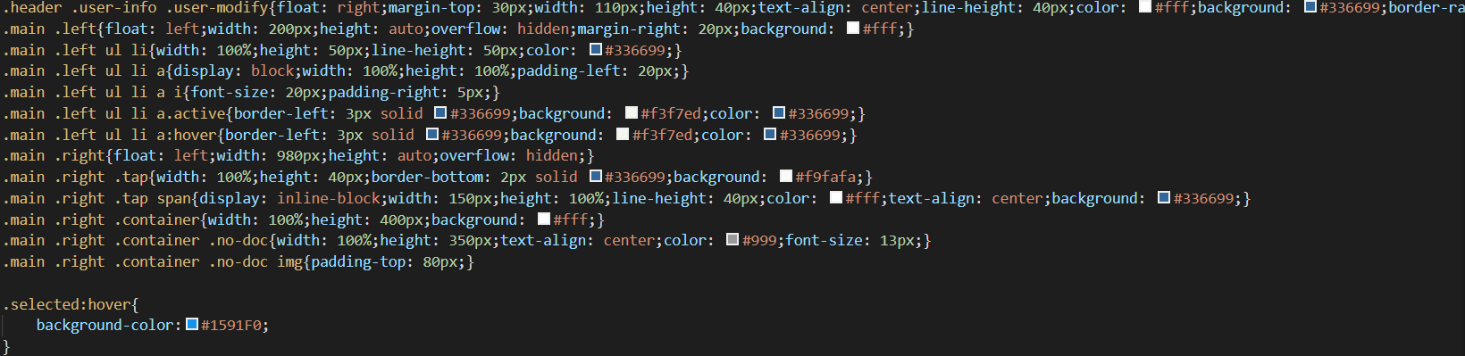

###### Figure 4.4.31: Section of code for the UI Changes

### 4.6 Problem and Difficulty

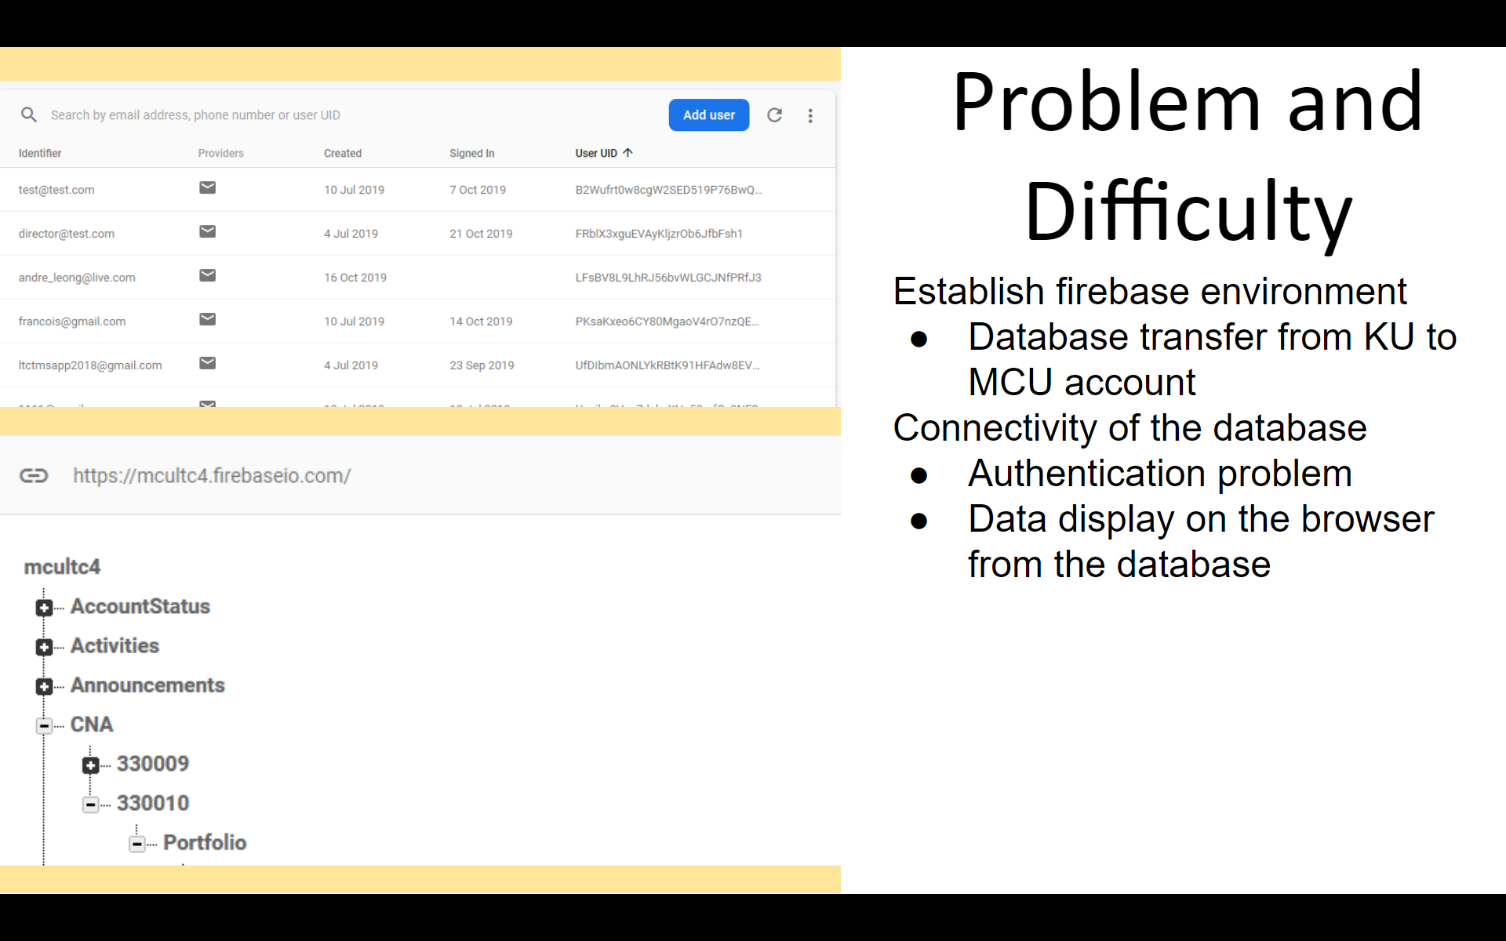

###### Figure 4.4.32: Screenshot of the database

There were several problems the team faced when developing the system. Establishing a firebase environment was a challenging task because of the need to transfer the database to the firebase account using a JSON[16] file. During the database transfer there were some issues regarding the authentication of the account and the user account could not log in. After the account was properly authenticated by Firebase the user account was able to log in again.

The connectivity with the database gave the team some problems because the connectivity to the cloud database is crucial for the system. In the beginning of the development the data that was shown on the web page was wrong. The team needed to do more research on the database structure and the part of the code that retrieves the data from the database.

### 4.7 Future Changes

This section contains the features that the group has planned for the future. Due to limited time and resources, the team still has changes that are not completely implemented and can still be further developed in future versions.

#### 4.7.1 Calendar

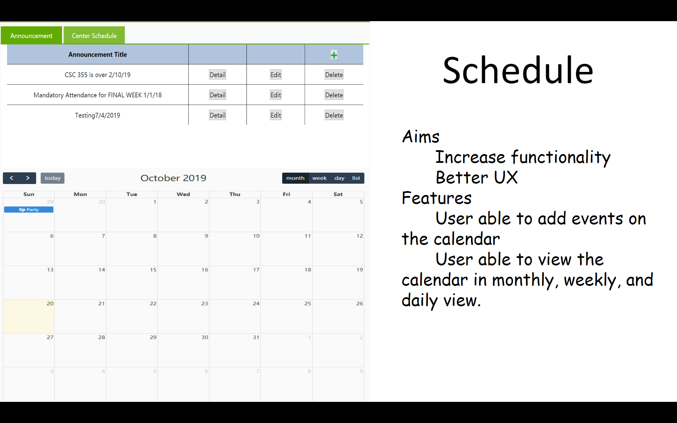

###### Figure 4.4.33: Announcements



###### Figure 4.4.34: Calendar

The system calendar that the team implemented is a third party calendar from fullcalendar.io[17].The current calendar that is in the system is integrated with Google calendar. The events of the calendar can only be edited via a separate Google calendar window. The calendar in the announcement page can only show the events that were written in the Google calendar. The agenda for the future plan is to make the calendar in the system work independently without Google calendar by saving all the events in Firebase. For version 2.1, the browser team has put a calendar there to increase the functionality of the system despite its’ dependence on Google Calendar. There are several features in the calendar: the user can add an event by clicking on a specific date on the calendar, change the calendar view into monthly, weekly, or daily view and integrate the system calendar with Google calendar for easy and scheduling.

One benefit of the Google Calendar however, is easy integration with Android devices and devices that already have a version of Google Calendar installed. In this way, users that are registered with the LTC-TMS Google calendar will automatically have notifications and updates in their own Google Calendar without having to open the LTC-TMS mobile application, so this is something to keep in mind when planning for future versions.

### 4.8 Industry Standards and Best Practices(Browser)

In deciding on the User Interface and User Experience changes for the Web Portal, the Browser Team looked to established industry standards and best practices to find their guiding philosophies.

#### 4.8.1 Account Options

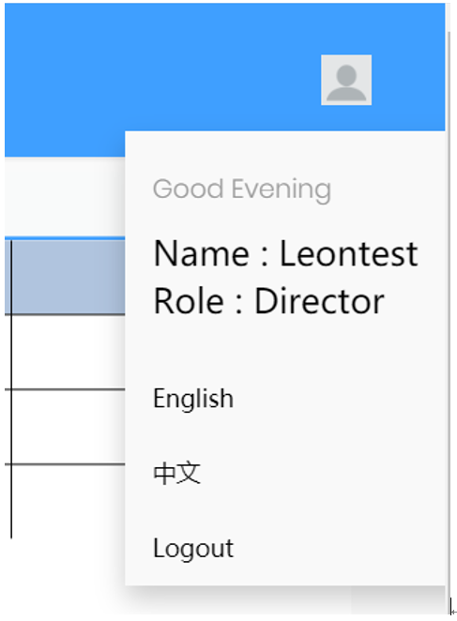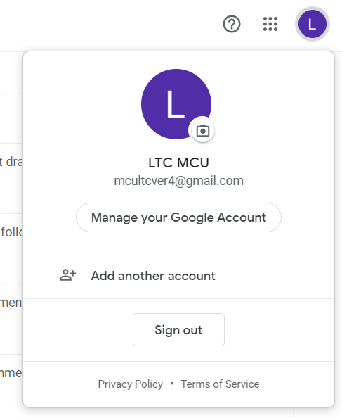

###### Figure 4.4.35 : Example of design philosophies present in the LTC-TMS v2.1 web portal compared side by side with the Google logout button[18]

This is evident in several of the changes made to the web portal’s interface design. The account options menu shown in Figure 4.4.35 is a good showcase of these influences.

Initially, the User’s account and information was displayed as a bar on almost every single page of the web portal in version 2.0, permanently using a significant amount of valuable screen space that could have otherwise been used for displaying important information.

In version 2.1, non essential information and options have been moved and resized so that they now take up far less screen space.

Items such as the user’s name and role were deemed non-essential, and functions such as Logout and Language changes are “one-off” functions that are unlikely to be used more than once per session. Hence, they are hidden inside the “Account Options menu” which only appears when the user clicks on the small “User” button on the upper right.

Furthermore, this is in keeping with established industry design conventions as can be seen in Google’s own logout button when using a Google account in Google Chrome, or various Google online services such as Google Drive.

In many languages, sentences and words are read from left to right on a page. In the present, even Chinese is commonly written and read from left to right, and therefore the placement of a small button on the upper right corner to access infrequently used functions keeps it unobtrusive, and out of the way when users are viewing more prominent screen elements closer towards the upper middle or upper left of the screen.

#### 4.8.2 Search and Sort Bar

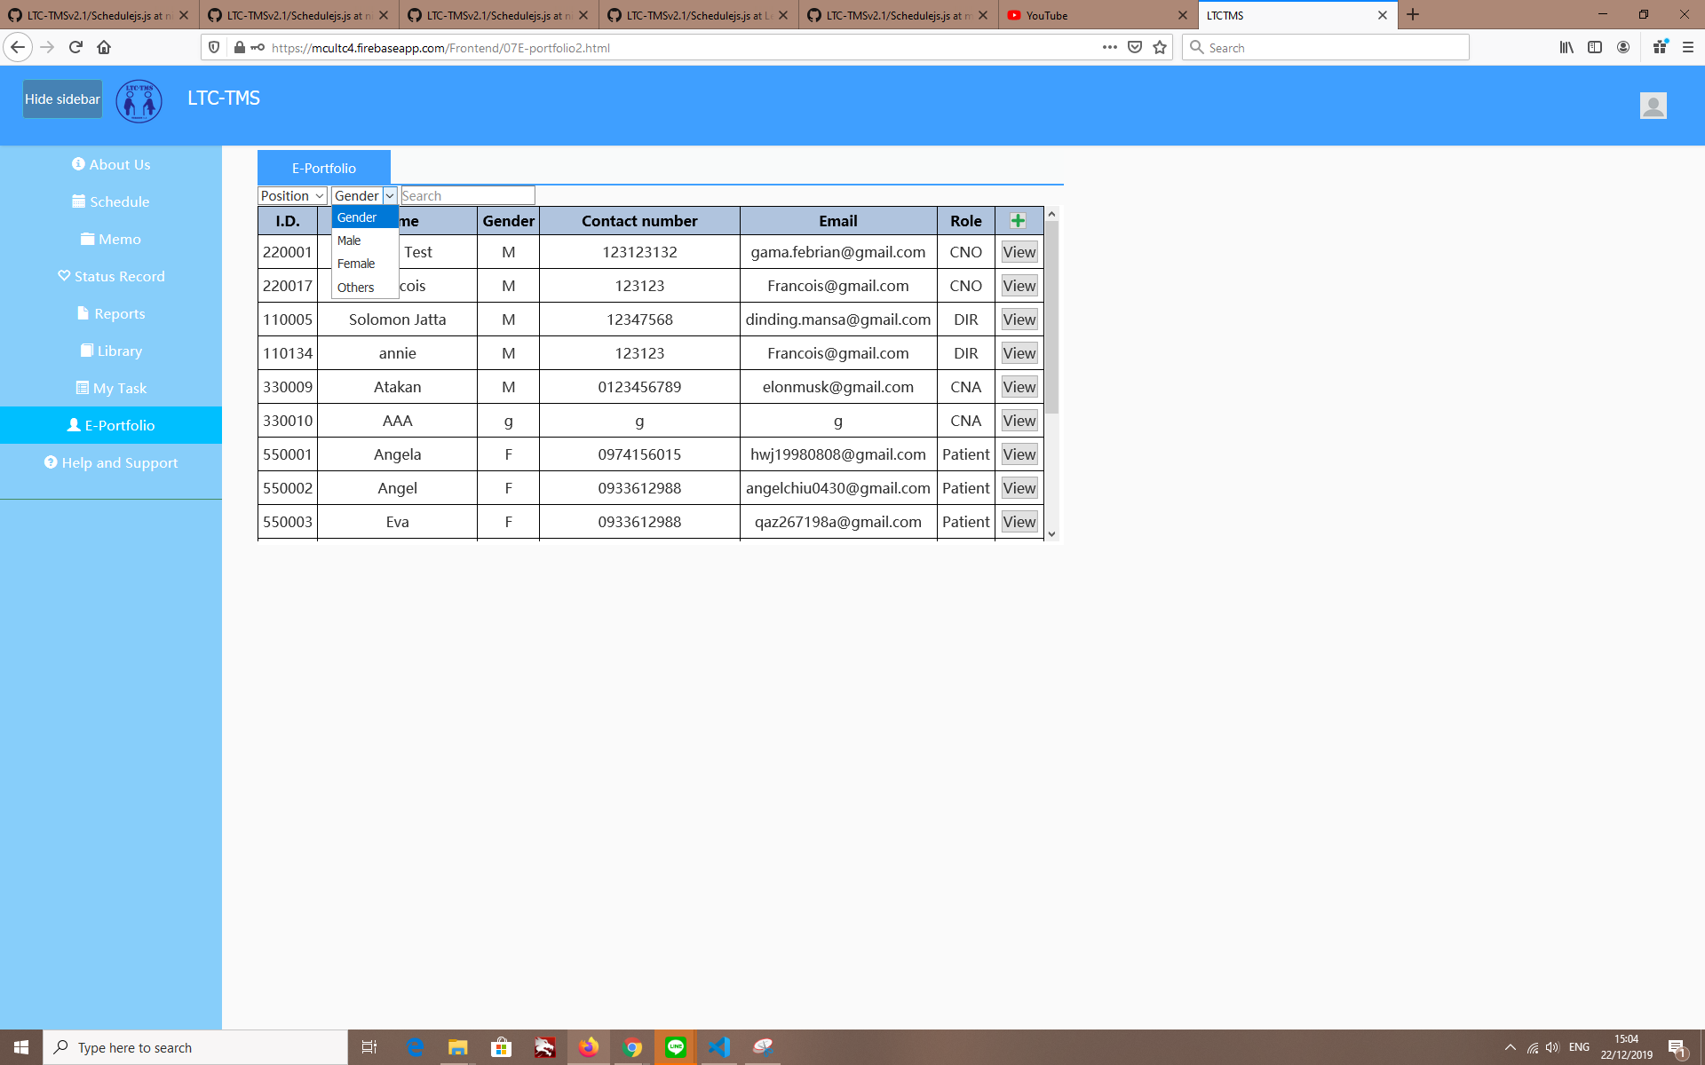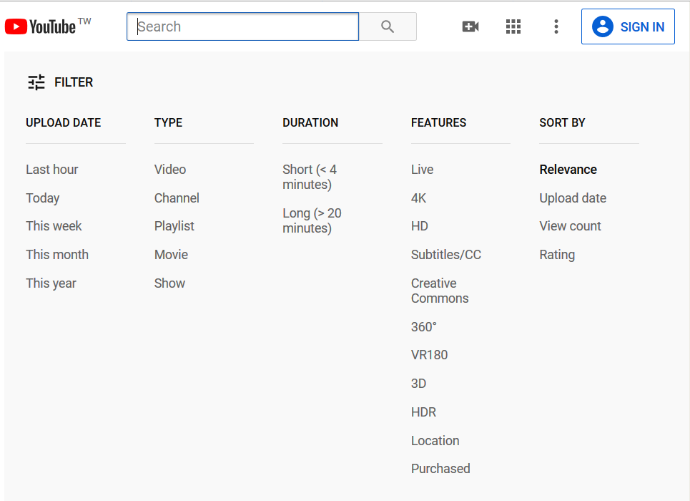

###### Figure 4.4.36 : comparison of search bars from the LTC-TMS v2.1web portal and Youtube’s search page[19]

Another area that clearly shows the Projects dedication to better usability for its intended users is the search bar.

In version 2.0, the search bar and filter options were placed in an animated side panel. A user would have to click on a small arrow and wait for the animation to completely display the sidebar, and then wait for it hide the sidebar in order to view the retrieved data. This animation, while perhaps more visually impressive, was deemed superfluous, leading to a redesign of the search options into the search bar as it currently appears in verion 2.1.

Again, this is in keeping with the industry practice of knowing the intended user, and the purpose of the project. Firstly, the web portal is primarily aimed at the Facility Director, Chief Nursing Officer and the IT Admin. Secondly, their work with web portal will be strictly professional in nature.

The animation was removed to streamline the process of data retrieval. Now, the users of the web portal no longer have to wait for the animation to complete before they can get back to work. Furthermore, as the search bar is now permanently placed at the top of the table, the retrieved data is no longer obstructed from view. This was partially inspired by the design from Youtube’s search bar where users can quickly check search keywords at a glance, and relevant videos are unobstructed. However, differing from youtube, the filter options are also visible at all times for quick and easy access, while Youtube hides its more specific filter options as they are likely far less frequently used, yet take up much valuable screen space.

This is all in the service of improving the User Experience by better allowing the user to focus on their intended tasks, and perform them more quickly.

## 5.0 APPLICATION TEAM

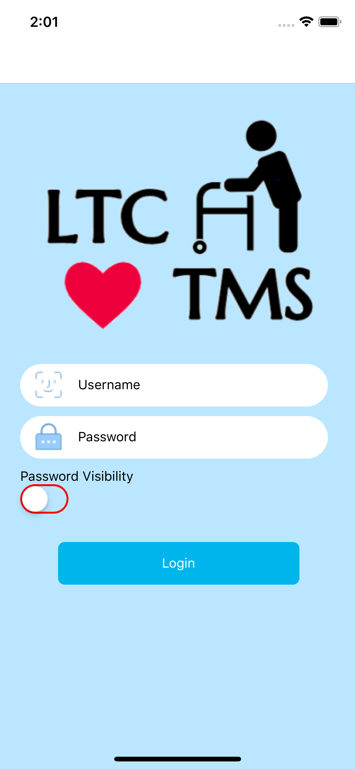

### 5.1 Tools and Requirements

###### 

###### 

###### Figure 4.5.1: Application Tools

To code the application, the Visual Studio Code IDE[20] was used along with React Native[21] which is a Javascript framework for coding. Along with these tools GitHub was utilised as a collaboration platform where as a group, the app team coded together and used as version control. Firebase which is an online real time database was also used by the app team as the database that was used along with the hardware and browser components to access whatever data was needed.

The app team intends for the application to be used on many devices across different platforms, so while modifying the app, different hardware devices such as a Macbook Pro and iPhone X were used for the Apple environment and different android mobile devices for the Android environment using Android studio[22].

### 5.2 Users, Focus and Goals

Below are the main users, focus and goals that the app team will keep in mind when they are working on the application.

##### Users

CNA and Family

##### Focus

The focus for this section are: Data Viewing, Data Recording and Sending Feedback.

##### Goals

The goals are to view patient status and also send feedback and report to Firebase.

The main users of the app are CNA and Family members of LTC residents. These are the target groups that the app and its’ functions were catered to. There are some main aspects that the app team focused on with the app. The first is Data Viewing which include, viewing the daily status of a patient, announcements, portfolio data etc. The second is Data recording - recording important day-to-day information such as shower time, teeth brushing time, and breakfast time. Other data include Vital Status data such as Systolic and Diastolic pressure and ambient room temperature. Next is Sending Feedback which means if there is any important information that the user would like to share or they have any problems that they want to report they can send feedback. These Feedback and Reports are then sent to firebase so as to be accessed by technical staff and facility administrators on the browser side.

### 5.3 User Interface Maps

These are the user interface maps for the CNA and Family/Patient accounts on the app. It shows the different screens and pages that are available for the user to use. After the users log in there are two outcomes. They are either logged into a CNA account or a Family/Patient account. On the navigation tab of the mobile app, there are five main pages that are also shown in the user interface maps. They are: Home, Record, Library, Center Info and Portfolio. These pages may also branch off into deeper pages with added usability and functionality.

For example in the case of the Library page:

Family/CNA → Library → Tasks → Detailed Steps

For the most part the user interface map for these two accounts are identical. However, they differ slightly when you focus on the Patient record page. The CNA account has two added functions which are Add Daily Status and Add Vital Status. This means that the Family/Patient account is restricted from adding or modifying any data here.

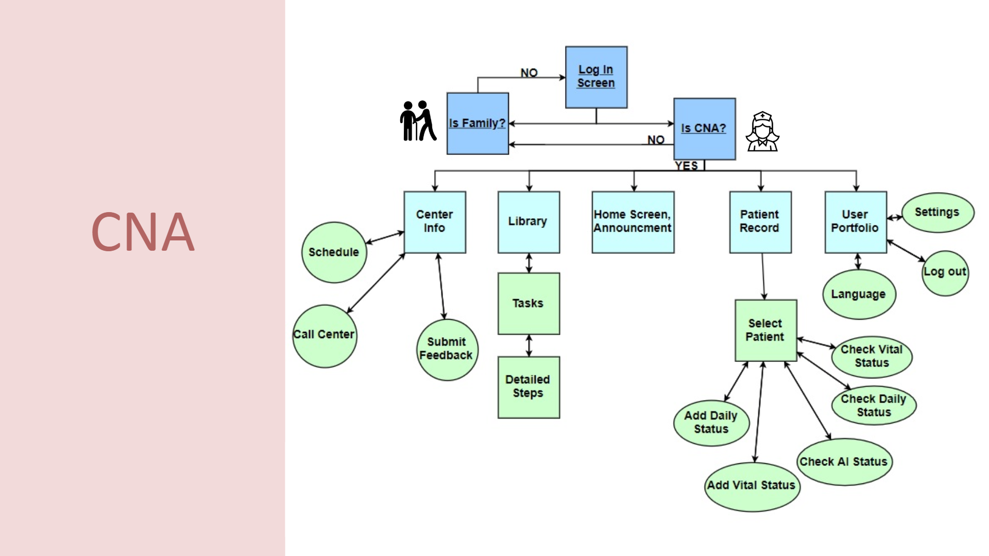

###### Figure 4.5.2 :CNA User Interface Map

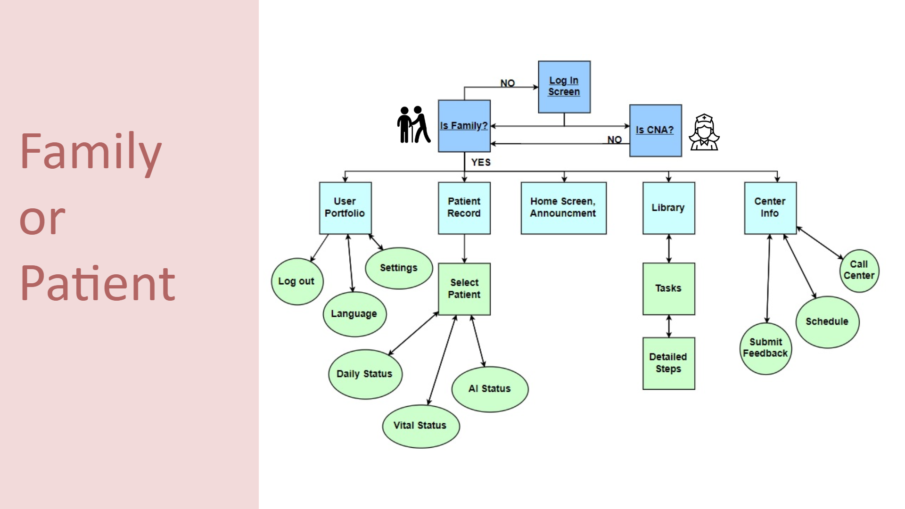

###### Figure 4.5.3:Family User Interface Map

### 5.4 APP FUNCTIONS

#### 5.4.1 Login Page

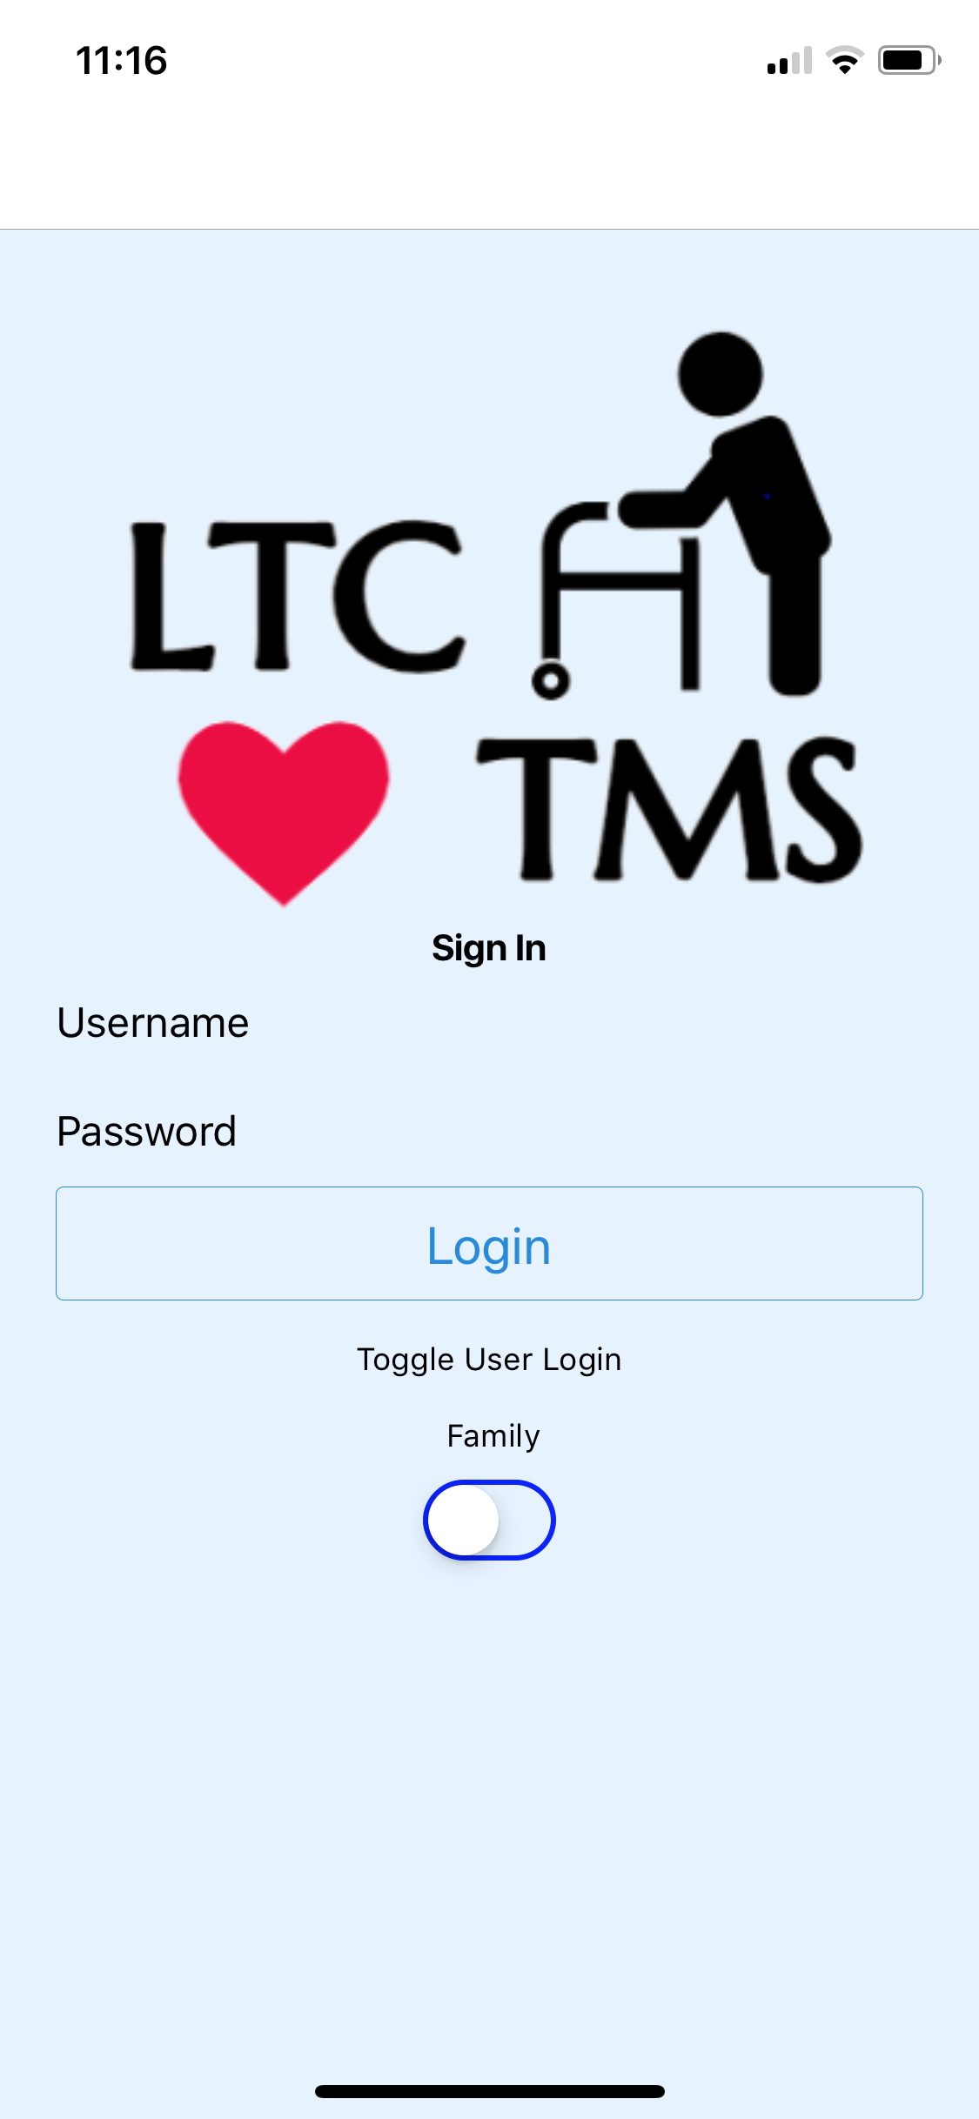 

###### Figure 4.5.4 : Comparison of old and new Login Page

##### Aims

The aims for this page are to have clearer page design and to make logging in more user friendly.

##### Features

The features implemented are, a new password visibility toggle, automatic account type detection, a keyboard shortcut and also visible text boxes. The app team has removed the Patient - CNA toggle button to make the app easier to use. In the old sign in screen from version 2.0[23] , the user had to use a toggle button to choose the type of account they were going to use to access the system. Now in the version 2.1, the backend code automatically catches whether the user is logging in with a CNA account or Family account.

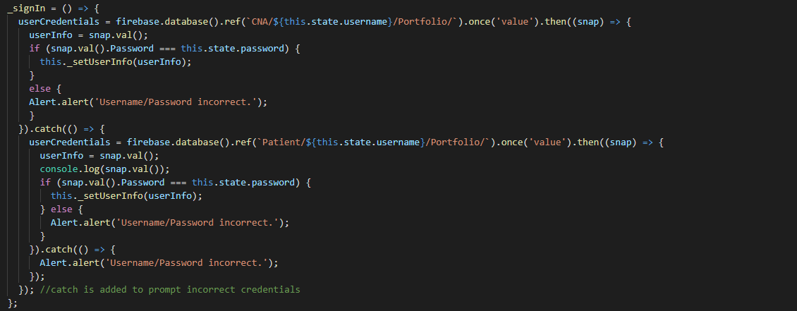

###### Figure 4.5.5: Section of code for the Login Page

#### 5.4.2 Home Page

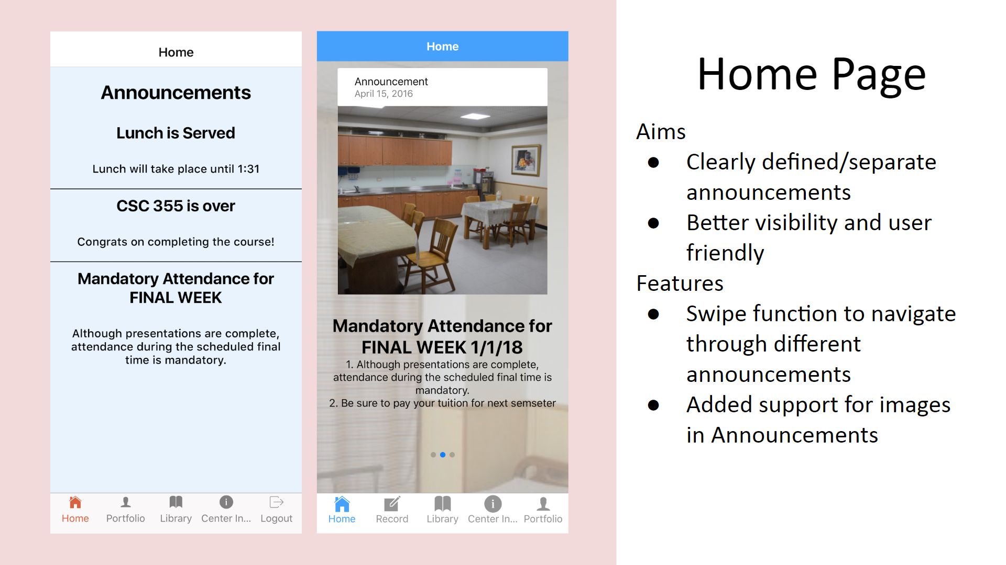 

###### Figure 4.5.6 : Image showing changes to the Announcements page

##### Aims

The aims for this page are to have clearly defined/separated announcements and better visibility for better readability.

##### Features

The features implemented for this page consists of a swipe function[24] to navigate through different announcements and added support for images in Announcements.

The previous home screen[25] had a table like structure of the announcements that was changed into a more readable/interactive format for version 2.1. Users can now view clear details regarding the date, titles and content of the announcement. There is also new code using a Swiper function to enable users to swipe across the screen to navigate through different announcements. Pictures can now be viewed by the user so as to have more context about the announcement.

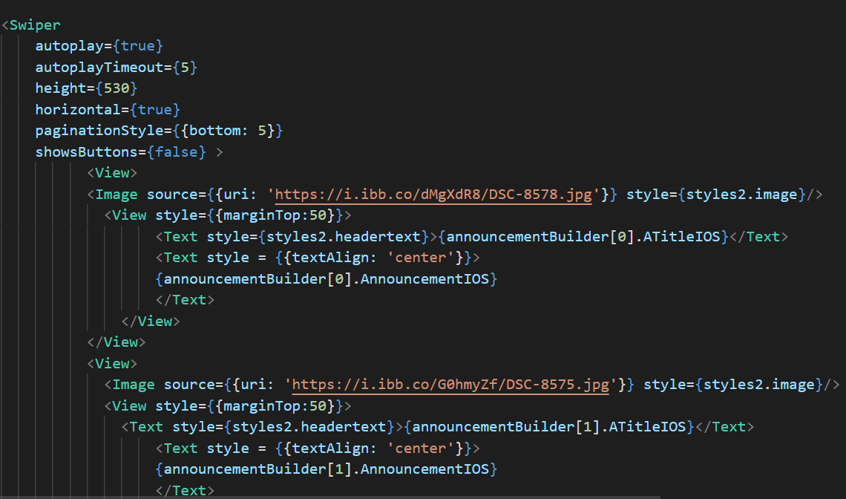

###### Figure 4.5.7: Section of code for the Home Page

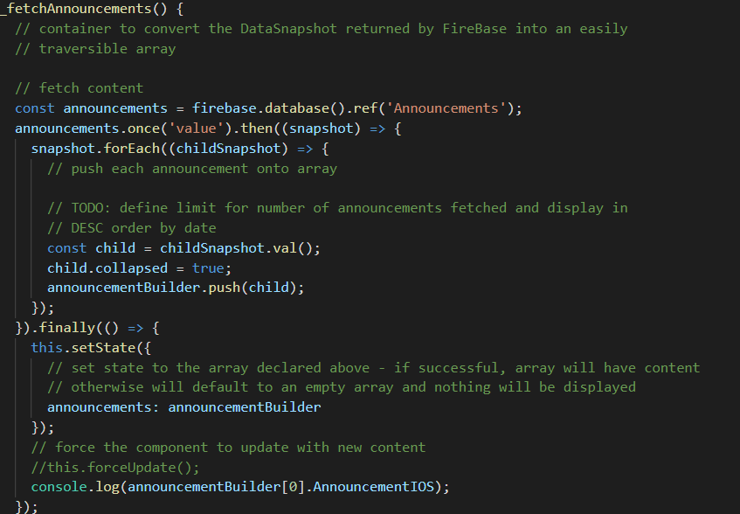

###### Figure 4.5.8: Another section of code for the Home Page

#### 5.4.3 CNA - Patient Records

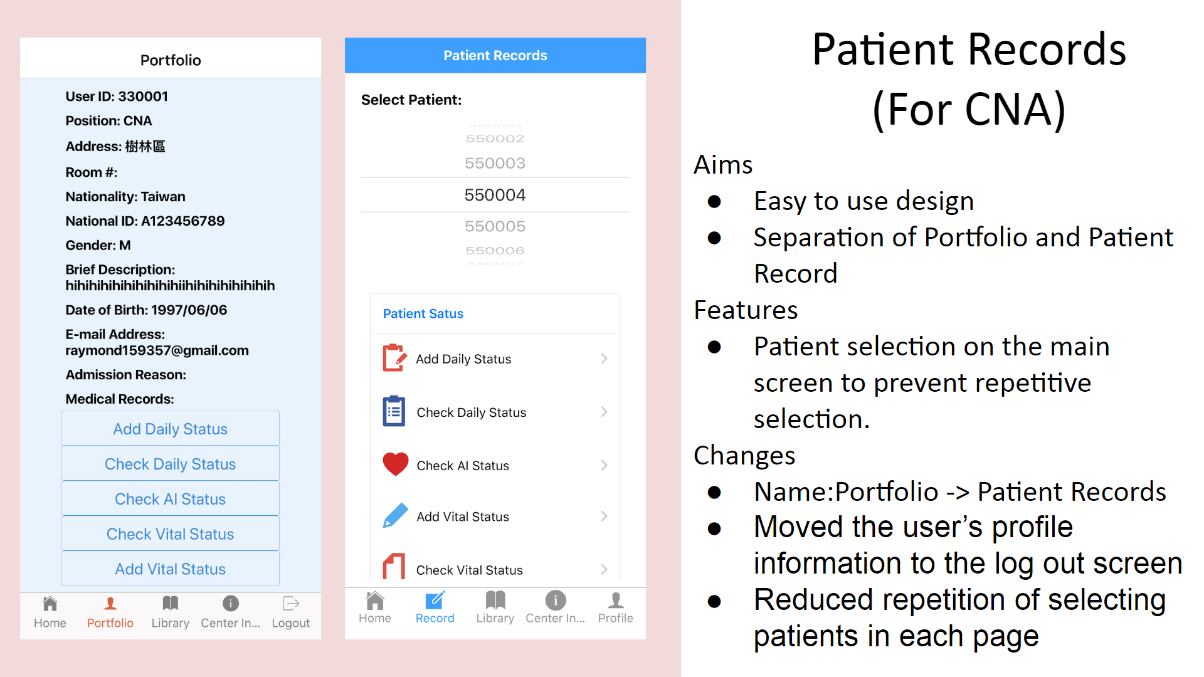 

###### Figure 4.5.9 : Image showing changes made to the CNA’s patient records page

##### Aims

The aims for this page are to have an easy to use design with separation of the portfolio and patient records.

##### Features

The features and changes are a new patient selection menu on the main screen to prevent repetitive selection. The team changed the portfolio screen[26] to be the patient records page and combined the log out function with the profile page.

By doing this the app team have reduced the repetition of selecting patients for each status type. In version 2.0, users needed to select the patient ID every time to access each status. Now in version 2.1, users need to select the patient ID in the patient records screen only once and then they can open all status pages without needing to select patient ID again, making status viewing and recording much more efficient.

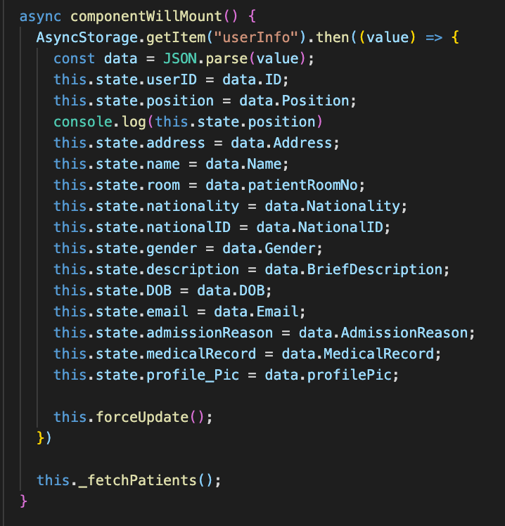

###### Figure 4.5.10: Section of code for the CNA’s Patient Records Page

#### 5.4.4 CNA - Daily Status Add

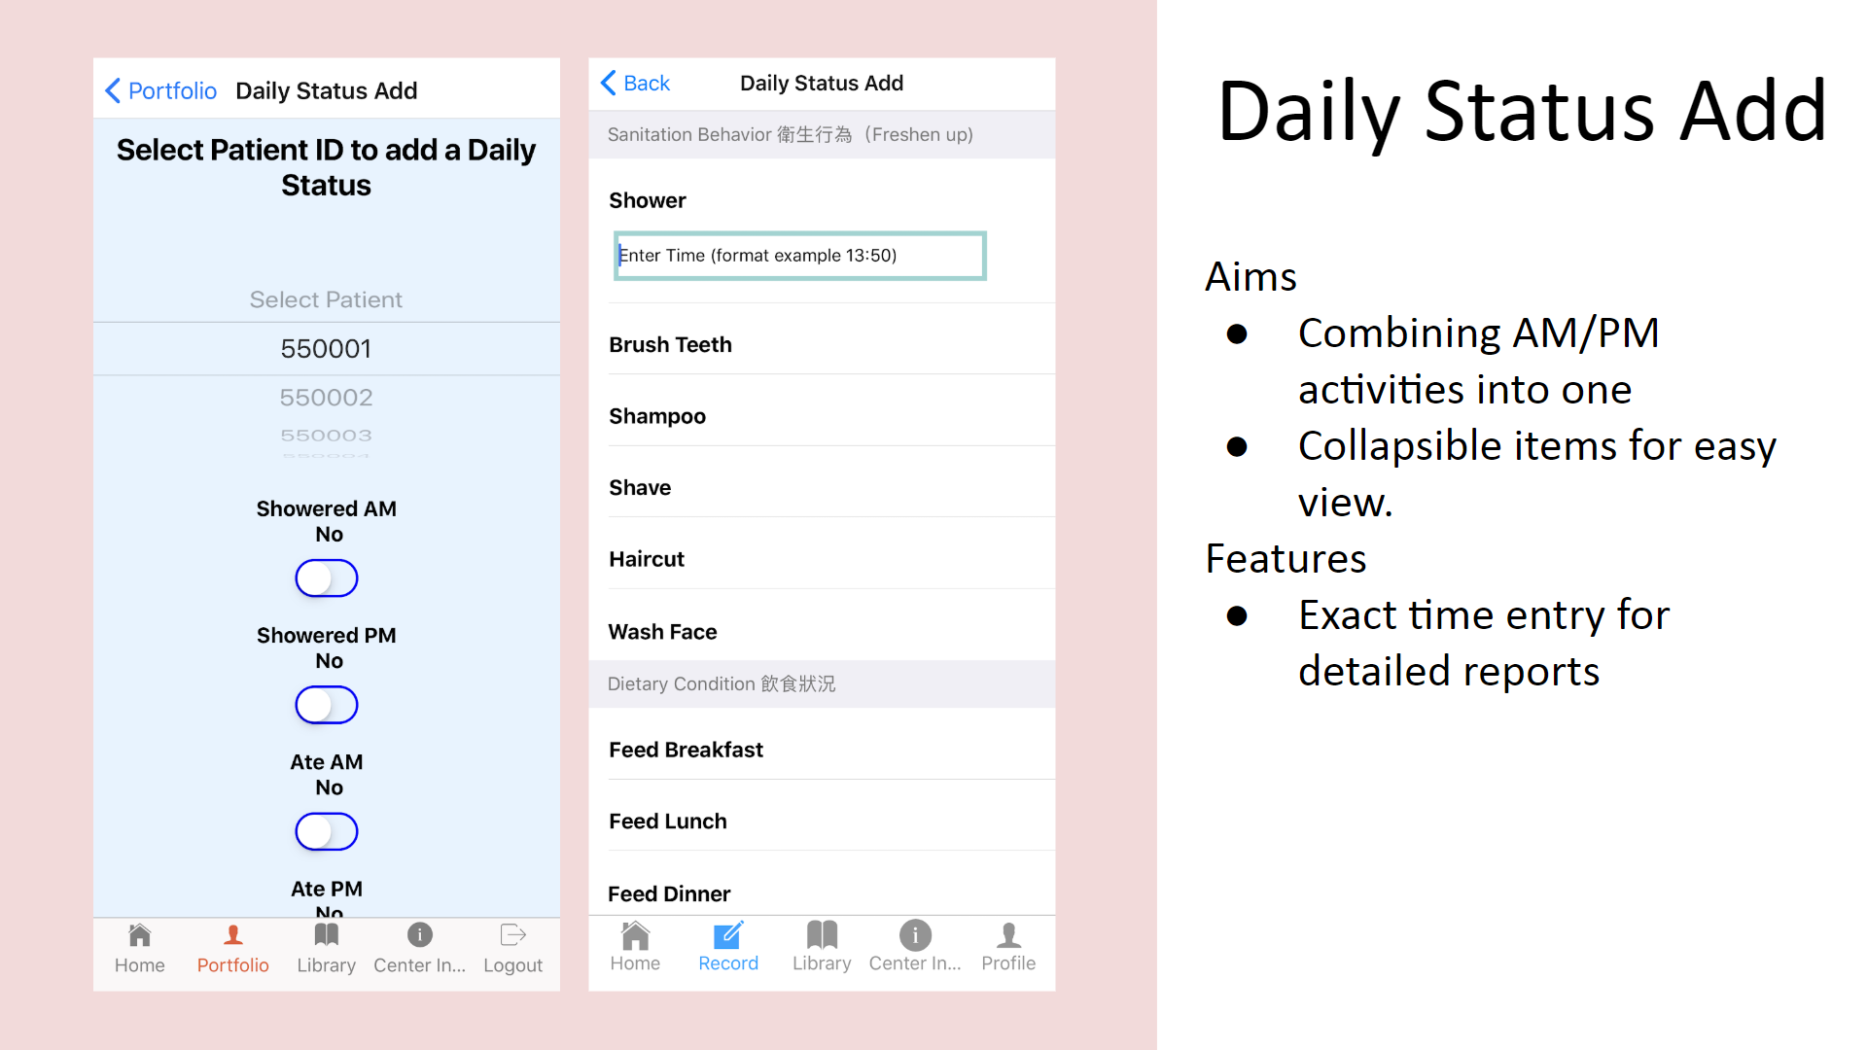 

###### Figure 4.5.11 : Image showing changes made to the CNA’s Daily Status Add page

##### Aims

The aims of this page are to combine AM/PM activities into one page and to have collapsible items for easy viewing.

##### Features

The features consists of the ability to have an exact time entry for detailed reports. The app team improved the content support of the previous daily status add screen[27] in this page as well as changed the design for better readability.

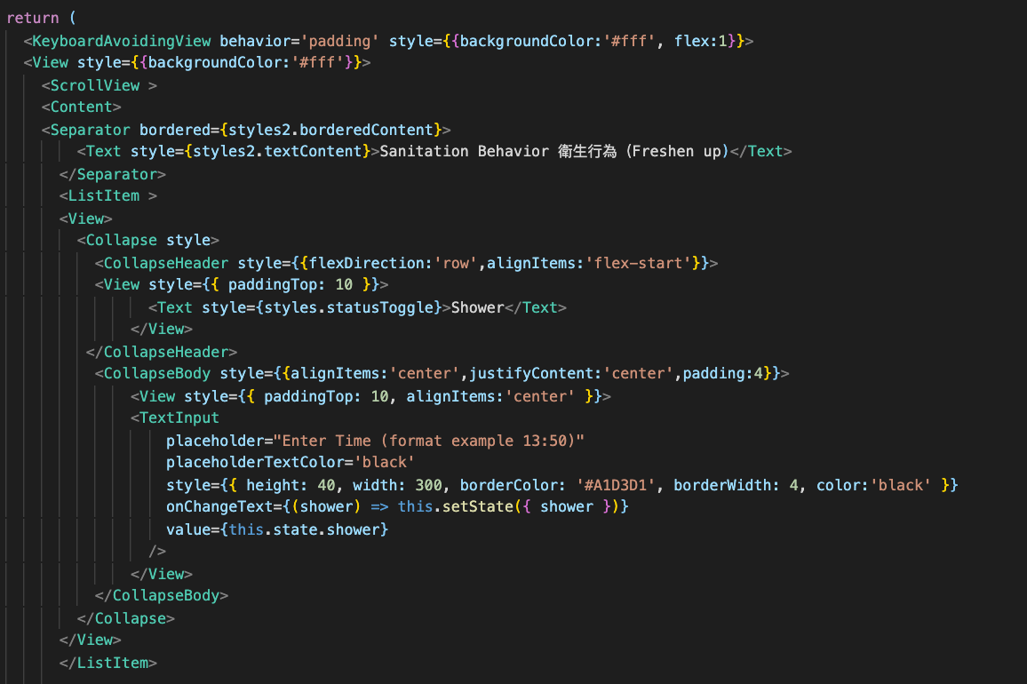

###### Figure 4.5.12: Section of code for the CNA’s Daily Status Add

###### Table 4.5.1: the content of daily status add

|  |  |
| --- | --- |
| Before | After |
| Shower | Shower |
| Ate | Dental care |
| Brush teeth | Shampoo |
| Poop time | Shave |
| Urinate Time | Haircut |
|  | Wash Face |
|  | Breakfast |
|  | Lunch |
|  | Dinner |
|  | Turn over/Back care |
|  | Defecation |
|  | Urination |

###### 

In version 2.0, the content of daily status only had the following options : shower, ate, brush teeth, poop and urinate time. Now in version 2.1, there are 12 states and they are divided into 4 categories - Sanitation Behavior (shower/dental care/shampoo/shave/haircut/wash face) , Dietary Condition (Breakfast/lunch/dinner), Basic Care and Defecation/ Urination.

#### 

#### 5.4.5 CNA - Vital Status Add

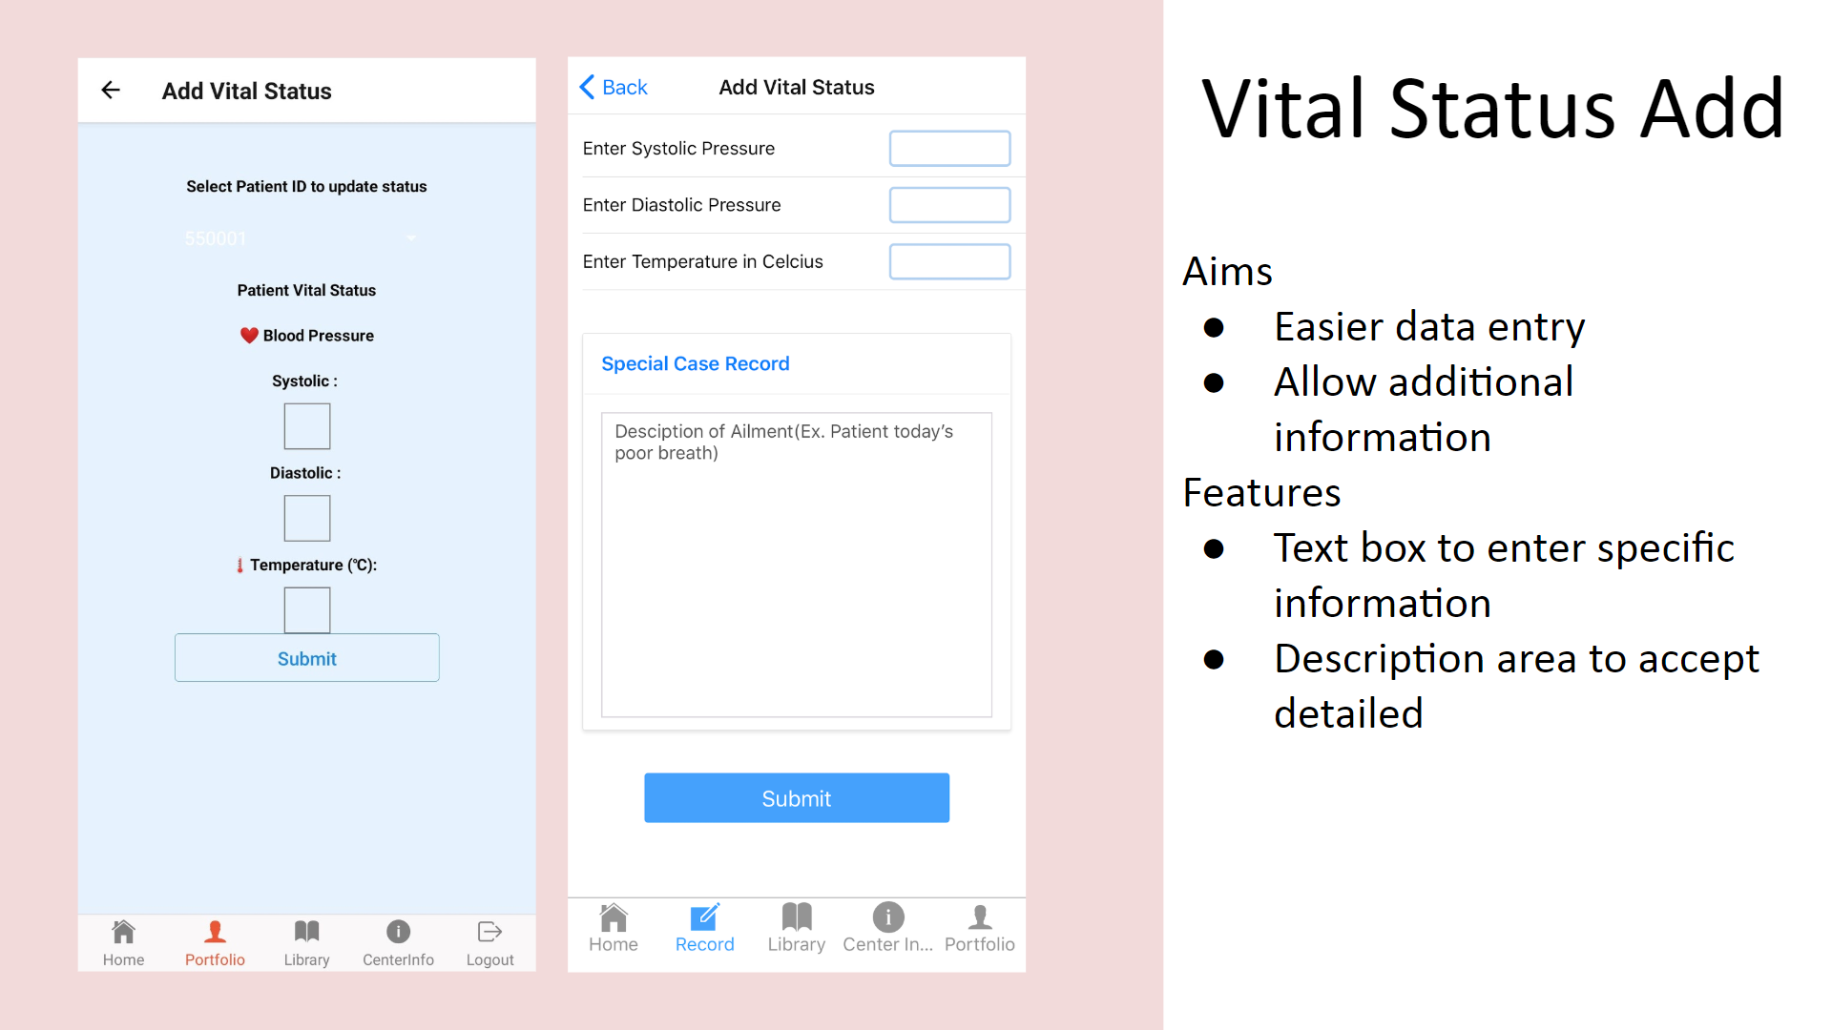 

###### Figure 4.5.13 : Image showing changes made to the Vital Status Add Page

##### Aims

The aims of this page are simply to make data entry easier and to allow for additional information and notes to be recorded.

##### Features

The features are a textbox which is used to enter specific information that the CNA would like to record. The entire screen has been redesigned in order to keep the design and theme consistent with other pages. Special Case Record container is where the CNA can address the patients health report in detail if there is a special case. In the vital status add screen from version 2.0[28], there was no section to add comments on this page. The development team believes that it is a necessary implementation because not every patient has the same health conditions.

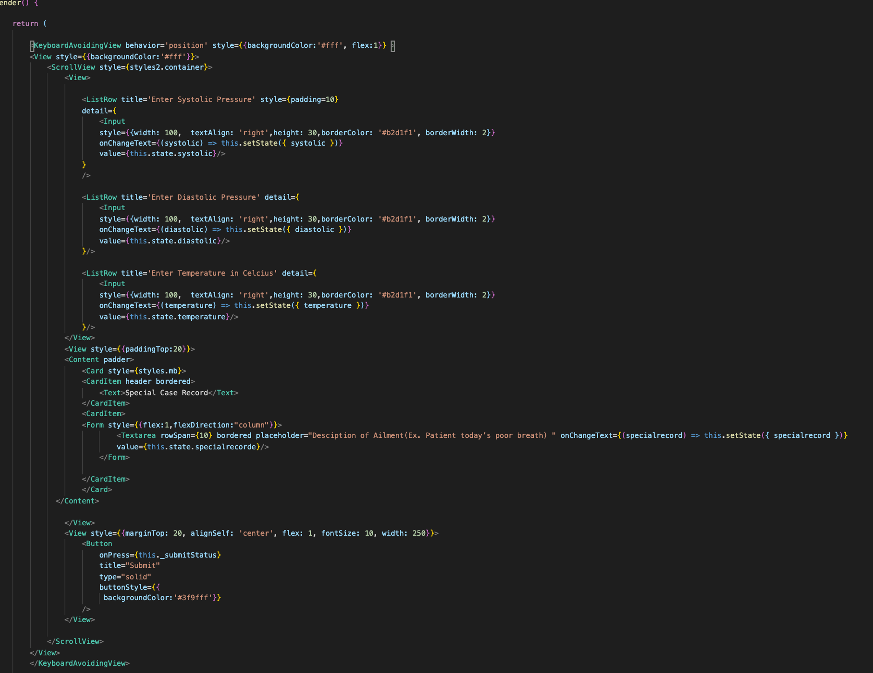

###### Figure 4.5.14: Section of code for the CNA’s Vital Status ADD

#### 5.4.6 Family - Patient Record

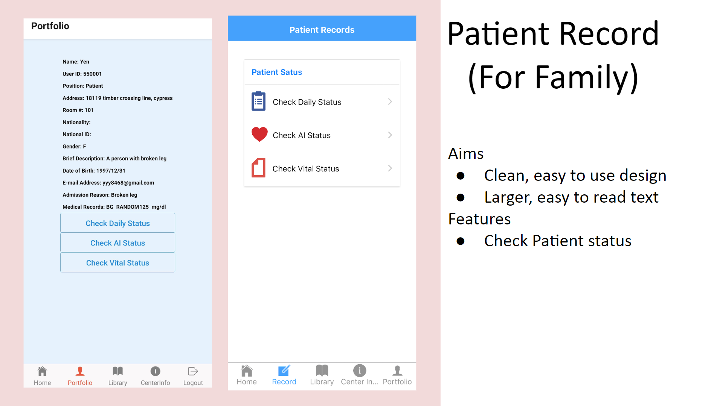 

###### Figure 4.5.15 : Image showing changes made to the Patient Record page

##### Aims

The aims of this page is to have a clean and easy to use design by utilizing larger easy to read text.

##### Features

This feature deals with checking patient status. In version 2.0, users can select the patient ID to check Daily, AI, Vital status which should not be allowed. In version 2.1, portfolio was moved to another page but three functions were left which are Check Daily Status, Check AI Status, Check Vital status. Also the function buttons were made clearer and icons were added for each function.

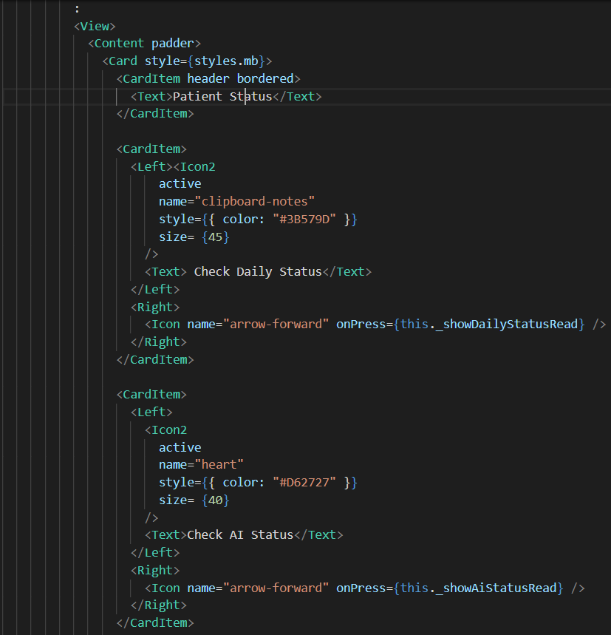

###### Figure 4.5.16: Section of code for Family patient record

#### 5.4.7 Daily Status Read

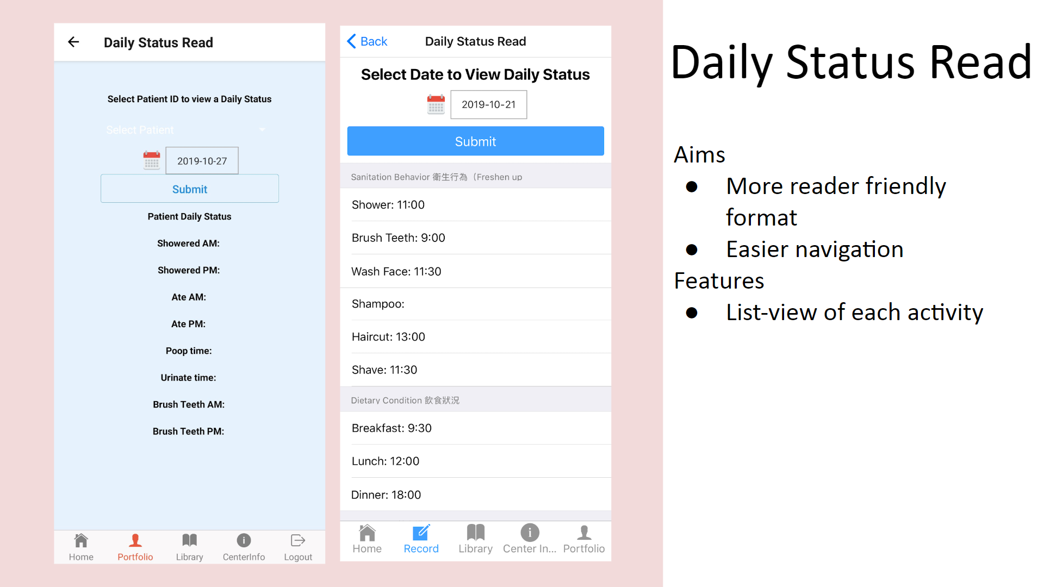 

###### Figure 4.5.17 :Image showing changes made to the Daily Status Read page

##### Aims

The aims of the daily status read page are to have a more reader friendly format allow for easier navigation.

##### Features

The new feature of this page is the list-view that was added for each activity. In the daily status read page from version 2.0[29], users can select the patient ID to check other patient’s Daily status which shouldn’t be allowed. Now in the new version, family members can only check their own patient’s status in the records screen, and the alignment was set to better readability.

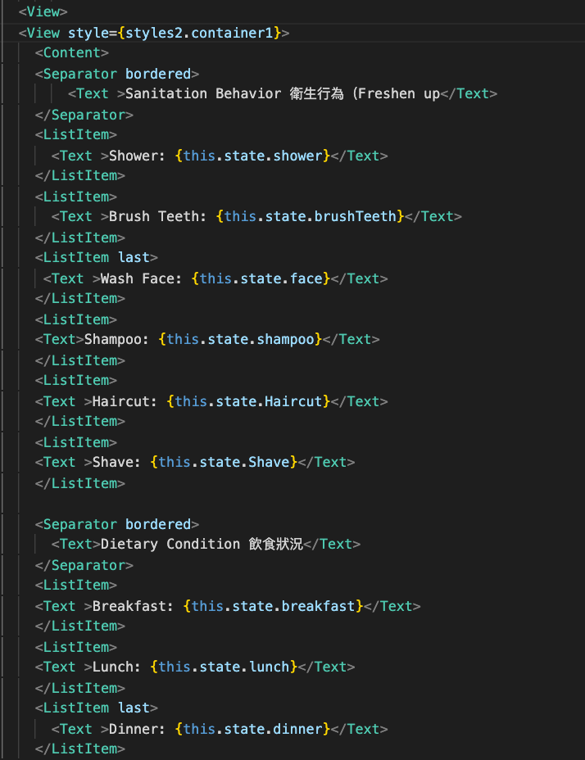

###### Figure 4.5.18: Section of code for Family read daily status

###### 

#### 5.4.8 Library

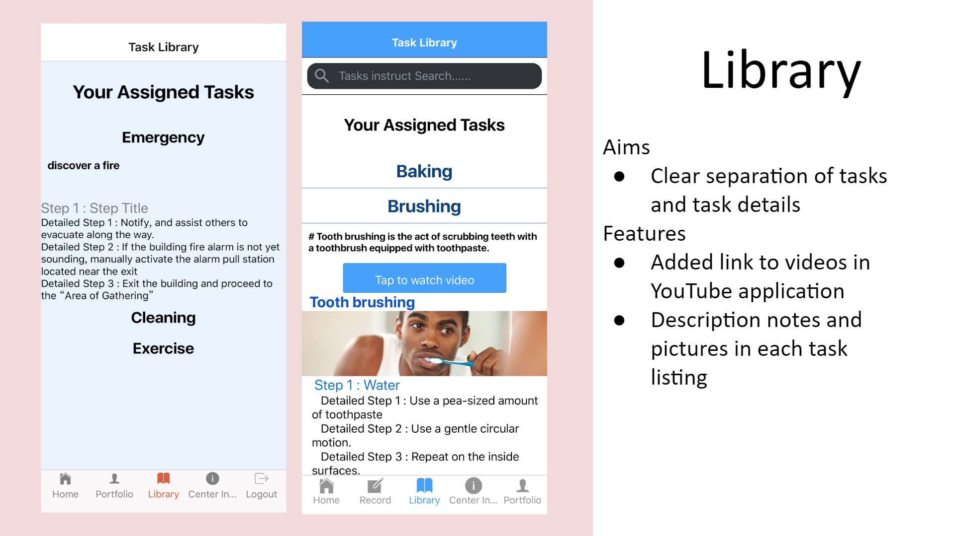 

###### Figure 4.5.19 :Image showing changes to the new Task Library

##### Aims

The aims of this page are primarily to have clear separation of tasks and task details.

##### Features

The new page features an embedded link to Youtube videos that are available to watch and also description notes and pictures in each task listing. In the previous task library screen[30], this page didn’t show any brief description, pictures, videos or instructions. Furthermore, the text alignment and formatting wasn’t clear enough. In this version, the team has added a brief description, picture, and button for video instruction. Each task is separated with a line and the alignment has been adjusted for better clarity.

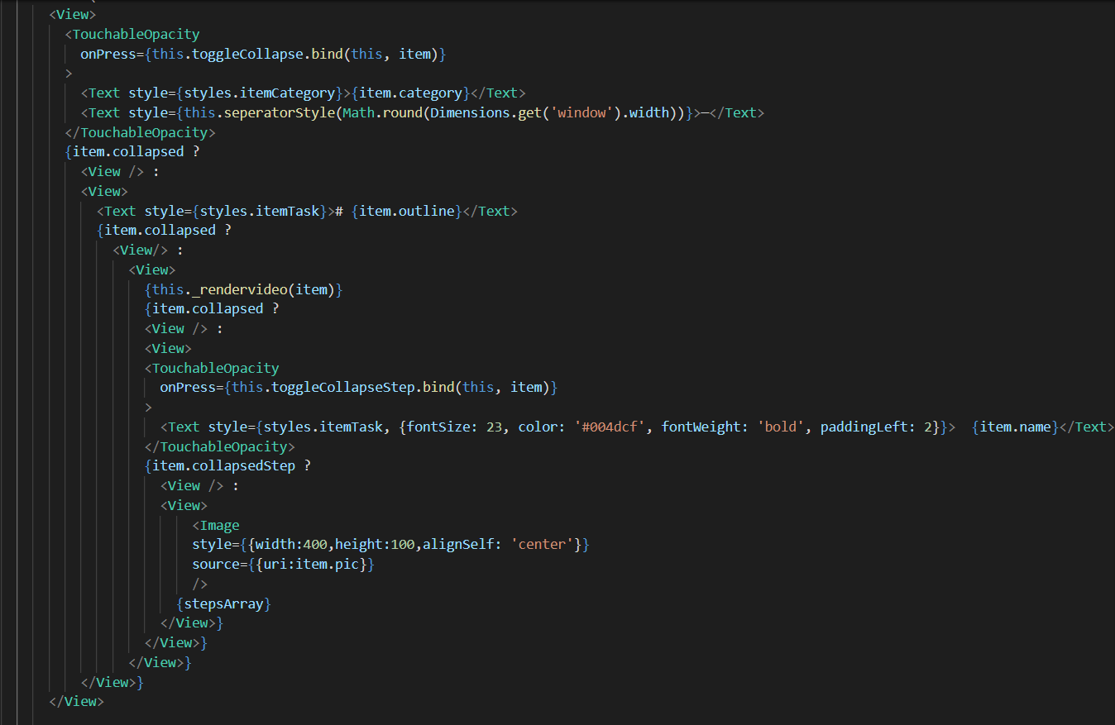

###### Figure 4.5.20: Section of code for Task Library

#### 5.4.9 Centre Info

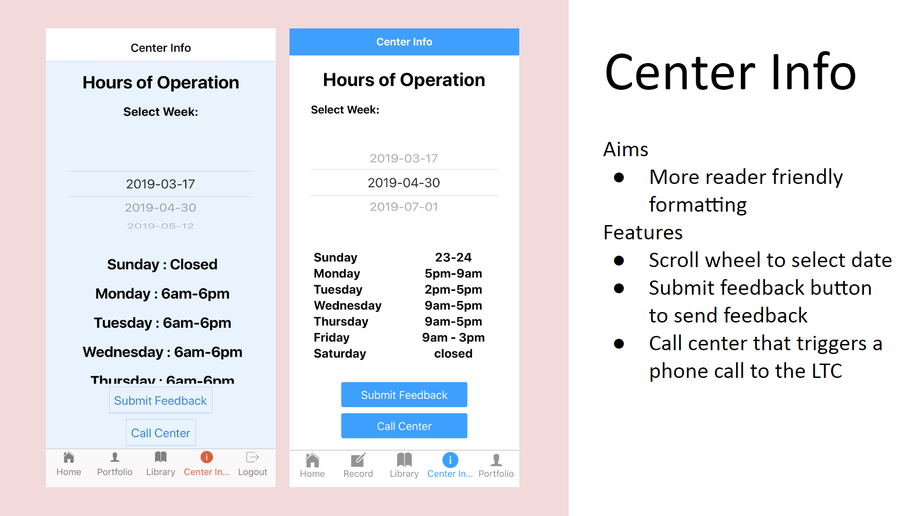 

###### Figure 4.5.21 : Image showing difference between old and new Center Info page

##### Aims

The aims of the Center Info page[31] are to create a more user friendly layout.

##### Features

The features include a scroll wheel to select the date. There is also a feedback button to send feedback and also a call center button that triggers a phone call to the LTC. The app team has realigned the center schedule opening and closing time text to a more appropriate format. The app team has also changed the design of the buttons. In the prior version of the app, the buttons were transparent and with the new white background it was not as visible. Now in version 2.1, the team has changed the color of the buttons to blue for better visibility. The page text was also realigned to make it more readable.

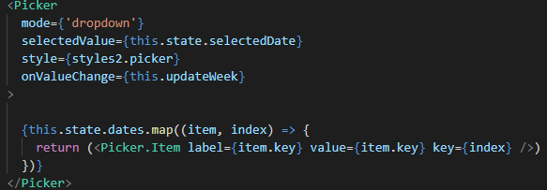

###### Figure 4.5.22: Section of code for the Centre Info page

#### 5.4.10 Submit Feedback

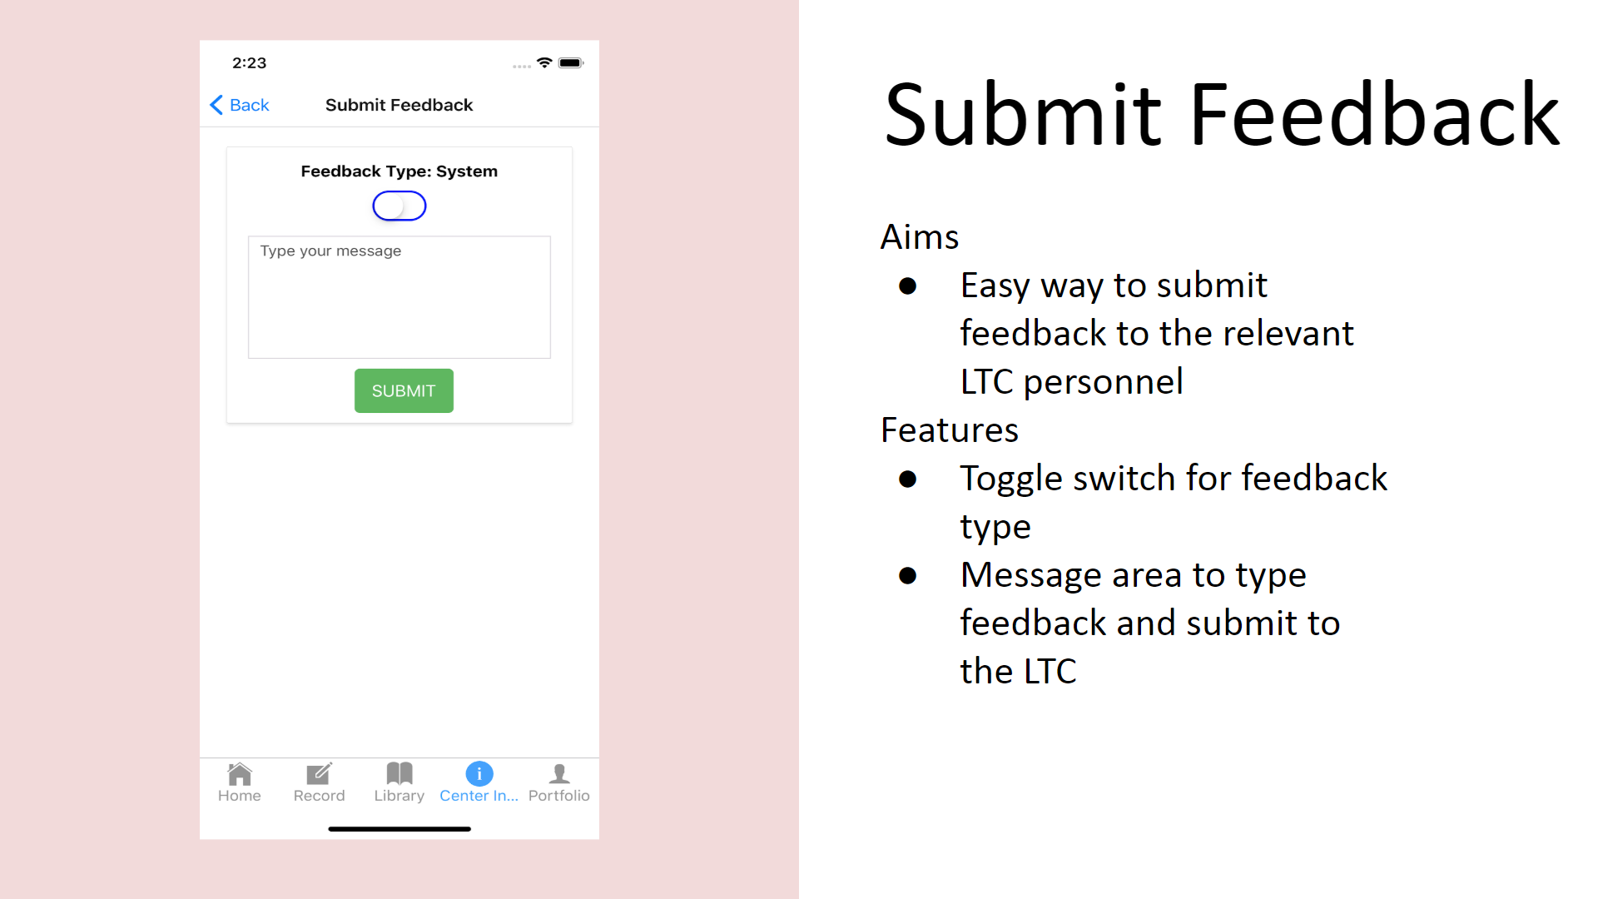

###### Figure 4.5.23 : the Submit Feedback Page as it appears in version 2.1

##### Aims

The main purpose of the submit feedback page[32] is to have an easy way to submit feedback to the relevant LTC personnel.

##### Features

The features are a toggle switch to select feedback type and also a message area to type in the feedback message to be submitted. This page is mostly unchanged because the app team feels that it coincides with what the team is aiming for with the new UI. It is an easy way for the user of the app to communicate with the LTC. There is a reasonable sized text box where users are able to type their message along with a toggle. Below that, there is also a submit button that users can click to send their feedback.

#### 5.4.11 Call Centre

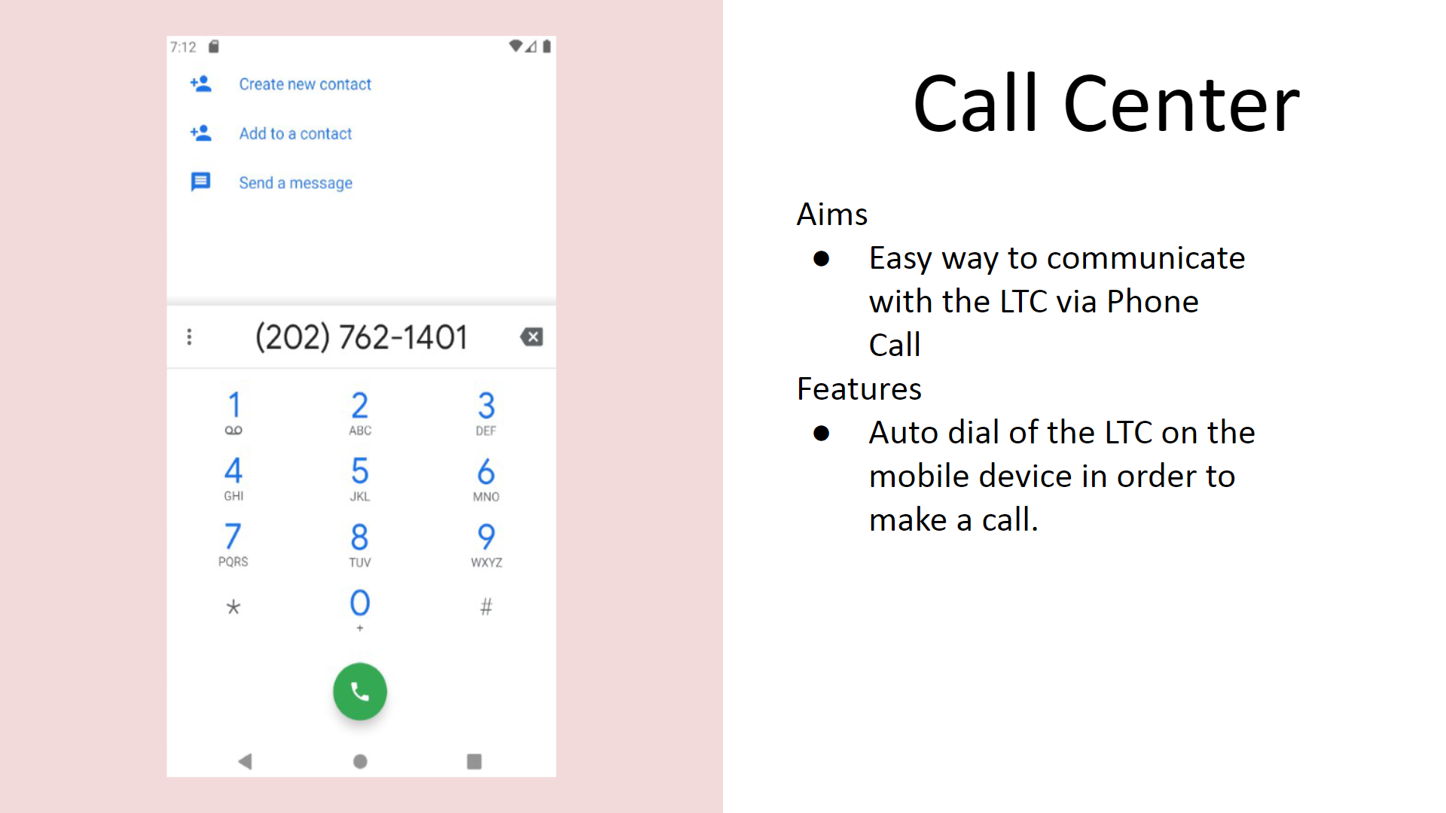

###### Figure 4.5.24 : Image showing LTC phone number loaded into the mobile dialing area

##### Aims

The aim is to have an easy way to communicate with the LTC via Phone Call.

##### Features

The feature of this page is the auto dialing of the LTC centre’s phone number on the mobile device in order to make a call. Pressing the “call center” button will automatedly dial the number by itself in the phone page. This page is mostly unchanged. It is a useful function according to the project target of having a more user friendly user experience. Users need not memorise tedious lists of LTC phone numbers.

#### 5.4.12 Portfolio

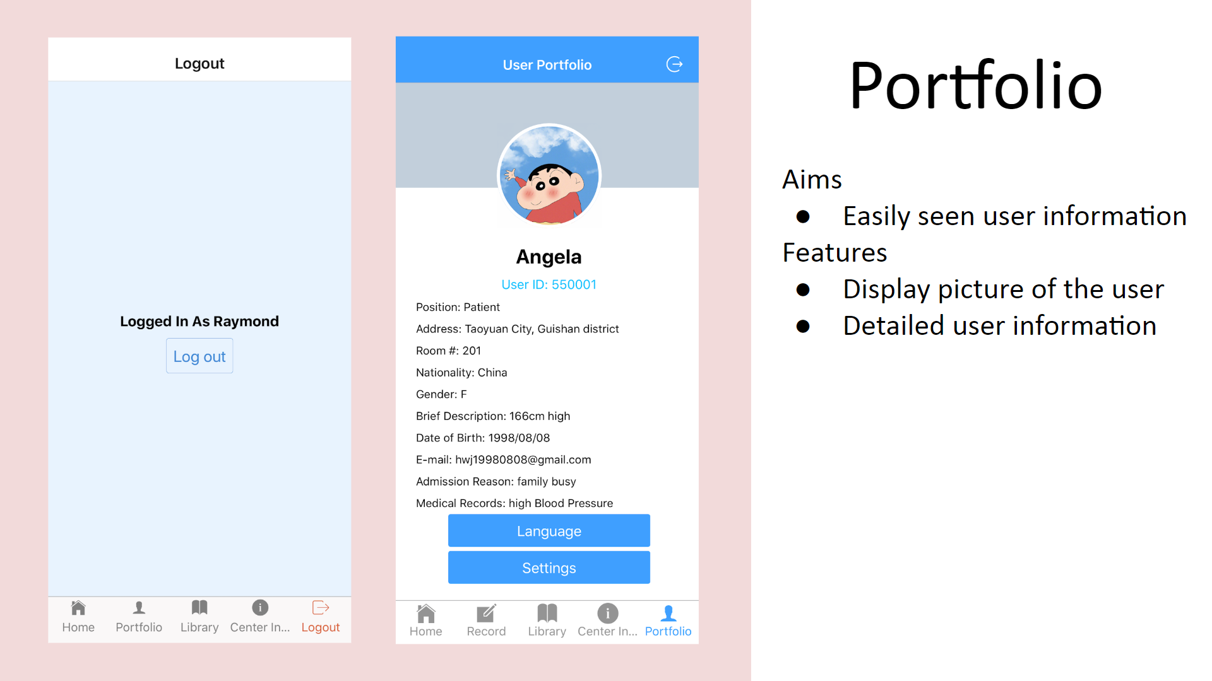 

###### Figure 4.5.25 : Image showing difference between old and new Portfolio page

##### Aims

The main purpose of the portfolio is to have easily accessible and readable user information while aggregating all user related settings and options on the same page.

##### Features

The features consist of a display picture of the user along with all related user information. This page also contains the log out button as well as a template for language selections and additional user settings that can be implemented in future iterations. The user’s profile picture will be loaded from an uploaded file in Firebase.

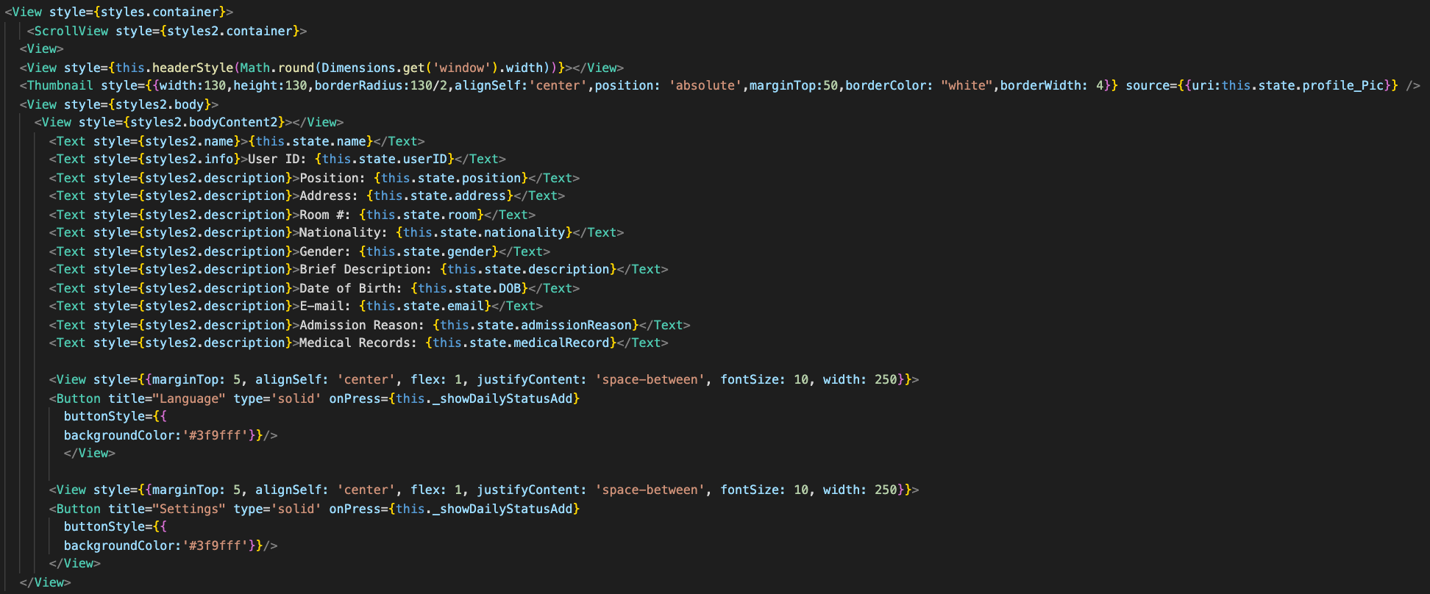

###### Figure 4.5.26: Section of code for the Portfolio page

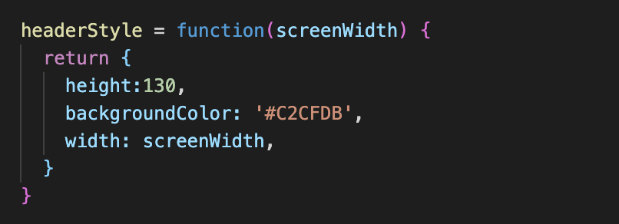

###### Figure 4.5.27: Another section of code for the Portfolio page

#### 5.4.13 Logout Page

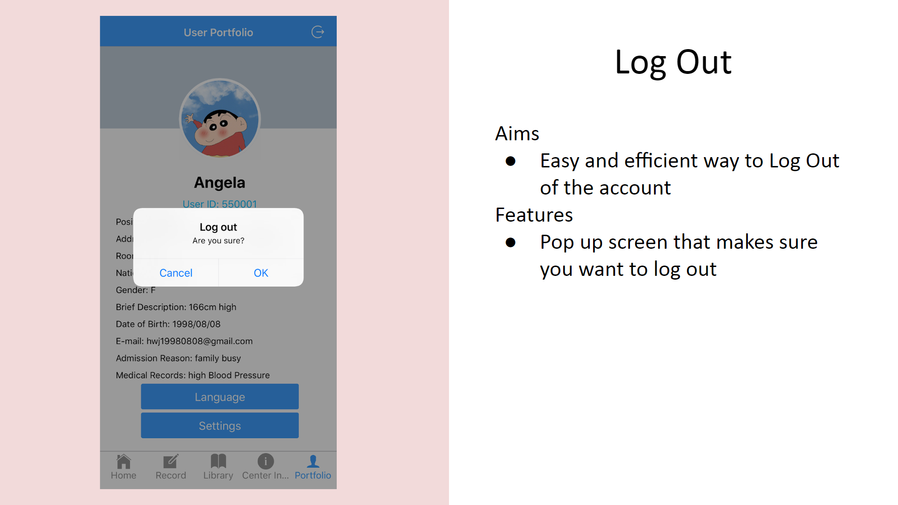

###### Figure 4.5.28 : the Log Out page as it currently appears in version 2.1

##### Aims

The aim of this is to prevent users from accidentally logging out due to an unintended button press

##### Features

The log out screen[33] features a pop up screen that prompts the user to confirm whether they indeed would like to log out.

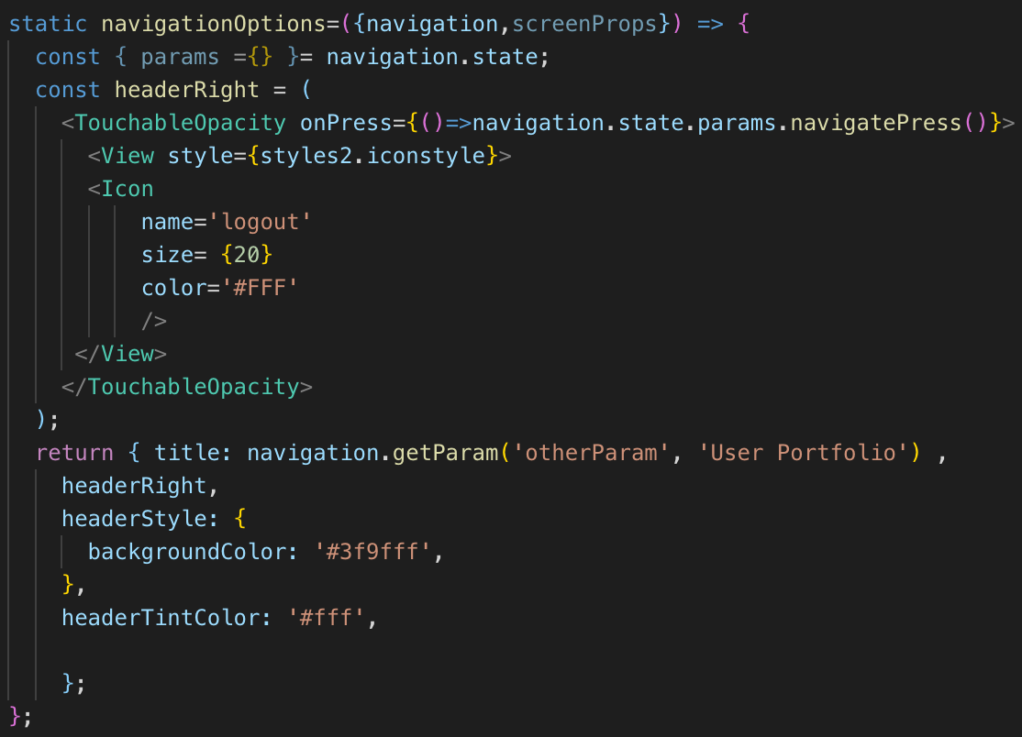

###### Figure 4.5.29: Section of code for the logout button

### 5.5 Industry Standards and Best Practices(App)

Keeping in mind the intended users of the mobile application, and the types of devices the application program will likely be used in, several primary design factors became the main focus points for the App team of the development group.

These main points were designing a clearer page layout, an improved visual element design and maintaining a shallow interface map.

#### 5.5.1 Clearer Page Layout

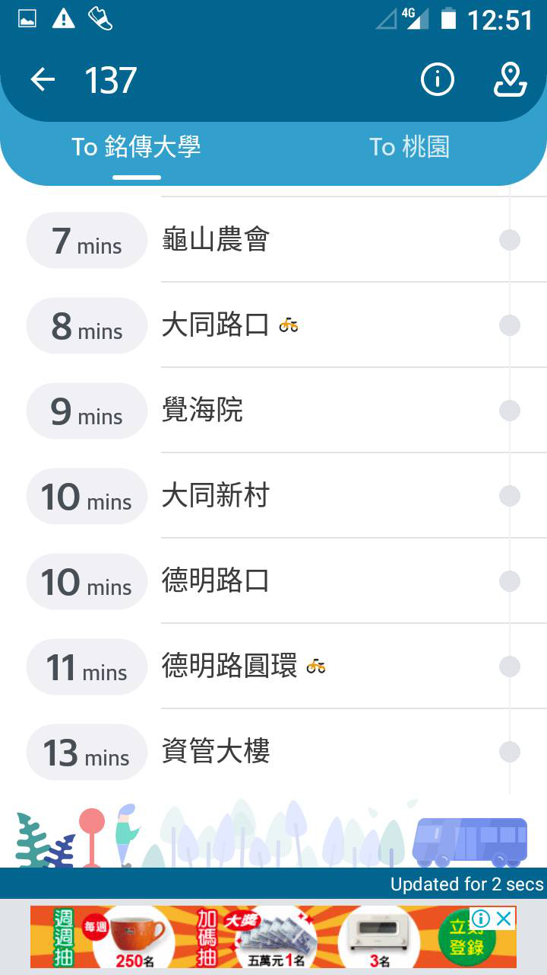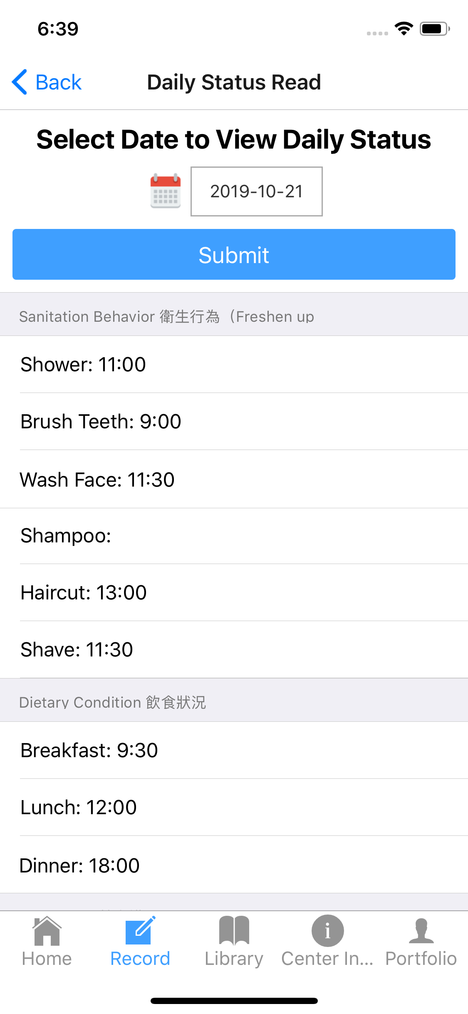

###### Figure 4.5.30: Example of spacing used in popular public transport app “BusTracker Taiwan”[34] and LTC-TMS v2.1 mobile application component

Considering that a major use of the application is for data viewing and recording, as well as the smaller screen size of mobile devices compared to traditionally large desktop or workstation monitors, ensuring that text and visual elements remain clear and distinct on the page was a priority in design.

In figure 4.5.30, the LTC-TMS application shows clear white space and line separators for each row. The lines help to separate each row into its own distinctly separate space, while the wider spacing helps give the text some more separation so that users do not feel that the elements on the page are too cluttered.

#### 5.5.2 Visual Element Design

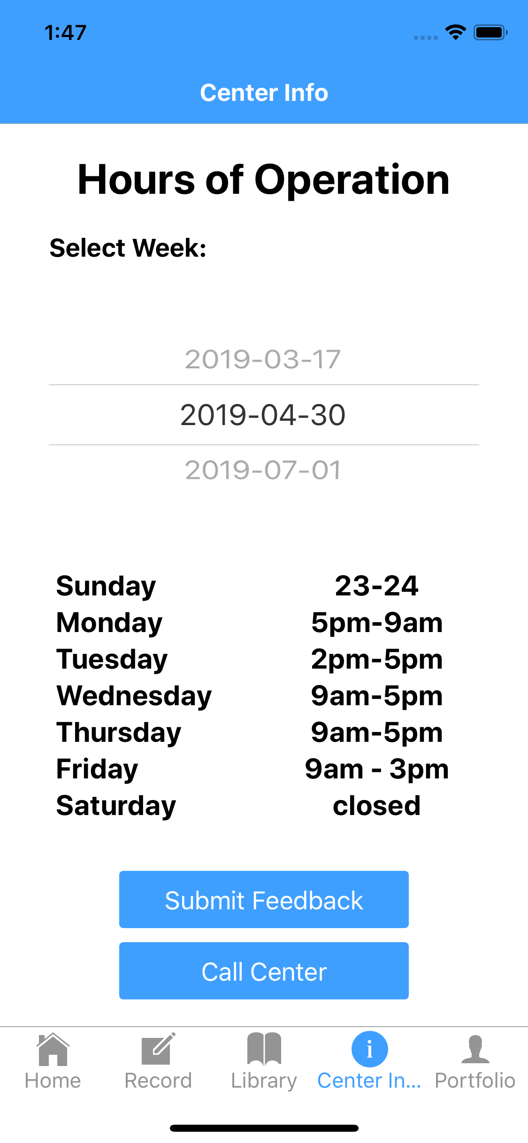

###### Figure 4.5.31: Examples of improved visual element designs in the LTC-TMS v2.1 mobile application component

Related to having a clearer page layout, is also an improved visual element design. Note that the buttons too have their own spacing to make sure they are visually distinct. Buttons on the same page are designed to have the same size as each other, so that a user’s eye will be able to quickly identify buttons on the page.

Some buttons such as the submit button on the upper right corner of figure 4.5.31 are stretched across the screen for ease of access when in a hurry. Note the slight space gaps between the ends of the button and edges of the application screen. Meanwhile, non interactive bars such as the “Center Info” bar on the upper left corner of the figure are stretched across the entirety of the screen width, with no gap spacing from the edges, visually signalling that it is not a button.

Different interactable buttons on the page also have different colour schemes. For example, the “permanent” buttons at the bottom of the app are always in grey, except for the page the user is currently on, which is highlighted in blue. In contrast, the pages specific to the page the user is on, will be in blue, with white text. This again, helps to visually separate the two areas and the two different types of buttons.

#### 5.5.3 Shallow interface map

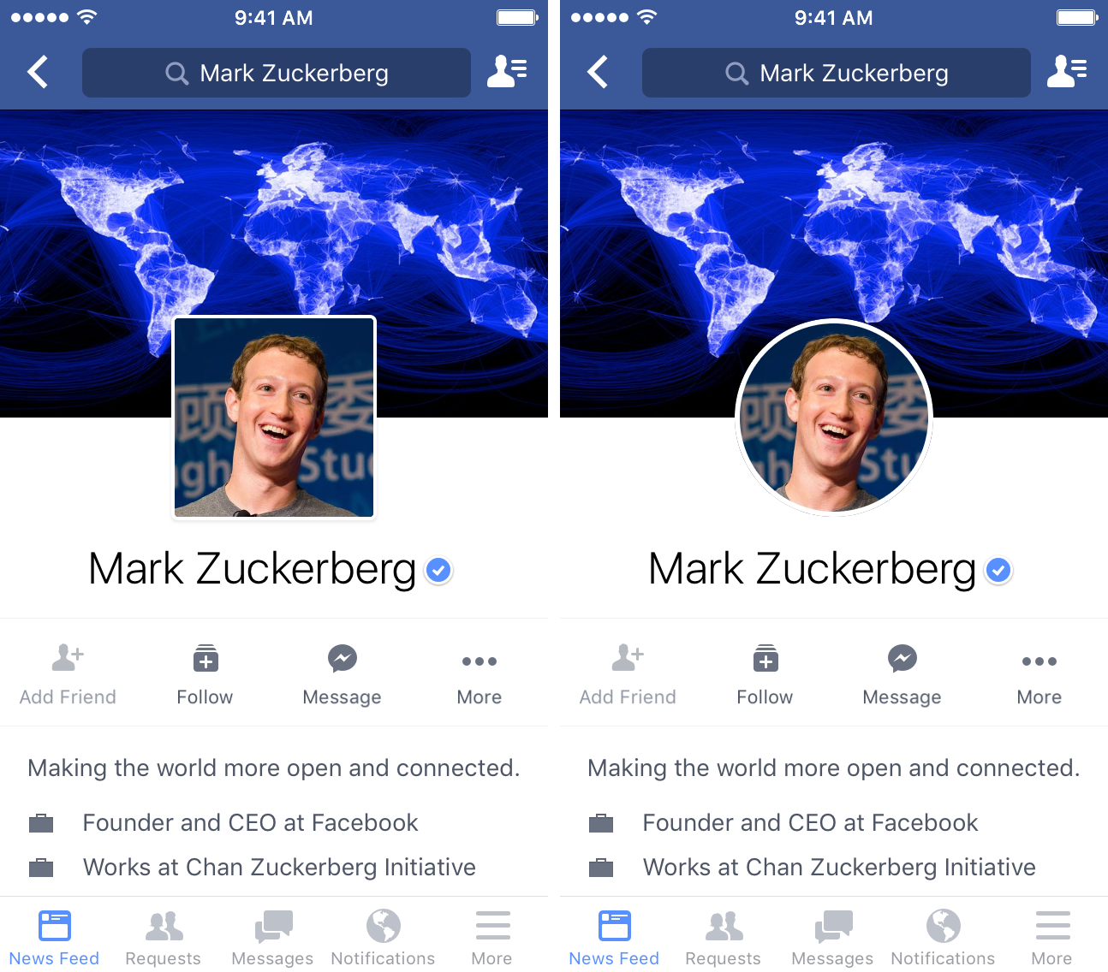

###### Figure 4.5.32: Example of “page” button layout from Facebook App[35] and LTC-TMS v2.1 mobile application component

Finally, the priority was maintaining a shallow interface map in version 2.1 which was already inherited from version 2.0. Meaning, that the interface tree which was already shallow in version 2.0 would have no further layers added to its depth.

This restriction however, means that adding any new features could either make existing pages too complex and bloated, or extend the breadth of the interface tree to a point of being impractical, hence buttons and functions were streamlined as much as possible so that singular functions do not end up requiring entire pages, while any further additions of functionality in later versions will have to be carefully planned out so as not to introduce superfluity and bloat.

Another design element inherited from version 2.0 is the set of buttons permanently placed at the bottom of the application page. This design element was refined however, by following the ideal that only “root” pages, that is, pages that themselves serve as gateways to a large supercategory of pages and functions would become “root buttons”.

This again follows many industry designs as can be seen in the example of the Facebook Application, and banking apps such as “Home Bank” from CTBC bank. The Logout button was also removed as a “root button”, instead appearing as page specific button found in the upper right corner of the Profile page, while several button templates were added to the Profile page as place holders for future functions such as language options and user account options to be added in version 3.0 and beyond.

### 5.6 Limitation of Application and Solutions

Learning a new coding language was certainly a difficult task for the Application Team and with that challenge, it brought some limitations to the application.

It was the first time that the development team was using React Native or coded in Javascript so it was quite difficult for the team to install all the required repositories and successfully build the application.

Learning all of the new syntax and functions that were required for the team to fully understand the code and continue the development was also very challenging.

One of the limitations was the iOS development. Even though React Native is a cross platform coding framework, in order to build the application for iOS the team needed to have MacOS devices. Only one of the team members of the application development team had those devices to test and build the iOS version which slowed down progress.

In order to solve this issue, the application team also installed a virtual machine that runs MacOS so that everyone in application team could test their code in the iOS build as well. Even though this has solved the problem, iOS emulators running on the MacOS virtual machine were too slow for us to fully test the application.

It was also the first time that the team fully used GitHub and Firebase in a project so making the connection to both of these platforms was also quite challenging. One of the limitations for Firebase that the group had was having Firebase as the only server for the application. Anytime a team member modified the database it could potentially affect the application.

During the middle of the project, the app team had lost the connection to the server. It was later discovered that the server login credentials were incorrect in the App configuration as the code the group was trying to operate at that time was still using the old credentials that the app team received from Version 2.0. This issue was quickly solved thereafter.

## 6.0 QA TEAM



## 

## 

## 

### 6.1 Quality Management Report

The purpose of this Quality Management Report documentation is to summarize the project development quality of LTC-TMS. The following will include System Quality Summary and Quality Manager’s Reflection. The quality manager is also required to recheck the system related documents for the changes that would develop.

QA Team members and roles are listed in the table below:

###### Table 4.6.1. QA Team Members

|  |  |  |
| --- | --- | --- |
| Role | Name | Responsibility |
| QA Leader | Jimari | App, Browser Testing |
| Tester | Annie | Hardware Testing |
| Tester | Francois | Browser Testing |

### 6.2 System Quality Summary

##### System Test Results

Table 4.6.2 has shown the test result of the system. In each row it contains a device type to indicate which device version it is applied to. The totals for this tables combines old and new test cases and both MRR and Test Case numbers.

###### Table 4.6.2 System Total Test Results

|  |  |  |  |
| --- | --- | --- | --- |
| System Type | Passed | Failed | Total |
| Browser | 30 | 11 | 41 |
| App | 22 | 3 | 25 |
| Hardware | 7 | 0 | 7 |
| Total | 59 | 14 | 73 |

##### Test Tracking

Figure 4.6.1 displays a bar chart of the testing percentage of the LTC-TMS. In each column in the bar chart it will show the Passed and Failed Bar with Passed on the left and Failed on the right.

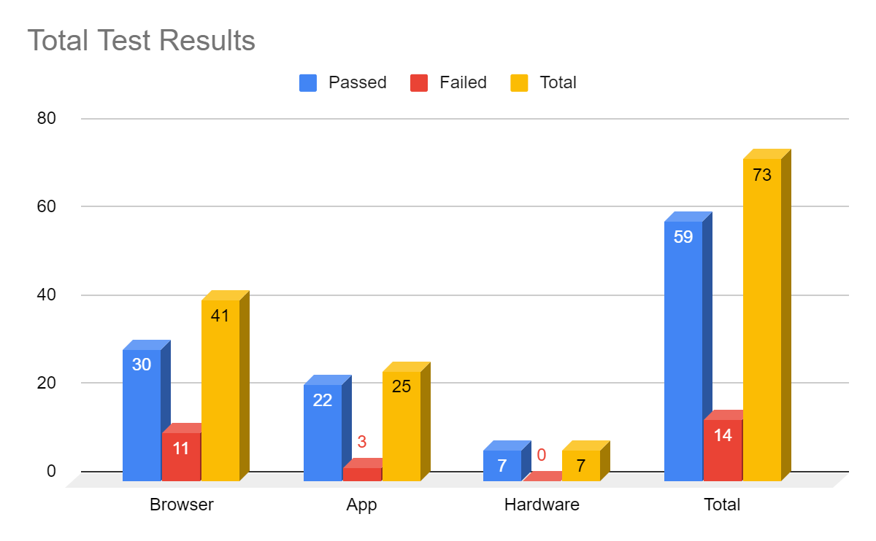

###### Figure 4.6.1 Bar Chart of Testing Results

### 6.3 Quality Manager’s Reflection

The development team started work in July, 2019 and estimated that the end of the project will be January 2020. The development team was given the task of improving the UI and UX of the Long-term Care Center system.

For system quality, the team tried their best to use the software and hardware that was available to them along with proper planning to ensure the quality of the project is of the highest quality.

For the android testing, manual testing was used because the QA team was unable to configure the program to run on the automated testing software. Of course, this is not ideal and errors and bugs could have been missed because of the human element but the team tried their best to be as thorough as possible. The browser testing was done both manually and using the automated testing tool Katalon. The entire team helped to test the browser but was mainly done by Francois who is also on the Browser team. The QA team had trouble at first using Katalon because it was a new software to them. The team tried to follow some Youtube examples and whatever literature that could be found on the internet.

The QA team believes that there should always be a balance between quality and efficiency and have tried their best to strike this balance. After all of the optimisation and fixes, there are still a few bugs here and there but these will not cause any critical errors in the system.

## 7.0 DATABASE TEAM



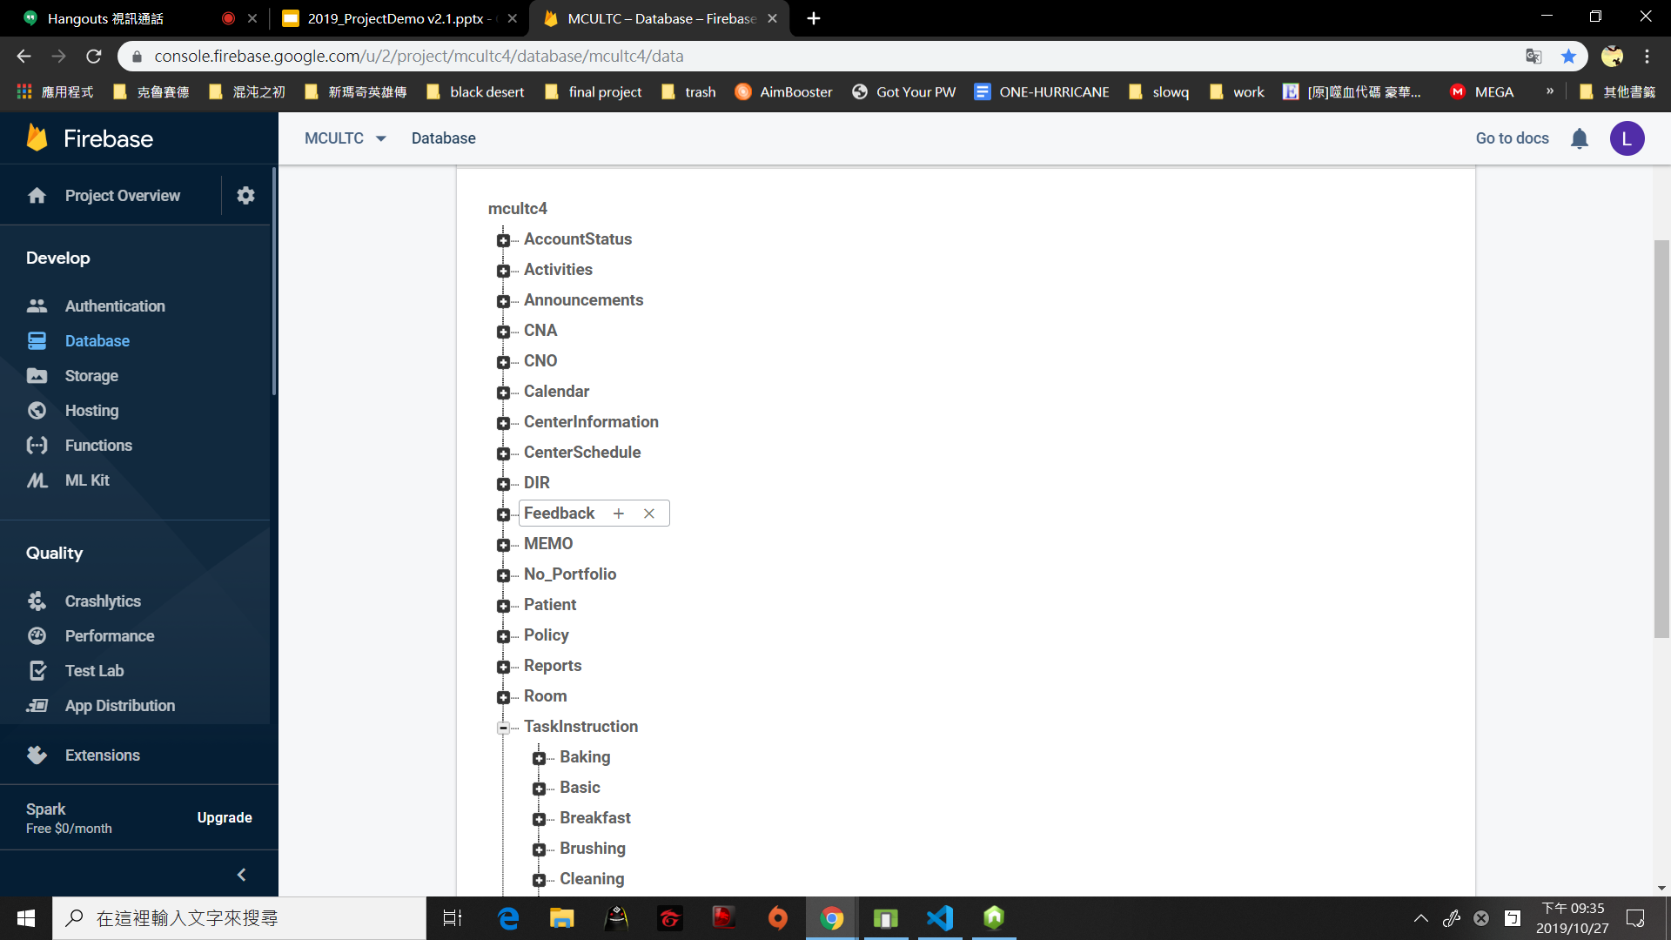

###### Figure 4.7.1: Screenshot of database

The database team manages all the data of this project. The team uses Firebase, a real time cloud database, as the DB. To use Firebase, the team had to create a new account for the project, then transfer the data structure from KU to fit the project. While Browser, APP and Hardware teams are working, the team modified the structure of data so that the DB team can serve those teams better. The team also took care of the connection to the database so the data won't get lost during the upload and download.



## 

# 5 APPENDIX

## 1.0 WORKING HOURS

### 1.1 Table of Work Hours

##### (2019.03.08-2020.01.10)

###### Table 5.1.1: Total working hours

|  |  |  |  |  |
| --- | --- | --- | --- | --- |
|  | Spring Semester  (0308-0624) | Summer Break  (0625-0909) | Fall Semester  (0910-1212) | Total |
| Eva | 77 | 93.5 | 94.5 | 265 |
| Annie | 72 | 96 | 70 | 238 |
| Andre | 96 | 125 | 220 | 441 |
| Kevin | 88 | 80 | 125 | 293 |
| Francios | 95 | 99 | 100 | 294 |
| Leon | 97 | 98 | 100 | 295 |
| Joyce | 122 | 103 | 100 | 325 |
| Atakan | 72.5 | 90 | 90 | 252.5 |
| Angela | 98.5 | 98.5 | 110 | 307 |
| Jimari | 49.5 | 75 | 119.5 | 244 |
| Vincent | 50 | 65 | 120 | 235 |
| Total | 917.5 | 1023 | 1249 | 3189.5 |

### 1.2 Meeting Minutes

|  |  |  |
| --- | --- | --- |
| Date: 2019-06-19  Location: FF205 | Time: 14:00~16:00 | Duration: 2 hours |
| Attendance | | |
| 1. Andre 2. Atakan 3. Angela 4. Annie 5. Eva 6. Francois | 1. Jimari 2. Joyce 3. Kevin 4. Leon 5. Vincent | |

|  |  |  |
| --- | --- | --- |
| Item | Discussion | Action |
| 01 | Meeting called to order at 1400   * Weekly Project Meeting was called to order at 1400, chaired by Andre Leong | N/A |
| 02 | Announcement 1   * Print out the document that we need to hand to the professor. | Decision: To save money, we decide only to print the pages that have diagrams in color and the others will print in colorless. |
| 03 | Announcement 2   * Video meeting on 6/24 21:00-23:00 | N/A |
| 04 | Announcement 3   * Attendance fee is released. Anyone who is late will have to pay. | N/A |
| 05 | Address of concerns   * Hardware team needs to buy the Microbit and the other related device. | PIC: Hardware team |
| 06 | Assignment of Work   * Setup the document for everyone to fill in their free time in the summer and decide the general meeting time for this project. | PIC: Andre will setup the google document and make sure the meeting time is available for most people. |
| 08 | Meeting Adjourned at 16:10 | N/A |

|  |  |  |
| --- | --- | --- |
| Date: 2019-06-24  Location: FF205 | Time: 21:00~22:00 | Duration: 1 hours |
| Attendance | | |
| 1. Andre 2. Atakan 3. Angela 4. Annie 5. Eva 6. Francois | 1. Jimari 2. Joyce 3. Kevin 4. Leon 5. Vincent | |

|  |  |  |
| --- | --- | --- |
| Item | Discussion | Action |
| 01 | Meeting called to order at 21:00   * Weekly Project Meeting was called to order at 1400 chaired by Andre Leong | N/A |
| 02 | Announcement 1   * Hospital visiting is on 7/18 | N/A |
| 03 | Weekly Progress Update  APP Team Progress Update   * Progress   + Debugging the codes   + Decide the working list   Browser Team Progress Update   * Progress   + Debugging the codes   + Decide the working list   Hardware Progress Update   * Progress   + Microbit is arrived | N/A |
| 04 | Assignment of Research   * Microbit Hardware specifications must be researched to assess the feasibility of potential feature changes | PIC: Eva will research Micro Bit Hardware specifications and present her findings on {meeting 2 weeks later} |
| 05 | Assignment of Work   * QAteam will have their first meeting and setup the QA testing document. | PIC: QA team |
| 06 | Meeting Adjourned at 22:00 | N/A |

|  |  |  |
| --- | --- | --- |
| Date: 2019-06-29  Location: FF205 | Time: 14:00~14:35 | Duration: 0.5 hours |
| Attendance | | |
| 1. Andre 2. Angela 3. Annie 4. Eva 5. Francois | 1. Jimari 2. Joyce 3. Kevin 4. Leon 5. Vincent | |

|  |  |  |
| --- | --- | --- |
| Item | Discussion | Action |
| 01 | Meeting called to order at 14:00   * Weekly Project Meeting was called to order at 1400 chaired by Andre Leong | N/A |
| 02 | Announcement 1   * The first presentation is in October | N/A |
| 03 | Weekly Progress Update  APP Team Progress Update   * Features Changes   + Logout function * Design Changes   + User Interface   + Taxt bar   Browser Team Progress Update   * Features Changes   + Filter * Design Changes   + Profile searching bar * Progress   + The connection to DB   Hardware Progress Update   * Progress   + Raspberry pi and the other device all arrive. | N/A |
| 04 | Meeting Adjourned at 14:35 | N/A |

|  |  |  |
| --- | --- | --- |
| Date: 2019-07-13  Location: FF205 | Time: 14:00~16:00 | Duration: 2 hours |
| Attendance | | |
| 1. Andre 2. Atakan 3. Angela 4. Annie 5. Eva 6. Francois | 1. Jimari 2. Joyce 3. Kevin 4. Leon 5. Vincent | |

|  |  |  |
| --- | --- | --- |
| Item | Discussion | Action |
| 01 | Meeting called to order at 1400   * Weekly Project Meeting was called to order at 1400 chaired by Andre Leong | N/A |
| 02 | Announcement 1   * Next meeting time is 7/20 13:30 | N/A |
| 03 | Weekly Progress Update  APP Team Progress Update   * Design Changes   + Login page   + Tables and formatting in library page   Browser Team Progress Update   * Features Changes   + About us page * Design Changes   + Picture of the logo * Progress   + Debug the website   + Reading the code of calender   Hardware Progress Update   * Progress   + Microbit is working perfect | N/A |
| 04 | Meeting Adjourned at 16:00 | N/A |

|  |  |  |
| --- | --- | --- |
| Date: 2019-07-20  Location: FF205 | Time: 13:30~15:00 | Duration: 1.5 hours |
| Attendance | | |
| 1. Andre 2. Atakan 3. Angela 4. Annie 5. Eva 6. Francois | 1. Jimari 2. Joyce 3. Kevin 4. Leon 5. Vincent | |

|  |  |  |
| --- | --- | --- |
| Item | Discussion | Action |
| 01 | Meeting called to order at 13:30   * Weekly Project Meeting was called to order at 1400 chaired by Andre Leong | N/A |
| 02 | Announcement 1   * QA team will finish the first test on 7/24 | N/A |
| 03 | Weekly Progress Update  APP Team Progress Update   * Features Changes   + New tuggle * Design Changes   + Announcement page   + Task structure   Browser Team Progress Update   * Progress   + Debugging the code of website   Hardware Progress Update   * Progress   + Connecting the device | N/A |
| 04 | Address of concerns   * LTC report: the report of new idea and function for our system after we visit the hospital. | PIC: Angela is summarizing the problem and idea we have. |
| 05 | Meeting Adjourned at 15:00 | N/A |

|  |  |  |
| --- | --- | --- |
| Date: 2019-08-17  Location: FF205 | Time: 13:45~15:15 | Duration: 1.5 hours |
| Attendance | | |
| 1. Andre 2. Atakan 3. Annie 4. Francois 5. Jimari 6. Joyce | 1. Kevin 2. Leon 3. Vincent | |

|  |  |  |
| --- | --- | --- |
| Item | Discussion | Action |
| 01 | Meeting called to order at 13:45   * Weekly Project Meeting was called to order at 1400 chaired by Andre Leong | N/A |
| 02 | Weekly Progress Update  APP Team Progress Update   * Design Changes   + Center info page * Progress   + Problem with teammate's emulator   Browser Team Progress Update   * Progress   + Coding for the website   Hardware Progress Update   * Features Changes * Design Changes * Progress   + Setting up the operating system for devices | N/A |
| 03 | Meeting Adjourned at 15:15 | N/A |

|  |  |  |
| --- | --- | --- |
| Date: 2019-08-24  Location: FF205 | Time: 13:45~14:45 | Duration: 1 hours |
| Attendance | | |
| 1. Andre 2. Atakan 3. Annie 4. Francois 5. Jimari 6. Joyce | 1. Kevin 2. Leon 3. Vincent | |

|  |  |  |
| --- | --- | --- |
| Item | Discussion | Action |
| 01 | Meeting called to order at 13:45   * Weekly Project Meeting was called to order at 1400 chaired by Andre Leong | N/A |
| 02 | Weekly Progress Update  APP Team Progress Update   * Features Changes   + Login button * Design Changes   + Announcement page   Browser Team Progress Update   * Features Changes   + E-portfolio * Design Changes   + Theme color * Progress   + Coding for calender   Hardware Progress Update   * Progress   + Connecting to DB | N/A |
| 03 | Meeting Adjourned at 14:45 | N/A |

|  |  |  |
| --- | --- | --- |
| Date: 2019-09-07  Location: FF205 | Time: 13:30~14:30 | Duration: 1 hours |
| Attendance | | |
| 1. Andre 2. Atakan 3. Annie 4. Eva 5. Francois 6. Joyce | 1. Joyce 2. Leon | |

|  |  |  |
| --- | --- | --- |
| Item | Discussion | Action |
| 01 | Meeting called to order at 13:30   * Weekly Project Meeting was called to order at 1400 chaired by Andre Leong | N/A |
| 02 | Weekly Progress Update  APP Team Progress Update   * Progress   + Coding for App   Browser Team Progress Update   * Features Changes   + Calendar setup   + Translate to chinese vision   Hardware Progress Update   * Progress   + Environment setup   + Server setup | N/A |
| 03 | Meeting Adjourned at 14:30 | N/A |

|  |  |  |
| --- | --- | --- |
| Date: 2019-09-09  Location: FF205 | Time: 14:30~15:30 | Duration: 1 hours |
| Attendance | | |
| 1. Andre 2. Ataka 3. Angela 4. Annie 5. Eva 6. Francois | 1. Jimari 2. Joyce 3. Kevin 4. Leon 5. Vincent | |

|  |  |  |
| --- | --- | --- |
| Item | Discussion | Action |
| 01 | Meeting called to order at 14:30   * Weekly Project Meeting was called to order at 1400 chaired by Andre Leong | N/A |
| 02 | Announcement 1   * Fall semester has started and have some new event coming. | N/A |
| 03 | Address of concerns   * Project demo will be on 10/21~10/25 | Decision: For the project demo, we need to prepare PPT and other equipment. |
| 04 | Meeting Adjourned at 1530 | N/A |

|  |  |  |
| --- | --- | --- |
| Date: 2019-09-16  Location: FF205 | Time: 14:30~15:30 | Duration: 1 hours |
| Attendance | | |
| 1. Andre 2. Atakan 3. Angela 4. Annie 5. Eva 6. Francois | 1. Jimari 2. Joyce 3. Kevin 4. Leon 5. Vincent | |

|  |  |  |
| --- | --- | --- |
| Item | Discussion | Action |
| 01 | Meeting called to order at 14:30   * Weekly Project Meeting was called to order at 1400 chaired by Andre Leong | N/A |
| 02 | Weekly Progress Update  APP Team Progress Update   * Design Changes   + Background of the system   + Text bar in the system   + New button design in the system   Browser Team Progress Update   * Features Changes   + Help and support page * Progress   + Coding for calender   Hardware Progress Update   * Progress   + New problem with server   + Sensor is working | N/A |
| 03 | Meeting Adjourned at 15:30 | N/A |

|  |  |  |
| --- | --- | --- |
| Date: 2019-09-23  Location: FF205 | Time: 14:00~15:00 | Duration: 1 hours |
| Attendance | | |
| 1. Andre 2. Atakan 3. Angela 4. Annie 5. Eva 6. Francois | 1. Jimari 2. Joyce 3. Kevin 4. Leon 5. Vincent | |

|  |  |  |
| --- | --- | --- |
| Item | Discussion | Action |
| 01 | Meeting called to order at 14:00   * Weekly Project Meeting was called to order at 1400 chaired by Andre Leong | N/A |
| 02 | Announcement 1   * IT exhibition will start at 12/3 and end at 12/6. | N/A |
| 03 | Weekly Progress Update  APP Team Progress Update   * Design Changes   + Daily status page   + Login icon   + Theme color   Browser Team Progress Update   * Design Changes   + Help and support page * Progress   + New problem with the connection between calendar and DB   Hardware Progress Update   * Progress   + Change the operating system to Python | N/A |
| 04 | Address of concerns   * Hardware team needs to buy one more raspberry pi. | PIC: Hardware team. |
| 05 | Meeting Adjourned at 15:00 | N/A |

|  |  |  |
| --- | --- | --- |
| Date: 2019-09-30  Location: FF205 | Time: 14:00~14:30 | Duration: 0.5 hours |
| Attendance | | |
| 1. Andre 2. Atakan 3. Angela 4. Annie 5. Eva 6. Francois | 1. Jimari 2. Joyce 3. Kevin 4. Leon 5. Vincent | |

|  |  |  |
| --- | --- | --- |
| Item | Discussion | Action |
| 01 | Meeting called to order at 14:00   * Weekly Project Meeting was called to order at 1400 chaired by Andre Leong | N/A |
| 02 | Announcement 1   * Video meeting with KU on 10/02 | Decision: Everyone should attend. |
| 03 | Address of concerns   * Issues about video meeting with KU: Professor’s schedule, equipment. | PIC: Andre will go ask the professor and bring the projector to project room. |
| 04 | Meeting Adjourned at 14:30 | N/A |

|  |  |  |
| --- | --- | --- |
| Date: 2019-10-02  Location: FF205 | Time: 20:00~21:00 | Duration: 1 hours |
| Attendance | | |
| 1. Andre 2. Atakan 3. Angela 4. Annie 5. Eva 6. Francois | 1. Jimari 2. Joyce 3. Kevin 4. Leon 5. Vincent | |

|  |  |  |
| --- | --- | --- |
| Item | Discussion | Action |
| 01 | Meeting called to order at 20:00   * Project Meeting with KU was called to order at 2000 chaired by professor Lin | N/A |
| 02 | Functionality of system from MCU  APP Team   * Changes of UI * Changes of the application structure   Browser Team   * New function of calender * New function of help and support page * Changes of UI   Hardware Team   * Changes of the device in system | N/A |
| 03 | Functionality of system from KU  APP Team   * New features of notification * Changes of CNA build in schedules * New function of biometric login   Browser Team   * Changes of status record page * New function of help and support page * New function of natural calender * New feature of search for task * New feature of sorting libraries alphabetically * New feature of feedback with director account   Hardware Team   * New function of sending notification to CNO * New function of camera on hardware * New function of screen on hardware | N/A |
| 04 | Address of concerns   * Communication of each team to hand over the update of the project. * Next official meeting. | Decision: Team leader should response for the meeting with KU |
| 05 | Meeting Adjourned at 21:00 | N/A |

|  |  |  |
| --- | --- | --- |
| Date: 2019-10-14  Location: FF205 | Time: 14:00~16:00 | Duration: 2 hours |
| Attendance | | |
| 1. Andre 2. Atakan 3. Angela 4. Annie 5. Eva 6. Francois | 1. Jimari 2. Joyce 3. Kevin 4. Leon 5. Vincent | |

|  |  |  |
| --- | --- | --- |
| Item | Discussion | Action |
| 01 | Meeting called to order at 14:00   * Weekly Project Meeting was called to order at 1400 chaired by Andre Leong | N/A |
| 02 | Announcement 1   * We should take photo for the project demo. Taking pictures either on Mon. or Wed.. | PIC: Andre will take photo for everyone. |
| 03 | Announcement 2   * Project demo reschedule to Nov. 1. | N/A |
| 04 | Weekly Progress Update  APP Team Progress Update   * Features Changes   + Search function * Design Changes   + New design of announcement page   Browser Team Progress Update   * Progress   + Fix the problem in status record page   Hardware Progress Update   * Progress   + New raspberry pi is working   + Fix the connection between raspberry pi and microbit | N/A |
| 06 | Address of concerns   * We need to have a Mac to test the project on IOS. | Decision: Asked and borrow from school |
| 08 | Assignment of Work   * QA team are going to have a second round of testing. | PIC:QA teams |
| 11 | Meeting Adjourned at 16:00 | N/A |

|  |  |  |
| --- | --- | --- |
| Date: 2019-10-21  Location: FF205 | Time: 14:30~15:30 | Duration: 1 hours |
| Attendance | | |
| 1. Andre 2. Atakan 3. Angela 4. Annie 5. Eva 6. Francois | 1. Jimari 2. Joyce 3. Kevin 4. Leon 5. Vincent | |

|  |  |  |
| --- | --- | --- |
| Item | Discussion | Action |
| 01 | Meeting called to order at 14:30   * Weekly Project Meeting was called to order at 1400 chaired by Andre Leong | N/A |
| 02 | Announcement 1   * We should have a rehearsal of the demo presentation | Decision: We choose it on 10/31 700p.m. |
| 03 | Weekly Progress Update  APP Team Progress Update   * Design Changes   + The format of center info page * Progress   + Fix the library clone   + Fix the announcement clone   Browser Team Progress Update   * Progress   + Fix the display problem in status record page   + The connection between calendar and DB   Hardware Progress Update   * Progress   + To generate the report on the server | N/A |
| 04 | Address of concerns   * Demo presentation is coming and we should prepare. Arrangement what we are going to present in the presentation. | Decision: We will have a PPT and have some equipment to set up for the presentation. |
| 05 | Meeting Adjourned at 15:30 | N/A |

|  |  |  |
| --- | --- | --- |
| Date: 2019-10-28  Location: FF205 | Time: 14:00~15:00 | Duration: 1 hours |
| Attendance | | |
| 1. Andre 2. Atakan 3. Angela 4. Annie 5. Eva 6. Francois | 1. Jimari 2. Joyce 3. Kevin 4. Leon 5. Vincent | |

|  |  |  |
| --- | --- | --- |
| Item | Discussion | Action |
| 01 | Meeting called to order at 14:00   * Weekly Project Meeting was called to order at 1400 chaired by Andre Leong | N/A |
| 02 | Weekly Progress Update  APP Team Progress Update   * Design Changes   + Picture of task   + Daily status page   Browser Team Progress Update   * Progress   + Debugging the calendar   Hardware Progress Update   * Progress   + Success of connecting to DB | N/A |
| 03 | Address of concerns   * The Power Point for demo presentation | N/A |
| 04 | Meeting Adjourned at 15:00 | N/A |

|  |  |  |
| --- | --- | --- |
| Date: 2019-11-11  Location: FF205 | Time: 14:00~15:00 | Duration: 1 hours |
| Attendance | | |
| 1. Andre 2. Atakan 3. Angela 4. Annie 5. Eva 6. Francois | 1. Jimari 2. Joyce 3. Kevin 4. Leon 5. Vincent | |

|  |  |  |
| --- | --- | --- |
| Item | Discussion | Action |
| 01 | Meeting called to order at 14:00   * Weekly Project Meeting was called to order at 1400 chaired by Andre Leong | N/A |
| 02 | Announcement 1   * Professor wants the draft of project report before the end of Nov.. | Decision: Setup the doodle document for everyone to modify it |
| 03 | Address of concerns   * The feedback from professor about demo presentation. Talk about more of the project history; To shoe our code; add more explanation about project function and feature. | N/A |
| 04 | Meeting Adjourned at 15:00 | N/A |

|  |  |  |
| --- | --- | --- |
| Date: 2019-11-18  Location: FF205 | Time: 14:00~14:30 | Duration: 0.5 hours |
| Attendance | | |
| 1. Andre 2. Atakan 3. Angela 4. Annie 5. Eva 6. Francois | 1. Jimari 2. Joyce 3. Kevin 4. Leon 5. Vincent | |

|  |  |  |
| --- | --- | --- |
| Item | Discussion | Action |
| 01 | Meeting called to order at 14:00   * Weekly Project Meeting was called to order at 1400 chaired by Andre Leong | N/A |
| 02 | Announcement 1   * We will go to talk with professor Lin on Wed. about the draft | N/A |
| 03 | Address of concerns   * IT exhibition is coming soon. We should start preparing for it. | N/A |
| 04 | Meeting Adjourned at 1530 | N/A |

|  |  |  |
| --- | --- | --- |
| Date: 2019-11-25  Location: FF205 | Time: 14:00~16:00 | Duration: 2 hours |
| Attendance | | |
| 1. Andre 2. Atakan 3. Angela 4. Annie 5. Eva 6. Francois | 7. Jimari  8. Joyce  9. Kevin  10. Leon  11. Vincent | |

|  |  |  |
| --- | --- | --- |
| Item | Discussion | Action |
| 01 | Meeting called to order at 14:00   * Weekly Project Meeting was called to order at 1400 chaired by Andre Leong | N/A |
| 02 | Announcement 1   * We will have online video meeting for finalize the stuff we need to print. | Decision: video meeting on Thu. 7p.m. & Sun. 8 p.m. |
| 03 | Weekly Progress Update  Browser Team Progress Update   * Features Changes   + Change to google calendar   + Calendar sharing | N/A |
| 04 | Address of concerns   * The document we need on IT exhibition   + Flyer, 8 pages, including Cover, App team, Browser team ,Hardware team, Intro, DB   + Poster, size of text is 14 and paragraph spacing is 1.25   + Baner, the design can base on the cover of poster | N/A |
| 05 | Assignment of Work   * Everyone should work on the document   + Flyer     - Each team should finish their part     - Andre & Jimari will do the Intro     - Leon will do the DB page   + Poster will finish by Eva and Annie   + Baner will finish by Eva | N/A |
| 06 | Meeting Adjourned at 16:00 | N/A |

|  |  |  |
| --- | --- | --- |
| Date: 2019-12-02  Location: FF205 | Time: 14:00~15:30 | Duration: 1.5 hours |
| Attendance | | |
| 1. Andre 2. Atakan 3. Angela 4. Annie 5. Eva 6. Francois | 7. Jimari  8. Joyce  9. Kevin  10. Leon  11. Vincent | |

|  |  |  |
| --- | --- | --- |
| Item | Discussion | Action |
| 01 | Meeting called to order at 14:00   * Weekly Project Meeting was called to order at 1400 chaired by Andre Leong | N/A |
| 02 | Announcement 1   * The day after tomorrow is the IT exhibition. Do not late. | N/A |
| 03 | Address of concerns   * We will setup part of the equipment tomorrow morning. Bring the Hardware, TV monitor, cable and flag to the exhibition place | PIC: Andre, Leon and Kevin will come to project room in the morning and bring the equipment[ment to the exhibition place |
| 04 | Assignment of Work   * IT exhibition has three days and we will take turns to attend it.   + Wed.     - 09:00-12:00 Decorate the poster, flyer and the baner     - 12:00-14:00 After opening, Joyce & Eva will stay     - 14:00-16:00 Turn to Atakan & Annie’s group   + Thu.     - 09:00-12:00 Turn to Francois & Jimari’s group     - 12:00-14:00 Turn to Leon & Kevin’s group     - 14:00-16:00 Turn to Vincent & Andre’s group   + Fri.     - 09:00-12:00 Ending, everyone should attend | N/A |
| 05 | Meeting Adjourned at 15:30 | N/A |

|  |  |  |
| --- | --- | --- |
| Date: 2019-12-09  Location: FF205 | Time: 14:00~15:30 | Duration: 1.5 hours |
| Attendance | | |
| 1. Andre 2. Atakan 3. Angela 4. Annie 5. Eva 6. Francois | 1. Jimari 2. Joyce 3. Kevin 4. Leon 5. Vincent | |

|  |  |  |
| --- | --- | --- |
| Item | Discussion | Action |
| 01 | Meeting called to order at 1400   * Weekly Project Meeting was called to order at 1400 chaired by Andre Leong | N/A |
| 03 | Announcement 1   * We should add the effort hour in to project final report. | Decision: Everyone should finish the effort hour record before Thursday. |
| 04 | Announcement 2   * There are 4 copies of project final report have to pass to Anita by this Friday. | PIC: Angla will print the document this Friday |
| 06 | Address of concerns   * The final presentation will be on 12/24 5:00 p.m. * We will need to have rehearsal and practice the final presentation | Decision: We will modify the PPT of demo and use it as final |
| 11 | Meeting Adjourned at 15:30 | N/A |

## 2.0 QA Testing

### 2.1 INTRODUCTION

#### 2.1.1 Purpose

The purpose of this section is to outline the tests on the system which will be performed to verify and validate the functionalities of the LTC-TMS. The specifications for the tests themselves, the testing environments, and the desired outcomes are given in detail in three sections which are explained next in Test Approach.

#### 2.1.2 Test Approach

The testing phase consists of three major parts, arranged as follows:

Section ii: Test Configurations, which are the various mobile environments/devices on which testing will be performed. To ensure that the app and the browser version work in a variety of Android, iOS and computer devices, the testers are using , phones, and computers, with different versions of Operating Systems. Section iii: Test Cases, which test a single functionality; these will be performed by individual testers, with results documented in tables.

Prior to the testing phase, the developers performed unit testing while implementing the requirements. Once the basic functions were working, the testers will then begin formal “black box” validation and verification testing and documentation of defects also occur at this time.

#### 2.1.3 Testing and Product Delivery Dates

The project has three major phases called Sprints which should be deliveries to the client on time. Sprint 1 is scheduled for August 30th 2019. Sprint 2 is scheduled for October 26th, 2019. The final delivery or Sprint 3 is scheduled for 18th December, 2019.

#### 2.1.4 Explanatory Material: Acronyms & References Table

The acronyms specified in the table below will be used throughout this document.

###### Table 5.2.1 Acronyms frequently used

|  |  |
| --- | --- |
| Acronyms | Full Name |
| FR | Functional Requirements |
| LTC-TMS | Long Term Care - Task Management System |
| KU | Kutztown University |
| MRR | Modification Request Report |
| SRS | Software Requirements Specification |

## 3.0 TEST CONFIGURATIONS

The purpose of using multiple testing devices is to ensure the software works on the various targeted devices. A test configuration is what device the testers are using, the environment of the device and the operation system. Note: Test Devices with simulator at the end are being used via laptop computer and an emulator.

###### Table 5.3.1 Showing QA team test configurations

|  |  |  |  |  |  |
| --- | --- | --- | --- | --- | --- |
| Test Config Number | Team Member | Role | Development Environment | Test Device | Test Device OS |
| TC 1.1 | Jimari | Tester | Chrome Web Browsers | Acer Nitro 5 | Windows 10 |
| TC 2.1 | Jimari | Tester | Android OS | Nexus 6 | Android 9.0 |
| TC 2.2 | Francois | Tester | Apple IOS | iPhone Xs Max | IOS 12.1.4 |
| TC 3.3 | Francois | Tester | Chrome Web Browser | Asus X302UV | Windows 10 |
| TC 4.1 | Annie | Tester | Chrome Web Browsers | Acer Aspire S | Windows 10 |
| TC 5.1 | Annie | Tester | Raspberry PI | MCKU-BOX/MCKU-Life | Raspberry PI-OS |
|  | | | | | |

## 

## 4.0 TEST CASES

The features that will be tested outline the general functionality of each application, respectively. Requirement IDs are based from which components they belong to. Browser ID will have a 0 in front of the number. App requirements will be defined by having a 1 in front of the original number. Hardware requirements will have a 2 in front of the original number.

### 4.1 Browser

#### 4.1.1 General Testing

##### Log In (IT admin)

|  |  |
| --- | --- |
| Test Case/Browser | |
| Test Case ID | 0.01 |
| Owner of Test | Annie |
| Test Name | Login as IT admin |
| Last Revision Date | 11/20/2019 |
| Test Location | FF Project Room |
| Test Configuration | TC 4.1 |
| Test Interdependencies | N/A |
| Test Objective | Director must be able to log in successfully |
| Test Procedure | |
| Test Setup | Open the browser application |
| Steps to Perform | 1. Navigate to website 2. Enter username 3. Enter Password |
| Expected Results | Login should trigger an error if the information is wrong or a success message if the user was able to login successfully. |
| Test Data | <https://mcultc4.firebaseapp.com/Frontend/00Login2.html> |
| Test Result | |
| Tester | Annie |
| Test Result (Pass/Fail) | Pass |
| Notes | Pass |
| Test Date | 7/10/2019 |

##### Create account (IT admin)

|  |  |
| --- | --- |
| Test Case/Browser | |
| Test Case ID | 0.02 |
| Owner of Test | Francois |
| Test Name | IT admin create account |
| Last Revision Date | 11/20/2019 |
| Test Location | FF Project Room |
| Test Configuration | TC 3.3 |
| Test Interdependencies | N/A |
| Test Objective | IT admin must be able to create account in successfully |
| Test Procedure | |
| Test Setup | Open the browser application |
| Steps to Perform | 1. Navigate to website  2. Enter Username  3. Enter Password  4. View User Management  5. Create Account  6. Enter New Username  7. Enter New Password |
| Expected Results | IT admin creates new account in successfully |
| Test Data | <https://mcultc4.firebaseapp.com/Frontend/00Login2.html> |
| Test Result | |
| Tester | Francois |
| Test Result (Pass/Fail) | Pass |
| Notes | Pass |
| Test Date | 7/10/2019 |

##### Delete account (IT admin)

|  |  |
| --- | --- |
| Test Case/Browser | |
| Test Case ID | 0.03 |
| Owner of Test | Annie |
| Test Name | IT admin delete account |
| Last Revision Date | 11/20/2019 |
| Test Location | FF Project Room |
| Test Configuration | TC 4.1 |
| Test Interdependencies | N/A |
| Test Objective | IT admin delete the account |
| Test Procedure | |
| Test Setup | Open the browser application |
| Steps to Perform | 1. Navigate to website 2. Enter username 3. Enter Password 4. Log in 5. User management page 6. Delete Account 7. Refresh the page 8. Enter username 9. Enter Password 10. Log in 11. User management page |
| Expected Results | In the user management page the delete account already deleted. |
| Test Data | <https://mcultc4.firebaseapp.com/Frontend/00Login2.html> |
| Test Result | |
| Tester | Annie |
| Test Result (Pass/Fail) | Pass |
| Notes | Pass |
| Test Date | 7/10/2019 |

##### View tabs (IT admin)

|  |  |
| --- | --- |
| Test Case/Browser | |
| Test Case ID | 0.04 |
| Owner of Test | Jimari |
| Test Name | View Tabs on IT Admin Page |
| Last Revision Date | 11/20/2019 |
| Test Location | FF Project Room |
| Test Configuration | TC 1.1 |
| Test Interdependencies | N/A |
| Test Objective | IT admin must be able to view the Contact Us Tab, View Feedback Tab and View User Management Tab |
| Test Procedure | |
| Test Setup | Open the browser application |
| Steps to Perform | 1.Navigate to website  2. Enter Username  3. Enter Password  4. View Contact Us  5. View Feedback  6. View User Management |
| Expected Results | IT admin should be able to view the information in all the tabs. |
| Test Data | <https://mcultc4.firebaseapp.com/Frontend/00Login2.html> |
| Test Result | |
| Tester | Jimari |
| Test Result (Pass/Fail) | Pass |
| Notes | Pass |
| Test Date | 7/10/2019 |

##### Log out (IT admin)

|  |  |
| --- | --- |
| Test Case/Browser | |
| Test Case ID | 0.05 |
| Owner of Test | Jimari |
| Test Name | Log Out as IT admin |
| Last Revision Date | 11/20/2019 |
| Test Location | FF Project Room |
| Test Configuration | TC 1.1 |
| Test Interdependencies | N/A |
| Test Objective | IT Admin must be able to log out successfully |
| Test Procedure | |
| Test Setup | Open the browser application |
| Steps to Perform | 1. Navigate to the setting wheel.  2. Click the logout button.  3. Confirm you want to logout. |
| Expected Results | Log out click should go to confirm log out and click once and IT admin account will be logged out. |
| Test Data | <https://mcultc4.firebaseapp.com/Frontend/00Login2.html> |
| Test Result | |
| Tester | Jimari |
| Test Result (Pass/Fail) | Fail |
| Notes | After clicking the logout you need to confirm twice before the account is logged out. |
| Test Date | 7/10/2019 |

#### 4.1.2 Director Specific Testing

##### Log in

|  |  |
| --- | --- |
| Test Case/Browser | |
| Test Case ID | 0.06 |
| Owner of Test | Jimari Prince |
| Test Name | Log In as Director |
| Last Revision Date | 11/20/2019 |
| Test Location | FF Project Room |
| Test Configuration | TC 1.1 |
| Test Interdependencies | N/A |
| Test Objective | Director must be able to log in successfully |
| Test Procedure | |
| Test Setup | Open the browser application |
| Steps to Perform | 1. Navigate to website 2. Enter username 3. Enter Password |
| Expected Results | Login should trigger an error if the information is wrong or a success message if the user was able to login successfully. |
| Test Data | <https://mcultc4.firebaseapp.com/Frontend/00Login2.html> |
| Test Result | |
| Tester | Jimari |
| Test Result (Pass/Fail) | Pass |
| Notes | Pass |
| Test Date | 7/10/2019 |

##### Add Schedule

|  |  |
| --- | --- |
| Test Case/Browser | |
| Test Case ID | 0.07 |
| Owner of Test | Annie |
| Test Name | Director - Director add schedule |
| Last Revision Date | 11/20/2019 |
| Test Location | FF Project Room |
| Test Configuration | TC 4.1 |
| Test Interdependencies | N/A |
| Test Objective | Director create new schedule |
| Test Procedure | |
| Test Setup | Open the browser application |
| Steps to Perform | 1. Navigate to website 2. Set text 3. Set encrypted text 4. Click log in 5. Click Schedule 6. Click plus button 7. Set text 8. Click Submit |
| Expected Results | Director create new schedule. |
| Test Data | <https://mcultc4.firebaseapp.com/Frontend/00Login2.html> |
| Test Result | |
| Tester | Annie |
| Test Result (Pass/Fail) | Pass |
| Notes | Pass |
| Test Date | 7/15/2019 |

##### Delete schedule

|  |  |
| --- | --- |
| Test Case/Browser | |
| Test Case ID | 0.08 |
| Owner of Test | Annie |
| Test Name | Director delete schedule |
| Last Revision Date | 11/20/2019 |
| Test Location | FF Project Room |
| Test Configuration | TC 4.1 |
| Test Interdependencies | N/A |
| Test Objective | Direct delete the schedule |
| Test Procedure | |
| Test Setup | Open the browser application |
| Steps to Perform | 1. Navigate to website 2. Set text 3. Set encrypted text 4. Click log in 5. Click Schedule 6. Click delete button 7. Click sure |
| Expected Results | Director delete schedule. |
| Test Data | <https://mcultc4.firebaseapp.com/Frontend/00Login2.html> |
| Test Result | |
| Tester | Annie |
| Test Result (Pass/Fail) | Pass |
| Notes | Pass |
| Test Date | 7/14/2019 |

##### Create/edit/delete the memo

|  |  |
| --- | --- |
| Test Case/Browser | |
| Test Case ID | 0.09 |
| Owner of Test | Annie |
| Test Name | Director create/edit/delete the Memo |
| Last Revision Date | 11/20/2019 |
| Test Location | FF Project Room |
| Test Configuration | TC 4.1 |
| Test Interdependencies | N/A |
| Test Objective | Direct create/edit/delete |
| Test Procedure | |
| Test Setup | Open the browser application |
| Steps to Perform | 1. Navigate to website 2. Set text 3. Set encrypted text 4. Click log in 5. Click Memo 6. Click Add memo 7. Set text 8. Click Submit 9. Click Edit 10. Set text 11. Click Submit 12. Click Delete 13. Click Sure |
| Expected Results | Director create/edit/delete the Memo Successfully. |
| Test Data | <https://mcultc4.firebaseapp.com/Frontend/00Login2.html> |
| Test Result | |
| Tester | Annie |
| Test Result (Pass/Fail) | Pass |
| Notes | Pass |
| Test Date | 7/15/2019 |

##### Check Details of my task

|  |  |
| --- | --- |
| Test Case/Browser | |
| Test Case ID | 0.10 |
| Owner of Test | Annie |
| Test Name | Check details in my task |
| Last Revision Date | 11/20/2019 |
| Test Location | Home |
| Test Configuration | TC 4.1 |
| Test Interdependencies | N/A |
| Test Objective | See the details in my task |
| Test Procedure | |
| Test Setup | Open the browser application |
| Steps to Perform | 1. Click my task 2. Click details 3. Click Here: see the details of the task 4. Click close task |
| Expected Results | Check my task can see the details. |
| Test Data | <https://mcultc4.firebaseapp.com/Frontend/00Login2.html> |
| Test Result | |
| Tester | Annie |
| Test Result (Pass/Fail) | Pass |
| Notes | Pass |
| Test Date | 7/15/2019 |

##### Edit my task

|  |  |
| --- | --- |
| Test Case/Browser | |
| Test Case ID | 0.11 |
| Owner of Test | Annie |
| Test Name | Edit my task |
| Last Revision Date | 11/20/2019 |
| Test Location | Home |
| Test Configuration | TC 4.1 |
| Test Interdependencies | N/A |
| Test Objective | Edit my task |
| Test Procedure | |
| Test Setup | Open the browser application |
| Steps to Perform | 1. Click my task 2. Click edit 3. Enter task name 4. Select category 5. Enter VIdeo URL 6. Enter task outline 7. Select task visibility(visible) 8. Select publication status(published) 9. Task step1 input step name (one) 10. Select File open and upload 11. Input detailed step 12. Add detailed step 13. Add step 14. Save task |
| Expected Results | Edit my task successfully. |
| Test Data | <https://mcultc4.firebaseapp.com/Frontend/00Login2.html> |
| Test Result | |
| Tester | Annie |
| Test Result (Pass/Fail) | Pass |
| Notes | Pass |
| Test Date | 7/15/2019 |

##### Assign My task

|  |  |
| --- | --- |
| Test Case/Browser | |
| Test Case ID | 0.12 |
| Owner of Test | Annie |
| Test Name | Assign my task to patient |
| Last Revision Date | 11/20/2019 |
| Test Location | Home |
| Test Configuration | TC 4.1 |
| Test Interdependencies | N/A |
| Test Objective | Assign tasks to others |
| Test Procedure | |
| Test Setup | Open the browser application |
| Steps to Perform | 1. Click my task 2. Click assign 3. Click assign task 4. Click close |
| Expected Results | Check my task can assign to the patient |
| Test Data | <https://mcultc4.firebaseapp.com/Frontend/00Login2.html> |
| Test Result | |
| Tester | Annie |
| Test Result (Pass/Fail) | Pass |
| Notes | Pass(but not sure is the task directly send to the patient successfully or not because don’t know patient’s account id and password) |
| Test Date | 7/21/2019 |

##### Remove My task

|  |  |
| --- | --- |
| Test Case/Browser | |
| Test Case ID | 0.13 |
| Owner of Test | Annie |
| Test Name | Remove my task |
| Last Revision Date | 11/20/2019 |
| Test Location | Home |
| Test Configuration | TC 4.1 |
| Test Interdependencies | N/A |
| Test Objective | Remove the task from my task |
| Test Procedure | |
| Test Setup | Open the browser application |
| Steps to Perform | 1. Click my task 2. Click remove |
| Expected Results | Remove the task |
| Test Data | <https://mcultc4.firebaseapp.com/Frontend/00Login2.html> |
| Test Result | |
| Tester | Annie |
| Test Result (Pass/Fail) | Pass |
| Notes | Pass |
| Test Date | 7/21/2019 |

##### Generate report

|  |  |
| --- | --- |
| Test Case/Browser | |
| Test Case ID | 0.14 |
| Owner of Test | Annie |
| Test Name | Director generate report |
| Last Revision Date | 11/20/2019 |
| Test Location | FF Project Room |
| Test Configuration | TC 4.1 |
| Test Interdependencies | N/A |
| Test Objective | Director generate report |
| Test Procedure | |
| Test Setup | Open the browser application |
| Steps to Perform | 1. Click reports 2. Select start date 3. Select patient name 4. Click generate report |
| Expected Results | Successfully generate the patient report |
| Test Data | <https://mcultc4.firebaseapp.com/Frontend/00Login2.html> |
| Test Result | |
| Tester | Annie |
| Test Result (Pass/Fail) | Fail |
| Notes | When I click the generate report and wait for a while there’s nothing come out. |
| Test Date | 7/21/2019 |

##### Check E-portfolio

|  |  |
| --- | --- |
| Test Case/Browser | |
| Test Case ID | 0.15 |
| Owner of Test | Annie |
| Test Name | Check e-portfolio |
| Last Revision Date | 11/20/2019 |
| Test Location | Home |
| Test Configuration | TC 4.1 |
| Test Interdependencies | N/A |
| Test Objective | To see user’s and patient’s e-portfolio |
| Test Procedure | |
| Test Setup | Open the browser application |
| Steps to Perform | 1. Click e-portfolio 2. Choose position 3. Choose gender 4. Click view 5. Click back |
| Expected Results | Remove the task |
| Test Data | <https://mcultc4.firebaseapp.com/Frontend/00Login2.html> |
| Test Result | |
| Tester | Annie |
| Test Result (Pass/Fail) | Pass |
| Notes | Pass |
| Test Date | 7/21/2019 |

##### Add E-portfolio

|  |  |
| --- | --- |
| Test Case/Browser | |
| Test Case ID | 0.16 |
| Owner of Test | Annie |
| Test Name | Add e-portfolio |
| Last Revision Date | 11/20/2019 |
| Test Location | Home |
| Test Configuration | TC 4.1 |
| Test Interdependencies | N/A |
| Test Objective | Add e-portfolio successfully |
| Test Procedure | |
| Test Setup | Open the browser application |
| Steps to Perform | 1. Click e-portfolio 2. Click plus button 3. Select Role(cna and patient) 4. Fill in the text 5. Click submit |
| Expected Results | Add e-portfolio in the system successfully |
| Test Data | <https://mcultc4.firebaseapp.com/Frontend/00Login2.html> |
| Test Result | |
| Tester | Annie |
| Test Result (Pass/Fail) | Fail |
| Notes | Nothing come out(message box or other else) and check the portfolio the data didn’t save. |
| Test Date | 7/21/2019 |

##### Help and support

|  |  |
| --- | --- |
| Test Case/Browser | |
| Test Case ID | 0.17 |
| Owner of Test | Francois |
| Test Name | Read the feedback from staff and family |
| Last Revision Date | 11/20/2019 |
| Test Location | FF Project Room |
| Test Configuration | TC 4.1 |
| Test Interdependencies | N/A |
| Test Objective | The feedback must be able to read successfully |
| Test Procedure | |
| Test Setup | Open the browser application |
| Steps to Perform | 1. Click help and support 2. Click staff feedback 3. Click family feedback |
| Expected Results | Director read the feedback successfully |
| Test Data | <https://mcultc4.firebaseapp.com/Frontend/00Login2.html> |
| Test Result | |
| Tester | Francois |
| Test Result (Pass/Fail) | Fail |
| Notes | Nothing comes out(such as feedback) |
| Test Date | 7/21/2019 |

#### 4.1.3 CNO Specific Testing

##### Log in

|  |  |
| --- | --- |
| Test Case/Browser | |
| Test Case ID | 0.18 |
| Owner of Test | Francois |
| Test Name | Log in as CNO |
| Last Revision Date | 11/20/2019 |
| Test Location | FF Project Room |
| Test Configuration | TC 3.3 |
| Test Interdependencies | N/A |
| Test Objective | CNO must be able to log in successfully |
| Test Procedure | |
| Test Setup | Open the web browser |
| Steps to Perform | 1. Navigate to website 2. Enter username 3. Enter Password |
| Expected Results | Login should trigger an error if the information is wrong or a success message if the user was able to login successfully |
| Test Data | <https://mcultc4.firebaseapp.com/Frontend/00Login2.html> |
| Test Result | |
| Tester | Francois |
| Test Result (Pass/Fail) | Pass |
| Notes | Pass |
| Test Date | 7/19/2019 |

##### Add Schedule

|  |  |
| --- | --- |
| Test Case/Browser | |
| Test Case ID | 0.19 |
| Owner of Test | Francois |
| Test Name | Add schedule |
| Last Revision Date | 11/20/2019 |
| Test Location | FF Project Room |
| Test Configuration | TC 3.3 |
| Test Interdependencies | N/A |
| Test Objective | New schedule must be able to add successfully |
| Test Procedure | |
| Test Setup | Open the web browser |
| Steps to Perform | 1. Navigate to website 2. Set text 3. Set encrypted text 4. Click log in 5. Click Schedule 6. Click plus button 7. Set text 8. Click Submit |
| Expected Results | CNO create new schedule successfully |
| Test Data | <https://mcultc4.firebaseapp.com/Frontend/00Login2.html> |
| Test Result | |
| Tester | Francois |
| Test Result (Pass/Fail) | Pass |
| Notes | Pass |
| Test Date | 7/19/2019 |

##### Delete schedule

|  |  |
| --- | --- |
| Test Case/Browser | |
| Test Case ID | 0.20 |
| Owner of Test | Francois |
| Test Name | Delete schedule |
| Last Revision Date | 11/20/2019 |
| Test Location | FF Project Room |
| Test Configuration | TC 3.3 |
| Test Interdependencies | N/A |
| Test Objective | The schedule must be able to delete successfully |
| Test Procedure | |
| Test Setup | Open the web browser |
| Steps to Perform | 1. Navigate to website 2. Set text 3. Set encrypted text 4. Click log in 5. Click Schedule 6. Click delete button 7. Click sure |
| Expected Results | CNO delete schedule successfully |
| Test Data | <https://mcultc4.firebaseapp.com/Frontend/00Login2.html> |
| Test Result | |
| Tester | Francois |
| Test Result (Pass/Fail) | Pass |
| Notes | Pass |
| Test Date | 7/19/2019 |

##### Create/edit/delete the memo

|  |  |
| --- | --- |
| Test Case/Browser | |
| Test Case ID | 0.21 |
| Owner of Test | Francois |
| Test Name | Create/edit/delete the Memo |
| Last Revision Date | 11/20/2019 |
| Test Location | FF Project Room |
| Test Configuration | TC 3.3 |
| Test Interdependencies | N/A |
| Test Objective | CNO creates/edit/delete |
| Test Procedure | |
| Test Setup | Open the web browser |
| Steps to Perform | 1. Navigate to website 2. Set text 3. Set encrypted text 4. Click log in 5. Click Memo 6. Click Add memo 7. Set text 8. Click Submit 9. Click Edit 10. Set text 11. Click Submit 12. Click Delete 13. Click Sure |
| Expected Results | CNO create/edit/delete the Memo successfully |
| Test Data | <https://mcultc4.firebaseapp.com/Frontend/00Login2.html> |
| Test Result | |
| Tester | Francois |
| Test Result (Pass/Fail) | Pass |
| Notes | Pass |
| Test Date | 7/19/2019 |

##### Check Details of my task

|  |  |
| --- | --- |
| Test Case/Browser | |
| Test Case ID | 0.22 |
| Owner of Test | Francois |
| Test Name | Check details in my task |
| Last Revision Date | 11/20/2019 |
| Test Location | FF Project Room |
| Test Configuration | TC 3.3 |
| Test Interdependencies | N/A |
| Test Objective | Check the details in my task |
| Test Procedure | |
| Test Setup | Open the web browser |
| Steps to Perform | 1. Click my task 2. Click details 3. Click Here: see the details of the task 4. Click close task |
| Expected Results | CNO can check my task in details |
| Test Data | <https://mcultc4.firebaseapp.com/Frontend/00Login2.html> |
| Test Result | |
| Tester | Francois |
| Test Result (Pass/Fail) | Pass |
| Notes | Pass |
| Test Date | 7/19/2019 |

##### Edit my task

|  |  |
| --- | --- |
| Test Case/Browser | |
| Test Case ID | 0.23 |
| Owner of Test | Francois |
| Test Name | Edit my task |
| Last Revision Date | 11/20/2019 |
| Test Location | FF Project Room |
| Test Configuration | TC 3.3 |
| Test Interdependencies | N/A |
| Test Objective | Edit my task |
| Test Procedure | |
| Test Setup | Open the web browser |
| Steps to Perform | 1. Click my task 2. Click edit 3. Enter task name 4. Select category 5. Enter VIdeo URL 6. Enter task outline 7. Select task visibility(visible) 8. Select publication status(published) 9. Task step1 input step name (one) 10. Select File open and upload 11. Input detailed step 12. Add detailed step 13. Add step 14. Save task |
| Expected Results | CNO can edit my task successfully |
| Test Data | <https://mcultc4.firebaseapp.com/Frontend/00Login2.html> |
| Test Result | |
| Tester | Francois |
| Test Result (Pass/Fail) | Pass |
| Notes | Pass |
| Test Date | 7/19/2019 |

##### Assign My task

|  |  |
| --- | --- |
| Test Case/Browser | |
| Test Case ID | 0.24 |
| Owner of Test | Francois |
| Test Name | Assign my task to patient |
| Last Revision Date | 11/20/2019 |
| Test Location | FF Project Room |
| Test Configuration | TC 3.3 |
| Test Interdependencies | N/A |
| Test Objective | Assign tasks to others |
| Test Procedure | |
| Test Setup | Open the web browser |
| Steps to Perform | 1. Click my task 2. Click assign 3. Click assign task 4. Click close |
| Expected Results | Check my task can assign to the patient successfully |
| Test Data | <https://mcultc4.firebaseapp.com/Frontend/00Login2.html> |
| Test Result | |
| Tester | Francois |
| Test Result (Pass/Fail) | Pass |
| Notes | Pass( Not sure is the task send to the patient directly ,but not because we don’t know the patient's account id and password) |
| Test Date | 7/19/2019 |

##### Remove My task

|  |  |
| --- | --- |
| Test Case/Browser | |
| Test Case ID | 0.25 |
| Owner of Test | Francois |
| Test Name | Remove my task |
| Last Revision Date | 20/11/2019 |
| Test Location | FF Project Room |
| Test Configuration | TC 3.3 |
| Test Interdependencies | N/A |
| Test Objective | Remove the task from my task |
| Test Procedure | |
| Test Setup | Open the web browser |
| Steps to Perform | 1. Click my task 2. Click remove |
| Expected Results | CNO remove the task successfully |
| Test Data | <https://mcultc4.firebaseapp.com/Frontend/00Login2.html> |
| Test Result | |
| Tester | Francois |
| Test Result (Pass/Fail) | Pass |
| Notes | Pass |
| Test Date | 7/19/2019 |

##### Generate report

|  |  |
| --- | --- |
| Test Case/Browser | |
| Test Case ID | 0.26 |
| Owner of Test | Francois |
| Test Name | Generate report |
| Last Revision Date | 11/20/2019 |
| Test Location | FF Project Room |
| Test Configuration | TC 3.3 |
| Test Interdependencies | N/A |
| Test Objective | The report must be able to generate successfully |
| Test Procedure | |
| Test Setup | Open the web browser |
| Steps to Perform | 1. Click reports 2. Select start date 3. Select patient name 4. Click generate report |
| Expected Results | CNO can generate the patient report successfully |
| Test Data | <https://mcultc4.firebaseapp.com/Frontend/00Login2.html> |
| Test Result | |
| Tester | Francois |
| Test Result (Pass/Fail) | Fail |
| Notes | When I click the generate report and wait for a while there’s nothing come out. |
| Test Date | 7/19/2019 |

##### Check E-portfolio

|  |  |
| --- | --- |
| Test Case/Browser | |
| Test Case ID | 0.27 |
| Owner of Test | Francois |
| Test Name | Check e-portfolio |
| Last Revision Date | 11/20/2019 |
| Test Location | FF Project Room |
| Test Configuration | TC 3.3 |
| Test Interdependencies | N/A |
| Test Objective | To see user’s and patient’s e-portfolio |
| Test Procedure | |
| Test Setup | Open the CNO browser |
| Steps to Perform | 1. Click e-portfolio 2. Choose position 3. Choose gender 4. Click view 5. Click back |
| Expected Results | Remove the task successfully |
| Test Data | <https://mcultc4.firebaseapp.com/Frontend/00Login2.html> |
| Test Result | |
| Tester | Francois |
| Test Result (Pass/Fail) | Pass |
| Notes | Pass |
| Test Date | 7/19/2019 |

##### Add E-portfolio

|  |  |
| --- | --- |
| Test Case/Browser | |
| Test Case ID | 0.28 |
| Owner of Test | Francois |
| Test Name | Add e-portfolio |
| Last Revision Date | 11/20/2019 |
| Test Location | FF Project Room |
| Test Configuration | TC 3.3 |
| Test Interdependencies | N/A |
| Test Objective | Add e-portfolio for new users |
| Test Procedure | |
| Test Setup | Open the web browser |
| Steps to Perform | 1. Click e-portfolio 2. Click plus button 3. Select Role(cna and patient) 4. Fill in the text 5. Click submit |
| Expected Results | Add e-portfolio successfully |
| Test Data | <https://mcultc4.firebaseapp.com/Frontend/00Login2.html> |
| Test Result | |
| Tester | Francois |
| Test Result (Pass/Fail) | Fail |
| Notes | Nothing come out(such as message box) and check the data of e-portfolio didn’t save. |
| Test Date | 7/19/2019 |

##### Help and support

|  |  |
| --- | --- |
| Test Case/Browser | |
| Test Case ID | 0.29 |
| Owner of Test | Francois |
| Test Name | Read the feedback from staff and family |
| Last Revision Date | 11/20/2019 |
| Test Location | FF Project Room |
| Test Configuration | TC 3.3 |
| Test Interdependencies | N/A |
| Test Objective | The feedback must be able to read successfully |
| Test Procedure | |
| Test Setup | Open the web browser |
| Steps to Perform | 1. Click help and support 2. Click staff feedback 3. Click family feedback |
| Expected Results | CNO can read the feedback successfully |
| Test Data | <https://mcultc4.firebaseapp.com/Frontend/00Login2.html> |
| Test Result | |
| Tester | Francois |
| Test Result (Pass/Fail) | Failed |
| Notes | Nothing comes out when clicking the function |
| Test Date | 7/19/2019 |

### 4.2 APP

#### 4.2.1 General Testing

##### Log In

|  |  |
| --- | --- |
| Test Case/App | |
| Test Case ID | 1.0 |
| Owner of Test | Jimari Prince |
| Test Name | Family Log In |
| Last Revision Date | 11/20/2019 |
| Test Location | FF Building Project Room |
| Test Configuration | TC 2.1 |
| Test Interdependencies | N/A |
| Test Objective | Verify family can log into system with Family account. |
| Test Procedure | |
| Test Setup | Run application |
| Steps to Perform | 1. Login as Family by entering UserName 2. Enter Password 3. Click the Login button |
| Expected Results | 1. Login is successful 2. The login button works |
| Test Data | Family - Username=”550002” / Password=”angel1234” |
| Test Result | |
| Tester | Jimari Prince |
| Test Result (Pass/Fail) | Pass |
| Notes | Pass |
| Test Date | 7/20/2019 |

##### Log Out

|  |  |
| --- | --- |
| Test Case/App | |
| Test Case ID | 1.01 |
| Owner of Test | Jimari Prince |
| Test Name | Family Log Out |
| Last Revision Date | 11/20/2019 |
| Test Location | FF Building Project Room |
| Test Configuration | TC 2.1 |
| Test Interdependencies | N/A |
| Test Objective | Verify family can log out of the system. |
| Test Procedure | |
| Test Setup | Run application |
| Steps to Perform | 1. Navigate to Portfolio Tab 2. Click Log Out 3. Click Ok |
| Expected Results | 1. Log out is successful 2. The log out button works 3. Log Out confirmation is shown |
| Test Data | Family - Username=”550002” / Password=”angel1234” |
| Test Result | |
| Tester | Jimari Prince |
| Test Result (Pass/Fail) | Pass |
| Notes | Pass |
| Test Date | 7/20/2019 |

##### Log In

|  |  |
| --- | --- |
| Test Case/App | |
| Test Case ID | 1.02 |
| Owner of Test | Jimari Prince |
| Test Name | CNA Log In |
| Last Revision Date | 11/20/2019 |
| Test Location | FF Building Project Room |
| Test Configuration | TC 2.1 |
| Test Interdependencies | N/A |
| Test Objective | CNA can log into system with CNA account. |
| Test Procedure | |
| Test Setup | Run application |
| Steps to Perform | 1. Login as CNA by entering UserName 2. Enter Password 3. Click the Login button |
| Expected Results | 1. Login is successful 2. The login button works |
| Test Data | CNA - Username=”330001” / Password=”raymond456” |
| Test Result | |
| Tester | Jimari Prince |
| Test Result (Pass/Fail) | Pass |
| Notes | Pass |
| Test Date | 7/20/2019 |

##### Log Out

|  |  |
| --- | --- |
| Test Case/App | |
| Test Case ID | 1.03 |
| Owner of Test | Jimari Prince |
| Test Name | CNA Log Out |
| Last Revision Date | 11/20/2019 |
| Test Location | FF Building Project Room |
| Test Configuration | TC 2.1 |
| Test Interdependencies | N/A |
| Test Objective | Verify CNA can log out of the system. |
| Test Procedure | |
| Test Setup | Run application |
| Steps to Perform | 1. Navigate to Portfolio Tab 2. Click Log Out 3. Click Ok |
| Expected Results | 1. Log out is successful 2. The log out button works 3. Log Out confirmation is shown |
| Test Data | Family - Username=”330001” / Password=”raymond456” |
| Test Result | |
| Tester | Jimari Prince |
| Test Result (Pass/Fail) | Pass |
| Notes | Pass |
| Test Date | 7/20/2019 |

##### View Announcement

|  |  |
| --- | --- |
| Test Case/App | |
| Test Case ID | 1.04 |
| Owner of Test | Jimari Prince |
| Test Name | Announcement Viewing(Family) |
| Last Revision Date | 11/20/2019 |
| Test Location | FF Building Project Room |
| Test Configuration | TC 2.1 |
| Test Interdependencies | N/A |
| Test Objective | Verify family can select announcement and view details. |
| Test Procedure | |
| Test Setup | Run application |
| Steps to Perform | 1. Login as Family by entering UserName 2. Enter Password 3. Click the Login button 4. View Announcement |
| Expected Results | 1. Login was successful 2. Mechanism to view announcement is available 3. User can view details of announcement |
| Test Data | Family - Username=”550002” / Password=”angel1234” |
| Test Result | |
| Tester | Jimari Prince |
| Test Result (Pass/Fail) | Pass |
| Notes | Pass |
| Test Date | 7/20/2019 |

##### View Announcement

|  |  |
| --- | --- |
| Test Case/App | |
| Test Case ID | 1.05 |
| Owner of Test | Jimari Prince |
| Test Name | Announcement Viewing(CNA) |
| Last Revision Date | 11/20/2019 |
| Test Location | FF Building Project Room |
| Test Configuration | TC 2.1 |
| Test Interdependencies | N/A |
| Test Objective | Verify CNA can view announcement and view details. |
| Test Procedure | |
| Test Setup | Run application |
| Steps to Perform | 1. Login as CNA by entering UserName 2. Enter Password 3. Click the Login button 4. Select Announcement to expand |
| Expected Results | 1. Login was successful 2. Mechanism to view announcement is available 3. User can view details of announcement |
| Test Data | Family - Username=”330001” / Password=”raymond456” |
| Test Result | |
| Tester | Jimari Prince |
| Test Result (Pass/Fail) | Pass |
| Notes | Pass |
| Test Date | 7/20/2019 |

##### Update Vital Status

|  |  |
| --- | --- |
| Test Case/App | |
| Test Case ID | 1.06 |
| Owner of Test | Jimari Prince |
| Test Name | Update Vital Status |
| Last Revision Date | 11/20/2019 |
| Test Location | FF Building |
| Test Configuration | TC 2.1 |
| Test Interdependencies | N/A |
| Test Objective | Verify CNA can update vital status of patient |
| Test Procedure | |
| Test Setup | Application installed on device |
| Steps to Perform | 1. Login as CNA by entering Username 2. Enter Password 3. Select CNA login button 4. Click the Login button 5. Select Portfolio 6. Select Vital Status 7. Update Vital Status |
| Expected Results | 1. Login to Homepage 2. Display Portfolio 3. Display Vital Status Page |
| Test Data | Username=“330001” / Password=“raymond456” |
| Test Result | |
| Tester | Jimari Prince |
| Test Result (Pass/Fail) | Pass |
| Notes | Pass |
| Test Date | 7/20/2019 |

##### Verify Submit Vital Status

|  |  |
| --- | --- |
| Test Case/App | |
| Test Case ID | 1.07 |
| Owner of Test | Jimari Prince |
| Test Name | CNA – Verify before Submitting Vital Status |
| Last Revision Date | 11/20/2019 |
| Test Location | FF Building |
| Test Configuration | TC 2.1 |
| Test Interdependencies | N/A |
| Test Objective | Verify CNA is requested to verify self before submitting vital status |
| Test Procedure | |
| Test Setup | Application installed on device |
| Steps to Perform | 1. Login as CNA by entering Username 2. Enter Password 3. Select CNA login button 4. Click the Login button 5. Select Portfolio 6. Select Vital Status 7. Update Vital Status 8. Enter CNA ID |
| Expected Results | 1. Login to Homepage 2. Display Portfolio 3. Display Vital Status Page |
| Test Data | Username=“330001” / Password=“raymond456” |
| Test Result | |
| Tester | Jimari Prince |
| Test Result (Pass/Fail) | Pass |
| Notes | Pass |
| Test Date | 7/20/19 |

##### Confirmation Vital Status was Submitted

|  |  |
| --- | --- |
| Test Case/App | |
| Test Case ID | 1.08 |
| Owner of Test | Jimari Prince |
| Test Name | CNA - Receive Confirmation Vital Status was Submitted |
| Last Revision Date | 11/20/2019 |
| Test Location | FF Building |
| Test Configuration | TC 2.1 |
| Test Interdependencies | N/A |
| Test Objective | Verify CNA is given confirmation that vital status was submitted |
| Test Procedure | |
| Test Setup | Application installed on device |
| Steps to Perform | 1. Login as CNA by entering Username 2. Enter Password 3. Select CNA login button 4. Click the Login button 5. Select Portfolio 6. Select Vital Status 7. Update Vital Status 8. Enter CNA ID 9. Select Submit 10. Check patient record for new data |
| Expected Results | 1. Login to Homepage 2. Display Portfolio 3. Display Vital Status Page 4. Submission sent to database |
| Test Data | Username=“330001” / Password=“raymond456” |
| Test Result | |
| Tester | Jimari Prince |
| Test Result (Pass/Fail) | Pass |
| Notes | Pass |
| Test Date | 7/20/2019 |

##### View AI Status

|  |  |
| --- | --- |
| Test Case/App | |
| Test Case ID | 1.09 |
| Owner of Test | Jimari Prince |
| Test Name | CNA – View Patient’s Automated Recorded Status |
| Last Revision Date | 11/20/2019 |
| Test Location | FF Building |
| Requirements Tested | FR 1.11 |
| Test Configuration | TC 2.1 |
| Test Interdependencies | N/A |
| Test Objective | Verify CNA is able to view the AI status record of patients |
| Test Procedure | |
| Test Setup | Application installed on device |
| Steps to Perform | 1. Login as CNA by entering Username 2. Enter Password 3. Select CNA login button 4. Click the Login button 5. Select Portfolio 6. Select AI Status Record |
| Expected Results | 1. Login to Homepage 2. Display Portfolio 3. Display AI Record |
| Test Data | Username=“330001” / Password=“raymond456” |
| Test Result | |
| Tester | Jimari Prince |
| Test Result (Pass/Fail) | Fail |
| Notes | No data is displayed because hardware is not yet functional. |
| Test Date | 7/20/2019 |

#### 

##### Check Center Schedule

|  |  |
| --- | --- |
| Test Case/App | |
| Test Case ID | 1.10 |
| Owner of Test | Jimari Prince |
| Test Name | CNA/Family – Check opening days and times in the week |
| Last Revision Date | 11/20/2019 |
| Test Location | FF Building |
| Test Configuration | TC 2.1 |
| Test Interdependencies | N/A |
| Test Objective | Verify CNA/Family is able to select the week and view opening times |
| Test Procedure | |
| Test Setup | Application installed on device |
| Steps to Perform | 1. Login as CNA/Family by entering Username 2. Navigate to Center Info Screen 3. Select Week 4. View Opening times |
| Expected Results | 1. Login to Homepage 2. Display Center Info 3. View Available Opening Times |
| Test Data | Username=“330001” / Password=“raymond456” |
| Test Result | |
| Tester | Jimari Prince |
| Test Result (Pass/Fail) | Pass |
| Notes | The weeks are not updated from the database because the information in the database is outdated. |
| Test Date | 7/20/2019 |

##### Call LTC

|  |  |
| --- | --- |
| Test Case/App | |
| Test Case ID | 1.11 |
| Owner of Test | Jimari Prince |
| Test Name | CNA/Family – Call LTC |
| Last Revision Date | 11/20/2019 |
| Test Location | FF Building |
| Requirements Tested | FR 1.13 |
| Test Configuration | TC 2.1 |
| Test Interdependencies | N/A |
| Test Objective | Verify CNA/Family is able to call the LTC. |
| Test Procedure | |
| Test Setup | Application installed on device |
| Steps to Perform | 1. Login as CNA/Family by entering Username and password   2. Navigate to Center Info Screen  3. Click call center button |
| Expected Results | 1. Login to Homepage 2. Display Center Info 3. Phone’s call function will open with center number inputted |
| Test Data | Username=“330001” / Password=“raymond456” |
| Test Result | |
| Tester | Jimari Prince |
| Test Result (Pass/Fail) | Pass |
| Notes | Pass |
| Test Date | 7/20/2019 |

## 5.0 New Changes Testing

These are test cases of the new changes implemented in the system.

### 5.1 APP

##### Change Login Method

|  |  |
| --- | --- |
| Test Case/App | |
| Test Case ID | 1.12 |
| Owner of Test | Jimari Prince |
| Test Name | Family/CNA – Change Login Method |
| Last Revision Date | 11/20/2019 |
| Test Location | FF Building |
| Test Configuration | TC 2.1 |
| Test Interdependencies | N/A |
| Test Objective | Verify new login method |
| Test Procedure | |
| Test Setup | Application installed on device |
| Steps to Perform | 1. Enter username and password of some account   b) CNA/Family Toggle has been deleted   1. Click log in |
| Expected Results | Login to Homepage |
| Test Data | Username=“330001” / Password=“raymond456” |
| Test Result | |
| Tester | Jimari Prince |
| Test Result (Pass/Fail) | Pass |
| Notes | Pass |
| Test Date | 9/31/2019 |

#### 

##### Add Eye Icon Function

|  |  |
| --- | --- |
| Test Case/App | |
| Test Case ID | 1.13 |
| Owner of Test | Jimari Prince |
| Test Name | Family/CNA – Add Eye Icon Function |
| Last Revision Date | 11/20/2019 |
| Test Location | FF Building |
| Test Configuration | TC 2.1 |
| Test Interdependencies | N/A |
| Test Objective | Test to see if eye icon can show the password when you type it in. |
| Test Procedure | |
| Test Setup | Application installed on device |
| Steps to Perform | 1. Enter username and password of some account 2. Click Eye Icon |
| Expected Results | See password in text form |
| Test Data | Username=“330001” / Password=“raymond456” |
| Test Result | |
| Tester | Jimari Prince |
| Test Result (Pass/Fail) | Pass |
| Notes | Pass |
| Test Date | 9/31/2019 |

##### Scroll function at Log in

|  |  |
| --- | --- |
| Test Case/App | |
| Test Case ID | 1.14 |
| Owner of Test | Jimari Prince |
| Test Name | App – Scroll Function at Log In |
| Last Revision Date | 11/20/2019 |
| Test Location | FF Building |
| Requirements Tested | FR 1.42 |
| Test Configuration | TC 2.1 |
| Test Interdependencies | N/A |
| Test Objective | Test to see if you can scroll down when you are typing in the password. |
| Test Procedure | |
| Test Setup | Application installed on device |
| Steps to Perform | 1. Enter username and password of some account 2. Try to scroll down the screen so you are able to see the keyboard and password field |
| Expected Results | Clear view of password and on screen keyboard |
| Test Data | Username=“330001” / Password=“raymond456” |
| Test Result | |
| Tester | Jimari Prince |
| Test Result (Pass/Fail) | Pass |
| Notes | Pass |
| Test Date | 9/31/2019 |

##### AI Status Check

|  |  |
| --- | --- |
| Test Case/App | |
| Test Case ID | 1.15 |
| Owner of Test | Jimari Prince |
| Test Name | App – AI Status Check |
| Last Revision Date | 11/20/2019 |
| Test Location | FF Building |
| Test Configuration | TC 2.1 |
| Test Interdependencies | N/A |
| Test Objective | Test to see if we can see any AI data. |
| Test Procedure | |
| Test Setup | Application installed on device |
| Steps to Perform | 1. Enter username and password of some account 2. Navigate to Record page 3. Click Check AI status |
| Expected Results | Able to see data being recorded from the hardware device. |
| Test Data | Username=“330001” / Password=“raymond456” |
| Test Result | |
| Tester | Jimari Prince |
| Test Result (Pass/Fail) | Fail |
| Notes | Unable to connect or see the data from the hardware device. |
| Test Date | 9/31/2019 |

##### Log Out Function

|  |  |
| --- | --- |
| Test Case/App | |
| Test Case ID | 1.16 |
| Owner of Test | Jimari Prince |
| Test Name | App – Log Out Function |
| Last Revision Date | 11/20/2019 |
| Test Location | FF Building |
| Test Configuration | TC 2.1 |
| Test Interdependencies | N/A |
| Test Objective | Test the new log out button. |
| Test Procedure | |
| Test Setup | Application installed on device |
| Steps to Perform | 1. Enter username and password of some account 2. Navigate to Portfolio 3. Click Logout icon on top right at screen 4. Click Ok |
| Expected Results | Able to Log out of account |
| Test Data | Username=“330001” / Password=“raymond456” |
| Test Result | |
| Tester | Jimari Prince |
| Test Result (Pass/Fail) | Pass |
| Notes | Pass |
| Test Date | 9/31/2019 |

##### Patient Record

|  |  |
| --- | --- |
| Test Case/App | |
| Test Case ID | 1.17 |
| Owner of Test | Jimari Prince |
| Test Name | App – Patient Record |
| Last Revision Date | 11/20/2019 |
| Test Location | FF Building |
| Requirements Tested | FR 1.42 |
| Test Configuration | TC 2.1 |
| Test Interdependencies | N/A |
| Test Objective | Test new Patient Record screen |
| Test Procedure | |
| Test Setup | Application installed on device |
| Steps to Perform | 1. Enter username and password of family/patient account 2. Navigate to Record 3. View Options for the new Record screen |
| Expected Results | Able to see new UI of Record Page |
| Test Data | Username=“330001” / Password=“raymond456” |
| Test Result | |
| Tester | Jimari Prince |
| Test Result (Pass/Fail) | Pass |
| Notes | Pass |
| Test Date | 9/31/2019 |

##### User Portfolio

|  |  |
| --- | --- |
| Test Case/App | |
| Test Case ID | 1.18 |
| Owner of Test | Jimari Prince |
| Test Name | App – Portfolio |
| Last Revision Date | 11/20/2019 |
| Test Location | FF Building |
| Test Configuration | TC 2.1 |
| Test Interdependencies | N/A |
| Test Objective | Move portfolio to Log Out screen and rename it. View new User Portfolio screen. |
| Test Procedure | |
| Test Setup | Application installed on device |
| Steps to Perform | 1. Enter username and password of some account 2. Navigate to Portfolio 3. View User Portfolio |
| Expected Results | Able to see new UI of Portfolio Page |
| Test Data | Username=“330001” / Password=“raymond456” |
| Test Result | |
| Tester | Jimari Prince |
| Test Result (Pass/Fail) | Pass |
| Notes | Pass |
| Test Date | 9/31/2019 |

##### Daily Status Add

|  |  |
| --- | --- |
| Test Case/App | |
| Test Case ID | 1.19 |
| Owner of Test | Jimari Prince |
| Test Name | App – Daily Status Add |
| Last Revision Date | 11/20/2019 |
| Test Location | FF Building |
| Test Configuration | TC 2.1 |
| Test Interdependencies | N/A |
| Test Objective | Added new fields in the daily status to be more detailed and accept more data. |
| Test Procedure | |
| Test Setup | Application installed on device |
| Steps to Perform | 1. Enter username and password of CNA account 2. Navigate to Record 3. Click Add Daily Status 4. View new added input fields |
| Expected Results | Able to see new options where you can add data (shave, poop, feed lunch etc.) |
| Test Data | Username=“330001” / Password=“raymond456” |
| Test Result | |
| Tester | Jimari Prince |
| Test Result (Pass/Fail) | Pass |
| Notes | Pass |
| Test Date | 9/31/2019 |

##### Daily Status Add

|  |  |
| --- | --- |
| Test Case/App | |
| Test Case ID | 1.20 |
| Owner of Test | Jimari Prince |
| Test Name | App – Daily Status Add |
| Last Revision Date | 11/20/2019 |
| Test Location | FF Building |
| Test Configuration | TC 2.1 |
| Test Interdependencies | N/A |
| Test Objective | Change true/false option for daily status add to a text field to add text data. |
| Test Procedure | |
| Test Setup | Application installed on device |
| Steps to Perform | 1. Enter username and password of CNA account 2. Navigate to Record 3. Click Add Daily Status 4. View new text fields 5. Input Text |
| Expected Results | Able to see new text field and input text from keyboard. |
| Test Data | Username=“330001” / Password=“raymond456” |
| Test Result | |
| Tester | Jimari Prince |
| Test Result (Pass/Fail) | Pass |
| Notes | Pass |
| Test Date | 9/31/2019 |

##### Daily Status Add

|  |  |
| --- | --- |
| Test Case/App | |
| Test Case ID | 1.21 |
| Owner of Test | Jimari Prince |
| Test Name | App – Daily Status Add |
| Last Revision Date | 11/20/2019 |
| Test Location | FF Building |
| Test Configuration | TC 2.1 |
| Test Interdependencies | N/A |
| Test Objective | Add icons/images for daily status add options |
| Test Procedure | |
| Test Setup | Application installed on device |
| Steps to Perform | 1. Enter username and password of CNA account 2. Navigate to Record 3. Click Add Daily Status 4. View Status Fields and check the icons next to the screen |
| Expected Results | Each field should have an icon next to it. |
| Test Data | Username=“330001” / Password=“raymond456” |
| Test Result | |
| Tester | Jimari Prince |
| Test Result (Pass/Fail) | Pass |
| Notes | Pass |
| Test Date | 9/31/2019 |

##### Task Library

|  |  |
| --- | --- |
| Test Case/App | |
| Test Case ID | 1.22 |
| Owner of Test | Jimari Prince |
| Test Name | App – Task Library |
| Last Revision Date | 11/20/2019 |
| Test Location | FF Building |
| Test Configuration | TC 2.1 |
| Test Interdependencies | N/A |
| Test Objective | Check the new search function in Task Library |
| Test Procedure | |
| Test Setup | Application installed on device |
| Steps to Perform | 1. Enter username and password of some account 2. Navigate to Library 3. Type in the name of a task in search bar 4. Click Enter |
| Expected Results | It should find the related task in the library |
| Test Data | Username=“330001” / Password=“raymond456” |
| Test Result | |
| Tester | Jimari Prince |
| Test Result (Pass/Fail) | Fail |
| Notes | The search bar is there, but it is unable to search for the specified task. |
| Test Date | 11/31/2019 |

##### Task Library

|  |  |
| --- | --- |
| Test Case/App | |
| Test Case ID | 1.23 |
| Owner of Test | Jimari Prince |
| Test Name | App – Task Library |
| Last Revision Date | 11/20/2019 |
| Test Location | FF Building |
| Requirements Tested | FR 1.42 |
| Test Configuration | TC 2.1 |
| Test Interdependencies | N/A |
| Test Objective | Check the new layout for task library and make sure video link is working |
| Test Procedure | |
| Test Setup | Application installed on device |
| Steps to Perform | 1. Enter username and password of some account 2. Navigate to Library 3. View new layout and drop down menu 4. Click the video link |
| Expected Results | 1. All texts should be aligned and drop down menu working 2. Video is allowed to play on the device |
| Test Data | Username=“330001” / Password=“raymond456” |
| Test Result | |
| Tester | Jimari Prince |
| Test Result (Pass/Fail) | Pass |
| Notes | Pass |
| Test Date | 9/31/2019 |

##### Announcements

|  |  |
| --- | --- |
| Test Case/App | |
| Test Case ID | 1.24 |
| Owner of Test | Jimari Prince |
| Test Name | App – Announcements |
| Last Revision Date | 11/20/2019 |
| Test Location | FF Building |
| Requirements Tested | FR 1.42 |
| Test Configuration | TC 2.1 |
| Test Interdependencies | N/A |
| Test Objective | Check new announcements creen, test swipe function to view different announcements |
| Test Procedure | |
| Test Setup | Application installed on device |
| Steps to Perform | 1. Enter username and password of some account 2. View Announcements screen with pictures 3. Swipe from right to left to see different announcements |
| Expected Results | 1. All texts should be aligned and pictures can be seen 2. Swipe function allows you to see more announcements |
| Test Data | Username=“330001” / Password=“raymond456” |
| Test Result | |
| Tester | Jimari Prince |
| Test Result (Pass/Fail) | Pass |
| Notes | Pass |
| Test Date | 9/31/2019 |

### 5.2 Browser

#### 5.2.1 Director Specific Testing

##### About Us

|  |  |
| --- | --- |
| Test Case/Browser | |
| Test Case ID | 0.30 |
| Owner of Test | Francois |
| Test Name | Testing About Us without blank space |
| Last Revision Date | 11/20/2019 |
| 19Test Location | FF Project Room |
| Test Configuration | TC 3.3 |
| Test Interdependencies | N/A |
| Test Objective | Director can view the webpage without blank space in About Us |
| Test Procedure | |
| Test Setup | Open the web browser |
| Steps to Perform | 1. Navigate to website 2. Set text 3. Set encrypted text 4. Click log in 5. Click About Us 6. Scroll the page |
| Expected Results | Director view the webpage without blank space successfully |
| Test Data | <https://mcultc4.firebaseapp.com/Frontend/00Login2.html> |
| Test Result | |
| Tester | Francois |
| Test Result (Pass/Fail) | Pass |
| Notes | Pass |
| Test Date | 10/28/2019 |

##### Implement the calendar in Schedule

|  |  |
| --- | --- |
| Test Case/Browser | |
| Test Case ID | 0.31 |
| Owner of Test | Francois |
| Test Name | Testing the calendar in Schedule |
| Last Revision Date | 11/20/2019 |
| Test Location | FF Project Room |
| Test Configuration | TC 3.3 |
| Test Interdependencies | N/A |
| Test Objective | Director can create and save an event in the new calendar |
| Test Procedure | |
| Test Setup | Open the web browser |
| Steps to Perform | 1. Navigate to website 2. Set text 3. Set encrypted text 4. Click log in 5. Click Schedule 6. Click the date in calendar 7. Input an event 8. Click OK |
| Expected Results | Director create and save an event successfully |
| Test Data | <https://mcultc4.firebaseapp.com/Frontend/00Login2.html> |
| Test Result | |
| Tester | Francois |
| Test Result (Pass/Fail) | Fail |
| Notes | Director can create an event, but can not save it |
| Test Date | 10/28/2019 |

##### Fixed Status Record

|  |  |
| --- | --- |
| Test Case/Browser | |
| Test Case ID | 0.32 |
| Owner of Test | Francois |
| Test Name | Testing Status Record |
| Last Revision Date | 11/20/2019 |
| Test Location | FF Project Room |
| Test Configuration | TC 3.3 |
| Test Interdependencies | N/A |
| Test Objective | Director can search and view each record in Status Record |
| Test Procedure | |
| Test Setup | Open the web browser |
| Steps to Perform | 1. Navigate to website 2. Set text 3. Set encrypted text 4. Click log in 5. Click Status Record 6. Click each record 7. Select the date 8. Select Patient ID 9. Click display |
| Expected Results | Director searches and view each record successfully |
| Test Data | <https://mcultc4.firebaseapp.com/Frontend/00Login2.html> |
| Test Result | |
| Tester | Francois |
| Test Result (Pass/Fail) | Fail |
| Notes | Only display part of record(Such as Daily Status, Vital Status, and AI Status). |
| Test Date | 10/28/2019 |

##### The change of filter in E-Portfolio

|  |  |
| --- | --- |
| Test Case/Browser | |
| Test Case ID | 0.33 |
| Owner of Test | Francois |
| Test Name | Change the position of filter in E-Portfolio |
| Last Revision Date | 11/20/2019 |
| Test Location | FF Project Room |
| Test Configuration | TC 3.3 |
| Test Interdependencies | N/A |
| Test Objective | Director can be more efficient way to search user information |
| Test Procedure | |
| Test Setup | Open the web browser |
| Steps to Perform | 1. Navigate to website 2. Set text 3. Set encrypted text 4. Click log in 5. Click E-Portfolio 6. Click the filter 7. Input a name |
| Expected Results | Director search user information easily |
| Test Data | <https://mcultc4.firebaseapp.com/Frontend/00Login2.html> |
| Test Result | |
| Tester | Francois |
| Test Result (Pass/Fail) | Pass |
| Notes | Pass |
| Test Date | 10/28/2019 |

##### Help and support

|  |  |
| --- | --- |
| Test Case/Browser | |
| Test Case ID | 0.34 |
| Owner of Test | Francois |
| Test Name | Read the feedback from staff and family |
| Last Revision Date | 11/20/2019 |
| Test Location | FF Project Room |
| Test Configuration | TC 3.3 |
| Test Interdependencies | N/A |
| Test Objective | The feedback must be able to read successfully |
| Test Procedure | |
| Test Setup | Open the web browser |
| Steps to Perform | 1. Navigate to website 2. Set text 3. Set encrypted text 4. Click log in 5. Click Help and Support 6. Click staff feedback 7. Click family feedback |
| Expected Results | Director can read the feedback successfully |
| Test Data | <https://mcultc4.firebaseapp.com/Frontend/00Login2.html> |
| Test Result | |
| Tester | Francois |
| Test Result (Pass/Fail) | Pass |
| Notes | Pass |
| Test Date | 10/28/2019 |

##### Chinese translation

|  |  |
| --- | --- |
| Test Case/Browser | |
| Test Case ID | 0.35 |
| Owner of Test | Francois |
| Test Name | Testing language switcher |
| Last Revision Date | 11/20/2019 |
| Test Location | FF Project Room |
| Test Configuration | TC 3.3 |
| Test Interdependencies | N/A |
| Test Objective | Language must be able to switch into Chinese |
| Test Procedure | |
| Test Setup | Open the web browser |
| Steps to Perform | 1. Navigate to website 2. Set text 3. Set encrypted text 4. Click log in 5. Click profile picture 6. Click Chinese |
| Expected Results | Director switch to Chinese successfully |
| Test Data | <https://mcultc4.firebaseapp.com/Frontend/00Login2.html> |
| Test Result | |
| Tester | Francois |
| Test Result (Pass/Fail) | Pass |
| Notes | Pass |
| Test Date | 10/28/2019 |

#### 5.2.2 CNO Specific Testing

##### About Us

|  |  |
| --- | --- |
| Test Case/Browser | |
| Test Case ID | 0.36 |
| Owner of Test | Francois |
| Test Name | Testing About Us without blank space |
| Last Revision Date | 11/20/2019 |
| Test Location | FF Project Room |
| Test Configuration | TC 3.3 |
| Test Interdependencies | N/A |
| Test Objective | CNO can view the webpage without blank space in About Us |
| Test Procedure | |
| Test Setup | Open the web browser |
| Steps to Perform | 1. Navigate to website 2. Set text 3. Set encrypted text 4. Click log in 5. Click About Us 6. Scroll the page |
| Expected Results | CNO view the webpage without blank space successfully |
| Test Data | <https://mcultc4.firebaseapp.com/Frontend/00Login2.html> |
| Test Result | |
| Tester | Francois |
| Test Result (Pass/Fail) | Pass |
| Notes | Pass |
| Test Date | 10/28/2019 |

##### Implement the calendar in Schedule

|  |  |
| --- | --- |
| Test Case/Browser | |
| Test Case ID | 0.37 |
| Owner of Test | Francois |
| Test Name | Testing the calendar in Schedule |
| Last Revision Date | 11/20/2019 |
| Test Location | FF Project Room |
| Test Configuration | TC 3.3 |
| Test Interdependencies | N/A |
| Test Objective | CNO can create and save an event in the new calendar |
| Test Procedure | |
| Test Setup | Open the web browser |
| Steps to Perform | 1. Navigate to website 2. Set text 3. Set encrypted text 4. Click log in 5. Click Schedule 6. Click the date in calendar 7. Input an event 8. Click OK |
| Expected Results | CNO create and save an event successfully |
| Test Data | <https://mcultc4.firebaseapp.com/Frontend/00Login2.html> |
| Test Result | |
| Tester | Francois |
| Test Result (Pass/Fail) | Fail |
| Notes | CNO can create an event, but can not save it |
| Test Date | 10/28/2019 |

##### Status Record

|  |  |
| --- | --- |
| Test Case/Browser | |
| Test Case ID | 0.38 |
| Owner of Test | Francois |
| Test Name | Testing Status Record |
| Last Revision Date | 11/20/2019 |
| Test Location | FF Project Room |
| Test Configuration | TC 3.3 |
| Test Interdependencies | N/A |
| Test Objective | CNO can search and view each record in Status Record |
| Test Procedure | |
| Test Setup | Open the web browser |
| Steps to Perform | 1. Navigate to website 2. Set text 3. Set encrypted text 4. Click log in 5. Click Status Record 6. Click each record 7. Select the date 8. Select Patient ID 9. Click display |
| Expected Results | CNO search and view each record successfully |
| Test Data | <https://mcultc4.firebaseapp.com/Frontend/00Login2.html> |
| Test Result | |
| Tester | Francois |
| Test Result (Pass/Fail) | Fail |
| Notes | Only display part of record(Such as Daily Status, Vital Status, and AI Status). |
| Test Date | 10/28/2019 |

##### The change of filter in E-Portfolio

|  |  |
| --- | --- |
| Test Case/Browser | |
| Test Case ID | 0.39 |
| Owner of Test | Francois |
| Test Name | Change the position of filter in E-Portfolio |
| Last Revision Date | 11/20/2019 |
| Test Location | FF Project Room |
| Test Configuration | TC 3.3 |
| Test Interdependencies | N/A |
| Test Objective | CNO can have a more efficient way to search user information |
| Test Procedure | |
| Test Setup | Open the web browser |
| Steps to Perform | 1. Navigate to website 2. Set text 3. Set encrypted text 4. Click log in 5. Click E-Portfolio 6. Click the filter 7. Input a name |
| Expected Results | CNO search user information easily |
| Test Data | <https://mcultc4.firebaseapp.com/Frontend/00Login2.html> |
| Test Result | |
| Tester | Francois |
| Test Result (Pass/Fail) | Pass |
| Notes | Pass |
| Test Date | 10/28/2019 |

##### Help and support

|  |  |
| --- | --- |
| Test Case/Browser | |
| Test Case ID | 0.40 |
| Owner of Test | Francois |
| Test Name | Read the feedback from staff and family |
| Last Revision Date | 11/20/2019 |
| Test Location | FF Project Room |
| Test Configuration | TC 3.3 |
| Test Interdependencies | N/A |
| Test Objective | The feedback must be able to read successfully |
| Test Procedure | |
| Test Setup | Open the web browser |
| Steps to Perform | 1. Navigate to website 2. Set text 3. Set encrypted text 4. Click log in 5. Click Help and Support 6. Click staff feedback 7. Click family feedback |
| Expected Results | CNO can read the feedback successfully |
| Test Data | <https://mcultc4.firebaseapp.com/Frontend/00Login2.html> |
| Test Result | |
| Tester | Francois |
| Test Result (Pass/Fail) | Pass |
| Notes | Pass |
| Test Date | 10/28/2019 |

##### Chinese translation

|  |  |
| --- | --- |
| Test Case/Browser | |
| Test Case ID | 0.41 |
| Owner of Test | Francois |
| Test Name | Testing language switcher |
| Last Revision Date | 11/20/2019 |
| Test Location | FF Project Room |
| Test Configuration | TC 3.3 |
| Test Interdependencies | N/A |
| Test Objective | Language must be able to switch into Chinese |
| Test Procedure | |
| Test Setup | Open the web browser |
| Steps to Perform | 1. Navigate to website 2. Set text 3. Set encrypted text 4. Click log in 5. Click profile picture 6. Click Chinese |
| Expected Results | CNO switch to Chinese successfully |
| Test Data | <https://mcultc4.firebaseapp.com/Frontend/00Login2.html> |
| Test Result | |
| Tester | Francois |
| Test Result (Pass/Fail) | Pass |
| Notes | Pass |
| Test Date | 10/28/2019 |

#### 5.3 Hardware Testing

Introduction :

Hardware team has Master and Slave unit of BBC micro:bit. Slave unit connect with the pulse sensor it can show the heart rate graphic and value on Mu editor. The Master unit micro:bit connect with the raspberry pi with the computer.

Description and Testing :

Master Unit

1. Device: BBC micro:bit*1, Raspberry pi *1
2. Connection: BBC micro:bit connect Raspberry pi with usb port and the Raspberry pi connect with the computer. Raspberry pi will send the data through the wifi to cloud database ( firebase ).
3. Testing : Raspberry pi successfully get the data that collect from the micro:bit and send the data directly to the firebase.

Testing Result : Not Success

Slave Unit

1. Device: BBC micro:bit*1, Pulse sensor *1
2. Connection: Connect Raspberry Pi to the micro:bit using a USB to the Micro:bit cable
3. Testing :

Micro:bit Slave unit:

Click Button A: Show BPM and Average data with LED

Testing Result : Success

Click Button B: Send Patient id to the master unit

Testing Result : Success

Data sending

Master side:

Receive the data from the slave micro:bit (radio)- steps, temperature, heart rate

Testing Result : Success

Slave side:

Get the data from the pulse sensor

Testing Result : Success

## 6.0 SOFTWARE DEFECT STATES AND SEVERITY

In the event of a defect being discovered during the testing and development stages, it is tracked in the Modification Request Report (MRR). This document is accessible by all team members and allows them to view the status of each entry, including date submitted, assigned team member, severity level, and current state. The various states include:

Open: recently discovered defect that currently is not assigned to a developer. Assigned: the defect is paired with a developer(s).

Fixed: the developer(s) are cultivating a plan to determine the origin of the defect and potential resolutions to fix the issue.

Failed: The tester has retested the area where the defect occurs, and the defect still appeared.

Closed: the defect was successfully fixed, and no further related issues have developed.

There are 5 severity levels for defects: Neutral, Minor, Major, Critical and Enhancement, according to the MRR. Enhancements severity defects will be depicted as severity level 5, which means that they have close to no impact to the project. These kinds of defects there to try and make the project better, not to achieve any particular functional requirements. Minor defects will be depicted as a severity level 4, which can cause a small impact on the project. Defects with Minor severity level will need to be addressed within a week time. Defects with Neutral severity level are depicted as level 3, which means they do have some impact on the project. Major defects will have a severity level of 2, these will cause a moderate impact on the project. These defects will need to be addressed in 2 to 3 days. Critical defects will have a severity level of 1, which will either make it impossible for the user or tester to continue with the system. Defects with this severity will need to be addressed as soon as possible, hopefully within 24 hours of the error being found.

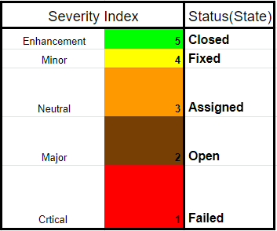

###### Figure 5.6.1 Image showing severity index parameters

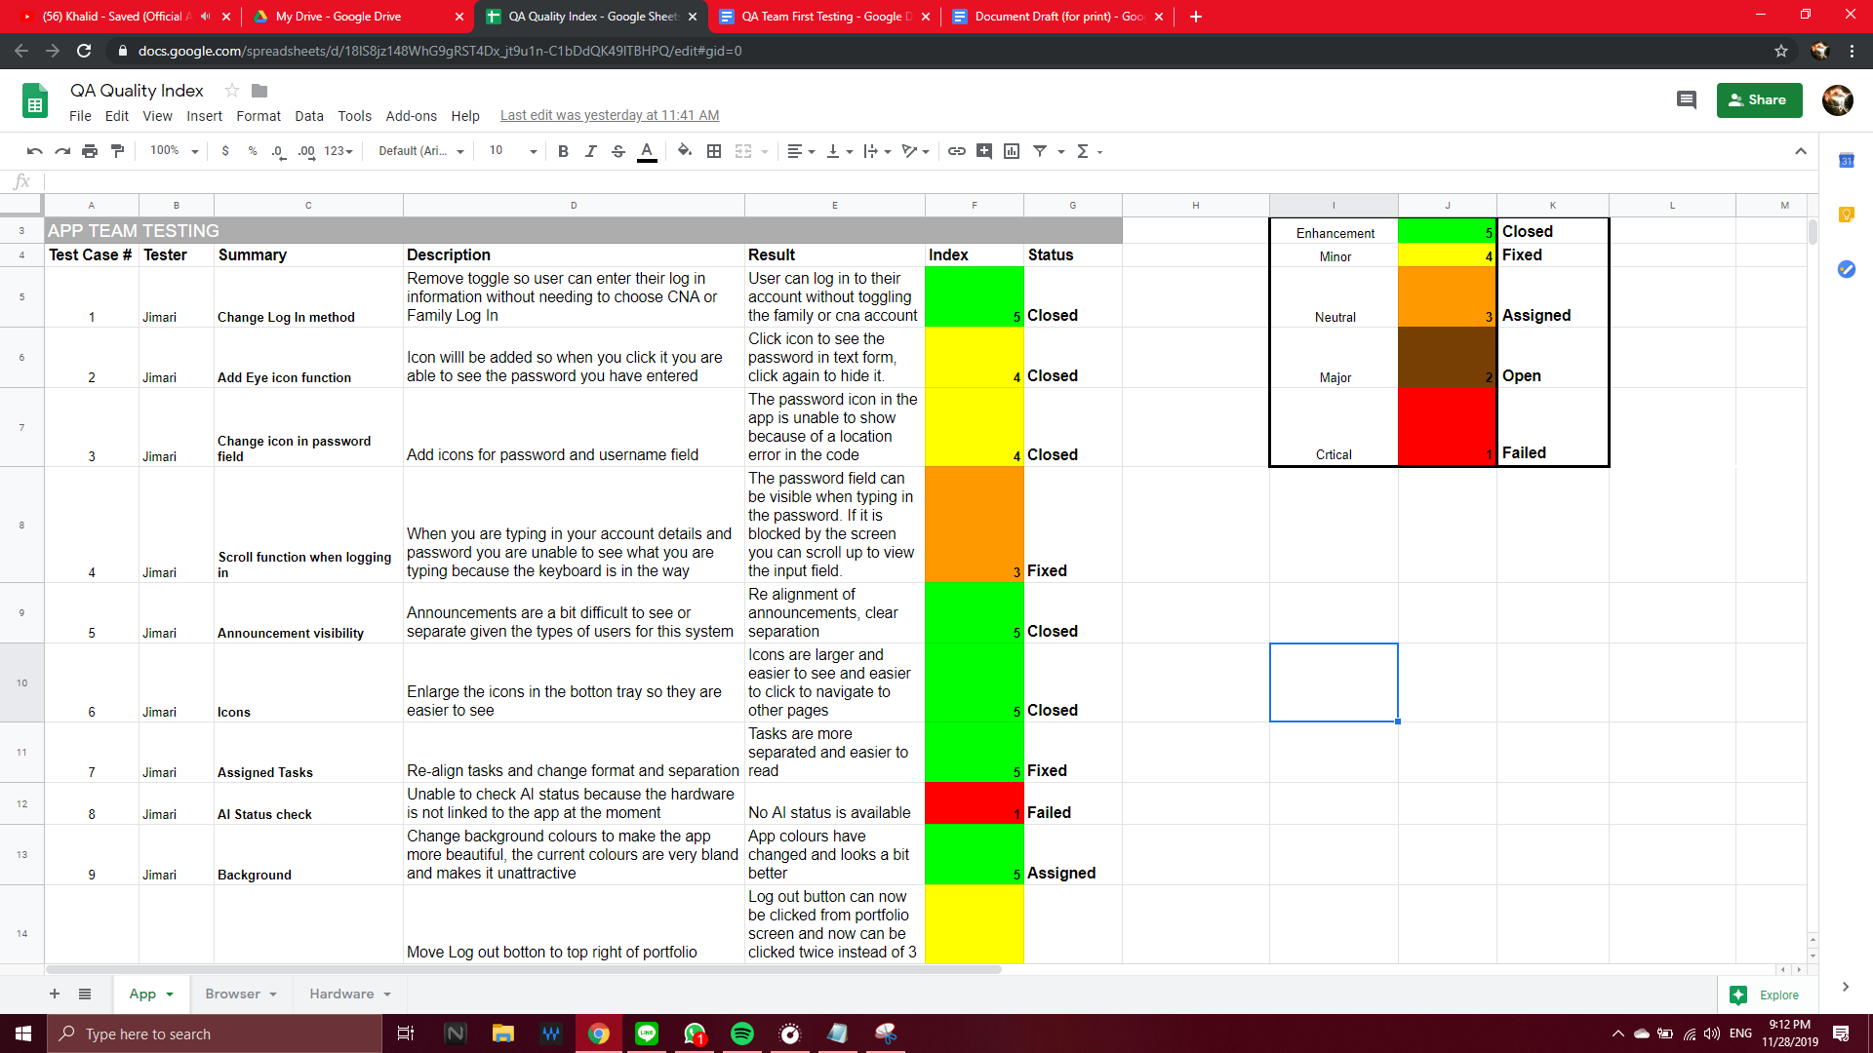

###### Figure 5.6.2 Image showing app severity index

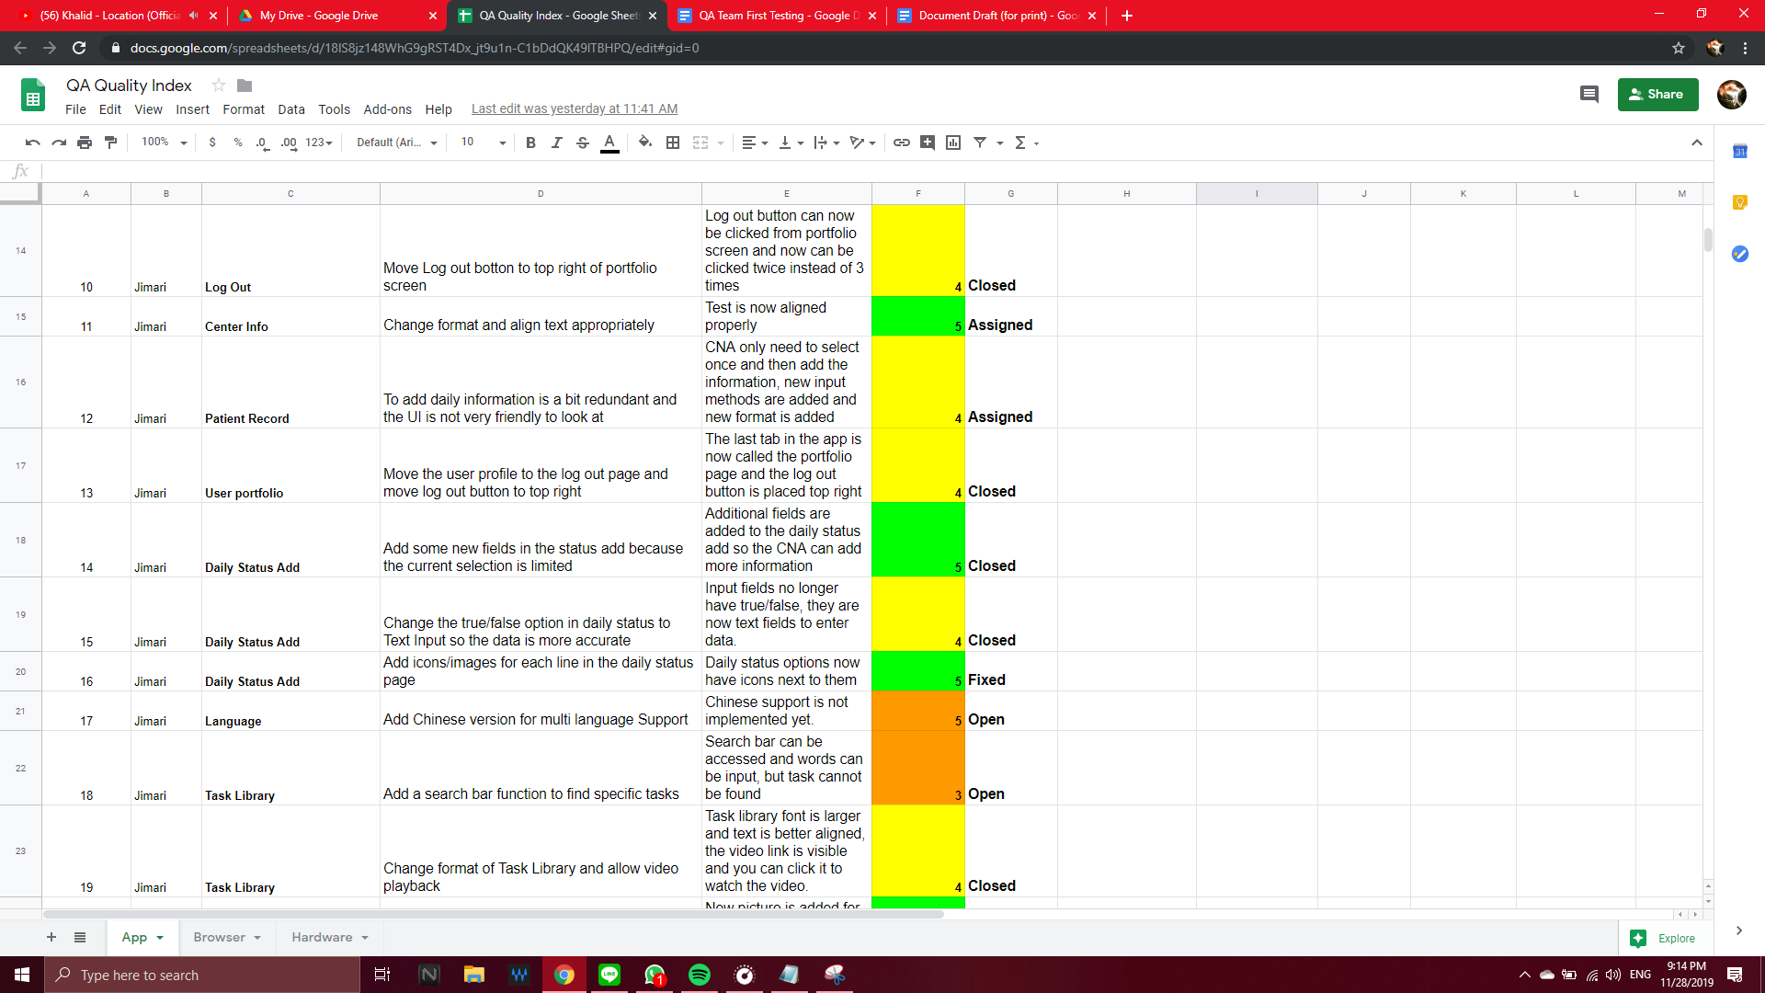

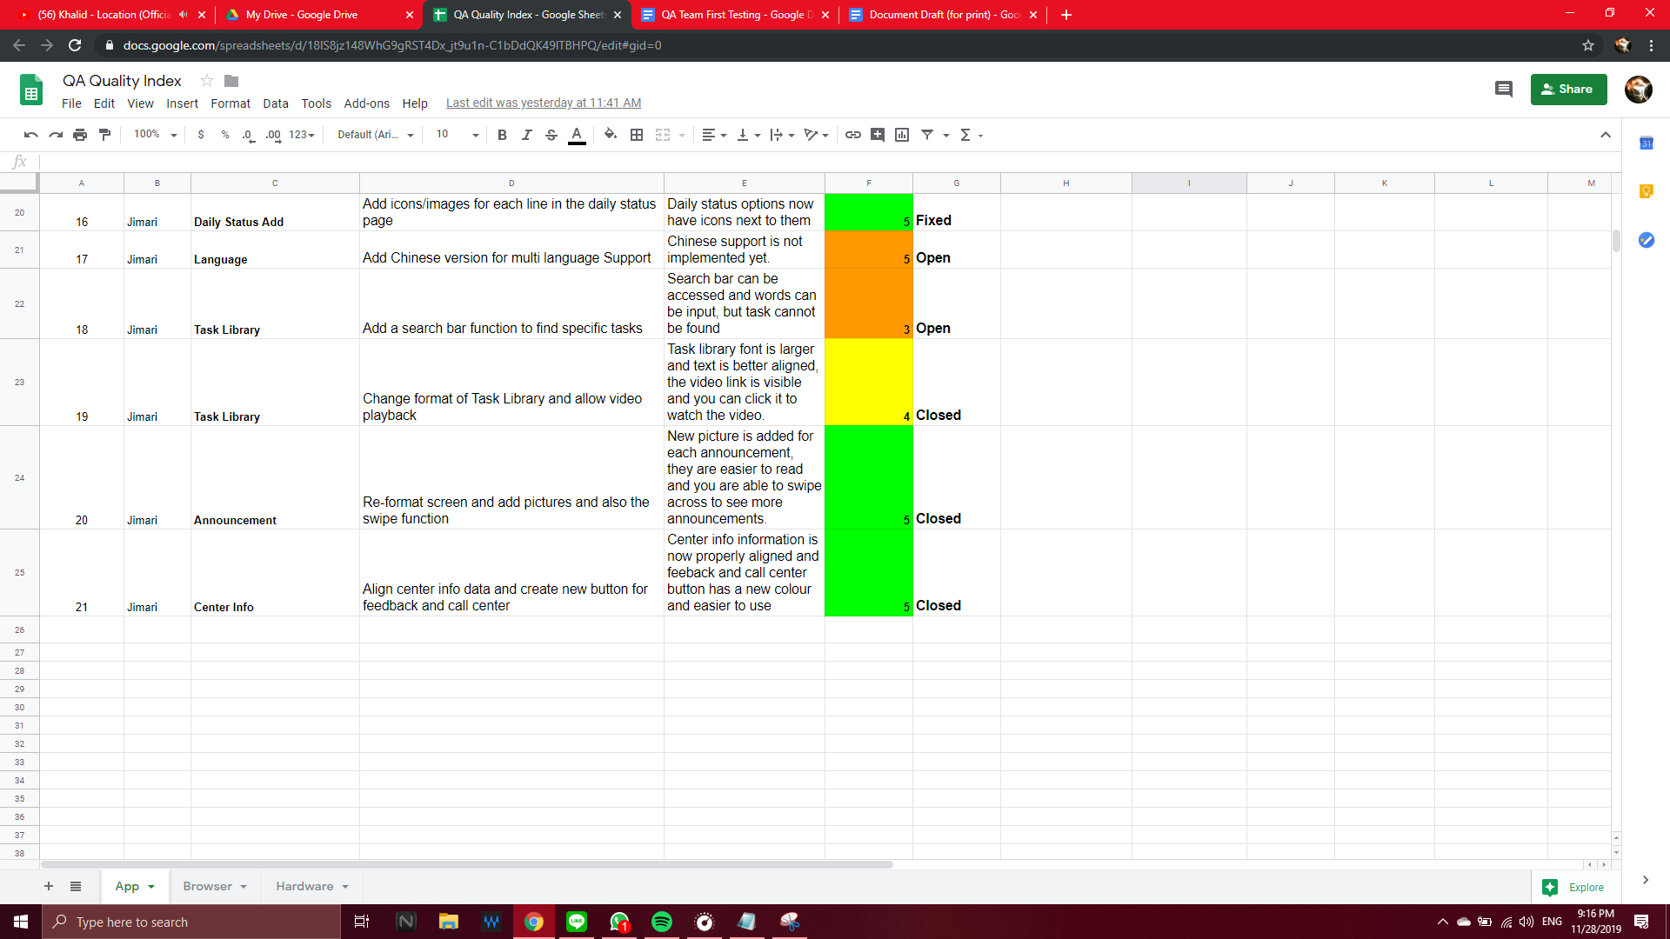

###### Figure 5.6.3 Image showing second app severity index

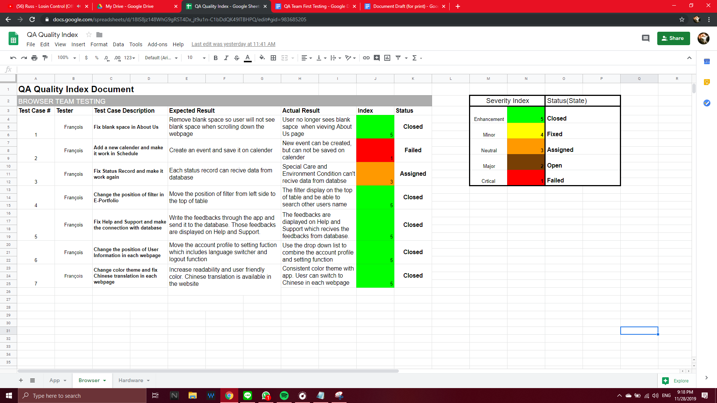

###### Figure 5.6.4 Image showing browser severity index

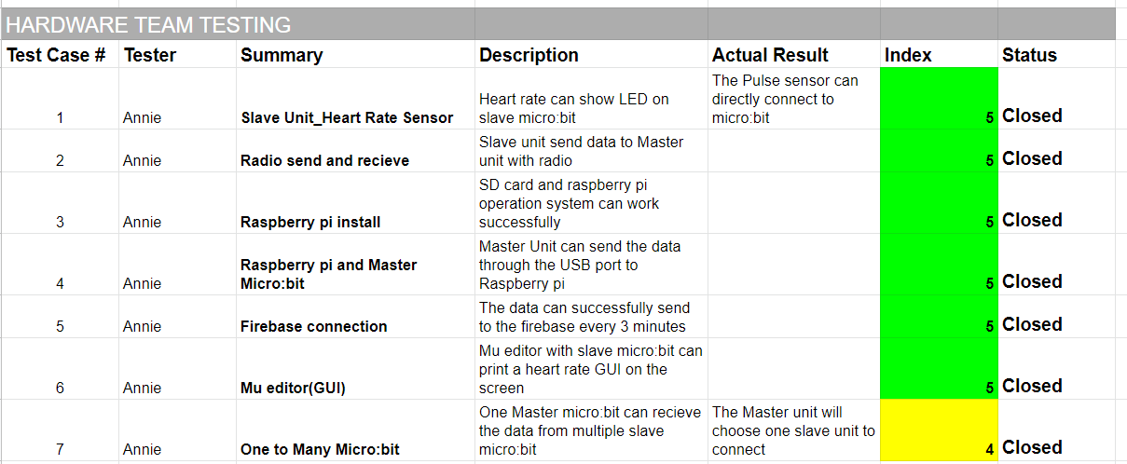

###### Figure 5.6.5 Image showing hardware severity index

## 7.0 TESTING RESPONSIBILITIES

Testers are categorized by what component they will be testing:

The Browser will be tested by Francois, Annie, Jimari. Mobile App testing will be done by Jimari and Hardware/Reports Device done by Annie. Each member will run their own test scenarios regarding which component group they were assigned to. Test cases will also be divided by components groups as well.

## 8.0 TEST ENTRANCE CRITERIA

The test entrance criteria on the development end is for the GitHub code merging team to successfully merge the code from all the systems components together after each sprint. This includes that each group has successfully, or partially, implemented the functional requirements for their team. During testing, defects code will be reported to the MRR with all the necessary information as to when, where and how the error occurred.

### 8.1 Acceptance Testing Criteria

Before deployment of the system, the necessary acceptance criteria should be met: The browser components should run smoothly on desired platforms such as Google Chrome, Firefox and Safari, Internet Explorer. The application should run smoothly on all desired mobile platforms such as IOS and Android devices. Also, testing data must be deleted from the Database. The device also needs to be functional and ready for use. Finally, login accounts for the IT Admin across each system component.

## 9.0 FINAL TESTING SCHEDULE

The QA team will perform the testing together using automatic testing tools like katalon studio and manual testing.

###### Table 5.9.1 Showing Test Schedule for the QA Team

|  |  |  |  |  |
| --- | --- | --- | --- | --- |
| Date | Test Type | Performed by | Purpose | Where |
| 20/11/2019 | System Testing | QA team | Test System functionalities | FF |
| 20/11/2019 | Android OS and Browser | QA team | Test System functionalities | FF |
| 27/11/2019 | Acceptance Testing | QA team | For final Delivery to client | FF |

## 

## 10.0 RISKS AND CONTINGENCIES

The risks listed in the table below are identified as events that could possibly interfere through the Sprint and Acceptance Testing Meetings.

###### Table 5.10.1 Showing Risks and Contingencies

|  |  |  |  |
| --- | --- | --- | --- |
| Risk | Likelihood | Impact | Mitigation |
| Sprint 1 | | | |
| Testers cannot open app or browser files | Not very likely | Moderate – could result in delays | QA team perform testing on their Laptops and mobile Phones |
| Severe Weather | Not likely | Moderate – could result in delays | Watch forecast, arrange an alternate meeting time/day if necessary |
| Schedule Conflicts | Very likely | Moderate –  Severe | Frequent communication between QA members to find the best time for everyone or in google hangout for virtual meeting |
| Sprint 2 | | | |
| Testers cannot run tests on emulators or on katalon | likely | Moderate-severe | Must Manually test the app on mobile devices and the website on browser |
| Severe Weather | Not very likely | Moderate | Meet with group on google Hangout or Line |
| QA team unable to use katalon on mobile devices | Somewhat likely | Moderate | QA Team will need to test their cases manually on browsers of the website and on mobile devices in app |
| Sprint 3 | | | |
| Testers cannot run tests on emulators or on katalon | Somewhat likely | Moderate-severe | Must Manually test the app on mobile devices and the website on browser |
| QA team unable to use katalon on mobile devices | likely | Moderate | QA Team will need to test their cases manually on browsers of the website and on mobile devices in app |



## 

# 6 REFERENCES

[1] (2019) *LTC_TMS_2.0_Microbit_slave.stl*. Pennsylvania, USA: Kutztown University

[2] Nicholas H.Tollervey (Nov 04, 2019) *Mu Documentation: Release 1.1.0.alpha.2.*

retrieved from https://buildmedia.readthedocs.org/media/pdf/mu/latest/mu.pdf

[3] Nicholas H.Tollervey (2019) *Mu and micro:bit.*

retrieved from https://codewith.mu/en/tutorials/1.0/microbit

[4] Paul Knighton (2018) *Pulse Sensor*.

retrieved from <https://sites.google.com/view/pknighton67/sensors/pulse-sensor/pulse-bpm-simple>

[5] (2019) *LTC_TMS_2.0_Microbit.py. Pennsylvania*, USA: Kutztown Universitymaster.py

[6] Tinderbox (2018) *Python: 安裝 pip 於 Windows 或 CentOS & 線上/離線安裝 (pip 101).*

retrieved from [https://medium.com/@CCstruggled/python-%E5%AE%89%E8%A3%9D-pip-%E6%96%BC-windows-%E6%88%96-centos-%E7%B7%9A%E4%](https://medium.com/@CCstruggled/python-%E5%AE%89%E8%A3%9D-pip-%E6%96%BC-windows-%E6%88%96-centos-%E7%B7%9A%E4%B8%8A-%E9%9B%A2%E7%B7%9A%E5%AE%89%E8%A3%9D-pip-101-fb6d8e3c611b)

[7] Nicolas Altamirano, Justin Frye, Nolan Perugini, Matt Sauchelli, Lucas Strickland, Tyler Whittaker (December 2018) *System Requirements Specification Version 3.0 - Hardware and Database Team.* Kutztown University Development Group 2019, Hardware and Database Team

[8] (2019) *LTC_TMS_2.0_report.py*. Pennsylvania, USA: Kutztown University

[9] *Mi Smart Band 4* , Xiaomi Corporation

retrieved from https://www.mi.com/global/mi-smart-band-4/specs

[10] *fitbit inspire & inspire HR* (2019) Fitbit, Inc.

retrieved from https://www.fitbit.com/eu/inspire[B8%8A-%E9%9B%A2%E7%B7%9A%E5%AE%89%E8%A3%9D-pip-101-fb6d8e3c611b](https://medium.com/@CCstruggled/python-%E5%AE%89%E8%A3%9D-pip-%E6%96%BC-windows-%E6%88%96-centos-%E7%B7%9A%E4%B8%8A-%E9%9B%A2%E7%B7%9A%E5%AE%89%E8%A3%9D-pip-101-fb6d8e3c611b)

[11] *Nodejs docs guides*. OpenJS Foundation.

Retrieved from https://nodejs.org/en/docs/guides/

[12] *Get started: write and deploy your first functions.*

Retrieved from <https://firebase.google.com/docs/functions/get-started?authuser=0>

[13] *Cloud Functions for Firebase.*

Retrieved from <https://firebase.google.com/docs/functions/?authuser=0#implementation_paths>

[14] *JavaScript Tutorial*. W3School.

Retrieved from https://www.w3schools.com/js/

[15] (2019). *jQuery API*. The jQuery Foundation.

Retrieved from <https://api.jquery.com/>

[16] *JSON - Introduction*. W3School.

Retrieved from https://www.w3schools.com/js/js_json_intro.asp

[17] (2019). *FullCalendar Documentation*. FullCalendar LLC.

Retrieved from <https://fullcalendar.io/docs>

[18] (2019). *Google Drive*. Google, LLC.

Retrieved from https://drive.google.com/drive/my-drive

[19] (2019). *Youtube*. Google, LLC.

Retrieved from https://www.youtube.com/

[20] (2019). *Code editing. Redefined*. Microsoft.

Retrieved from <https://code.visualstudio.com/>

[21] React Native Learn once, write anywhere. (2019).

Retrieved from <https://facebook.github.io/react-native/>

[22] Android studio. (2019).

Retrieved from <https://developer.android.com/studio>

[23] (2019) *LTC_TMS_2.0_SignInScreen.js*. Pennsylvania, USA: Kutztown University

[24] Android: How to handle right to left swipe gestures. (2019). Retrieved from <https://stackoverflow.com/questions/4139288/android-how-to-handle-right-to-left-swipe-gestures>

[25] (2019) *LTC_TMS_2.0_HomeScreen.js*. Pennsylvania, USA: Kutztown University

[26] (2019) *LTC_TMS_2.0_PortfolioScreen.js*. Pennsylvania, USA: Kutztown University

[27] (2019) *LTC_TMS_2.0_DailyStatusAddScreen.js*. Pennsylvania, USA: Kutztown University

[28] (2019) *LTC_TMS_2.0_VitalStatusAddScreen.js*. Pennsylvania, USA: Kutztown University

[29] (2019) *LTC_TMS_2.0_DailyStatusReadScreen.js*. Pennsylvania, USA: Kutztown University

[30] (2019) *LTC_TMS_2.0_TaskInstructionScreen.js*. Pennsylvania, USA: Kutztown University

[31] (2019) *LTC_TMS_2.0_CenterInfoScreen.js*. Pennsylvania, USA: Kutztown University

[32] (2019) *LTC_TMS_2.0_FeedbackScreen.js*. Pennsylvania, USA: Kutztown University

[33] (2019) *LTC_TMS_2.0_LogoutScreen.js*. Pennsylvania, USA: Kutztown University

[34] Yahoo! (December 20, 2019). *BusTracker Taiwan* (version 1.18.0 ). California, USA: Yahoo!

retrieved from https://play.google.com/store/apps/details?id=nexti.android.bustaiwan&hl=en_US

[35] Facebook, Inc (2019). *Facebook.* California, USA:Facebook, Inc

retrieved from https://www.facebook.com/